# Time not worked register

|  |
| --- |
| Content index Main screen  Description  Create new record  Data requested  Record Detail  Additional Information |

## Main screen

### Description

The screen for register cases for time not worked is shown on this image.

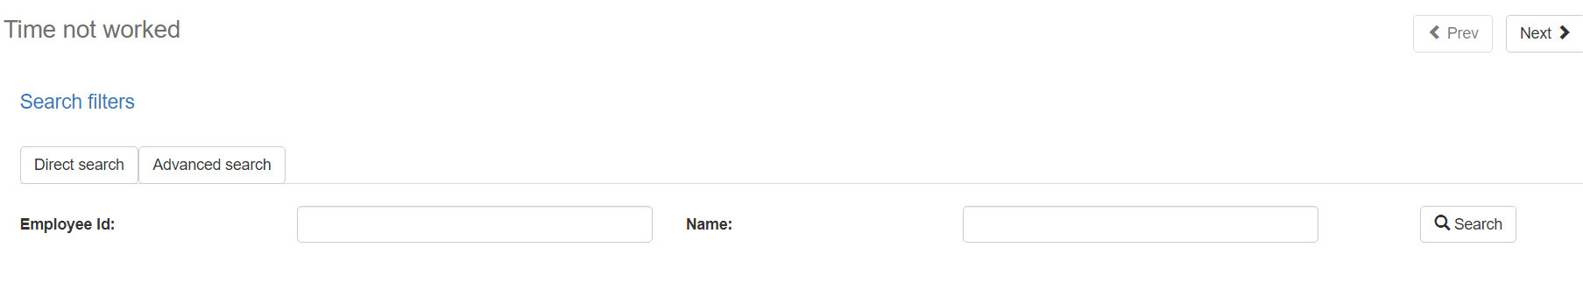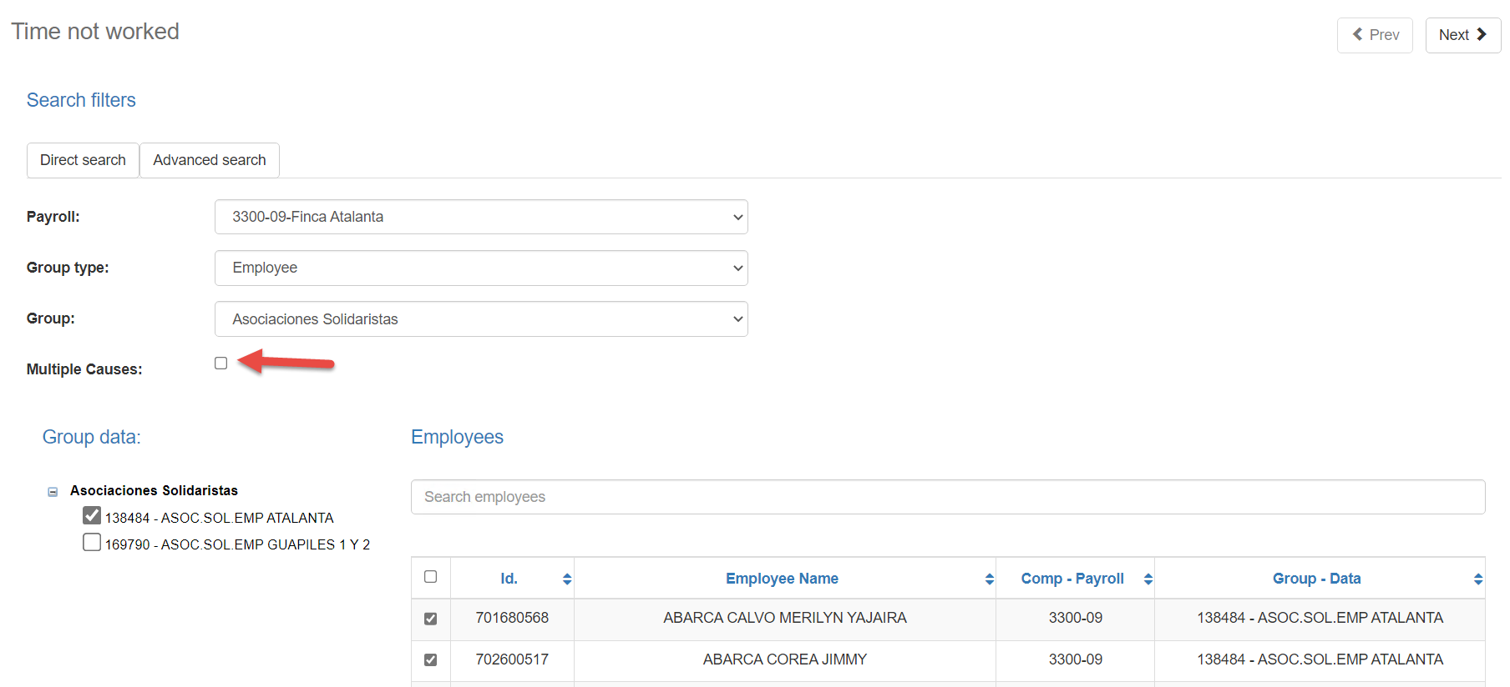

When selecting one or more employees, you can click on the button in the upper right called "Next". This screen is where the main data of the Time Not Worked will fill.

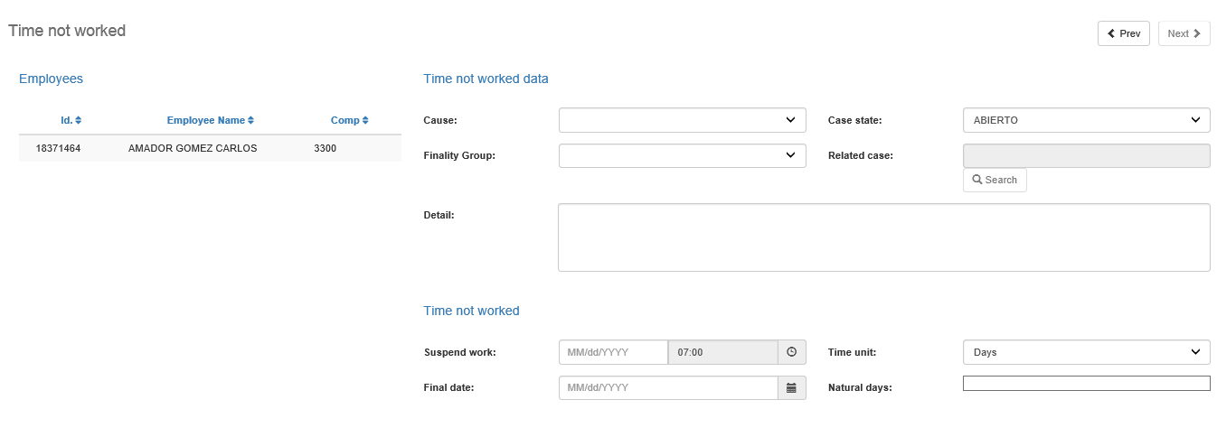

### Create new record

Back to top

To create a new time off record, you must first select the employee(s) for the time off. There are two ways to search for employees, the first can be done by means of a direct search for the worker through his identification number or by name, the other way is to select a payroll, then a type of group and then a group. By selecting all the mentioned values, the grouping data will be displayed. By selecting a grouping data, the system will bring up the employees related to that grouping from ADAM.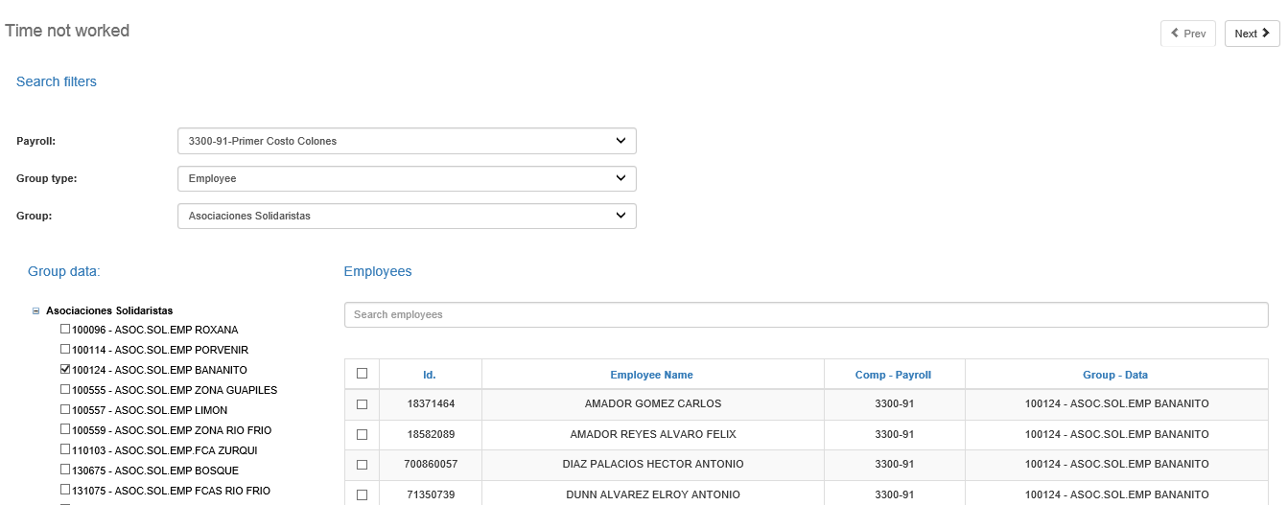

Additionally, in this second search, it allows us the option of entering multiple causes of absenteeism for employees; otherwise, if this option is not activated, the system will record the same cause of absenteeism for all selected employees.

When selecting one or several employees, you can click on the button at the top right called "Next". This screen is where the main data of the Time Out of Work record will be indicated.

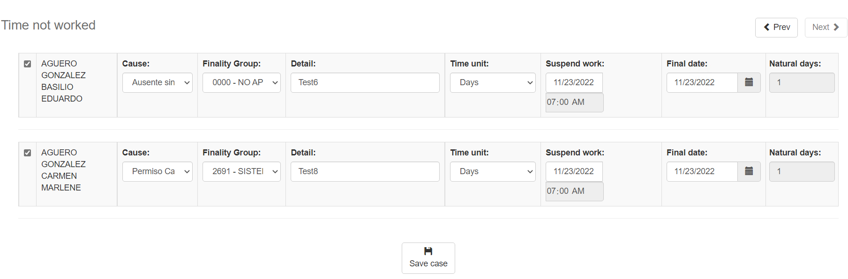

In the case of multiple causes, it allows us to enter the causes specific to each employee, as shown in the image attached above.

### Data requested

Back to top

The *Time not worked* screen has the following fields:

|  |  |
| --- | --- |
| **Field** | **Description** |
| Cause | Unique selection field where the type of Cause in which the time not worked will be register to the workers selected. Example: Abandono de trabajo, Accidente de Trabajo, Accidente de Tránsito. |
| Case state | Unique selection field, in which the user can choose the status of the new case.  The status will depend on the selected cause. If the cause is Accidents category, the status will show: Abierto, Cita, Reapertura.  If the case is for more than one worker, the Cita and Reapertura states will not be eligible. |
| Finality Group | Unique selection field where the finality group of the case is established. |
| Related sase | If the status of the case is Cita or Reapertura, a pop-up window will be enabled that will show the accident type cases of the worker. When selecting an accident record, it will be like the parent case of the appointment or reopening and the INS Case data (CRC Division) will be loaded. |
| INS Case | Text field that is enabled only for the Costa Rica division, and where the user can enter the case number of the I.N.S. |
| Detail | Text field in which the user can add a description of the case to be registered. Text field in which the user can add a description of the case to be registered. |
| Accident date | Text field or date type that will be enable when the cause is an accident as configured in the system. |
| Suspended work | Text field or date type that refers to the start date of the case. If the cause is an accident and it will be record in days then the time will be enable, otherwise the time will always be 07:00 am. |
| Final date | This is the end date of the case to be registered. |
| Time unit | Selection field where it is establish whether the case will be days or hours. If the user selects days, a subtraction will be made between the end date and the suspended date and it will be displayed in the “Natural days” field. If the user selects Hours then the end date will be equal to the suspended date and the user will be able to enter the hours of the case. The hours cannot be more than 8 hours. |
| Close time not worked | This check field will be enable only for accident-type causes. When you select the field, the system will create the case with the status Closed. For the Costa Rica division, when selecting this field, an INS Case is mandatory. |

### Record detail

Back to top

If the cause is configured as a cause that requires additional information, then the system will enable two more screens for the registration of the case.

By clicking on the Next button, the system will enable the selection of Case Details.

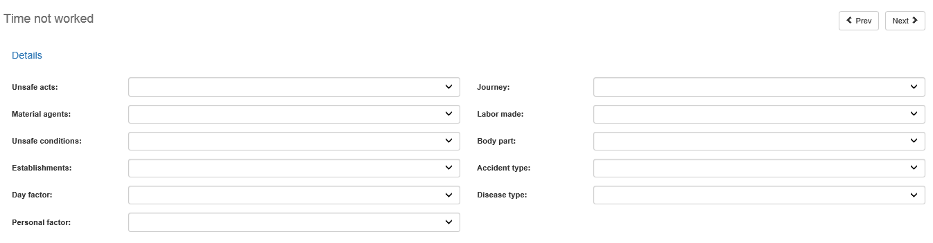

The screen presents the following fields:

|  |  |
| --- | --- |
| **Field** | **Description** |
| Unsafe acts | Single selection field where the values ​​for unsafe acts of the time not worked case are set. |
| Material agents | Single selection field where the values ​​for material agents of the time not worked case are set. |
| Unsafe conditions | Single selection field where the values ​​for unsafe conditions of the time not worked case are set. |
| Establishments | Single selection field where the values ​​for establishments of the time not worked case are set. |
| Day factor | Single selection field where the values ​​for day factor of the time not worked case are set. |
| Personal factor | Single selection field where the values ​​for personal factor of the time not worked case are set. |
| Journey | Single selection field where the values ​​for journey of the time not worked case are set. |
| Labor made | Single selection field where the values ​​for labor made of the time not worked case are set. |
| Body part | Single selection field where the values ​​for body part of the time not worked case are set. |
| Accident type | Single selection field where the values ​​for accident type of the time not worked case are set. |
| Disease type | Single selection field where the values ​​for disease type of the time not worked case are set. |

### Record Additional Information

Back to top

By clicking on the Next button, the system will enable the selection of Additional Information of the case.

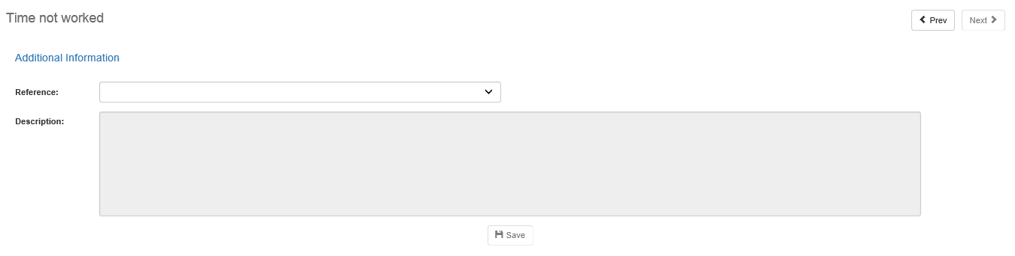

The screen presents the following fields:

|  |  |
| --- | --- |
| **Field** | **Description** |
| Reference | Single selection field where the type of reference to be saved. |
| Description | Unique selection field where the values ​​for references of the “time not worked” case are established. |

To save the reference and the description, click the Save button. A description can be save for reference.

To finalize the registration of the “Time not worked” case, you must click the Save Case button.

If there were no validations or exceptions, the necessary records will be insert into ADAM to create the Time not worked case. When this happens, a screen will be display with the list of registered cases.

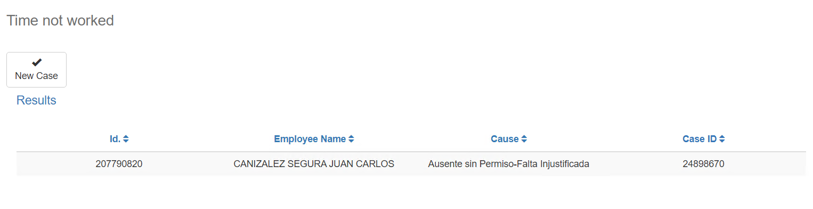

By pressing the New Record button, the system will redirect to the first screen to create a new “Time not worked” case

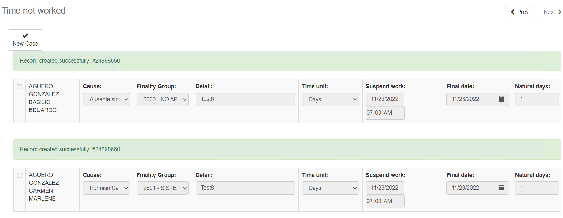

In the case of multiple records, the system will notify you with messages if the record was saved successfully or an error occurred during the saving process.