# Update Time not worked

|  |
| --- |
| Content index Main screen  Description  Search records  Update record  Update detail  Update Additional Information  Add files  Delete case |

## Main screen

### Description

On the *Update Time not worked screen*, the screen for edit registered time not worked cases is display.

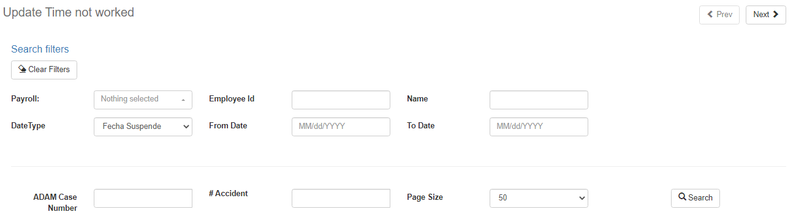

### Search records

Back to top

To search for records, the filters Employee, ADAM Case Number or INS Case (Costa Rica Division) are required. To search, one of the three filters is required or use all three for a more precise search.

To obtain values in the Employee filter, a previous search must be carried out, in which the filters are involved: Payroll, Employee Id, Name, Start Date, End Date. When placing the filter values, the system will search for employees related to the payroll, by employee id, by the name of the worker or by the dates in which cases have been made, considering the suspended date of the registered cases.

To show results and make them eligible for the update, you must select or enter data in the filters and click the Search button.

### Update record

Back to top

When selecting an employee, you can click on the button in the upper right called “Next”. This screen is where the registered Work Time Out data will be display, ready to be modified.

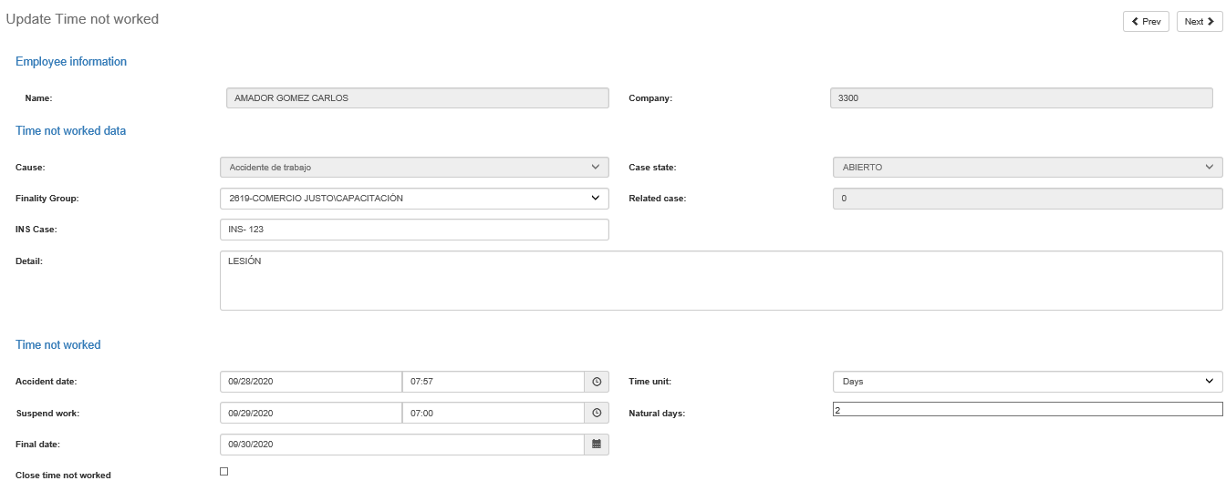

The Update Time not worked screen show the next fields:

|  |  |
| --- | --- |
| **Field** | **Description** |
| Name | Text field read only with employee name. |
| Company | Text field read only with company name of employee. |
| Cause | Read only field where the type of Cause in which the time not worked registered to the workers selected. Example: Abandono de trabajo, Accidente de Trabajo, Accidente de Tránsito. |
| Case state | Read only field where the user can see the state of registered case. |
| Finality Group | Unique selection field where the finality group of the case is established. |
| Related sase | Text field in of the parent case from the Cita or Reapertura. |
| INS Case | Text field that is enabled only for the Costa Rica division, and where the user can enter the case number of the I.N.S. |
| Detail | Text field in which the user can add a description of the case to be registered. Text field in which the user can add a description of the case to be registered. |
| Accident date | Text field or date type that will be enable when the cause is an accident as configured in the system. |
| Suspended work | Text field or date type that refers to the start date of the case. If the cause is an accident and it will be record in days then the time will be enable, otherwise the time will always be 07:00 am. |
| Final date | This is the end date of the case to be registered. |
| Time unit | Selection field where it is establish whether the case will be days or hours. If the user selects days, a subtraction will be made between the end date and the suspended date and it will be displayed in the “Natural days” field. If the user selects Hours then the end date will be equal to the suspended date and the user will be able to enter the hours of the case. The hours cannot be more than 8 hours. |
| Close time not worked | This check field will be enable only for accident-type causes. When you select the field, the system will create the case with the status Closed. For the Costa Rica division, when selecting this field, an INS Case is mandatory. |

### Update Time not worked detail

Back to top

If the cause of the Time not worked case to be updated is configure as a cause that requires additional information, then the system will enable two more screens to update the Details and Additional Information of the case.

By clicking on the Next button, the system will enable the selection of Case Details.

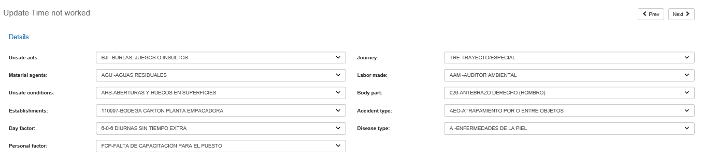

The screen shows the next fields:

|  |  |
| --- | --- |
| **Field** | **Description** |
| Unsafe acts | Single selection field where the values for unsafe acts of the time not worked case are set. |
| Material agents | Single selection field where the values for material agents of the time not worked case are set. |
| Unsafe conditions | Single selection field where the values for unsafe conditions of the time not worked case are set. |
| Establishments | Single selection field where the values for establishments of the time not worked case are set. |
| Day factor | Single selection field where the values for day factor of the time not worked case are set. |
| Personal factor | Single selection field where the values for personal factor of the time not worked case are set. |
| Journey | Single selection field where the values for journey of the time not worked case are set. |
| Labor made | Single selection field where the values for labor made of the time not worked case are set. |
| Body part | Single selection field where the values for body part of the time not worked case are set. |
| Accident type | Single selection field where the values for accident type of the time not worked case are set. |
| Disease type | Single selection field where the values for disease type of the time not worked case are set. |

### Update Additional information

Back to top

By clicking on the Next button, the system will enable the selection of Additional Information of the case.

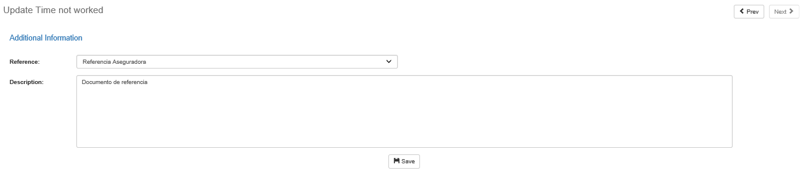

The screen shows the next fields:

|  |  |
| --- | --- |
| **Field** | **Description** |
| Reference | Single selection field where the type of reference to be saved. |
| Description | Unique selection field where the values ​​for references of the “time not worked” case are established. |

To save the reference and description, click the Save button. A description can be saved for reference. The values will be edit if they already exist.

To finish updating the case of Time not worked, you must click the Save Case button.

If there were no validations or exceptions, the necessary records will be update in ADAM for the Time not worked case. When this happens, the system will redirect to the initial screen.

### Add files

Back to top

When searching for registered cases, you will see a button labeled Files at the bottom. This button will appear at the end of each record where the cause is configured in a way that requires additional information.

To add files, you must select a record or click on the Files button.

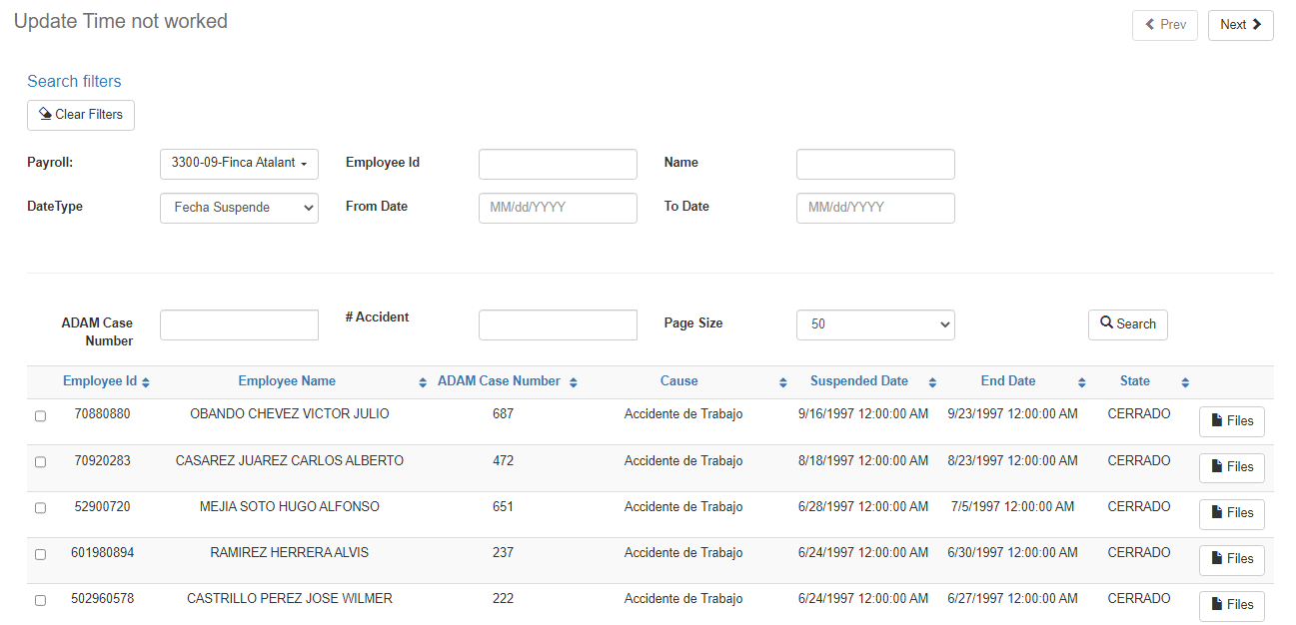

Clicking on the Files button will display a pop-up window with the necessary information to view, download, add and delete files.

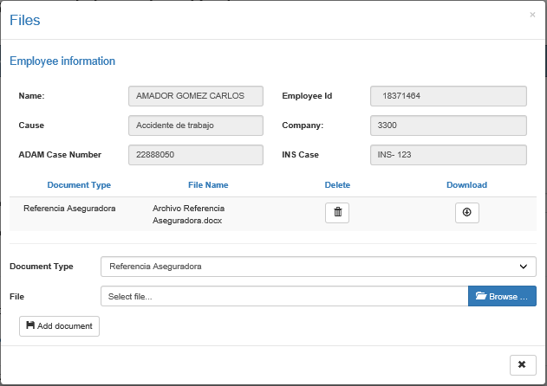

The screen shows the next fields:

|  |  |
| --- | --- |
| **Field** | **Description** |
| Name | Text field read only with employee name. |
| Employee Id | Read only field with employee Id. |
| Cause | Read only field where the type of Cause in which the time not worked registered to the workers selected. Example: Abandono de trabajo, Accidente de Trabajo, Accidente de Tránsito. |
| Company | Text field read only with company name of employee. |
| ADAM Case Number | Read only field with ADAM number of the registered case. |
| INS Case | Text field that is enabled only for the Costa Rica division, and where the user can review the case number of the I.N.S. |
| Document type | Single selection field where the user select the document type to be save. |
| File | File from File System selected by the user. |

To add a document, you must select a Document Type value and have selected a file. Then click on the Add document button.

To delete an attached file, click on the Delete button.

To download a registered file, click on the Download button.

### Delete record case

Back to top

To delete a Time not worked case, select a record from the first screen and click the next button. The case data will be present and on the final screen of the case (second screen when the type of case does not require additional information or otherwise the fourth screen) the Delete Case button will be present.

