# Causes

# Content index

Main screen

Description

Filtering

Results

Available operations

Remove

Add/Edit

Data requested

Duplicate records

## Main screen

### Description

The *Causes* screen displays the general catalog of Causes in the application available for Time not worked. The records on this screen are inputs for the *Time not worked* screen.

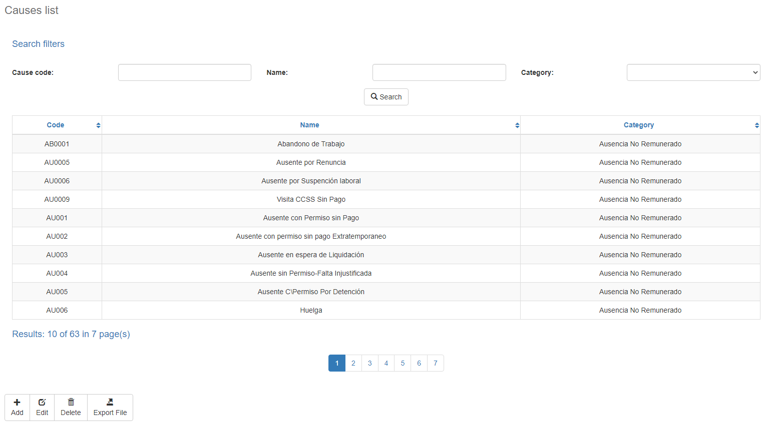

### Filtering

Back to top

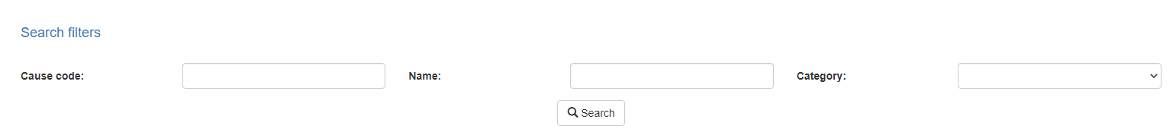

The list of Causes displayed on the maintenance page can be filtered using the fields available for this purpose at the top of the window: cause code, name or category. Including one or more filters and clicking the *Search* button will list the Causes that meet all the specified search criteria.

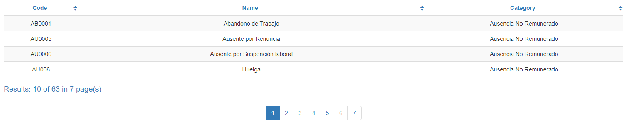

### Results

Back to top

The number of records retrieved as well as the number of pages on which they are split will be displayed at the bottom of the results table, where you can also select the desired page to browse. You can also sort the results by each of the columns by clicking on their header to display them in both ascending and descending ways by repeating the click on the header. This operation will sort all records on all available pages and display the results according to your preference.

## Available operations

Back to top

In *Causes* maintenance*,* you can add Causes to the general catalog, edit or delete existing Causes, reactivate previously deleted Causes and export information by division in Excel File.

### Remove

To delete a record, select the desired record from the available Causes list and click on the delete button. Immediately the system will display a confirmation screen where you can proceed with the operation or cancel it.

Upon confirming the delete operation, the system will disable the record but will retain your information for the history of the data so that it will be possible to retrieve this record in the future.

### Add / Edit

Back to top

If you want to add a new Causes in the app you must click the Add button. Clicking will display a pop-up screen where you will be prompted for the data required for the operation. This pop-up screen is the same screen that will appear when you select a record from the list and click the Edit button to modify your data.

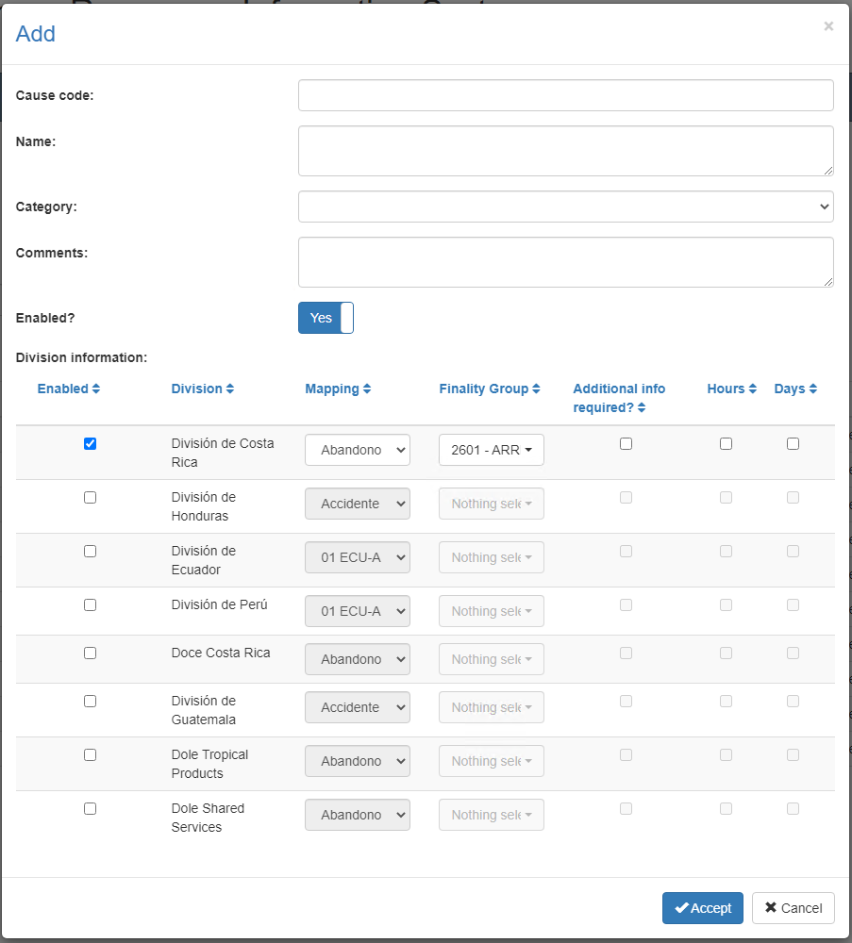

### Data requested

Back to top

The add/edit screen has the following fields:

|  |  |
| --- | --- |
| **Field** | **Description** |
| Cause code | Alphanumeric code of 50 characters as maximum length, which will represent the Causes in the system. |
| Name | Alphanumeric description of maximum length of 500 characters, with the Causes name in the system. |
| Category | Single selection list to associate the case with an existing and activate category in the system. |
| Comments | Alphanumeric description of maximum length of 1000 characters, with the Causes comments in the system. |
| Enabled? | Indicates whether the Causes is active for use in the system. |

|  |  |
| --- | --- |
| **Division Information** | |
| **Field** | **Description** |
| Enabled | Indicate if the division is related to the cause |
| Division | Alphanumeric code of 3 characters as maximum length, which will represent the Division in the system. |
| Mapping | Single selection list to associate the relation of the division to the cause with an existing and activate Mapping in the system. |
| Finality Group | Single selection list to associate the relation of the division to the cause with an existing and activate Finality Group in the system. |
| Additional info required | Indicates whether the relation of the division to the cause is require additional information |
| Hours | Indicates whether the relation of the division to the cause is allow records by hours. |
| Days | Indicates whether the relation of the division to the cause is allow records by days. |

When adding or editing a Causes click the accept button to finish the operation or cancel as well as the close icon at the top right of the pop-up screen to cancel the operation.

### Duplicate records

Back to top

At the end of an add or edit operation, the system will validate that the information by both code and name is not repeated with any other Causes in the system. If any data is repeated the system will give you the warning and some options to proceed:

* 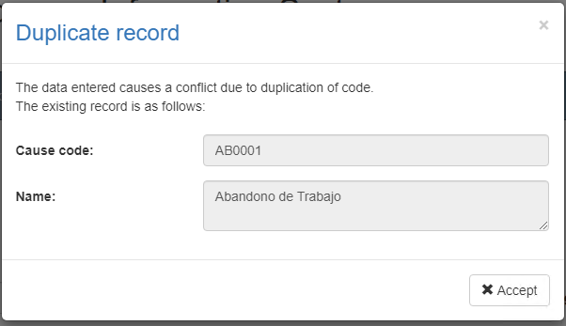Duplicate record

This screen will appear when the entered record causes a conflict with another active record in the system. In this case there is no choice but to accept the warning and modify the data.