# Users

# Content index

Main screen

Description

Filtering

Results

Available operations

Remove

Add/Edit

Data requested

Duplicate records

## Main screen

### Description

The *Users* screen displays the general catalog of Users who have permissions on the application.

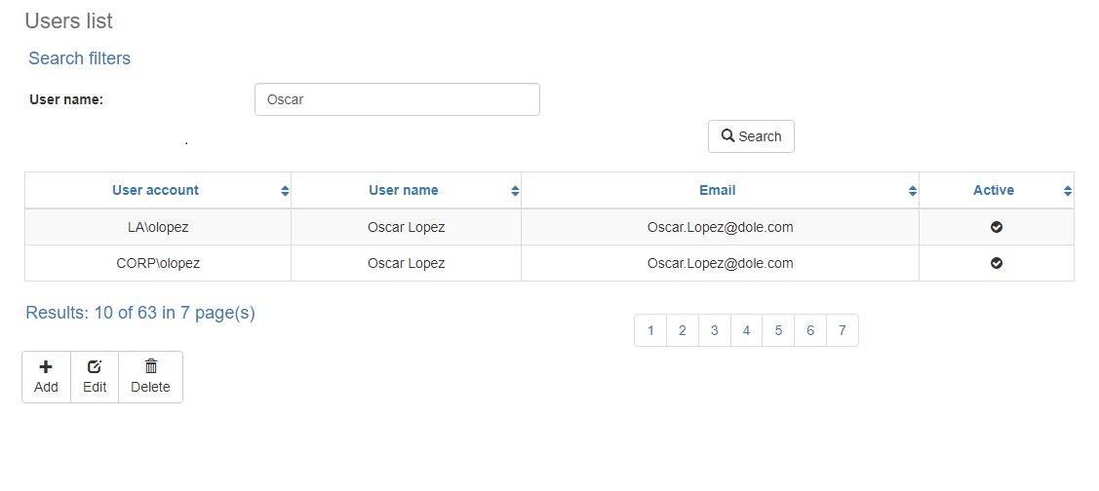

### Filtering

Back to top

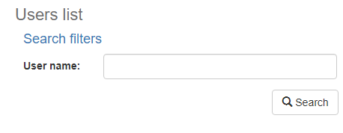The list of Users displayed on the maintenance page can be filtered using the fields available for this purpose at the top of the window: cause code, name or category. Including one or more filters and clicking the *Search* button will list the Users that meet all the specified search criteria.

### Results

Back to top

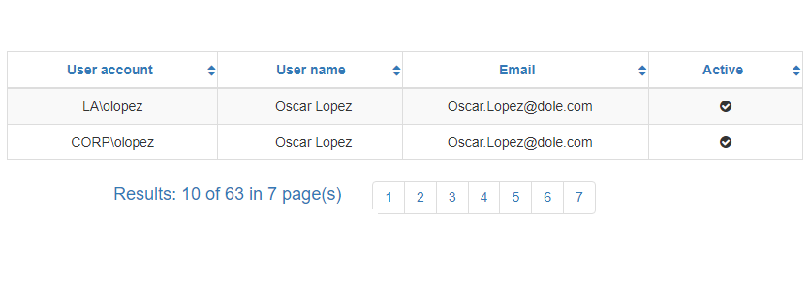The number of records retrieved as well as the number of pages on which they are split will be displayed at the bottom of the results table, where you can also select the desired page to browse. You can also sort the results by each of the columns by clicking on their header to display them in both ascending and descending ways by repeating the click on the header. This operation will sort all records on all available pages and display the results according to your preference.

## Available operations

Back to top

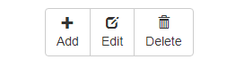In *Users* maintenance*,* you can add Users to the general catalog, edit or delete existing Users, reactivate previously deleted Users.

### Remove

To delete a record, select the desired record from the available Users list and click on the delete button. Immediately the system will display a confirmation screen where you can proceed with the operation or cancel it.

Upon confirming the delete operation, the system will disable the record but will retain your information for the history of the data so that it will be possible to retrieve this record in the future.

### Add / Edit

Back to top

If you want to add a new Users in the app you must click the Add button. Clicking will display a pop-up screen where you will be prompted for the data required for the operation. This pop-up screen is the same screen that will appear when you select a record from the list and click the Edit button to modify your data, the search for the user account should be done among the active directory users, this pop-up screen is found by clicking the Search button.

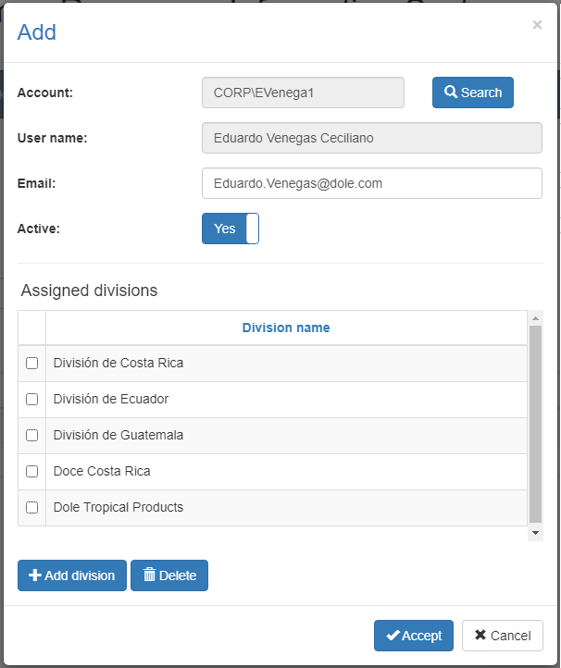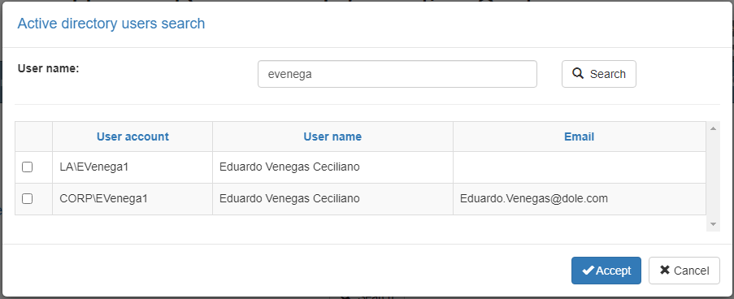

### Data requested

Back to top

The add/edit screen has the following fields:

|  |  |
| --- | --- |
| **Field** | **Description** |
| Account | Alphanumeric description of maximum length of 30 characters, with the User account in the system. |
| User name | Alphanumeric description of maximum length of 50 characters, with the User name in the system. |
| Email | Alphanumeric description of maximum length of 100 characters, with the User email in the system. |
| Active | Indicates whether the User is active for use in the system. |
| Divisions | Multiple selection list to associate the User with an existing and activate divisions in the system. |

When adding or editing a User click the accept button to finish the operation or cancel as well as the close icon at the top right of the pop-up screen to cancel the operation.

### Duplicate records

Back to top

At the end of an add or edit operation, the system will validate that the information by both code and name is not repeated with any other Users in the system. If any data is repeated the system will give you the warning and some options to proceed:

* Duplicate record

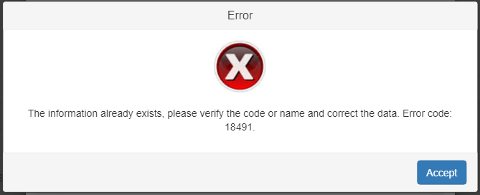

This screen will appear when the entered record Users a conflict with another active record in the system. In this case there is no choice but to accept the warning and modify the data.