# Enable Socio-economic card

# Content index

Main screen

Description

Filtering

Results

## Main screen

### Description

The *Enable Socio-economic card* screen display the finished socioeconomic card records are, allowing the socioeconomic to be enabled again for editing.

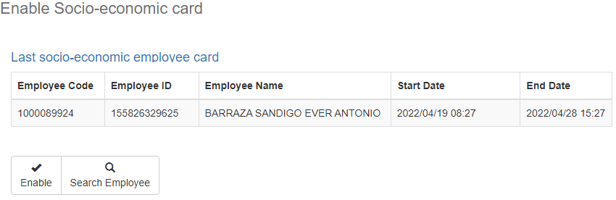

### Filtering

Back to top

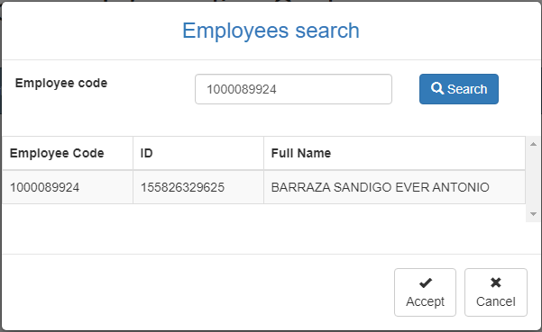The filters that are displayed on the main page can be filtered using the fields at the top of the window: Employee code and clicking on the Accept button will generate the summary of the survey completed by the employee.

### Results

Back to top

The socioeconomic records completed by the employee will be listed. To re-enable a socioeconomic record, the user can click on the *Enable* button, the user can change the employee by clicking on the *Search Employee* button, showing the employee search window again.