# Start survey

|  |
| --- |
| Table of contents Main screen  Description  Start new  Requested data  Other operations |

## Main screen

### Description

On the Socioeconomic File screen, the screen for capturing and editing the start of the socioeconomic file is shown, which first shows us when the page loads an acceptance of informed consent and when accepting it shows us the client search screen to which we are going Enter the survey data.

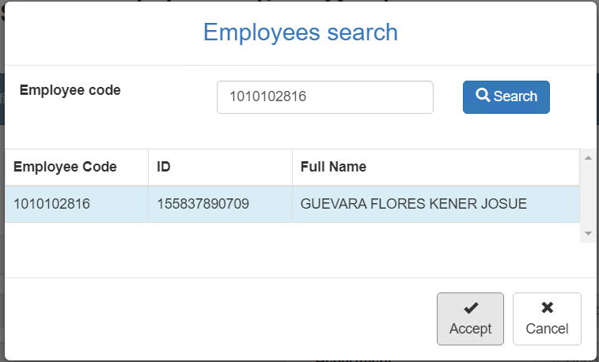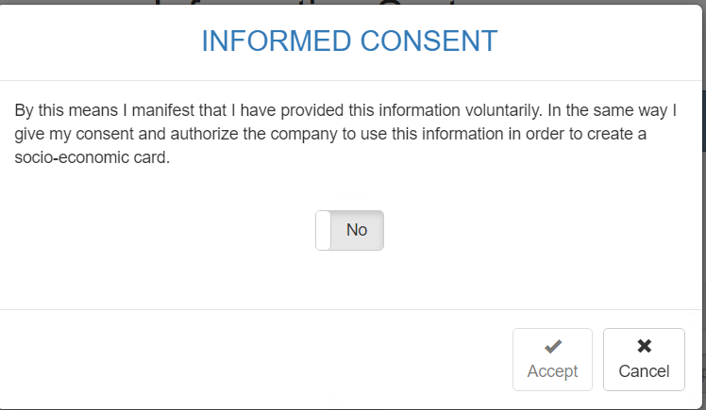

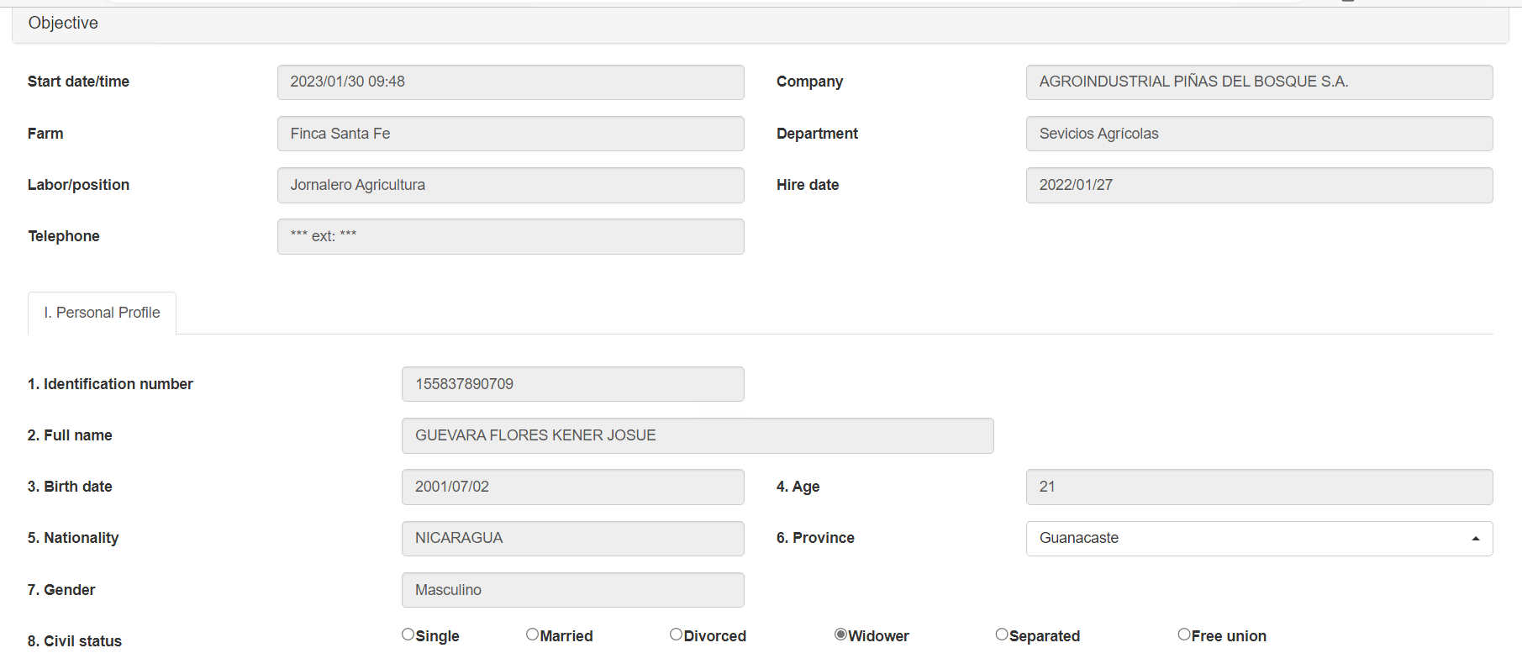

### Start new

Back to top

To start a survey, it is necessary to accept the informed consent and enter the ID of the employee to whom the information is to be uploaded, then we select the employee and click the accept button. Then the system proceeds to display an informative message that the survey can be saved as a draft, in addition to preloading data information in an informative manner, which cannot be modified.

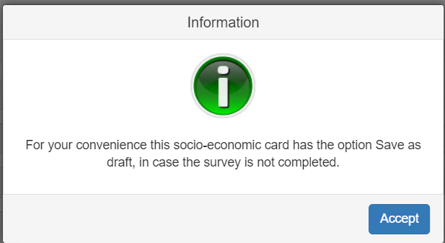

### Requested data

Back to top

The survey home screen presents the following fields:

|  |  |
| --- | --- |
| **Field** | **Description** |
| Province | Single selection field. |
| Civil status | Single selection buttons. |

Back to top

### Other operations

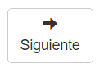

When the province and marital status values ​​have been selected, it is possible to click on the next button to proceed with the next window of the survey.