# Survey Summary

# Content index

Main screen

Description

Filtering

Results

## Main screen

### Description

On the Survey Summary screen, displays the summary of an employee's survey.

### Filtering

Back to top

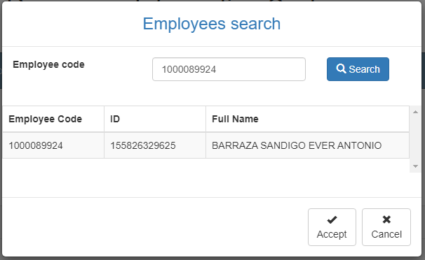The filters that are displayed on the main page can be filtered using the fields at the top of the window: Employee code and clicking on the Accept button will generate the summary of the survey completed by the employee

### Results

Back to top

The system displays the employee survey summary by grouping them by question type. To show or hide the answers marked by the employee, click on the group of questions.

