# Household Contribution Ranges

# Content index

Main screen

Description

Filtering

Results

Available operations

Remove

Add/Edit

Data requested

Duplicate records

## Main screen

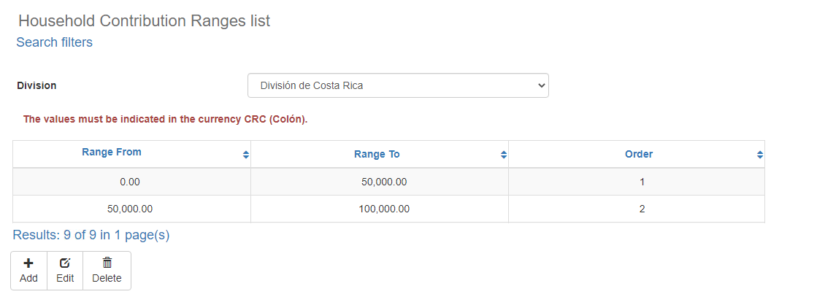

### Description

The *Household Contribution Ranges* screen displays the general catalog of Household Contribution Ranges in the application available for Social Responsability. The records on this screen are inputs for the *Social Responsability* screen.

### Filtering

Back to top



The list of Household Contribution Ranges displayed on the maintenance page can be filtered using the fields available for this purpose at the top of the window: Division. Including one or more filters and clicking the *Search* button will list the Household Contribution Ranges that meet all the specified search criteria.

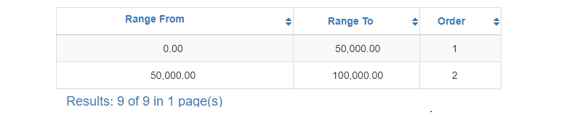

### Results

Back to top

The number of records retrieved as well as the number of pages on which they are split will be displayed at the bottom of the results table, where you can also select the desired page to browse. You can also sort the results by each of the columns by clicking on their header to display them in both ascending and descending ways by repeating the click on the header. This operation will sort all records on all available pages and display the results according to your preference.

## Available operations

Back to top

In *Household Contribution Ranges* maintenance*,* you can add Household Contribution Ranges to the general catalog, edit or delete existing Household Contribution Ranges, reactivate previously deleted Household Contribution Ranges and export information by division in Excel File.

### Remove

To delete a record, select the desired record from the available Household Contribution Ranges list and click on the delete button. Immediately the system will display a confirmation screen where you can proceed with the operation or cancel it.

Upon confirming the delete operation, the system will disable the record but will retain your information for the history of the data so that it will be possible to retrieve this record in the future.

### Add / Edit

Back to top

If you want to add a new Household Contribution Range in the app you must click the Add button. Clicking will display a pop-up screen where you will be prompted for the data required for the operation. This pop-up screen is the same screen that will appear when you select a record from the list and click the Edit button to modify your data.

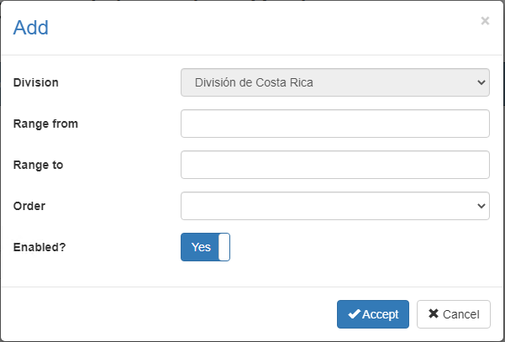

### Data requested

Back to top

The add/edit screen has the following fields:

|  |  |
| --- | --- |
| **Field** | **Description** |
| Division | Single selection list to associate the relation of the range with an existing and activate Division in the system. |
| Range from | Numeric description of maximum length of 9 numbers, with the range from. |
| Range to | Numeric description of maximum length of 9 numbers, with the range to. |
| Order | Single selection list to associate the relation of the range with an existing and activate order in the system. |
| Enabled? | Indicates whether the Household Contribution Range is active for use in the system. |

When adding or editing a Household Contribution Range click the accept button to finish the operation or cancel as well as the close icon at the top right of the pop-up screen to cancel the operation.

### Duplicate records

Back to top

At the end of an add or edit operation, the system will validate that the information by both code and name is not repeated with any other Household Contribution Ranges in the system. If any data is repeated the system will give you the warning and some options to proceed:

This screen will appear when the entered record Household Contribution Range a conflict with another active record in the system. In this case there is no choice but to accept the warning and modify the 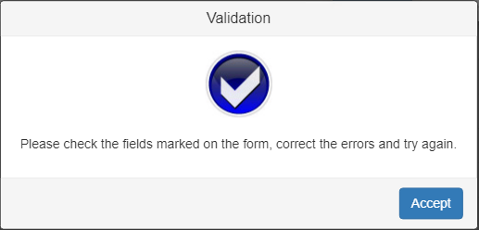data.