# Reasons for not medic attention

# Content index

Main screen

Description

Filtering

Results

Available operations

Remove

Add/Edit

Data requested

Duplicate records

## Main screen

### Description

The *Reasons for not medic attention* screen displays the general catalog of Reasons for not medic attention in the application available for Social Responsability. The records on this screen are inputs for the *Social Responsability* screen.

### Filtering

Back to top

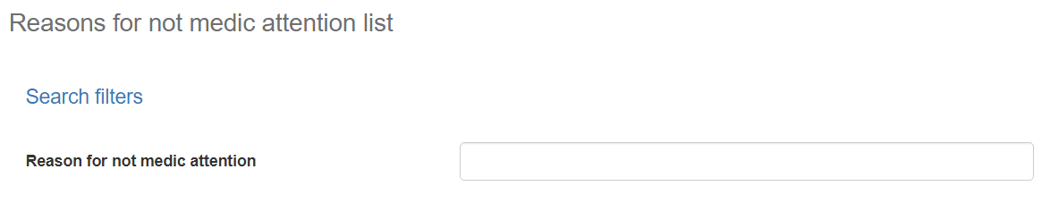

The list of Reasons for not medic attention displayed on the maintenance page can be filtered using the fields available for this purpose at the top of the window: cause code, name, or category. Including one or more filters and clicking the *Search* button will list the Reasons for not medic attention that meet all the specified search criteria.

### Results

Back to top

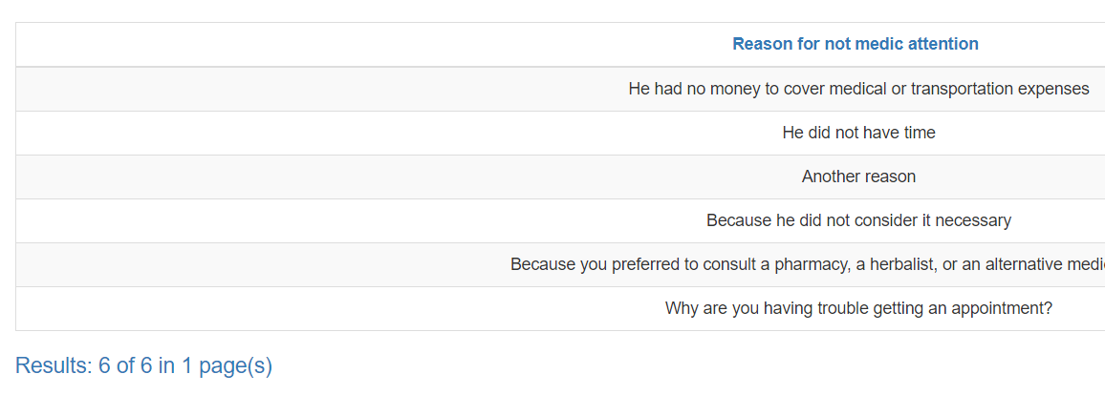The number of records retrieved as well as the number of pages on which they are split will be displayed at the bottom of the results table, where you can also select the desired page to browse. You can also sort the results by each of the columns by clicking on their header to display them in both ascending and descending ways by repeating the click on the header. This operation will sort all records on all available pages and display the results according to your preference.

## Available operations

Back to top

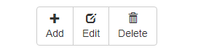In *Reasons for not medic attention* maintenance*,* you can add Reasons for not medic attention to the general catalog, edit or delete existing Reasons for not medic attention, reactivate previously deleted Reasons for not medic attention and export information by division in Excel File.

### Remove

To delete a record, select the desired record from the available Reasons for not medic attention list and click on the delete button. Immediately the system will display a confirmation screen where you can proceed with the operation or cancel it.

Upon confirming the delete operation, the system will disable the record but will retain your information for the history of the data so that it will be possible to retrieve this record in the future.

### Add / Edit

Back to top

If you want to add a new Reasons for not medic attention in the app you must click the Add button. Clicking will display a pop-up screen where you will be prompted for the data required for the operation. This pop-up screen is the same screen that will appear when you select a record from the list and click the Edit button to modify your data.

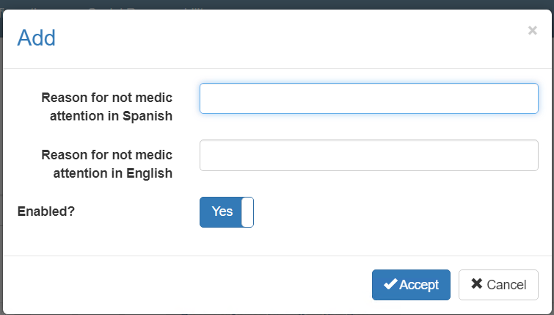

### Data requested

Back to top

The add/edit screen has the following fields:

|  |  |
| --- | --- |
| **Field** | **Description** |
| Reason for not medic attention in Spanish | Alphanumeric description with a maximum length of 150 characters, with the description of the reason in Spanish. |
| Reason for not medic attention English | Alphanumeric description with a maximum length of 150 characters, with the description of the reason in English. |
| Enabled? | Indicates whether the Reasons for not medic attention is active for use in the system. |

When adding or editing a Reasons for not medic attention click the accept button to finish the operation or cancel as well as the close icon at the top right of the pop-up screen to cancel the operation.

### Duplicate records

Back to top

At the end of an add or edit operation, the system will validate that the information by both code and name is not repeated with any other Reasons for not medic attention in the system. If any data is repeated the system will give you the warning and some options to proceed:

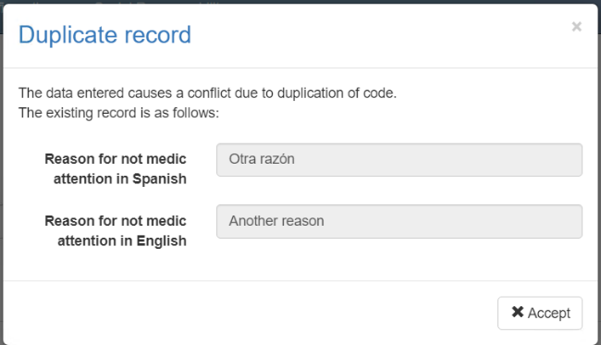

This screen will appear when the entered record Reasons for not medic attention a conflict with another active record in the system. In this case there is no choice but to accept the warning and modify the data.