# General Report of survey

# Content index

Main screen

Description

Filtering

Results

## Main screen

### Description

The report shows the general survey information of the Social Responsability existing in the application.

### Filtering

Back to top

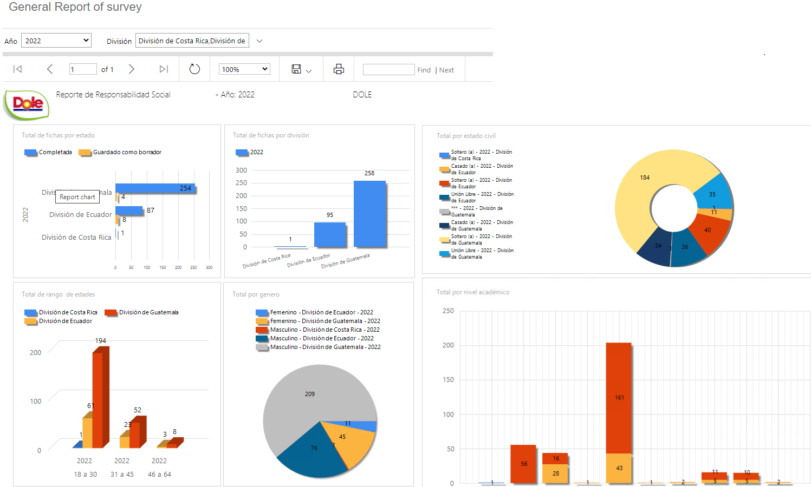

The filters that are displayed on the main report page can be filtered using the available fields at the top of the window: Year and Division. Including one or more filters and clicking on the View Report button, will be displayed graphs with Social Responsibility information that meet all the specified search criteria.

### Results

Back to top

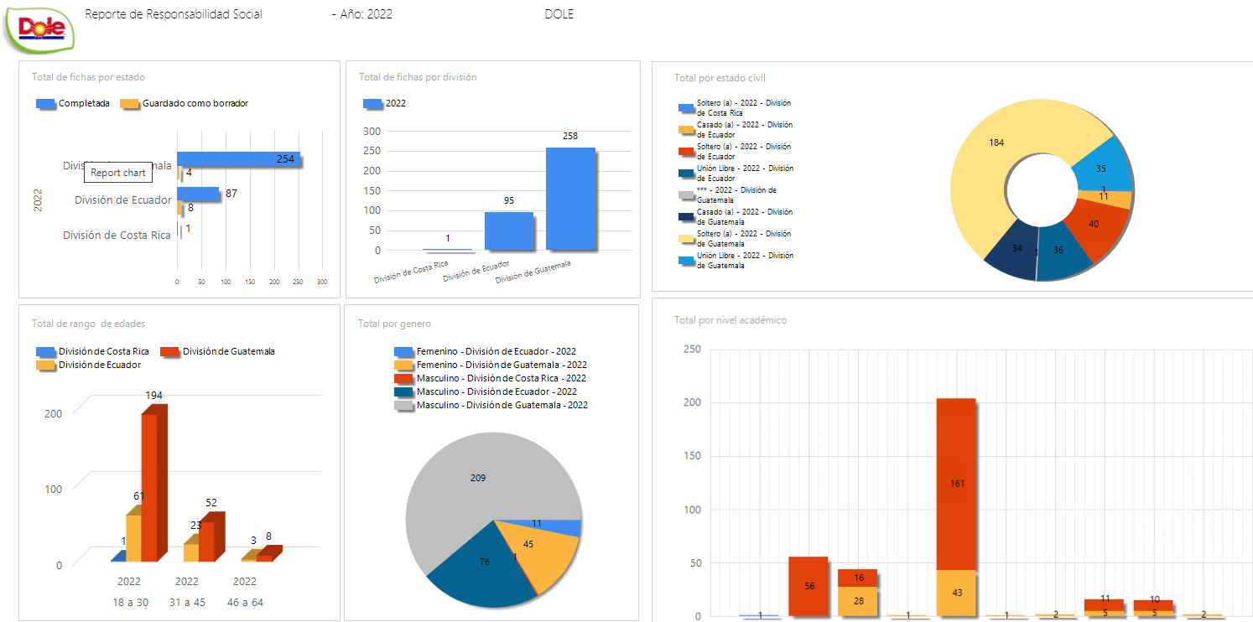

The results will be visible in graphs, the number of pages in which they are divided will be shown in the upper bar of the report, where you can select the desired page to explore them. Additionally, the report can be exported in several formats, for example: Word, PDF, Excel, among others. The print operation is enabled in the report output.