# Assign courses to Training Plan

# Content index

Main screen

Description

Filtering

Results

Available operations

Add

## Main screen

### Description

The screen shows the maintenance for assigning courses to the available plan for the existing training courses in the application.

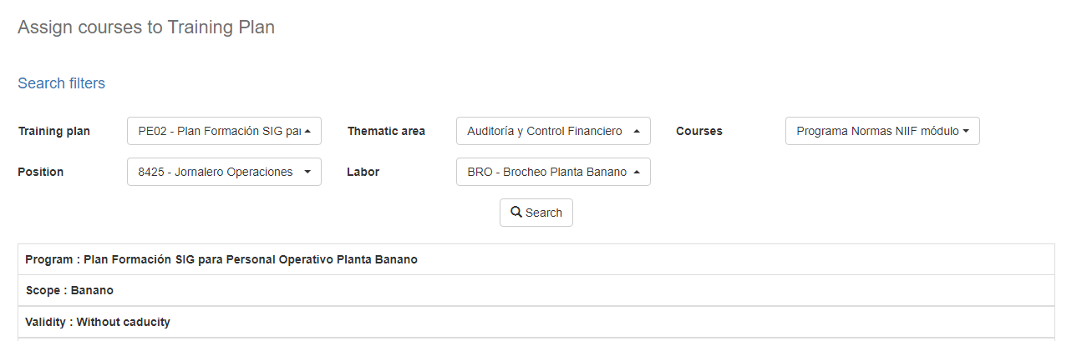

### Filtering

Back to top

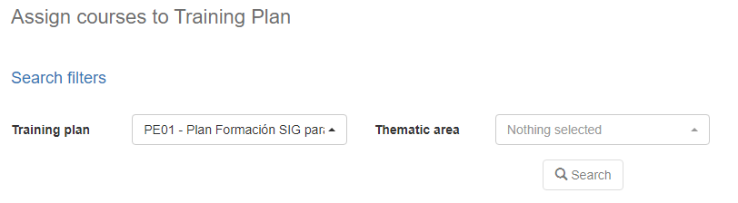The list of course assignments to plans displayed on the main maintenance page can be filtered using the available fields at the top of the window by training plan, subject area, course, or employee. By including one or more filters and clicking on the Search button the courses and employees that meet all the specified search criteria will be listed.

### Results

Back to top

The number of records retrieved are displayed with a checkbox for each of the employees associated with the previous filtering. This operation will sort all the records by employee name.

## Available operations

Back to top

### Add

if you wish to associate a course to an employee in the window, select the required record and press the Save button. When clicked, a pop-up screen will appear indicating that the operation was successful.

