# Training logbook register

|  |
| --- |
| Content index Main screen  Description  Create new  Data requested  Participants and grades  Other operations |

## Main screen

### Description

The Training *Logbook register screen* displays the window for capturing and editing the logbooks in the app.

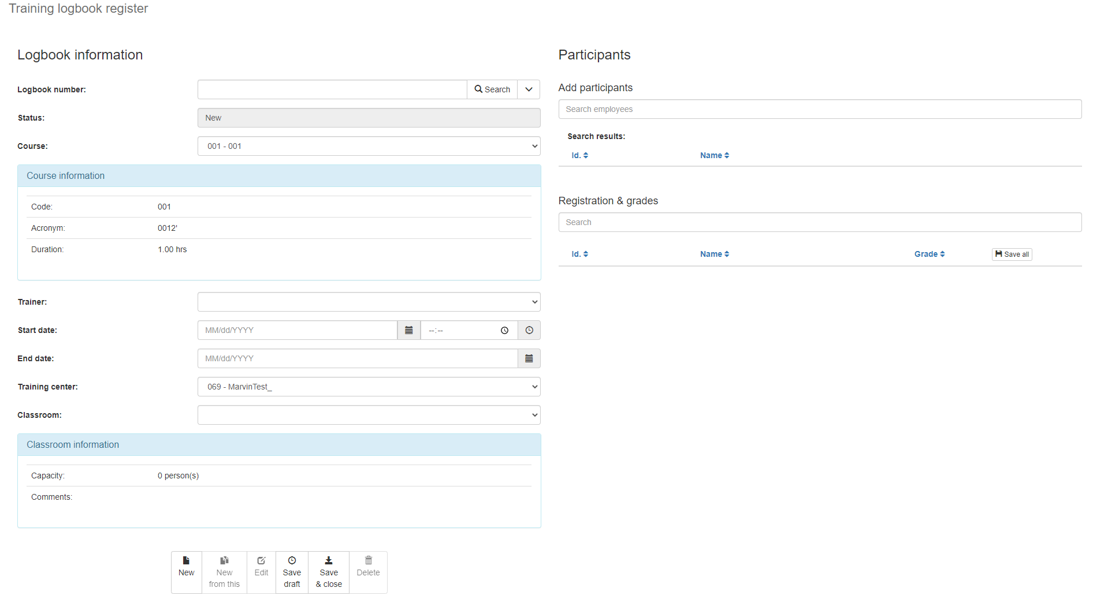

### Create new log

Back to top

To create a new logbook, select the entry from the menu to the registration page, or, if you are already on it and have information to discard, click the *New button* on the action bar at the bottom of the screen or in the available actions under the *Arrow* next to the Search button.

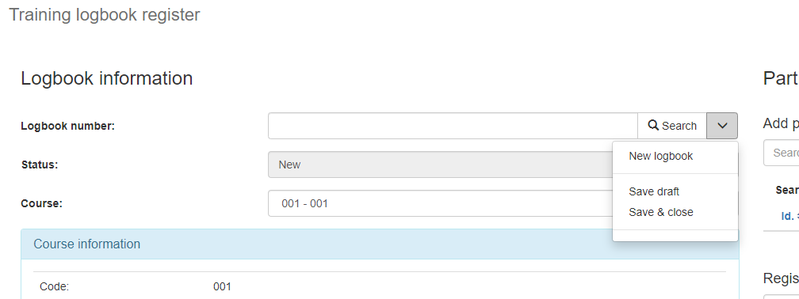

### Data requested

Back to top

The Training *Logbook register screen* has the following fields:

|  |  |
| --- | --- |
| **Field** | **Description** |
| Logbook number. | Numeric field. The system will automatically assign a logbook number when the registration process is complete either as a draft or as a final version. In this field you can also enter a logbook number and click on the Search button to query an existing logbook. |
| Status | Read-only field where the system displays the status of the displayed logbook:   * New: the logbook is in edit and has not been saved yet. * Draft: the logbook has been saved as a draft which will allow you to load the logbook later and edit its information. * Closed: the logbook has been saved and closed so your information is final and not editable. |
| Course | Single selection field where the course for which the displayed logbook responds is set. This field determines the information to be displayed in the box called *Course Information,* where the code, acronym, and duration of the course will be displayed.    Selecting this field will also determine the options available in the Trainer field where the available trainers to teach such a course will be displayed and the relevant option can be selected. |
| Trainer | Unique selection field where the trainer in charge of the deployed training is established. This field is determined by the selected course. |
| Start date | Date in MM/dd/yyyy format and time in HH:mm format to start training.  If a course has already been selected previously when you select a start date, the system can calculate the possible end date according to the course duration and suggest it in the respective field. The user may modify such a suggestion. |
| End date | Date in MM/dd/yyyy format on which the training will be completed.  As already mentioned, the system will be able to suggest the end date based on the start date and duration of the selected course but the user will always be able to determine the date of their preference. |
| Training center | Unique selection field where the training center where the course for which the deployed log will be taught is established.  The selection of this field will also determine the options available in the Classrooms field where the classrooms available for such Training Center where such a course can be taught will be displayed. |
| Classroom | Unique selection field where the classroom where the deployed training will be given is established. This field is determined by the selected Training Center.  This field determines the information that will be displayed in the box called *Classroom* *Information,* where the classroom capacity will be displayed, as well as additional comments from this  .  The capacity of the classroom will determine the number of people who can be added to the training in question. |
| Participants | In this section you can view, add, or remove participants to the training.  For more details see the *Participants and Registration grades* section. |

To save a training logbook, click the Save *Draft* or *Save & Close* button to complete the operation. When you do this, the system will display the assigned logbook number in the respective field.

To continue editing a draft logbook, select the *Edit* option and continue with your registration.

Back to top

### Participants and grades

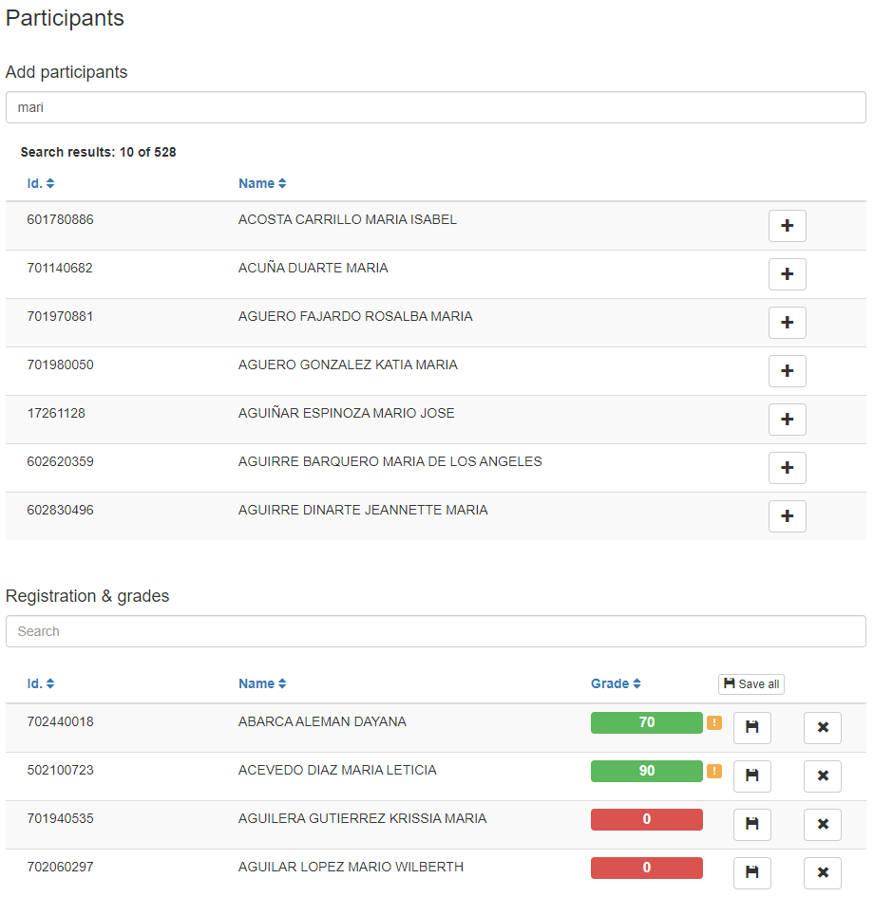

In the Participants section you can manage the employees who are enrolled in the training logbook selected.

To add new participants to the training logbook, use the text field called *Search Employees* under the Add Participants subtitle. Add part of the desired employee name or ID and wait for the system to complete the list with the search results of existing employees who meet the search criteria. If the desired record does not appear, be more specific in the search criteria and repeat the operation.

When the desired record appears in the search results, select the "+" button next to the employee's name. This will create the employee's enrollment in the current training logbook, and you will see the employee appear in the participant list.

At the bottom of the section you can find all employees enrolled for your logbook. In addition, here you can manage the grades obtained in the training logbook. Next to each employee's name you will find a button with an "x" that will serve to remove the employee from the training logbook.

To change the employee's grade, click the grade field and enter the grade. When you modify a grade, you will see a yellow alert icon appear that reminds you that the entered grade has not been saved in memory yet. Click the save button next to the grade to temporarily save it to memory. You can also use the *Save All* button located in the header to temporarily save all grades.

You can also use the *Search* text field under the Subtitle *Registration & grades* to locate a record.

### Other operations

In addition to the operations already described, in the lower section of the window you will find the *New from this* option that duplicates the current information on the screen to create a new logbook. In that new logbook you will initially have the same duplicated information and you can customize it according to your preference.

You can also find the *Delete* option that will allow you to delete the current logbook.