# Logbooks

# Content index

Main screen

Description

Filtering

Results

Available operations

Remove

Add/Edit

## Main screen

### Description

The *Logbooks* screen displays the list of training logbooks in the application.

### Filtering

Back to top

The list of logbooks displayed on the maintenance page can be filtered using the fields available for this at the top of the window: logbook numb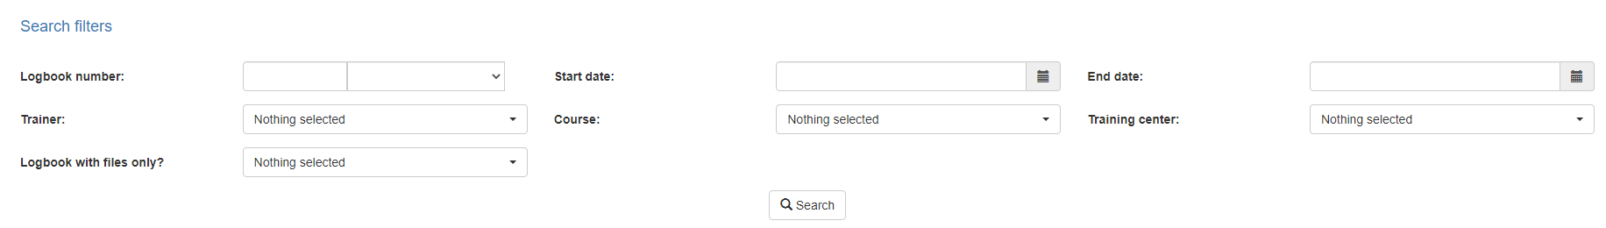er, status, trainer, start and end date, course or by training center. Including one or more filters and clicking the *Search* button will list the logbooks that meet all the specified search criteria.

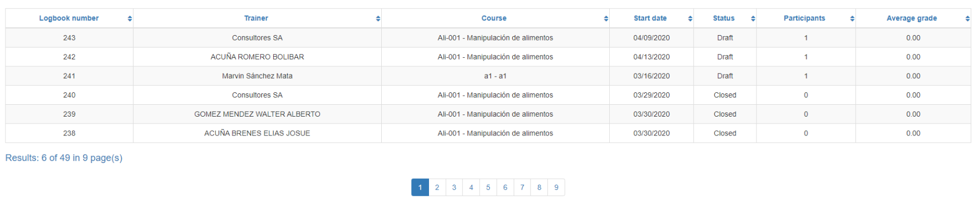

### Results

Back to top

The number of records retrieved as well as the number of pages on which they are split will be displayed at the bottom of the results table, where you can also select the desired page to browse. You can also sort the results by each of the columns by clicking on their header to display them in both ascending and descending ways by repeating the click on the header. This operation will sort all records on all available pages and display the results according to your preference.

## Available operations

Back to top

In *Logbooks* maintenance*,* you can add logbooks to the general catalog, edit or delete existing logbooks.

### View

Back to top

if you wish to view a record in the application, click on the view button. When you click on it, a new screen will appear with the log information. For more information on this screen, please refer to the training logbook logbook manual.