# Logbooks

# Content index

Main screen

Description

Filtering

Results

Available operations

Remove

Add/Edit

## Main screen

### Description

The *Logbooks* screen displays the list of training logbooks in the application.

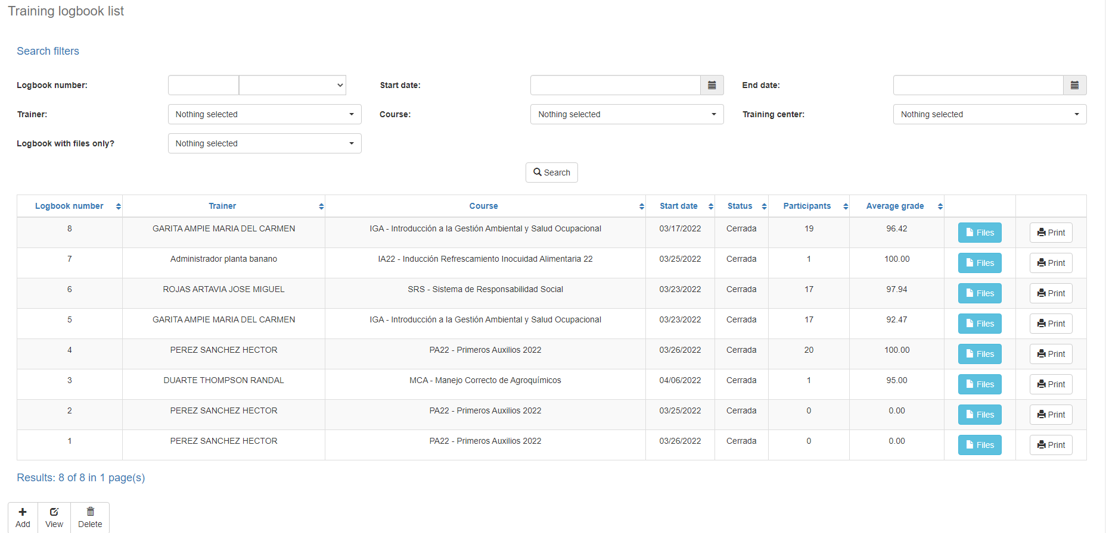

### Filtering

Back to top

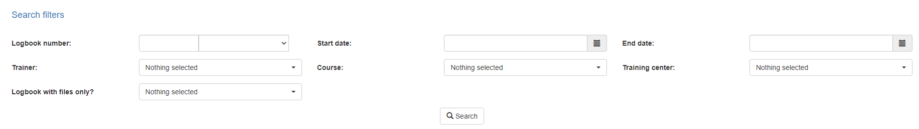The list of logbooks displayed on the maintenance page can be filtered using the fields available for this at the top of the window: logbook number, status, trainer, start and end date, course or by training center. Including one or more filters and clicking the *Search* button will list the logbooks that meet all the specified search criteria.

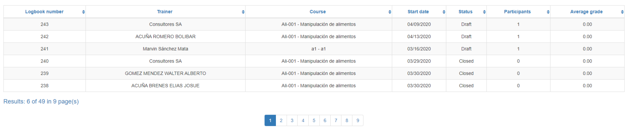

### Results

Back to top

The number of records retrieved as well as the number of pages on which they are split will be displayed at the bottom of the results table, where you can also select the desired page to browse. You can also sort the results by each of the columns by clicking on their header to display them in both ascending and descending ways by repeating the click on the header. This operation will sort all records on all available pages and display the results according to your preference.

## Available operations

Back to top

In *Logbooks* maintenance*,* you can add logbooks to the general catalog, edit or delete existing logbooks.

### Remove

To delete a record, select the desired record from the available logbook list and click on the delete button. Immediately the system will display a confirmation screen where you can proceed with the operation or cancel it.

Upon confirming the delete operation, the system will disable the record but will retain your information for the history of the data so that it will be possible to retrieve this record in the future.

### Add / View

Back to top

If you wish to add a new logbook to the application, click on the Add button. When you click on it, a new screen will appear where you will be able to perform the operation. This screen is the same that will appear when you select a log from the list and click on the View button to display its data. For more information about this screen please refer to the Training Logs Registration manual.