# Courses

|  |
| --- |
| Content index Main screen  Description  Filtering  Results  Available operations  Remove  Add/Edit  Data requested  Duplicate records  Trainers  Training purpose  Thematic area  Export |

## Main screen

### Description

The *Courses* screen displays the general catalog of courses available in the application available for trainings. The records on this screen are inputs for *Training logbooks* screen.

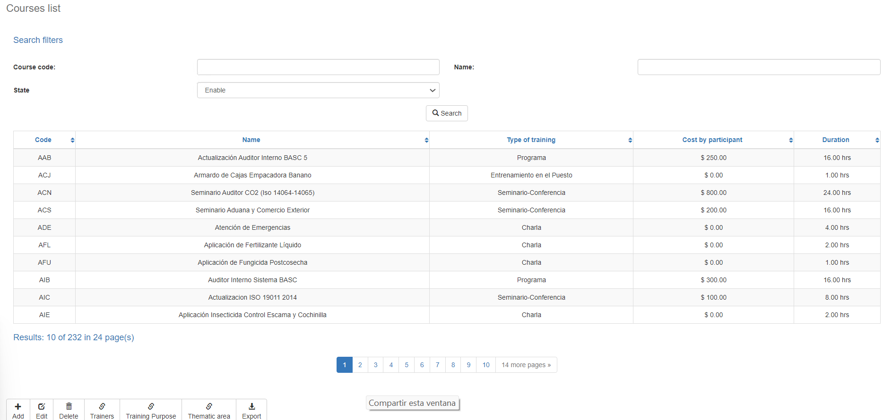

### Filtering

Back to top

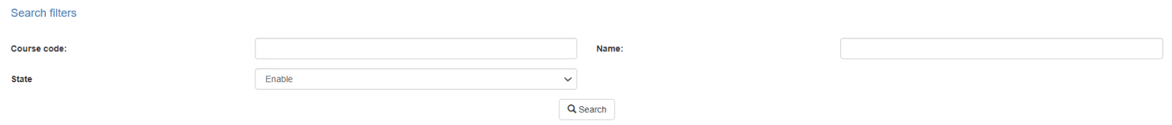The list of courses displayed on the maintenance page can be filtered using the fields available for this purpose at the top of the window: course code, name, or acronym. Including one or more filters and clicking the Search button will list the courses that meet all the specified search criteria.

### Results

Back to top

The number of records retrieved as well as the number of pages on which they are split will be displayed at the bottom 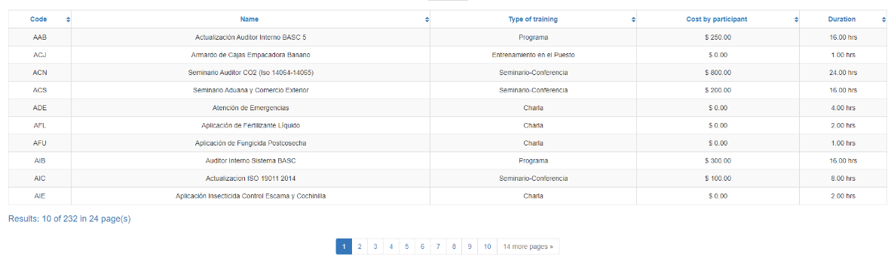of the results table, where you can also select the desired page to browse. You can also sort the results by each of the columns by clicking on their header to display them in both ascending and descending ways by repeating the click on the header. This operation will sort all records on all available pages and display the results according to your preference.

## Available operations

Back to top

In *Courses* Maintenance, you can add courses to the general catalog, edit or delete existing courses, and reactivate previously deletedors courses as well as associate trainers, training programs, payment rates and positions.

### Remove

To delete a record, select the desired record from the list of available courses and click on the delete button. Immediately the system will display a confirmation screen where you can proceed with the operation or cancel it.

Upon confirming the delete operation, the system will disable the record but will retain your information for the history of the data so that it will be possible to retrieve this record in the future.

### Add / Edit

Back to top

If you want to add a new course in the app you must click the Add button. Clicking will display a pop-up screen where you will be prompted for the data required for the operation. This pop-up screen is the same screen that will appear when you select a record from the list and click the Edit button to modify your data.

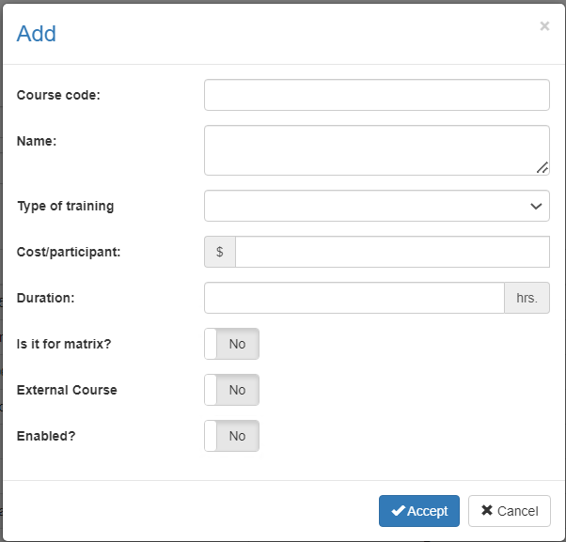

### Data requested

Back to top

The add/edit screen has the following fields:

|  |  |
| --- | --- |
| **Field** | **Description** |
| Course code | Alphanumeric code of 15 characters as maximum length, which will represent the course in the system. |
| Name | Alphanumeric description of maximum length of 500 characters, with the course name in the system. |
| Training type | Single selection list to associate the course with an existing and active training type in the system. |
| Cost/participant | Decimal number quantity, which describes the cost of the course per participant to be used in reports and estimates. |
| It is for MATRIX? | Indicates if the course is for Matrix. |
| External course? | Indicates if the course is external. |
| Enabled? | Indicates whether the course is active for use in the system. |

When adding or editing a course click the accept button to finish the operation or cancel or the close icon at the top right of the pop-up screen to cancel the operation.

### Duplicate records

Back to top

At the end of an add or edit operation, the system will validate that the information by both code and name is not repeated with any other course in the system. If any data is repeated the system will give you the warning and some options to proceed: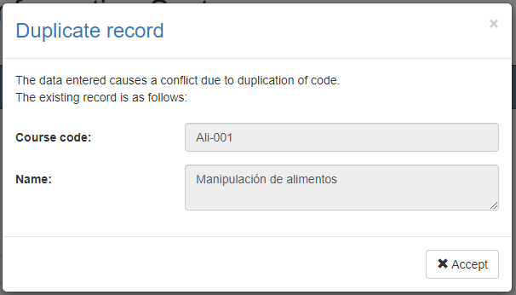

This screen will appear when the entered record causes a conflict with another active record in the system. In this case there is no choice but to accept the warning and modify the data.

### Record disabled

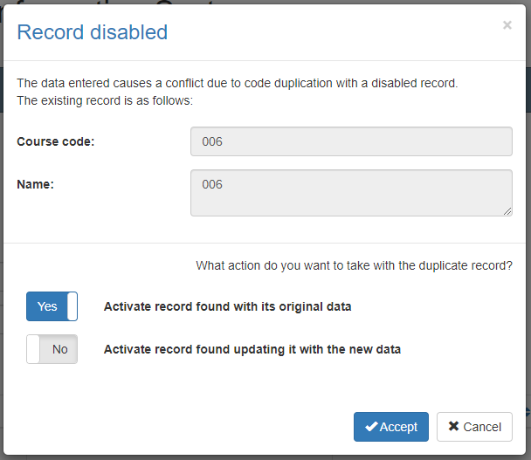This screen will appear when the entered record causes a conflict with an inactive record on the system. In this case the system has two options:

1. Activate the record found with your original data: With this option selected the system will not add a new record or modify the found record but will only activate the record found with its original data.
2. Activate record found by updating with the new data: With this option selected the system will not add a new record but will modify the record found with the entered data and activate that record to be used with the new information and its entire history in the system.

If you are not sure which option is best in your scenario, we recommend contacting the administrator and exposing the situation.

Back to top

### Trainers

Clicking the Instructors button will open the pop-up window where you can manage the instructors associated with the selected course. At the top of the window, you can find instructors already associated with the course for your consultation. Next to the name of each instructor you will find a button with an "x" that will eliminate the association between the course and such instructor.

To add new associations between the course and instructors, use the text field called *Find Instructors,* enter part of the desired instructor name, and wait for the system to complete the list with the search results of existing’s instructors that meet the search criteria. If the desired record does not appear, be more specific in the search criteria and repeat the operation.

When the desired record appears in the search results, select the "+" button next to the instructor's name. This will create an association between the course and the selected instructor, and you will see the instructor appear in the list of associated instructors.

To close this pop-up window, select the *OK* button or the close icon in the upper right corner.

Back to top

### Training purpose

Clicking the Training purpose button will open the pop-up window where you can manage the training purpose associated with the selected course. At the top of the window, you can find training purposes already associated with the course for your consultation. Next to the name of each purpose you will find a button with an "x" that will eliminate 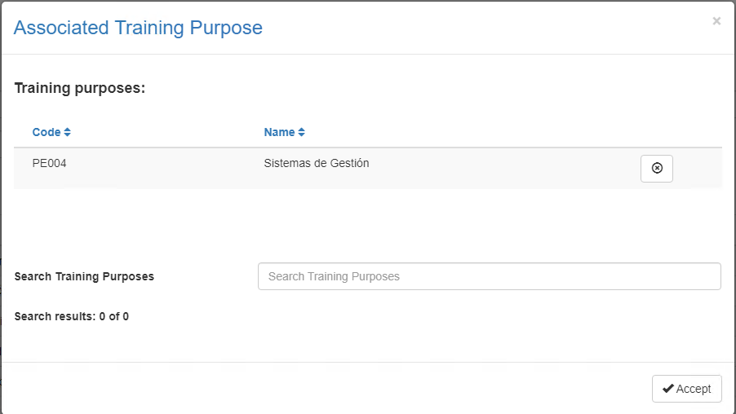the association between the course and such purpose.

To add new associations between the course and trainings purposes, use the text field called SearchTraining *purposes*, enter part of the desired *purpose name,* and wait for the system to complete the list with search results for existing purposes that meet the search criteria. If the desired record does not appear, be more specific in the search criteria and repeat the operation.

When the desired record appears in the search results, select the "+" button next to the purpose name. This will create an association between the course and the selected training purpose, and you will see the purpose appear in the list of associated purposes.

To close this pop-up window, select the *OK* button or the close icon in the upper right corner.

Back to top

### Thematic area

Clicking the Thematic areas button will open the pop-up window where you can manage the thematic areas associated with the selected course. At the top of the window, you can find for your consultation the thematic areas already associated with the course. Next to the name of each thematic area you will find a button with an "x" that 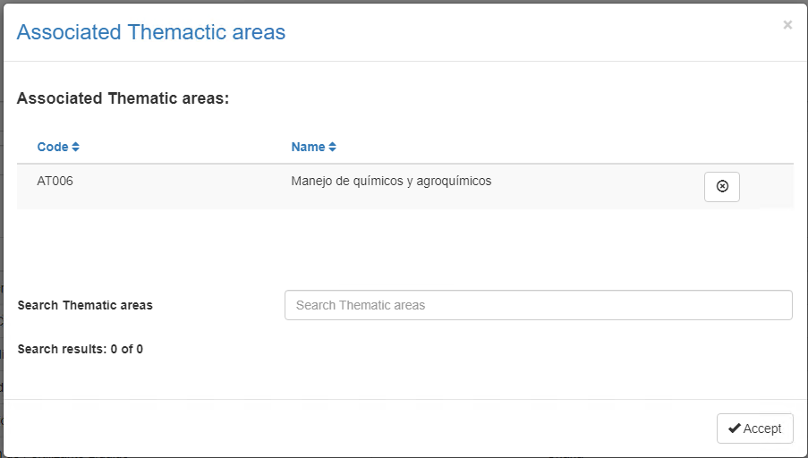will serve to eliminate the association between the course and such thematic area.

To add new associations between course and thematic areas, use the text field called *Search* for *thematic areas,* enter part of the desired thematic area name, and wait for the system to complete the list with existing payment rates that meet the search criteria. If the desired record does not appear, be more specific in the search criteria and repeat the operation.

When the desired record appears in the search results, select the button with a "+" next to the thematic area name. This will create an association between the course and the selected thematic area, and you will see the thematic area appear in the list of associated thematic areas.

To close this pop-up window, select the *OK* button or the close icon in the upper right corner.

### Export

Back to top

Clicking the Export button will automatically download the complete list of active courses that the system has registered in Excel format.