# Matrix Target

# Content index

Main screen

Description

Filtering

Results

Available operations

Remove

Add/Edit

Data requested

Duplicate records

## Main screen

### Description

The screen shows the general catalog of the available Matrix Target for Training in the application.

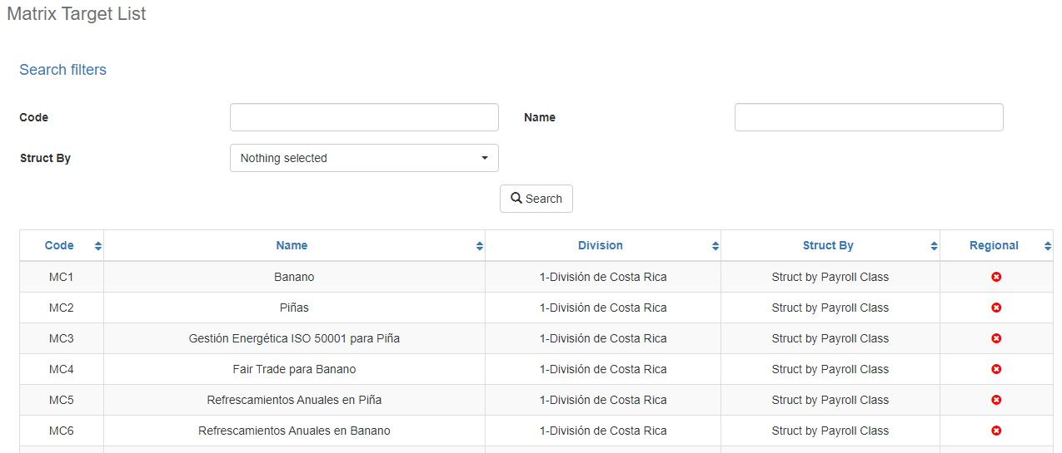

### Filtering

Back to top

The Matrix Target listing displayed on the main maintenance page can be filtered using the available fields at the top of the window by code or by name. Including one or more filters and clicking on the Search button will list the scope matrices that meet all the specified search criteria.

### Results

Back to top

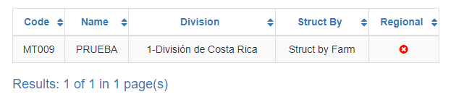

The number of records retrieved, as well as the number of pages into which they are divided, will be displayed at the bottom of the results table, where you can also select the desired page to browse. You can also sort the results by each of the columns by clicking on its header to display them both in ascending and descending order by repeating the click on the header. This operation will sort all records from all available pages and display the results according to your preference

## Available operations

Back to top

 In Matrix Target maintenance you can add records, edit or delete existing records, as well as reactivate previously deleted records.

### Remove

To delete a record, select the desired record from the list of available Matrix Scopes and click on the delete button. The system will immediately display a confirmation screen where you can proceed with the operation or cancel it.

By confirming the delete operation, the system will disable the record, but will retain its information for data history so that it will be possible to retrieve this record in the future.

### Add / Edit

Back to top

If you wish to add a new Matrix Target in the application, click on the Add button. When you click on this button, a pop-up screen will appear asking for the necessary data for the operation. This pop-up screen is the same that will appear when selecting a record from the list and clicking on the Edit button to modify its data.

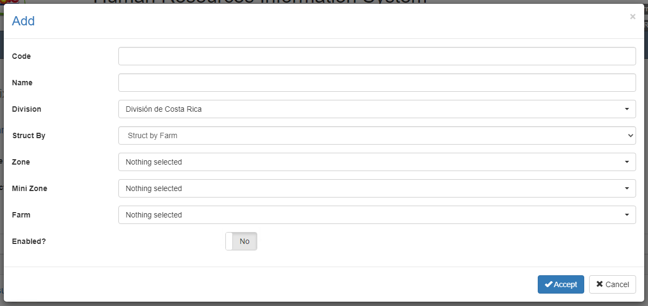

### Data requested

Back to top

The add/edit screen has the following fields:

|  |  |
| --- | --- |
| **Field** | **Description** |
| Code | Alphanumeric description of a maximum length of 10 characters, with the Matrix Scope code in the system. |
| Name | Alphanumeric description with a maximum length of 500 characters, with the description of the Matrix Scope in the system. |
| Division | Displays the list of the divisions registered in the system. |
| Structure by | Displays the list of structure types registered in the system. |
| Zone | Displays the list of zones registered in the system. |
| Mini Zone | Displays the list of mini zones registered in the system. |
| Farm | Displays the list of farms registered in the system |
| Company | Displays the list of companies registered in the system |
| Payroll Class | Displays the list of payroll types registered in the system |
| Enabled? | Indicates if the Scope Matrix is active for use in the system. |

When adding or editing a Matrix Scope click the accept button to finalize the operation or click cancel or the close icon at the top right of the pop-up screen to cancel the operation.

### Duplicate records

Back to top

At the end of an add or edit operation the system will validate that the information with no other Matrix Scope in the system. If any data is repeated, the system will give you a warning and some options to proceed:

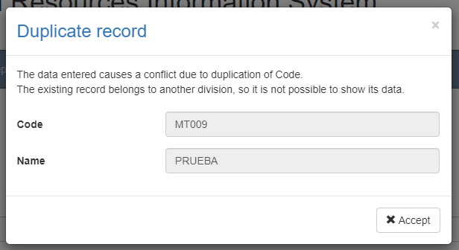

This screen will appear when the record entered conflicts with another active record in the system. In this case there is no choice but to accept the warning and modify the data.