# Thematic areas

|  |
| --- |
| Content index Main screen  Description  Filtering  Results  Available operations  Remove  Add/Edit  Data requested  Duplicate records  Courses |

## Main screen

### Description

The *Thematic areas* screen displays the general catalog of thematic areas available in the application available for trainings. The records on this screen are inputs for *Training logbooks* screen.

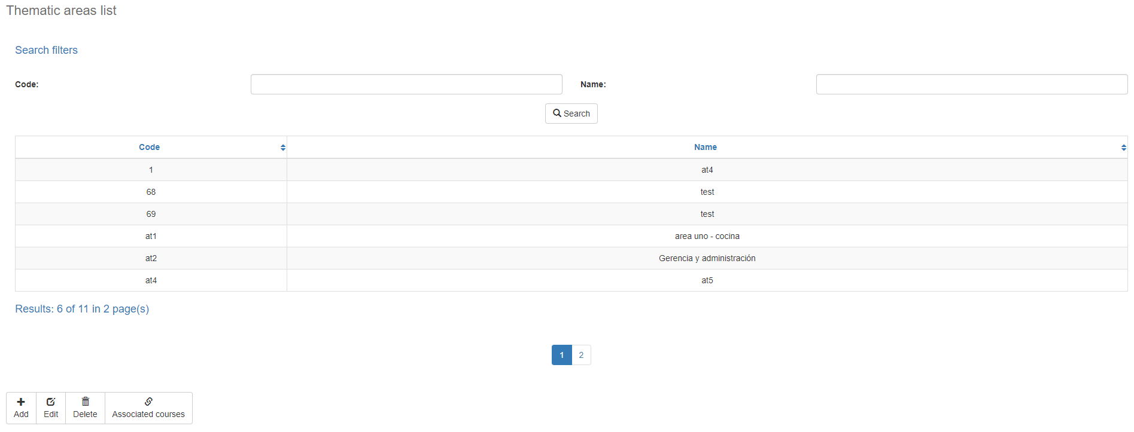

### Filtering

Back to top



The list of thematic areas displayed on the maintenance page can be filtered using the fields available for this purpose at the top of the window: thematic area code, or name. Including one or more filters and clicking the *Search* button will list the thematic areas that meet all the specified search criteria.

### Results

Back to top

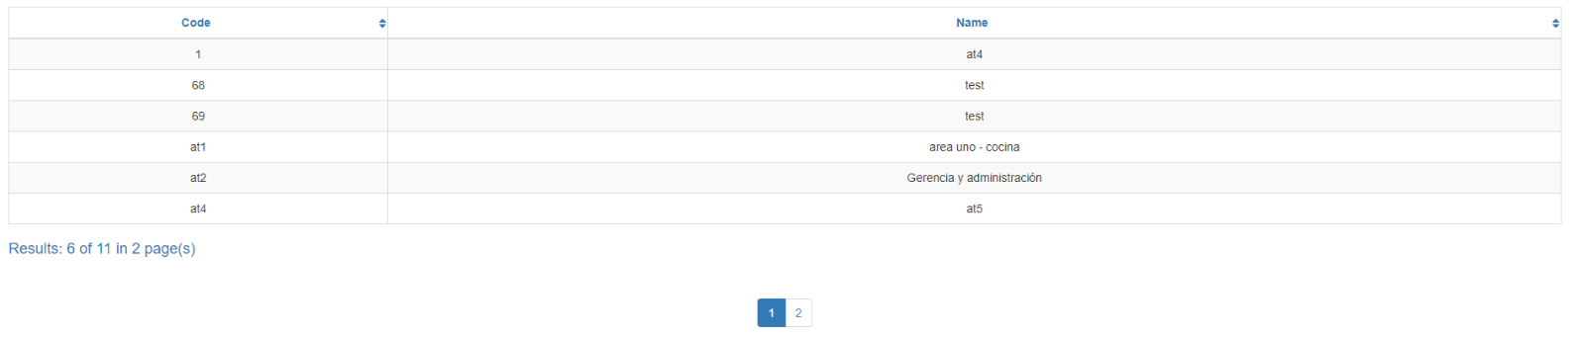The number of records retrieved as well as the number of pages on which they are split will be displayed at the bottom of the results table, where you can also select the desired page to browse. You can also sort the results by each of the columns by clicking on their header to display them in both ascending and descending ways by repeating the click on the header. This operation will sort all records on all available pages and display the results according to your preference.

## Available operations

Back to top

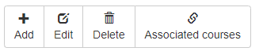In *Thematic areas* Maintenance, you can add thematic areas to the general catalog, edit or delete existing thematic areas, and reactivate previously deleted thematic areas as well as associate courses.

### Remove

To delete a record, select the desired record from the list of available thematic areas and click on the delete button. Immediately the system will display a confirmation screen where you can proceed with the operation or cancel it.

Upon confirming the delete operation, the system will disable the record but will retain your information for the history of the data so that it will be possible to retrieve this record in the future.

### Add / Edit

Back to top

If you want to add a new thematic area in the app you must click the Add button. Clicking will display a pop-up screen where you will be prompted for the data required for the operation. This pop-up screen is the same screen that will appear when you select a record from the list and click the Edit button to modify your data.

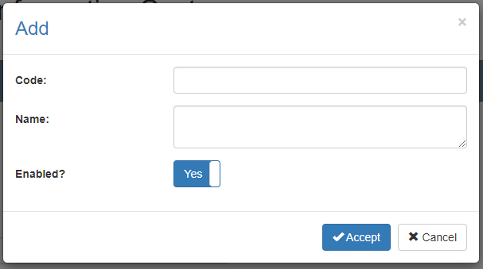

### Data requested

Back to top

The add/edit screen has the following fields:

|  |  |
| --- | --- |
| **Field** | **Description** |
| Thematic area code | Alphanumeric code of 10 characters as maximum length, which will represent the thematic area in the system. |
| Name | Alphanumeric description of maximum length of 500 characters, with the thematic area name in the system. |
| Enabled? | Indicates whether the thematic area is active for use in the system. |

When adding or editing a thematic area click the accept button to finish the operation or cancel or the close icon at the top right of the pop-up screen to cancel the operation.

### Duplicate records

Back to top

At the end of an add or edit operation, the system will validate that the information by both code and name is not repeated with any other thematic area in the system. If any data is repeated the system will give you the warning and some options to proceed:

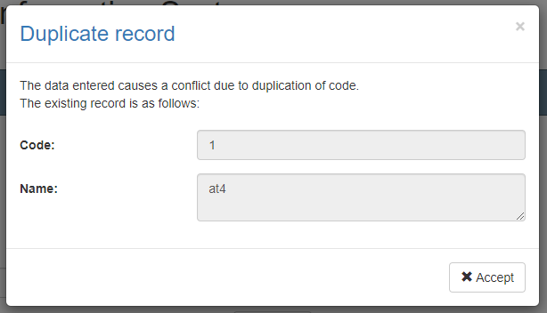

This screen will appear when the entered record causes a conflict with another active record in the system. In this case there is no choice but to accept the warning and modify the data.

### Record disabled

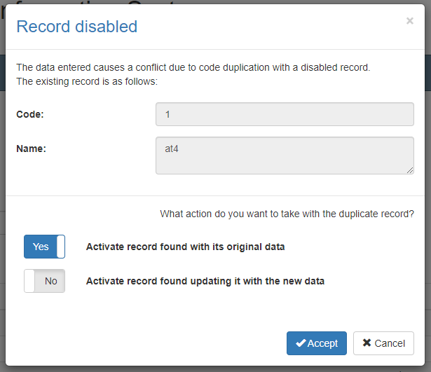This screen will appear when the entered record causes a conflict with an inactive record on the system. In this case the system has two options:

1. Activate the record found with your original data: With this option selected the system will not add a new record or modify the found record but will only activate the record found with its original data.
2. Activate record found by updating with the new data: With this option selected the system will not add a new record, but will modify the record found with the entered data and activate that record to be used with the new information and its entire history in the system.

If you are not sure which option is best in your scenario we recommend contacting the administrator and exposing the situation.

Back to top

### Courses

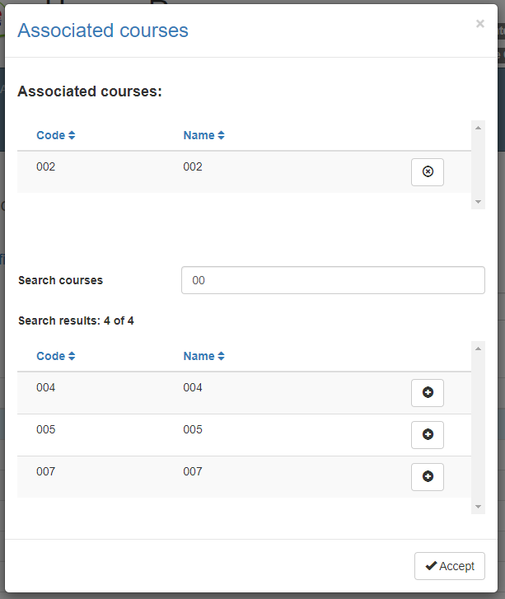

Clicking the Courses button will open the pop-up window where you can manage the courses associated with the selected thematic area. At the top of the window you can find courses already associated with the thematic area for your consultation. Next to the name of each course you will find a button with an "x" that will eliminate the association between the thematic area and such course.

To add new associations between the thematic area and courses, use the text field called *Find courses,* enter part of the desired course name, and wait for the system to complete the list with the search results of existings instructors that meet the search criteria. If the desired record does not appear, be more specific in the search criteria and repeat the operation.

When the desired record appears in the search results, select the "+" button next to the course's name. This will create an association between the thematic area and the selected course and you will see the courses appear in the list of associated courses.

To close this pop-up window select the *OK* button or the close icon in the upper right corner.