# Trainers

|  |
| --- |
| Content index Main screen  Description  Filtering  Results  Available operations  Remove  Add/Edit  Data requested  Duplicate records |

## Main screen

### Description

The *Trainers* screen displays the general catalog of trainers available in the application available for trainings. The records on this screen are inputs for *Training logbooks* screen.

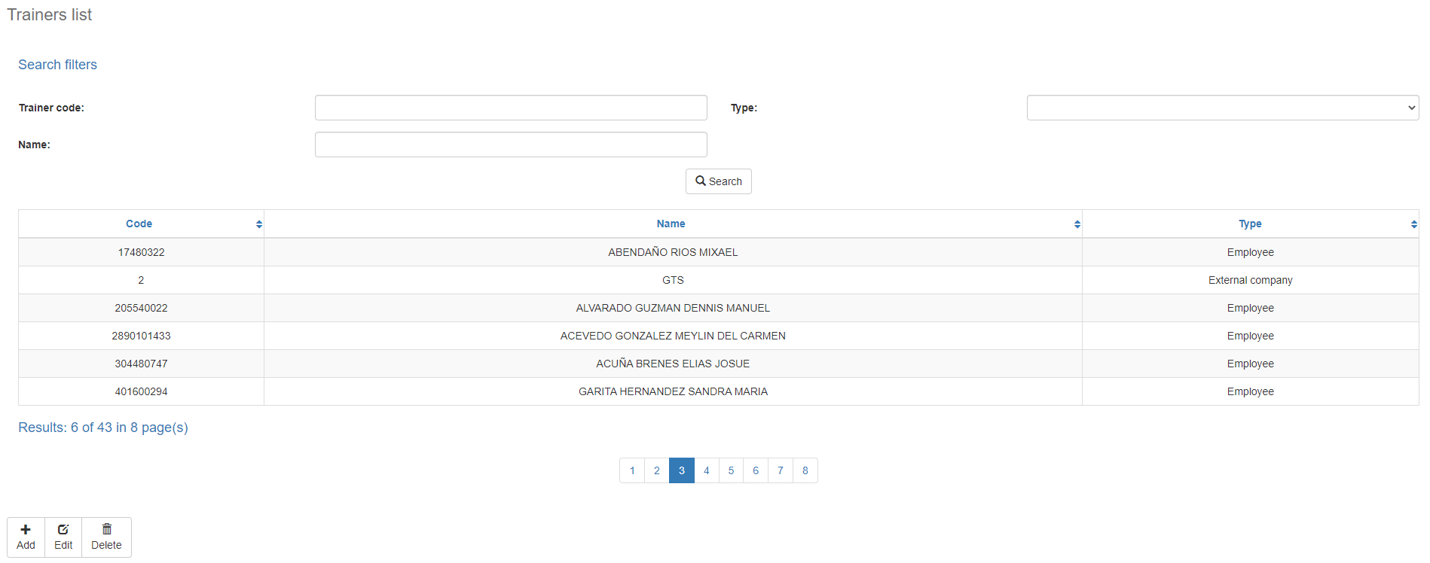

### Filtering

Back to top

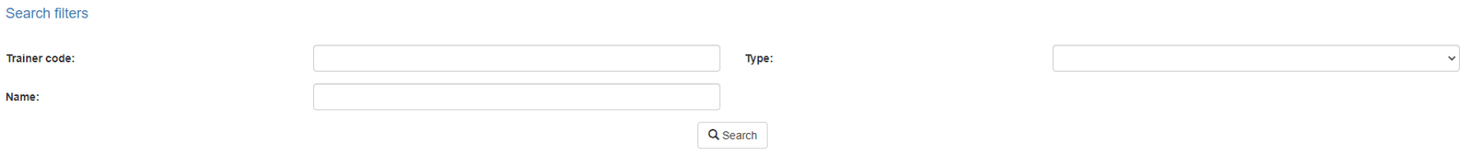The list of trainers displayed on the maintenance page can be filtered using the fields available for this purpose at the top of the window: trainer code, name, or type. Including one or more filters and clicking the *Search* button will list the trainers that meet all the specified search criteria.

### Results

Back to top

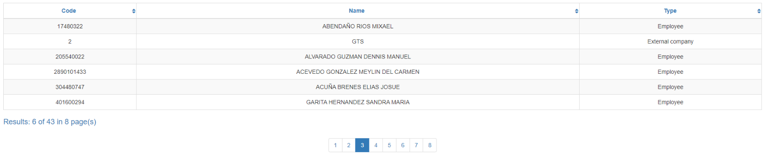The number of records retrieved as well as the number of pages on which they are split will be displayed at the bottom of the results table, where you can also select the desired page to browse. You can also sort the results by each of the columns by clicking on their header to display them in both ascending and descending ways by repeating the click on the header. This operation will sort all records on all available pages and display the results according to your preference.

## Available operations

Back to top

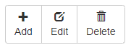

In *Trainers* Maintenance, you can add trainers to the general catalog, edit or delete existing trainers, and reactivate previously deleted trainers.

### Remove

To delete a record, select the desired record from the list of available trainers and click on the delete button. Immediately the system will display a confirmation screen where you can proceed with the operation or cancel it.

Upon confirming the delete operation, the system will disable the record but will retain your information for the history of the data so that it will be possible to retrieve this record in the future.

### Add / Edit

Back to top

If you want to add a new trainer in the app you must click the Add button. Clicking will display a pop-up screen where you will be prompted for the data required for the operation. This pop-up screen is the same screen that will appear when you select a record from the list and click the Edit button to modify your data.

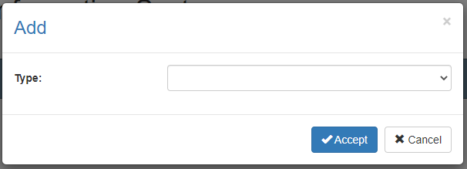

When you add a trainer, you must first select the type of trainer: employee, external company, or external person. Depending on the type of instructor selected you will need to fill in different data.

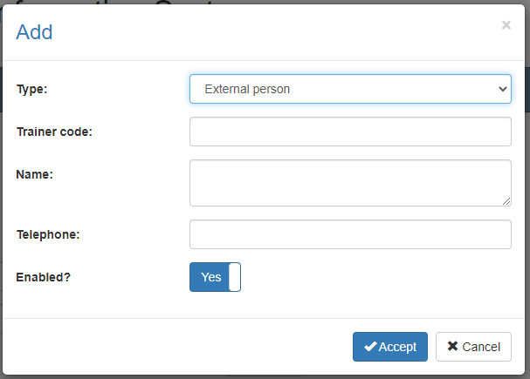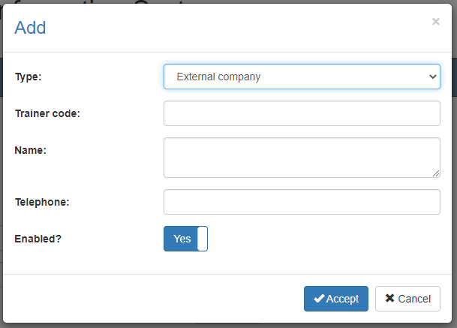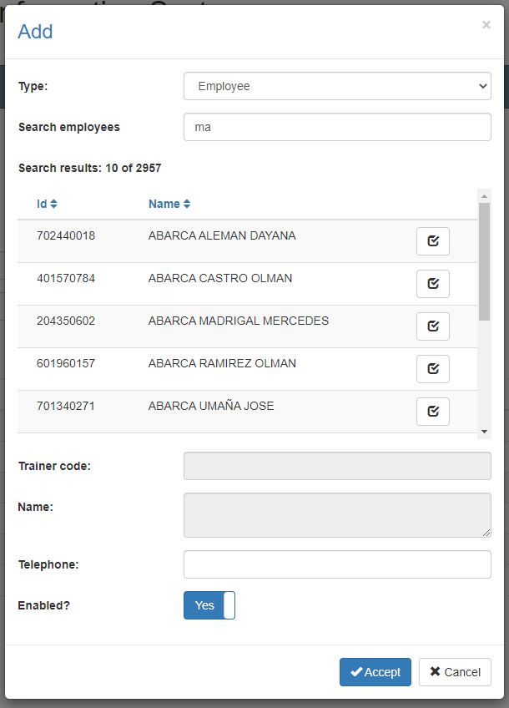

### Data requested

Back to top

The add/edit screen has the following fields:

|  |  |
| --- | --- |
| **Type: External Company and External Person** | |
| **Field** | **Description** |
| Trainer code | Alphanumeric code of 10 characters as maximum length, which will represent the trainer in the system. |
| Name | Alphanumeric description of maximum length of 500 characters, with the trainer name in the system. |
| Telephone | Optional alphanumeric description of maximum length of 20 characters, with the trainer's phone in the system. |
| Enabled? | Indicates whether the trainer is active for use in the system. |

|  |  |
| --- | --- |
| **Type: Employee** | |
| **Field** | **Description** |
| Search employees | Enter part of the desired trainer name, and wait for the system to complete the list with the search results of existings employees that meet the search criteria. If the desired record does not appear, be more specific in the search criteria and repeat the operation.  When the desired record appears in the search results, select the check button next to the employee's name. This will create an association between the trainer and the selected employee and you will see the employee code and name appear in the trainer information. |
| Telephone | Optional alphanumeric description of maximum length of 20 characters, with the trainer's phone in the system. |
| Enabled? | Indicates whether the trainer is active for use in the system. |

When adding or editing a trainer click the accept button to finish the operation or cancel or the close icon at the top right of the pop-up screen to cancel the operation.

### Duplicate records

Back to top

At the end of an add or edit operation, the system will validate that the information by both code and name is not repeated with any other trainer in the system. If any data is repeated the system will give you the warning and some options to proceed:

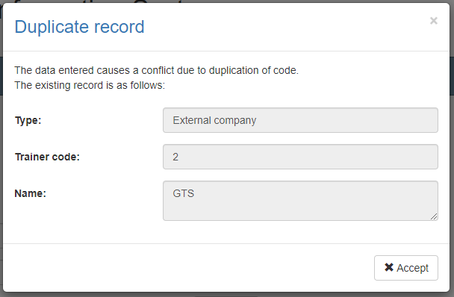

This screen will appear when the entered record causes a conflict with another active record in the system. In this case there is no choice but to accept the warning and modify the data.

### Record disabled

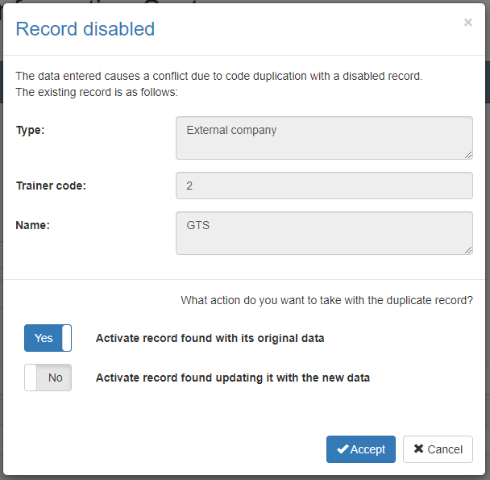This screen will appear when the entered record causes a conflict with an inactive record on the system. In this case the system has two options:

1. Activate the record found with your original data: With this option selected the system will not add a new record or modify the found record but will only activate the record found with its original data.
2. Activate record found by updating with the new data: With this option selected the system will not add a new record, but will modify the record found with the entered data and activate that record to be used with the new information and its entire history in the system.

If you are not sure which option is best in your scenario we recommend contacting the administrator and exposing the situation.

Back to top