# Training Plan

# Content index

Main screen

Description

Filtering

Results

Available operations

Remove

Add/Edit

Data requested

Duplicate records

Relate

Summary

## Main screen

### Description

The screen shows the general catalog of the Training Plans available for existing Trainings in the application.

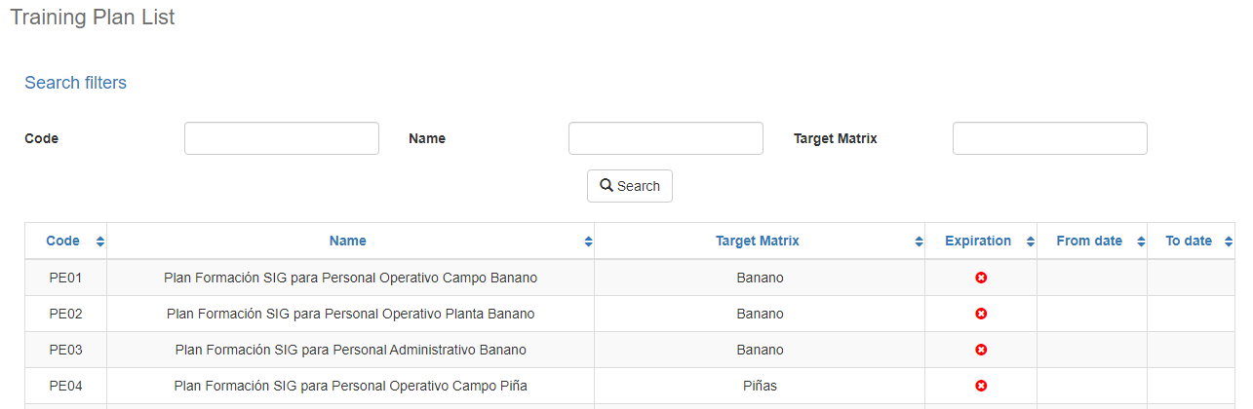

### Filtering

Back to top

The list of Training Plans displayed on the main maintenance page can be filtered using the available fields at the top of the window by code or by name. Including one or more filters and clicking on the Search button will list the training plan programs that meet all the specified search criteria.

### Results

Back to top

The number of records retrieved, as well as the number of pages into which they are divided, will be displayed at the bottom of the results table, where you can also select the desired page to browse. You can also sort the results by each of the columns by clicking on its header to display them both in ascending and descending order by repeating the click on the header. This operation will sort all records from all available pages and display the results according to your preference.

## Available operations

Back to top

In the maintenance of Training Plans you can add records, edit or delete existing records, as well as reactivate previously deleted records and relate positions / labor or employees.

### Remove

To delete a record, select the desired record from the list of available Training Plans and click on the delete button. The system will immediately display a confirmation screen where you can proceed with the operation or cancel it.

By confirming the delete operation, the system will disable the record, but will retain its information for data history so that it will be possible to retrieve this record in the future.

### Add / Edit

Back to top

If you wish to add a new Training Plan in the application, click on the Add button. When you click on it, a pop-up screen will appear asking for the necessary data for the operation. This pop-up screen is the same that will appear when selecting a record from the list and clicking on the Edit button to modify its data.

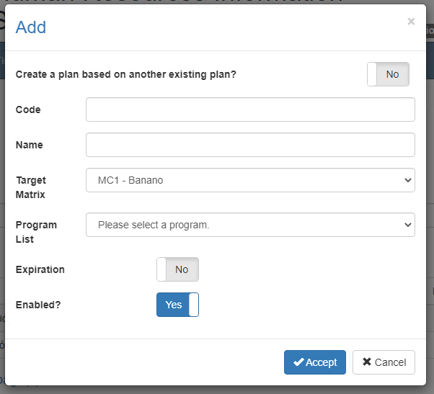

### Data requested

Back to top

The add/edit screen has the following fields:

|  |  |
| --- | --- |
| **Field** | **Description** |
| Code | Alphanumeric description of maximum length of 10 characters, with the code of the Training Plan in the system. |
| Name | Alphanumeric description of maximum length of 500 characters, with the description of the Training Plan in the system. |
| Matrix Target | Displays the scope matrix registered in the system. |
| Program List | Displays the list of programs registered in the system. |
| Expiration | Indicates if the Training Plan has expired in the system. |
| Enabled? | Indicates if the Training Plan is active for use in the system |
| Code | Alphanumeric description of maximum length of 10 characters, with the code of the Training Plan in the system. |

When adding or editing a Training Plan click the accept button to finalize the operation or click cancel or the close icon at the top right of the pop-up screen to cancel the operation.

### Duplicate records

Back to top

At the end of an add or edit operation the system will validate that the information has no other Training Plan in the system. If any data is repeated the system will give a warning and some options to proceed:

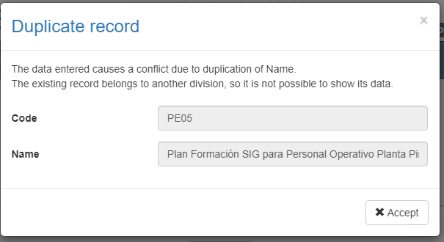

This screen will appear when the record entered conflicts with another active record in the system. In this case there is no choice but to accept the warning and modify the data.

### Relate

Ir al inicio

To associate or unlink employees, labor or positions from the Training Plan, click on the Relate button. When clicked, a pop-up screen will appear listing the positions, labor or employees according to the selected relationship. To mark one of these options as part of the Training Plan, select the item from the list to be displayed on the screen and to remove, deselect the item from the list.

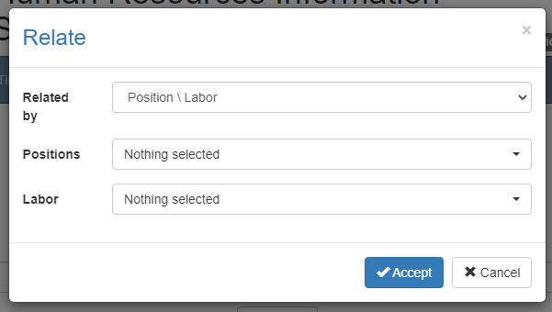

Only positions, labor or employees that are not assigned to a course can be deselected.

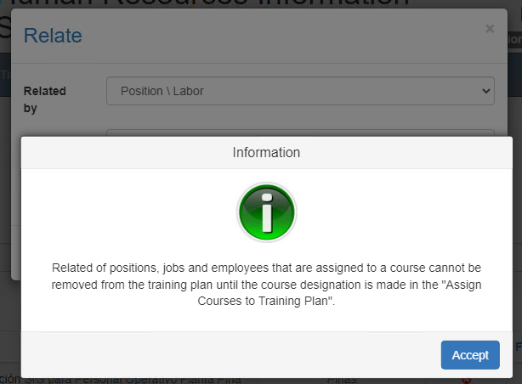

### Summary

Ir al inicio

To display the summary of the positions, labor and employees in the Training Plan, click on the Summary button. When clicked, a pop-up screen will appear listing the positions, labor and employees related to the training plan.

