# Training Program Plan

# Content index

Main screen

Description

Filtering

Results

Available operations

Remove

Add/Edit

Data requested

Duplicate records

Associated training plans

## Main screen

### Description

The screen shows the general catalog of the training plan programs available for existing trainings in the application.

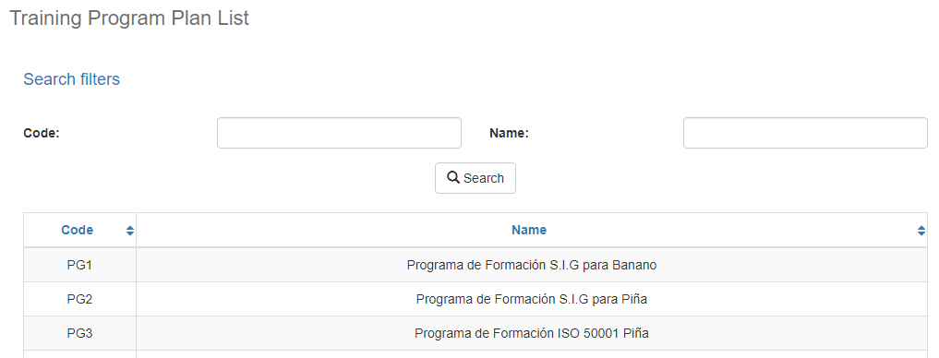

### Filtering

Back to top

The list of Training Plan Programs displayed on the main maintenance page can be filtered using the available fields at the top of the window by code or by name. Including one or more filters and clicking on the Search button will list the training plan programs that meet all the specified search criteria.

### Results

Back to top

The number of records retrieved, as well as the number of pages into which they are divided, will be displayed at the bottom of the results table, where you can also select the desired page to browse. You can also sort the results by each of the columns by clicking on its header to display them both in ascending and descending order by repeating the click on the header. This operation will sort all records from all available pages and display the results according to your preference.

## Available operations

Back to top

In the maintenance of training plan programs you can add records, edit or delete existing records, as well as reactivate previously deleted records and associate training plan to the program.

### Remove

To delete a record, select the desired record from the list of available Training Plan Programs and click on the delete button. Immediately the system will display a confirmation screen where you can proceed with the operation or cancel it.

By confirming the delete operation, the system will disable the record, but will retain its information for data history so that it will be possible to retrieve this record in the future.

### Add / Edit

Back to top

f you wish to add a new Training Plan Program in the application, click on the Add button. When you click on it, a pop-up screen will appear asking for the necessary data for the operation. This pop-up screen is the same that will appear when selecting a record from the list and clicking on the Edit button to modify its data.

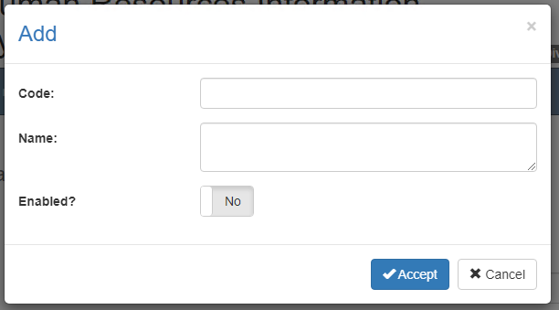

### Data requested

Back to top

The add/edit screen has the following fields:

|  |  |
| --- | --- |
| **Field** | **Description** |
| Code | Alphanumeric description of maximum length of 10 characters, with the Training Purpose code in the system. |
| Name | Alphanumeric description of maximum length of 500 characters, with the Training Purpose name in the system. |
| Enabled? | Indicates whether the Training Purpose is active for use in the system. |

When adding or editing a Training Plan Programs click the accept button to finalize the operation or click cancel or the close icon on the top right of the pop-up screen to cancel the operation.

### Duplicate records

Back to top

At the end of an add or edit operation the system will validate that the information with no other training plan programs in the system. If any data is repeated the system will give a warning and some options to proceed:

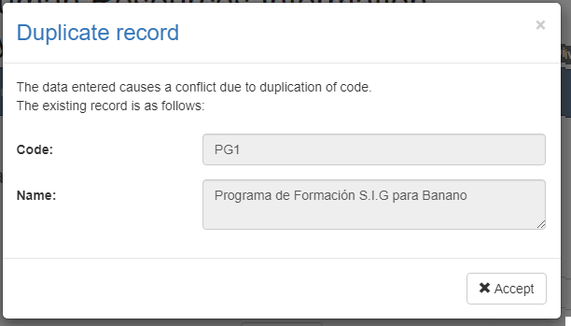

This screen will appear when the record entered conflicts with another active record in the system. In this case there is no choice but to accept the warning and modify the data.

### Associated training plans

Back to top

To associate or unlink plans to the Training program, click on the Associated Training Plans button. Clicking on the button will display a pop-up screen where the assigned courses will be listed, the option to search for courses allows you to associate the plans with the program. To mark the plan as part of the Training program, select the plus (+) icon button and to remove, select the x (x) icon button.

