# Dole Latin

# Content index

Main screen

Description

Filtering

Results

## Main screen

### Description

The report shows the general information of the thematic areas existing in the application.

### Filtering

Back to top

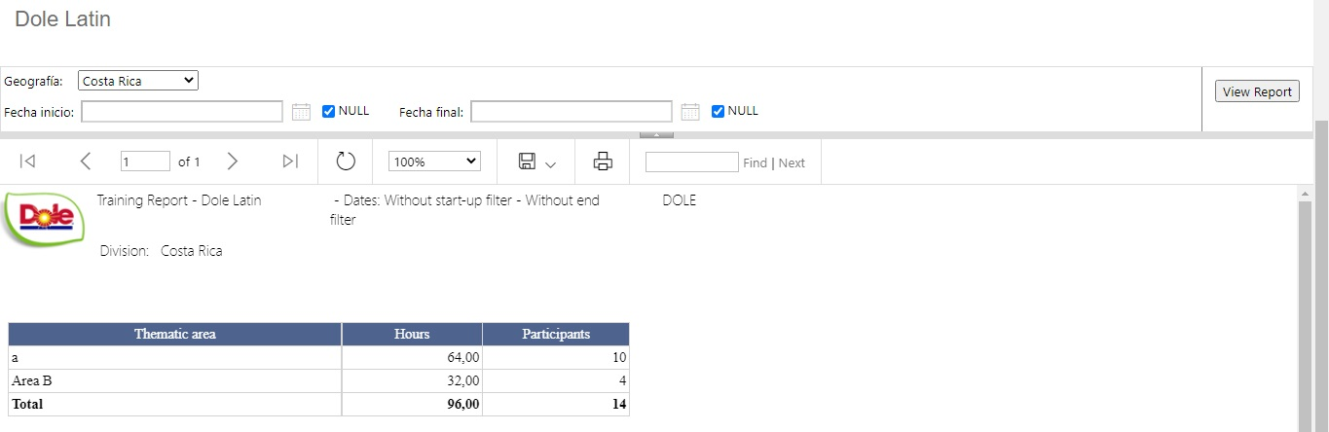



The filters displayed on the main page of the report can be filtered using the available fields at the top of the window: Geographic Code, Start Date and End Date. Including one or more filters and clicking on the View Report button will list the training sessions that meet all the specified search criteria.

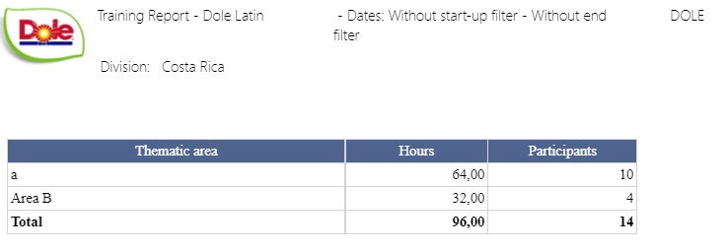

### Results

Back to top

The number of records retrieved, as well as the number of pages into which they are divided, will be displayed in the top bar of the report, where you can select the desired page to explore them. Additionally, the report can be exported in several formats, for example: Word, PDF, Excel, among others. The print operation is enabled in the report output.