# Training Shortages

# Content index

Main screen

Description

Filtering

Results

## Main screen

### Description

The report shows the general training information of the matrix of the mandatory courses existing in the application.

### Filtering

Back to top

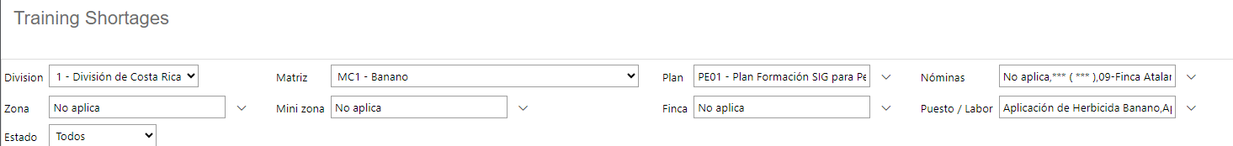The filters displayed on the main report page can be filtered using the available fields at the top of the window: Geographic Code, Matrix, Plan, Position and State. Including one or more filters and clicking on the View Report button will list the trainings given that meet all the specified search criteria.

### Results

Back to top

The number of records retrieved, as well as the number of pages into which they are divided, will be displayed in the top bar of the report, where you can select the desired page to explore them. Additionally, the report can be exported in several formats, for example: Word, PDF, Excel, among others. The print operation is enabled in the report output.

