<!DOCTYPE html>

<html lang="en">

<head>

    <meta charset="UTF-8">

    <meta name="viewport" content="width=device-width, initial-scale=1.0">

    <title>Image Page</title>

</head>

<body>

    <header>

        <h1>Beautiful Landscape</h1>

    </header>

    <img src="https://images.pexels.com/photos/417074/pexels-photo-417074.jpeg?auto=compress&cs=tinysrgb&w=600" alt="Beautiful Landscape" width="500" height="300">

    <p>This image captures the breathtaking beauty of nature with a serene landscape.</p>

</body>

</html>

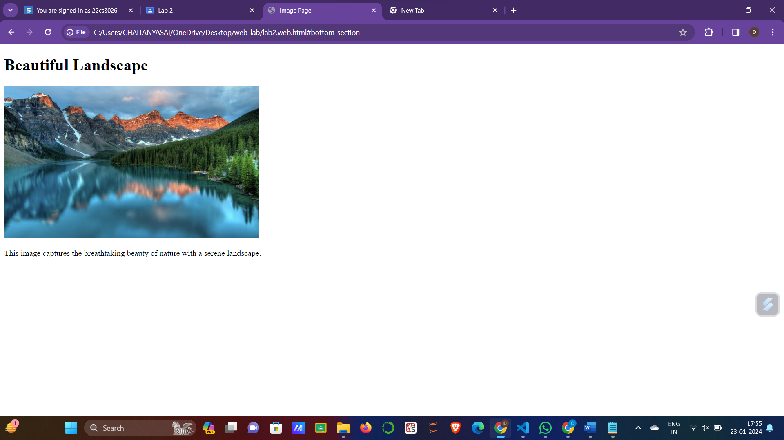

<!DOCTYPE html>

<html lang="en">

<head>

<meta charset="UTF-8">

<meta name="viewport" content="width=device-width, initial-scale=1.0">

<title>Image Page</title>

</head>

<body>

<header>

<h1>Beautiful Landscape</h1>

</header>

<img src="https://images.pexels.com/photos/417074/pexels-photo-417074.jpeg?auto=compress&cs=tinysrgb&w=600" alt="Beautiful Landscape" width="500" height="300">

<p>This image captures the breathtaking beauty of nature with a serene landscape.</p>

</body>

</html>

<!DOCTYPE html>

<html lang="en">

<head>

<meta charset="UTF-8">

<meta name="viewport" content="width=device-width, initial-scale=1.0">

<title>Country Politicians</title>

<style>

table {

border-collapse: collapse;

width: 50%;

margin: 0px;

}

th, td {

border: 1px solid black;

padding: 8px;

text-align: left;

}

th[colspan="2"] {

text-align: center;

}

</style>

</head>

<body>

<header>

<h1>Countries and Politician</h1>

</header>

<table>

<tr>

<th>Country</th>

<th colspan="2">Politicians</th>

</tr>

<tr>

<td rowspan="2">Turkmenistan</td>

<td>President</td>

<td>Gurbanguly Berdimuhamedow</td>

</tr>

<tr>

<td>Vice-President</td>

<td>Raşit Meredow</td>

</tr>

<tr>

<td rowspan="2">Eritrea</td>

<td>President</td>

<td>Isaias Afwerki</td>

</tr>

<tr>

<td>Vice-President</td>

<td>None</td>

</tr>

<!-- Add more rows for additional countries if needed -->

</table>

</body>

</html>

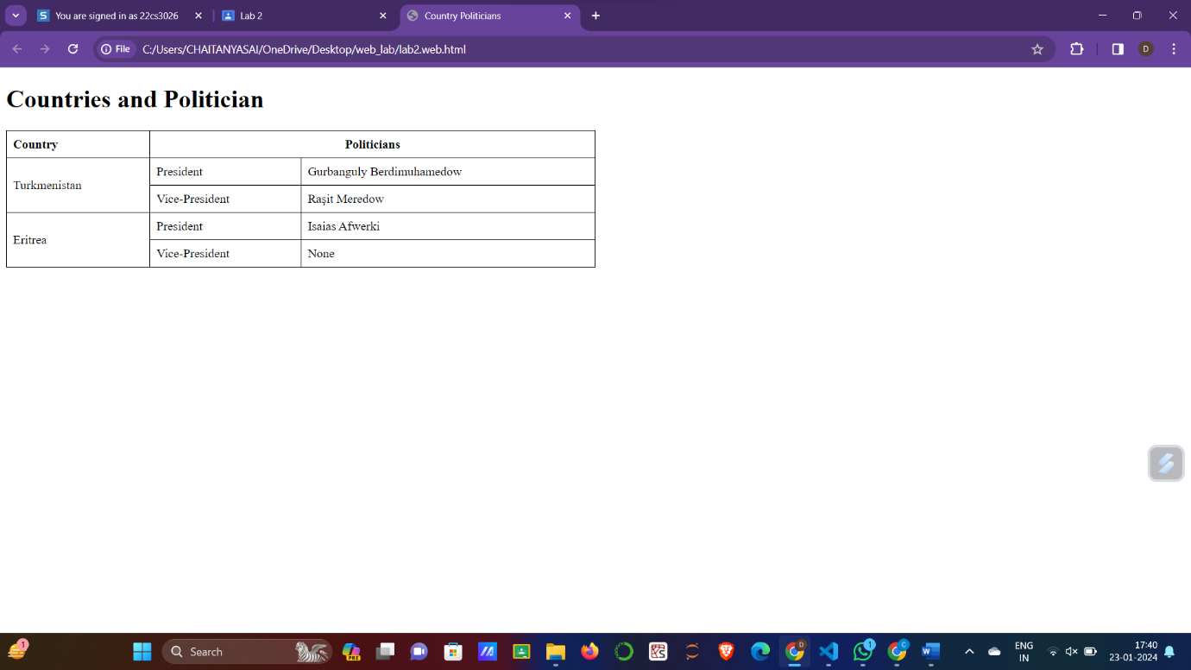

<!DOCTYPE html>

<html lang="en">

<head>

<meta charset="UTF-8">

<meta name="viewport" content="width=device-width, initial-scale=1.0">

<title>My Favorite Websites</title>

<style>

body {

font-family: Arial, sans-serif;

margin: 20px;

}

ul {

list-style-type: none;

padding: 0;

}

li {

margin-bottom: 10px;

}

a {

text-decoration: none;

color: #007bff;

font-weight: bold;

}

a:hover {

text-decoration: underline;

}

</style>

</head>

<body>

<h1>My Favorite Websites</h1>

<ul>

<li><a href="https://classroom.google.com" target="_blank">Google classroom</a></li>

<li><a href="https://www.youtube.com" target="_blank">youtube</a></li>

<li><a href="https://news.google.com/home?hl=en-IN&gl=IN&ceid=IN:en" target="_blank">google news</a></li>

</ul>

</body>

</html>

T8.

<!DOCTYPE html>

<html lang="en">

<head>

<meta charset="UTF-8">

<meta name="viewport" content="width=device-width, initial-scale=1.0">

<title>Jump Links</title>

<style>

body {

font-family: Arial, sans-serif;

margin: 20px;

}

#top-link, #bottom-link {

display: block;

text-align: center;

margin: 10px 0;

}

</style>

</head>

<body>

<a id="top-link" href="#bottom-section">Jump to Bottom</a>

<h1>Main Content of the Page</h1>

<a id="bottom-link" href="#top-link">Back to Top</a>

<div id="bottom-section"></div>

</body>

</html>

T9.

<!DOCTYPE html>

<html lang="en">

<head>

<meta charset="UTF-8">

<meta name="viewport" content="width=device-width, initial-scale=1.0">

<title>Image with Border</title>

</head>

<body>

<img src="download.jpeg" alt="Image with Border" style="border: 2px solid black; width: 200px; height: 200px;">

</body>

</html>

