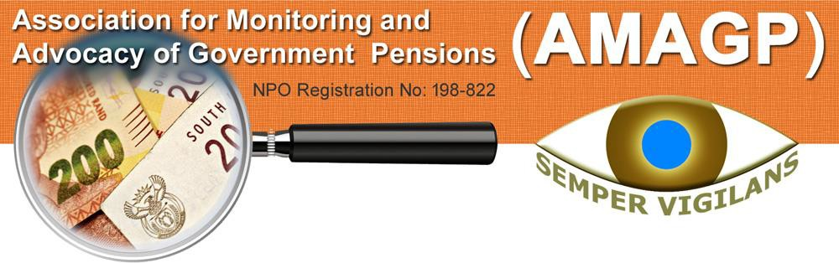

*The Association for Monitoring and Advocacy of Government Pensions: A volunteer independent group of pensioners and civil servants concerned about the long term viability of the GEPF and sustainability of its return on investments*.

[www.AMAGP.co.za](http://www.AMAGP.co.za/)



GEPF Watchdog - Waghond GEPF Forum

# NEWSLETTER NO 22 of 2021

AMAGP – Association for Monitoring and Advocacy of Government Pensions AR – annual report

BOT – Board of Trustees [of the GEPF]

FSCA – Financial Sector Conduct Authority [previously the FSB] GEPF - Government Employees’ Pension Fund

PIC – Public Investment Corporation PSA – Public Servants’ Association ROI – return on investment

SCOF – Standing Committee on Finance

SCOPA - Standing Committee on Public Accounts SOE – state owned entity

*The Government Employees Pension Fund (GEPF) is Africa’s largest pension fund. We have more than 1,2mn active members, in excess of 450 000 pensioners and beneficiaries, and assets worth more than R1,61trn. GEPF is a defined benefit pension fund that was established in May 1996 when various public sector funds were consolidated. Our core business, which is governed by the Government Employees Pension Law (or GEP Law), as amended, is to manage and administer pensions and other benefits for government employees in South Africa*.  *https://*[*www.GEPF.gov.za/*](http://www.GEPF.gov.za/) *dd 7 October 2021*

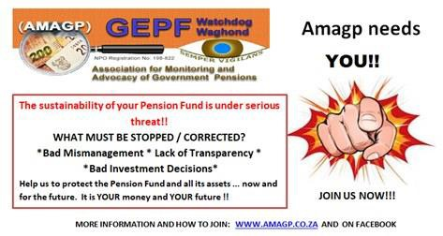

## The Editor’s Word

Note. The Fund’s investment values used in the newsletters are from the 2019 GEPF Annual Report. Soon to be updated from the 2021 GEPF AR.

The GEPF regularly publishes a newsletter. www.GEPF/media/publications/newsletter will allow you to download Fundnews and Fundletter. Worth while reading. Visit the website once a month just to check for any news.

The GEPF AR has been released, to read it go to https://[www.gepf.co.za/annual-reports/,](http://www.gepf.co.za/annual-reports/) click on the 2020/21 report. Note the

* closest we get to the actual figures are March 2021 when the financial year closed, thus six months out of date by now;
* actuarial valuation of the Fund is dated 2018, meaning the real value of all the investments, loans, real estate, bonds, etc are three years old;
* graphs compare actual value as at that year, which doesn’t necessarily equate to buying power.

I suspect if the values are compared to buying power adjusted for inflation, the graphs will present another picture.

**Now for news from the media**

The GEPF has sponsored an article about why not to cash in your pension. The obvious advantages and disadvantages are clear, but it is for you, dear future pensioner, to decide what to do.

The chairmanship of the PIC Board is a contentious issue, with its possibility and probability of political interference. The Daily Maverick gives its view on the chairmanship.

Moneyweb raises the question of the part ownership of SOE, such as SAA. The legislation of public and private ownership doesn’t exist, alas there is no SA precedent either. Our current ‘government’s’ penchant for absolute control makes for interesting viewing, although I doubt we will ever see much of the inner workings of this public/private partnership.

There are clear indications of the tourism industry recovering, however, we never know what the ‘government’ in its wisdom will decree when it feels like it. Let’s hope the improvement continues.

Transnet is in a financial crisis with its requirement for capital, while at the same also having to service debt. Some fancy footwork is required.

Industrials REIT is acquiring more property, showing continued faith in real estate recovering and investing in the future.

MTN is showing good results and looks like being a continued good investment. Read about it and its involvement outside SA.

Those of us already retired on pension know there is less money than you expected, except if you really planned properly. Read about some of the pension challenges you should already be planning for.

Dear readers, you will no doubt be aware of AMAGP through press releases and this newsletter, publicly questioning matters relating to investments made on behalf of our pension fund in companies related to Iqbal Survé. There are some developments in this respect you need to take note of.

The GEPF AR has been released recently and contains massive information. AMAGP will be releasing its views on the reporting in the report soon. In the meantime, here are some of the highlights from the report.

Moneyweb shares some views on threats to worry-free retirement, read the first instalment now.

**NEWSNUUSNEWS NUUSNEWSNUUS**

*Synopsis*

# The true cost of cashing in your pension



Teachers should think twice about retiring early. (Photo: Shutterstock)

## THIS STORY IS SPONSORED

Mail&Guardian

Maya Fisher-French, Sponsored by the GEPF 5 November 2021

Have you heard of the term Sdudla? I recently came across it in relation to members of the GEPF, specifically members who are teachers and nurses.

This is the practice of resigning from your post to access your pension fund. As teachers and nurses can work as contractors, many quit their jobs, take their pension balance and then work on contract for a few years before rejoining the department.

I received insight into the practice of Sdudla from chatting to my Facebook followers. One person wrote, “I know teachers who have done it. They resign to access their pension funds and then re-apply after a while.”

Another wrote “It is quite popular with teachers and nurses, although also with other government employees.”

Some warned against the practice: “I know of friends that have done so and now are struggling at retirement.”

Others informed me that divorcing to access their pensions is becoming even more popular. “Nowadays the ‘divorce’ method is proving more popular and is done by quite a variety of government employees, with the sole purpose of accessing their pension funds,” said one contributor, but as another warned, this is a risky strategy.

“I know a couple that divorced to access the man’s pension. After they got the money and

started spending; they never remarried. The husband didn’t want to and now the money’s gone, spent by the two of them. Eventually they separated.”

And that is exactly the point. So many of the teachers and nurses, who have played the Sdudla game, get to retirement age and then find that the money is gone and they have nothing left for their retirement.

In fact, the name Sdudla is quite apt: it means “I am not going anywhere, I am just spinning.” It is derived from a car sport where a driver revs up the engine as if driving away, only to swerve the steering wheel and the car drives in circles, leaving tyre marks depicting the figure eight. It may look impressive, but it is certainly not moving anyone forward physically or financially.

## Financially destitute

The problem is that this behaviour is leaving many teachers and nurses financially destitute when it comes to retirement. Sdudla is not a wise decision. It often ends in hardship once these people retire.

Let’s look at a hypothetical comparison of twins Martin and Lebo, who both start their careers as teachers at the age of 25. Martin uses the Sdudla strategy during his career and Lebo stays as a fully employed teacher until the age of 60.

Suppose Martin and Lebo join the GEPF at the starting pensionable salary of R208 000, and they are eligible to receive annual progression increases. If Martin leaves his position and rejoins the same position later, we assume that his starting pensionable salary at each age will only have grown by 5% p.a., an increase in line with inflation. For simplicity, we are assuming no promotion or change of positions and Martin and Lebo join the same position.

Martin works as a teacher from the age of 25 and then at 30 resigns to access his pension. The final salary 30 (the average last two years’ salary before resignation) will be R294 240.

Payout: At 30 when Martin resigns, his resignation benefit is R301 923. He will pay R49 846 in tax and take home R252 077. He

works on contract for five years before joining the department again at 35. He works as a teacher until 45, so another 10 years, and he again resigns to access his pension. His final salary at 45 would be R565 683.

Payout: At the age of 45 when Martin resigns, his resignation benefit will be R1 182 148. He pays R272 574 (around 23%) in tax and takes home R909 575.

Martin works on contract for two years and rejoins the department at 47. He works another 7 years until 55 and then resigns. He takes his benefit and works on contract until

1. His final salary at 55 would be R921 438.

Payout: At the age of 55 when Martin resigns, his resignation benefit will be R1 812 777. He will pay R499 599 in tax and take home R1,3mn.

In comparison, Martin’s twin sister Lebo started working as a teacher at 25 and stays in her employment until retirement at 60. Her starting salary is similar to Martin’s, R208 000, however, she receives above-inflation increases due to her years of service. Therefore, at retirement, Lebo’s final salary would be R1 427 942.

Her payout at retirement: Lebo’s gratuity benefit will be R3 358 782 and in addition, she receives an annuity benefit of R75 760 per month.

## The comparison

The total lump sum benefit that Martin had received from the fund before tax is R3 296 849. He receives no annuity benefit per month. On the other hand, the total lump sum benefit that Lebo will receive is R3 358 782 and R75 760 annuity benefit per month. In order to purchase an annuity income of R75 760 Martin would need R12,5mn. Even if Martin had invested some of his resignation benefits, it is unlikely he would have R12,5mn to purchase an annuity.

If Lebo lives for five years receiving the monthly annuity, her total benefit before tax would be R7 904 390 (excluding pension increases), and if she was married and has children under the age of 18, her beneficiaries are eligible for a pension when she passes away.

If Lebo passes away within the first five years of receiving her pension, her beneficiaries will receive a death benefit that is equivalent to the remainder of her monthly pension. She is also eligible for a funeral benefit, together with her spouse and eligible children.

Martin’s spouse and children don’t receive any benefits. In fact, Lebo will probably have to support Martin in retirement! At 55 it would be too late for Martin to start trying to catch up his pension.

Also note that apart from having a far worse pension outcome, Martin would also have earned a lower salary than Lebo. Government positions are structured where each position has different grades. Those who leave and rejoin the same position start at a first grade, which would only have inflationary increases. This is why Lebo’s final salary is higher than Martin’s.

Be very careful about playing the Sdudla game. The long-term consequences are not reversible.

Disclaimer: The assumptions used are for illustration purposes. The figures reflect inflation, so R1,3mn in 30 years’ time does not have the same buying power as it does today.

*Comment*

*This is a good example of why the GEPF pension is so good. While Martin had the luxury of using his accumulated pension several times he doesn’t have the security of worry-free retirement on pension while Lebo does.*

*Synopsis*

# Political interference fears: Deputy finance minister David Masondo takes over as chair of the PIC board

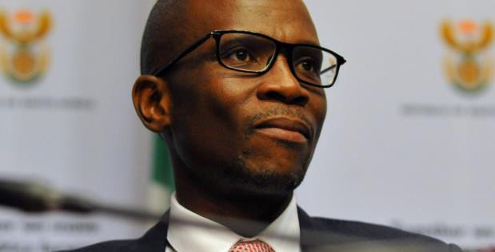

*Deputy Minister of Finance David Masondo. (Photo: Gallo Images / Ziyaad Douglas)*

Daily Maverick By Ray Mahlaka 4 Nov 2021

A politician has again been appointed to lead the board of the PIC in a move that risks politicising the running of the PIC. As chairperson, Deputy Finance Minister David Masondo will be supported by 12 others from business, the labour movement and academia.

Masondo replaces Reuel Khoza, a businessman, whose term as PIC board chair ended on 31 October after two years of overseeing and reforming the governance processes at the asset manager.

Appointing someone from the private sector to lead the PIC board was widely seen as a good move at the time, as it had the potential to help the company to make investment decisions based on merit and not political considerations.

It has been long argued that having the Deputy Finance Minister as board chair would make the PIC vulnerable to political interference when it comes to its investment decisions and governance processes.

The Mpati Commission of Inquiry found that the appointment of the Deputy Minister as the PIC’s Board chair “appears to have significantly contributed to ineffective governance and the deficient functioning of the board”. This is because deputy ministers are political appointments and automatically get the job of PIC board chair “by virtue of the office they held”, regardless of their skills. They often lose their jobs because of regular Cabinet reshuffles, creating instability and leadership continuity problems at the PIC.

The Commission recommended that whoever is appointed as the PIC board chair should have experience and expertise in pension funds, finance, markets and governance.

Masondo is a former national chair of the Young Communist League of SA with left- leaning ideas on managing the economy, such as unleashing quantitative easing to lower the fiscal deficit. Masondo is a member of the ANC’s National Executive Committee and serves on its economic transformation committee. He also holds a PhD from New York University in the field of political economy.

The appointment of businessman Khoza in July 2019 marked a step change as the PIC board had been chaired by the deputy finance minister ever since the asset manager was separated from the National Treasury and corporatised in 2005. This convention was not embedded in law.

However the PIC Amendment Act, which paved the way for a political figure to be appointed as the PIC’s Board chair, was signed in February, allowing for the PIC BOI to be chaired by a deputy minister appointed by the Finance Minister. In this case Deputy Finance Minister David Masondo as PIC board chair.

Even Khoza warned that efforts to depoliticise the PIC’s governance and management processes might be undermined by aspects of amendments to the PIC Act that allow the Deputy Finance Minister to be appointed as board chair. But the act does have positive aspects.

It introduced several measures to improve transparency and accountability in management. Among these are that the PIC must now get mandates from its clients, the biggest of which are the GEPF and the UIF, before investing their funds.

The new board needs to finalise several disciplinary processes, recover funds that the PIC has lost and implement the findings of the Mpati Commission. Among the companies the PIC plans to recover money from are those directly or indirectly controlled by businessman Iqbal Survé, including AYO Technology Solutions and Independent Media.

*Comment*

*Political interference will remain a threat to the PIC and GEPF. Political interference implies using the PIC and GEPF to further political objectives to the detriment of the beneficiaries of the GEPF and the other funds the PIC invests for.*

*Synopsis*

# When state-owned entities are no

|  |  |  |
| --- | --- | --- |
| **longer public** | **companies,** | **what** |
| **are the rules?** |  |  |
| Moneyweb  By Riza Moosa  5 November 2021 |  |  |

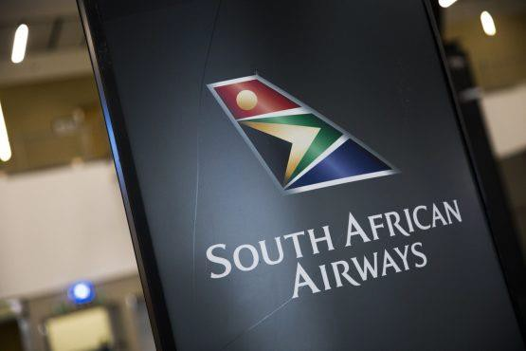

Image: Guillem Sartorio/Bloomberg

A number of SA’s SOE have a long history of poor management and high levels of debt that have put a substantial strain on the country’s national budget. This is particularly true for SOE that have had to rely on government bailouts to keep afloat. The government has been resolutely looking for ways to alleviate the financial burden of many SOE and turn their situations around.

For the SAA, the government’s strategy was to sell a 51% stake in the struggling airline to the Takatso Consortium. This means Takatso will take a controlling shareholding in the airline and the South African government has now become a minority shareholder. However, this decision introduces a number of considerations for SOE.

While the situation with SAA is unusual, it could become more common among other SOE if it proves to work in rectifying the financial challenges of the national airline.

So, what happens when a company formerly owned by the state becomes majority-owned by a private shareholder, and the government becomes a minority shareholder?

## Three key questions

This novel situation raises three key questions around the running and regulation of entities that were publicly owned and are now privately run.

## How do shareholders work together in this new private-public dynamic?

As government disposes of its shares in a public enterprise, new, private shareholders will enter into the business. When this happens, the government will need to contract with those shareholders as a private company would, by entering into a shareholders’ agreement that will dictate how the company is run, what the company can and cannot do, and what actions will require a higher threshold of voting (referred to as minority protections).

Essentially, a well-drafted shareholders’ agreement will lay out the duties and obligations of shareholders, determine how decisions will be made at a shareholder level, address existing and future shareholder funding, and set out a procedure for dispute resolution as well as the process for the exiting of shareholders from the company.

As there is no precedent or piece of legislation governing how private and public shareholders will run a company together, this introduces an interesting scenario for public- private partnerships with shareholder matters needing to be determined on a case-by-case basis.

## How will competition be protected in this new entity?

When a private company disposes of a majority stake in the business, the value of a proposed merger equals or exceeds R600mn, or the combined annual turnover or assets of both the firms are valued at or above R6,6bn, the Competition Act dictates that a merger filing must be made with the Competition Commission (CompCom) as there will be a change of control in the business.

This is to ensure that market participants in the merger are not decreasing competition by doing so, that there is no abuse of a dominant position by a firm that could lead to excessive or discriminatory pricing, and that a firm is not denying competitors access to essential facilities, as well as any other exclusionary acts.

With an already unclear competition policy on SOE, this presents new questions around the protection, promotion, and maintenance of competition in South Africa’s economy.

The CompCom is an independent statutory body, but perceptions may exist that it is also a government entity. It will therefore attract scrutiny to ensure that it makes decisions around these mixed enterprises fairly and in an unbiased manner. When the CompCom approves mergers, it often stipulates conditions to such approval.

Will, for instance, the Commission require the government to dispose of any other assets before allowing the disposal of its majority shares in an SOE, as it would sometimes require for any other private business?

Will it ensure that the government doesn’t abuse its dominance in the various sectors it has major stakes in?

Competition regulation around both SOE and new formerly state-controlled enterprises needs to be made clearer as soon as possible to address transparency in pricing, cross- subsidisation and bailouts.

## How will government deal with shareholder funding?

Most companies have three sources of funding: the money the company makes and keeps in the bank, shareholder funds, and commercial funding. When a company needs to secure funding there is often an agreed-to sequence that must be followed, usually set out in either the shareholders’ agreement or the company’s Memorandum of Incorporation. For instance, when the business needs money it should first look in its own pockets (the money it makes); then go to the shareholders; and then, if the shareholders can’t fund the business, it must look for funding in the market.

When government is in a position such as that presented by SAA, how, as a minority shareholder, will it continue to fund the enterprise and not have to write any more guarantees to save the SOE, particularly as it will have sold its shares in order to get out of debt?

With the announcement of the majority stake sale to Takatso, the South African government noted that it would no longer provide any funding to the airline. But all stakeholders of a business are required to fund the company, you don’t just own the business; it is one of your responsibilities as a shareholder to put money into the company when needed. If not, non-funding shareholders may get their shareholding diluted in favour of those shareholders who provide the required funding.

So is the government, as a minority shareholder, still liable to fund the company using taxpayers’ money, and is it willing to put its hands back into its pockets and continue funding the entity? If so, how will the decision to sell a majority stake in an SOE to a private business help the government in moving away from having to bail out SOE from its financial struggles?

Additionally, when an SOE is no longer a public entity, it is no longer shackled by the Public Finance Management Act, leaving these new mixed entities with a bit of regulatory breathing room.

So, what does it mean for government to have a stake in these entities and how can it ensure that it is not just perpetuating what it has had to do for years (continue to pour money into businesses that aren’t making money) by retaining a portion of its control?

If the government’s decision to sell a major stake in SAA becomes a trend among SOE, we will need new rules set out to govern these new entities in order to ensure that the interests of both private companies and the public are protected.

*Comment*

*A fresh look at the challenges facing SAA. The forgotten item is in the fine print, where the ‘government’ has a veto right irrespective of the shareholding. As long as that exists, ‘government’ retains control.*

*Synopsis*

# Lockdown easing: Tourism industry gears for recovery

Daily Maverick Roelof Botha

4 November 2021

Progress around the globe with mass vaccinations has played a major part in enabling the world to rapidly return to a normalised existence. In South Africa’s case, a sharp decline in the number of new Covid infections has allowed the hospitality industry to start recovering from the fairly stringent lockdown regulations.

Furthermore, the decision by Britain to remove South Africa from a so-called red list, has been met with relief and excitement over the prospects for a surge in international tourist arrivals this summer.

The early evidence is promising. British Airways, Virgin Atlantic, Lufthansa, Air France and Swiss-based Edelweiss Air have all resumed flights to Cape Town, which is South Africa’s premier tourist destination.

height of the pandemic, it makes more sense to compare data for 2021 with 2019 (pre- Covid), a practice that is also followed by the International Air Travel Association (IATA).

Although the September figure is still a far cry from the 400 000 international visitors that arrived two years earlier, it represents a recovery rate of close to 25%. Good news for South African hotels, restaurants and guest lodges, all of which may return to profitability during the traditional bumper summer season.

Many hotels “mothballed” since April last year will now reopen, including most of the hotels in the Sun International Group and the Commodore Hotel in Cape Town, which has been scheduled for reopening on 17 November.

## Positive policy response required

Hopefully, the authorities involved with the tourism supply chain will grasp the opportunity to make the most of the imminent resurgence of international tourism. As early as 2006, with the launch of the Accelerated and Shared Growth Initiative for South Africa (AsgiSA), the government acknowledged the vital role that tourism can play in the quest for higher growth and employment creation.

Unfortunately, significant damage was caused to the lofty ideals of a concerted tourism strategy during the Zuma administration, enacting legislation imposing onerous visa regulations on tourists.

Although a measure of relaxation has since been implemented, substantial scope exists for further amendments aimed at a regulatory system for visas that is more conducive to attracting tourists.

Provided by Daily Maverick

The reality is that international tourism is highly competitive and most countries around

© the globe are desperate to revive tourism. The message to the government should be clear: A proactive tourism strategy should be

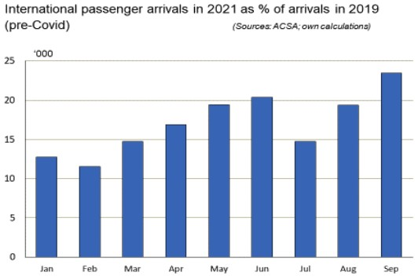

During September, more than 93 000 international visitors arrived at Johannesburg’s international airport, representing an increase of almost 50% over the number recorded in July. Due to the virtual cessation of international travel during the

prepared post haste, involving all the relevant stakeholders, with a strong focus on pragmatism and the removal of unnecessary obstacles to growth.

South Africa is a tourist paradise, offering endless opportunities to explore the outdoors via sport and adventure activities, while also possessing accommodation facilities of the highest possible standards.

*Comment*

*At long last the too strict lockdown is easing, allowing the tourism and with it the hospitality industry to revive.*

*Synopsis*

# Transnet risks defaulting on multi-billion rand near-term debt due to its struggle to raise new long-term debt

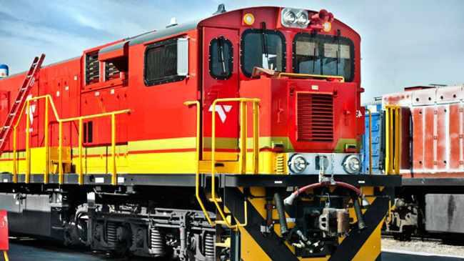

Photo: ANA file. IOL

By Siphelele Dludla 4 November 2021

Transnet yesterday vowed to work with the government to guide its future audits as the group risks defaulting on multi-billion Rand near-term debt maturities, due to its struggle to raise new long-term debt to bolster its diminishing liquidity profile.

This comes as Moody’s Investor Services has downgraded Transnet’s ratings status due to its weak liquidity profile and weak corporate governance. Moody’s downgraded the corporate family rating (CFR) of Transnet to Ba3 from Ba2 and the national scale senior unsecured Medium-Term Note (MTN) rating to A2.za from Aa2.za.

Transnet's baseline credit assessment (BCA), a measure of standalone credit quality prior to any assessment of potential extraordinary government support, was lowered to b1 from ba3 with a negative outlook.

Moody's senior analyst Lisa Jaeger said Transnet’s liquidity profile had continued to weaken since June’s rating, and that certain aspects of its corporate governance had not been sufficiently addressed. “These weaknesses include the company's repeated delays in publishing audited financial statements, its inability to obtain unqualified audit opinions and recurring breaches of debt covenants,” she said.

Jaeger said Moody's believed these governance failings heightened uncertainty around Transnet’s ability to access international capital markets in a timely manner ahead of a R15bn international bond maturity in July 2022.

“The outlook remains negative because liquidity pressure will continue to intensify unless Transnet raises a substantial amount of new long-term financing in the coming months,” Jaeger said.

Transnet last week reported a net loss of R8,4bn for the financial year ending 31 March 2021, down from a profit of R2,9bn the previous year.

This was due to the Covid-19 impact on Transnet operations and other expenses that were abnormal to its business operations such as cyberattacks. But what pushed Transnet deeper into Moody’s downgrade was its qualified audit by the auditor-general, and findings of irregular expenditure of R104bn.

Transnet has been squabbling with the auditor-general over differences in opinion on the accounting treatment of the multi-billion Rand 1 064 locomotives, which delayed the release of its financial results.

Transnet’s audit qualification has already resulted in a breach of loan covenants with an outstanding balance of R19bn as of 30 September 2021.

Moody's said it believed the company would be able to secure financing commitments that would allow it to meet all obligations due until September 2022, but the risk of default was increasing as sizeable maturities draw closer without refinancing secured.

Transnet, however, said it continued to actively work on a funding plan.

*Comment*

*An external simplified view of Transnet, with Transnet management trying to bring it back to profit. Commitment from top to bottom wil go a long way to improving matters.*

*Synopsis*

# Industrials REIT buys three more properties

8 November 2021 INCE|Community

By The Finance Ghost



In September, Stenprop announced that its name would change to Industrials REIT limited. That's a bit like Nike rebranding to Shoes Inc., a low score for creativity but a high score for simplicity and sending a clear message!

Industrial property has been all the rage in the past 18 months. It was the most resilient asset class during the pandemic. If you believe that online shopping and remote working has a strong future, then industrial property is the pick of the litter. Goods need to move from producers to consumers, regardless of whether those consumers choose to go to an office or drive to the shops.

Of course, I'm not telling you anything that the market doesn't already know. Industrial property funds have been chased hard by investors and the valuations reflect that, with funds frequently trading at or even above the net asset value per share.

Remember, property funds revalue their assets as part of the ordinary course of financial reporting, so the net asset value per share is supposed to be a reasonable

approximation of what the properties are worth (net of debt).

From a rebranding perspective, the choice of "Industrials REIT" at least plays into a market theme that is clearly strong.

The latest news from the company is that it has acquired three multi-let industrial estates in the UK. The transactions come to £18mn in total and have a blended net initial yield of 7,1%, which feels more than decent for a hard currency yield. It helps that the company is getting access to off-market deals.

This takes total acquisitions by the company to £55mn since 1 April 2021. Multi-let industrial properties now account for 92% of total assets and the company wants to become "fully focused" on these types of properties by 31 March 2022.

The share price is up more than 41% year-to- date and over 120% over five years. That's a track record that is worth paying attention to.

*Comment*

*We have about R223mn in Industrials REIT.*

*Synopsis*

## TITBITS

**Redefine** has confirmed a dividend of 60,12 cents per share, which means the company is paying out its entire distributable income for the year (52,96 cents) plus 7,16 cents related to taxable unrealised foreign exchange gains due to the appreciation of the rand. If I understand that correctly, it means that the fund would rather pay shareholders those gains than pay SARS. I doubt many shareholders would disagree with that approach

*We have about R7,1bn in Redefine in total. Good ROI.*

*Comment*

*Mergers, acquisitions, delisting, takeovers, consolidations; we all wonder when a snippet catches the eye if the Fund has an interest in that company*.

*Synopsis*

# MTN and the great data explosion

5 November 2021 INCE|Community

By The Finance Ghost

The performance of MTN's underlying African subsidiaries gave a strong clue of what was to come from MTN Group in this quarterly update. Still, the share price closed 6,7% higher as the market remembered that this share price still has legs in it.

Group service revenue was up 19,1%, driven by data revenue (up 34,5%) and FinTech revenue (up 35%). Voice revenue growth was only 6,9%, so it's quite clear where the future opportunity is.

The company has guided that a total of R31,1bn will be invested in capex in 2021 to "capture opportunities from explosive data traffic" in MTN SA and MTN Nigeria. The effective data tariff has dropped 29,7% year- on-year in South Africa, clearly demonstrating the deflationary power of tech that offshore CEOs often talk about. The trick is that volume growth typically more than makes up for price decreases.

MTN is actively chasing the FinTech opportunity with products like MoMo merchant payments. The insurance platform now has 14,8 million registered insurance policies. As people do more on their smartphones, the opportunity for telecom providers is clear.

Strong revenue growth is often leveraged up into an even better result in profitability, as expenses typically don't increase as quickly as revenue does when things are going well. That was the case in this result, with EBITDA margin up at 45% from 42,9% off the back of EBITDA growth of 24,1%.

The growth story isn't really in South Africa, although MTN posted a respectable 7,7% growth in revenue here. The EBITDA margin increased from 39,3% to 41,6%. MTN has 33,5 million subscribers within our borders, of which 26 million are prepaid.

MTN Nigeria is the one that the market really watches. Revenue was up 23,5% with an EBITDA margin of 52,6%, up from 51,1%.

Group subscriber growth quarter-on-quarter was 200 000, taking the group total to 271,9 million. Excluding Nigeria, the increase would've been 1,6 million. The substantial negative number from Nigeria was driven by new SIM registration regulations.

Although the market basically ignored the credit rating announcement when it came out in October, MTN points out that it now has its first investment grade rating from S&P since 2016. The net debt to EBITDA ratio is 0,6x, way below the covenant of 2,5x.

During Q3, MTN upstreamed R4,6bn from its operating companies, including R2,3bn from Nigeria, which is a huge part of why MTN has become a market darling..

MTN has also confirmed that its shareholding in IHS Towers after the US listing is 25,8%. That IPO hasn't been a success, with the listing price of $21 now a distant memory for those who chased the share on the opening day. IHS is now trading at $16 per share.

Speaking of IPO, MTN floated MTN Uganda on the Uganda Securities Exchange in October 2021, allowing local investors to participate in its growth. That was a precursor to the main event: a listing of MTN Nigeria. MTN intends to sell down approximately 14% of its current shareholding in MTN Nigeria.

MTN investors will be looking for a proper price for that sale, as MTN Nigeria is the biggest growth story in the group. For now at least, there are many smiling MTN shareholders after share price growth of around 127% year-to-date.

*Comment*

*We have about R4,53bn in MTN in total. MTN seems to be working hard at making money in many markets.*

*Synopsis*

# How costs can erode wealth creation in retirement

Ever asked if you have saved enough for retirement? You should also ask whether the costs associated with your investments are eating into your savings.

Moneyweb

9 November 2021

By Wouter Fourie - Ascor® Independent Wealth Managers



Image: Shutterstock

When presenting a financial course, I often like to ask delegates to write down their biggest fear when it comes to retirement. The more frequently raised worries are the inability to save enough and the fear of not being able to accumulate enough savings to provide a reasonably stress-free retirement. Together with this, seeing your wealth retracting owing to the effect of costs in wealth creation, is often cited as a major fear and, indeed, a threat.

To create and sustain wealth and increase your net worth, there are only three ways to do this, namely

* increase your income,
* decrease your expenses and
* be more efficient

in the use of your savings and other assets with the assistance of your financial advisor. For most, wealth is limited to the amount of income you earn and the value of assets you accumulated during your working life. It is only after your living expenses have been paid and all your taxes and commitments have been deducted that you will see what is left to be used for building wealth. For many, this means little to no actual money left to create wealth.

Nearly 75% of South Africans worry that they will not have enough money to live on when they retire, and they have every reason to be terrified. But don’t fret too much as it can sometimes be averted when taking a closer look at your expenses, fees and taxes.

According to the Financial Sector Conduct Authority (FCSA), when looking at the financial statements, statistics and quarterly reports from over 1 300 active funds (2019),

the following costs are eating away at your wealth, including

* accumulated funds or asset-based fees,
* contribution-based fees,
* fees taken from benefit payments,
* fees for transfers,
* investment fees,
* market value adjusters,
* fair value adjustments,
* administration expenses including admin fees,
* audit fees,
* actuarial fees,
* levies,
* consulting fees,
* training,
* trustee expenses,
* legal fees and many more.

These costs have a debilitating effect on your investments, particularly in a low-inflation, low-returns situation, where ongoing costs can erode the value of the initial capital you invest.

When investing sensibly, you have to make sure you are not spending a large portion of your growth in fees. Unlike the effect of compound growth, high fees have the reverse effect creating a black hole in your savings over time.

The generally accepted savings amount is around 15% of your monthly income during your working life, in most cases around 40 years. By starting early, you will benefit from compound interest, therefore reducing the effect and erosion of costs on your investment, providing for a healthy financial retirement.

Unfortunately, not everyone is in that position, so to reduce costs try doing the following:

* when it comes to pension funds try to negotiate better fees, benchmark fees and costs and make the necessary changes when needed, and
* do an audit to understand the true costs.

An audit will give a good indication of the transparency of costs from your service provider as well as the provider’s performance.

In South Africa, the 2019 Retirement Savings Cost Disclosure Standard makes it easier to compare prices and ensure that you compare apples with apples. Under the RSC disclosure standard, all retirement savings costs must be disclosed as a percentage of assets to concur with the accepted way of expressing savings growth as a percentage as well.

Your type of investment strategy can also impact your costs negatively, so always make sure you speak to your trusted financial advisor to assist in making the most cost- effective decisions to ensure future financial health in retirement.

*Comment*

*We easily forget what it costs to keep a household going when we are on pension. Especially if you spend too much in the first euphoria or having all that money. Take note, learn and apply sound money management principles.*

*Synopsis*

## MESSAGE FROM OUR AMAGP SPOKESPERSON

Supporters of AMAGP will no doubt be aware of us often publicly questioning matters relating to investments made on behalf of our pension fund in companies related to Dr Iqbal Survé. Companies like Ayo Technology Solutions and Independent Media especially were mentioned. AMAGP has now received a letter from Dr Survé's attorneys demanding that certain statements by us be withdrawn and removed as being false and defamatory of him and his companies. We deny these allegations, and as it is possible that this matter could result in judicial action against us, we are seeking legal advice and have appointed an attorney and advocate to assist us in the matter.

Our supporters will be kept informed of developments."

Adamus P Stemmet (AP) Durbanville

*Comment*

*Dear reader, our views about Survé and his business might not suit Survé, however, the facts referred to on which our reporting is based, don’t change.*

*Synopsis*

# GEPF investment portfolio grows 27,5%

Moneyweb

By Barbara Curson 11 Nov 2021

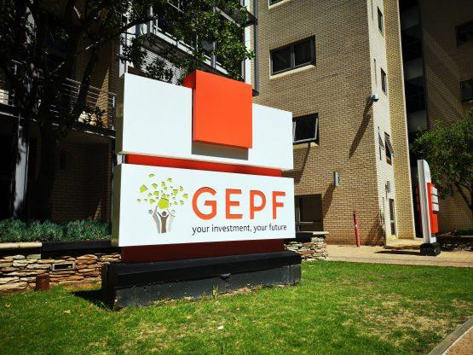

Image: Moneyweb

The GEPF has reached a significant milestone in the 25th anniversary of its founding, with the fund’s investment portfolio now valued at over R2trn.

This is revealed in the GEPF’s latest financial results for the year ended March 31, 2021, published on Monday. It shows that the fund’s investment portfolio has grown 27,5% or by R451bn for FY2021.

## Key performance indicators

* The market value of the fund increased to R2,09trn in 2021 (2020: R1,59trn), “despite the turbulent and unpredictable market conditions during the financial year”.
* Investment market value increased by 27,5% (2020: decline of 11,4%).
* The return on investment achieved is 23,1% (2020: negative 11,2%).
* Accumulated funds and reserves grew at an average annual rate of 8,9% for the 10- year period (2012 to 2021).
* Net investment income amounted to R483,8bn (2020: R179,7bn loss).
* Member contributions amounted to R82bn (2020: R80bn), and total benefits paid were R110,6bn (2020: R111bn).

The Fund believes: “The growth in the value of assets under management (AuM) confirms that the GEPF’s investment strategy aimed at achieving long-term growth is successfully

contributing to the financial soundness of the fund”.

The GEPF noted that “the increase in the investment value of the fund is mainly attributable to the recovery in financial markets, particularly equities and bonds.” This follows a contraction in 2020.

The Fund’s unlisted and property portfolios bore the brunt of market conditions resulting from the impact of the Covid 19 pandemic on the economy and suffered a decline.

“In this regard, impairment provisions had to be made to reflect the business reality of an asset at a particular point in time. As a result, the GEPF implemented a very conservative valuation of its unlisted and property assets. Such a valuation approach was done fully aware that improved market conditions could see assets subsequently recover or even exceed the value of the original investment.”

The value of impairments decreased to R7,4bn in 2021 (2020: R11,9bn). The GEPF

also reversed some R2,1bn impairments of assets which were impaired in previous years.

The GPAA received 27 960 pension claims in 2021 (2020: 34 134), reflecting a decrease of

18% in claims.

Its retirement claims for 2021 were R76bn (2020: R69,1bn). The Fund’s active members decreased to 1 265 406 in 2021 (2020: 1 269 161). The number of pensioners in the Fund decreased to 312 647 in 2021 (2020: 313

173).

Read:

The GEPF has taken steps to enhance and strengthen its oversight and monitoring of the GPAA and the PIC, including:

* Carrying out a comprehensive review of the Fund’s investment policy, investment mandate and management agreements with the PIC, including more stringent consequence management, a review of the fee models, and improved investment and reporting guidelines.
* Carrying out a review of the Fund’s operating model and quality of service provided by the GPAA, including the benchmarking of administrative systems to

meet the needs of the GEPF and its clients.

The GEPF says it remains optimistic on its future growth and will continue to play its part in growing the South African economy.

*Comment*

*Some comments on the basis of the article. I haven’t read the full report, I will wait for the AMAGP experts to analyse and distil what we must know.*

*The benefits paid were substantially higher than the member contributions. Thus, if it wasn’t for the investments, the Fund wouldn’t be able to maintain the current pension payments.*

*The assets were worth about R1,6trn a month ago, according to the GEPF website.*

*A month ago the beneficiaries and pensioners indicated on the Fund’s website were “in excess” of 450 000; the financial results now show about 312 000 in the same period. Hmmm.*

*The AR will probably explain the discrepancies, although I’m not so sure of that.*

*Synopsis*

# Ten threats to a financially secure retirement (Part 1)

Moneyweb

12 November 2021

By Wouter Fourie - Ascor® Independent Wealth Managers



Image: Shutterstock

Everyone longs for a financially secure retirement. A time when you can sit back and relax while you enjoy the fruits of your labour for the most part of 40 years or more.

However, there are numerous threats that can have a dire effect on your plans and dreams. Some of them are self-made and others can be inflicted on you. In compiling a list of the 10 main threats, here are the first five to consider when you try to achieve a financially secure retirement:

## Lack of proper planning

Since most retirement funds in South Africa are defined contribution (DC) funds, compared to defined benefit (DB) funds of the 1990s and before, a lack of proper planning is often the biggest threat. With DC funds placing a lot of the responsibility on you, you need to decide how to structure an inflation- matching retirement-income flow that will be sustainable until you (and your partner) die.

By setting realistic targets based on what you have achieved historically and what you need to achieve in the future, a financial plan should be the first step to avoid a major threat to your retirement. Most people tend to leave financial planning for retirement until a few years before they retire. To correct historical problems is often not possible when you have left it too late.

Planning includes setting goals and budgeting properly to achieve a sustainable income flow. As it is not a simple matter, most people need assistance in this regard, and it is strongly advised that they get sound advice from a reputable, skilful and knowledgeable financial planner with whom you have built up a long- term relationship. A financial planner who places your interests first.

With numerous factors and variables that need to be fed into complex calculations before the different potential outcomes can be compiled, you might end up selecting the most appropriate and affordable options and not the optimum desired option. In short, to avoid the threat of a lack of proper planning, involve a reputable financial planner from the start.

## Longevity or life-expectancy

People are living longer and getting older across the world. In South Africa, the latest predictions are 79 years old for a man and 84 for a woman but you might live even longer. In developed countries, longevity has become a

major issue and when people have saved what they consider to be sufficient, pensioners may find that they need to reduce their standards of living after 20 to 30 years into retirement.

Longevity means that you will need a lot more money when you retire to be financially secure through retirement. With every chance to live longer, it might get to a point where your retirement years can be almost as long as your working years. Major contributors to longevity have been advances in medical technology, better access to healthcare and generally more healthy lifestyles.

## Health

You might live longer in retirement but health issues common to old age could be a major threat to your secure retirement plans. With more and more people dying of mental and physical degenerative diseases, several issues arise as a consequence:

* Degenerative physical and mental diseases require expensive long-term treatment and care. As much as 60% and more of a total lifetime’s healthcare costs are spent after the age of 60.
* Many sophisticated treatments now available to help keep you alive for longer are expensive.
* The rise of medical costs is alarming and means that medical costs are likely to absorb an even greater proportion of your retirement income as you age.
* Many pensioners can no longer afford to contribute to a medical scheme and as a result they either downgrade their level of medical cover or bail out of medical schemes altogether.
* The need for frail care is likely to be a requirement as you age, with its associated costs.
* Dementia, which can make its effects felt very slowly, can have tragic financial consequences when you lose the ability to retain some measure of control over your affairs and make decisions that could undermine your financial security.

## Historical behaviour

What you have done (or didn’t do) in the past will impact your financial security in retirement. You face a significant problem if

you have not started saving soon enough, have not saved enough, have withdrawn your retirement savings along the way, have been hit by bad luck and made poor investment decisions. There are only three real solutions to the historical problem of not having sufficient money saved by the time you expect to retire namely continue to work, reduce your standard of living and rely on the goodwill of others such as friends and relatives.

## The choice of annuity or pension

The last threat in the first part of this two-part series, which will have a considerable impact on your income flow, is the choice of pension or pensions and the way some of the choices are structured.

With choices becoming complex, numerous and diverse, as well as the increasing risks, it is somewhat of a concern to the government. The introduction of regulations includes a requirement to ensure that members are given access to retirement benefit counselling. It also requires that your fund should offer you one or more default annuity options. If you do not opt for the default, you will need to purchase a pension from a commercial provider, probably at a higher cost and resulting in a lower pension.

*Comment*

*Worry free retirement on pension depends on your planning for it. Take note of these threats and the article to follow in a later newsletter.*

# THE GEPF WATCHDOG/WAGHOND FACEBOOK PAGE

The GEPF Watchdog/Waghond Facebook page is the social media platform of the non- profit organisation “The Association for the Monitoring and Advocacy of Government Pensions” (AMAGP). The AMAGP has only one agenda point – safeguarding the GEPF against looting and mismanagement.

Most of our GEPF members are content with the fact that pensioners still get their monthly pension (and some increases annually), and they are convinced by GEPF newsletters and

ambitious briefings by the GEPF Board of Trustees that our Pension Fund is in a superb condition. There is, however, another side to the coin! The AMAGP newsletters and press releases tell a different story.

Our Facebook and AMAGP are together more than 57 000 members and continually growing, but this isn’t enough. However, this continued growth confirms the ever increasing concern pension fund members and pensioners have about the future of their pensions.

As a member of the GEPF (working or retired), this Facebook page will keep you updated about any developments affecting the health of YOUR Pension Fund. It also provides you with the opportunity to participate in the debate and raise issues of concern. Although it is not part of the core business of this page, you may also raise matters regarding the day to day management of your pension administration, which we will gladly refer to the Government Pensions Administration Agency (GPAA). Please read the articles that are posted on the wall, BUT also “re” and “Files”. You can get further information on our website – there is no reason to be in the dark regarding our/your Pension Fund, and what you must do as a member.

This page will only have any value for you if you join the AMAGP. Note there are no membership fees. You don’t have to do any work for the AMAGP if you do not wish to do so – BUT your membership will add one more voice to AMAGP convince the government our pensions remain ours, not theirs to misuse. You can complete the online registration form under “Announcements” (English and Afrikaans) at the top of the Facebook page, or you can visit our website at [www.AMAGP.co.za,](http://www.AMAGP.co.za/) and complete the online application form that you will find under “Membership”.

We remain in dire need of dedicated persons to share in the burden of AMAGP. People who aren’t afraid to work for the common good of members and beneficiaries of the Fund.

The AMAGP does not want any GEPF member to leave the Fund, because it still is the best pension fund in the RSA – BUT, we

as members and owners of the Fund have to protect it against abuse.

Welcome to our page – please help us to get thousands more GEPF members to join this page and the AMAGP, so that we will have the required bargaining power. **We are the owners of the GEPF**, and we have the right and the power to force the GEPF Board of Trustees, and the PIC, to manage and invest OUR money in a responsible and profitable way. To the advantages of members and pensioners, not looters and mismanagers!

# VRYWARING

Die AMAGP maak die Nuusbrief beskikbaar as ‘n diens aan beide die publiek en AMAGP lede.

The AMAGP is nie verantwoordelik en uitdruklik vrywaar alle aanspreeklikheid vir enige skade van enige aard wat sal ontstaan uit die gebruik of aanhaling of afhanklikheid van enige informasie vervat in die Nuusbrief nie. Alhoewel die informasie in die Nuusbrief gereeld opgedateer word, kan geen waarborg gegee word dat die informasie reg, volledig en op datum is nie.

Alhoewel die AMAGP Nuusbrief skakels mag bevat wat direkte toegang tot ander internet bronne verleen, insluitende ander webtuistes, is die AMAGP nie verantwoordelik vir die akkuraatheid of inhoudelikheid van informasie binne daardie bronne of webtuistes nie.

# DISCLAIMER

The AMAGP provides the Newsletter as a service to both the public and AMAGP members.

The AMAGP is not responsible, and expressly disclaims all liability, for damages of any kind arising out of use, reference to, or reliance on any information contained within the Newsletter. While the information contained within the Newsletter is periodically updated, no guarantee is given that the information provided in the Newsletter is correct, complete, and up to date.

Although the AMAGP Newsletter may include links providing direct access to other internet resources, including other websites, the AMAGP is not responsible for the accuracy or content of information contained in these resources or websites.