Can Macro Regimes Be Traded in Real Time?
A regime-based allocation for a euro investor, 2006–2026
Daniel Cobileac
October 2026
Abstract
This report tests whether macro regimes, combinations of rising or falling growth and inflation, can be identified in real time and used to improve a portfolio. A euro investor tilts a diversified seven-ETF portfolio according to Euro area regimes built from the Economic Sentiment Indicator and HICP inflation, applying realistic publication lags to revised historical data and deducting trading costs. Over March 2006 – September 2026 the strategy earned about 1 percentage point a year more than a static neutral portfolio, but the gain is not statistically significant and comes mostly from 2008. The more robust finding concerns portfolio construction rather than timing: the static portfolio had lower volatility and a much smaller worst loss than 60/40 (−16% vs −25%), mostly because it holds less equity and shorter-duration bonds.

1. Introduction
Investors often describe the economy in terms of macro regimes, combinations of rising or falling growth and inflation, because asset classes behave very differently in each: equities tend to do well when growth is rising, bonds when inflation is falling, and real assets when inflation is rising. Practitioner frameworks such as the Investment Clock (Greetham & Hartnett, 2004) build allocation advice on this idea. Regimes are easy to identify in hindsight, however. In real time, economic data is published with a delay and later revised, so a backtest that matches each month's returns to that month's regime assumes knowledge no investor had, and overstates what regime investing can achieve.
This report asks whether regimes can be identified in real time, early enough to improve a portfolio. It differs from most existing studies in three ways. It takes the perspective of a euro investor, using euro returns and Euro area regimes, whereas most evidence is for US investors. It applies realistic publication lags, so that each decision uses only data that would have been released by then (although in its current, revised form), and it compares hard activity data (industrial production) with a survey that is published faster (the European Commission's Economic Sentiment Indicator). And it tests whether the resulting gain is statistically significant, rather than reporting the backtest alone.
The answer is mixed. Regime tilts added value, mostly during the 2008 crisis, but the gain is small, not statistically significant and not stable over time, while the static diversified portfolio had consistently lower volatility and smaller losses than 60/40, partly because it holds less equity. Section 2 reviews related work, Section 3 describes the data and the regime classification, Section 4 shows how assets behaved in each regime, Sections 5 to 7 present the backtest, its results and robustness tests, Section 8 applies the model to current data, and Section 9 discusses limitations before Section 10 concludes.

2. Related work
The idea that asset returns depend on the combination of growth and inflation is widely used in practice. The "Investment Clock" (Greetham & Hartnett, 2004) divides the economic cycle into four phases defined by growth and inflation, each favouring a different asset class: bonds, equities, commodities or cash. Ilmanen et al. (2014) classify months by whether composite growth and inflation indicators are above or below their sample median, and find that equities are mainly sensitive to growth and bonds to inflation, so that portfolios concentrated in one type of asset are exposed to one type of environment.
Several studies suggest that regimes can improve allocation. Blitz and van Vliet (2011) define four business-cycle phases from indicators including credit spreads and the ISM survey, and report that a dynamic allocation across these phases added about 0.4–0.9% a year over 1948–2007, before trading costs. Kritzman et al. (2012) report similar benefits using regimes detected with Markov-switching models (see Ang & Timmermann, 2012, for a survey). However, backtested results tend to overstate what can be achieved in practice: when many variants of a strategy are tried, the best one looks better than it really is (Harvey & Liu, 2015; Bailey & López de Prado, 2014).
This report contributes to this literature from the perspective of a euro investor, with realistic publication lags and explicit significance tests (see Section 1).

3. Data and regime classification
For the US, growth is measured by industrial production and inflation by the consumer price index, both as year-on-year changes from FRED. For the Euro area, inflation is the annual rate of the HICP (ECB) and growth is measured by the European Commission's Economic Sentiment Indicator (ESI, Eurostat), a monthly survey of industry (40%), services (30%), consumers (20%), retail (5%) and construction (5%) with a long-term average of 100. Headline rather than core inflation is used, because energy shocks such as 2022 are exactly the episodes the model needs to capture. GDP was not used because it is quarterly, published late and heavily revised. US CPI for October 2025 was never published because of the government shutdown, and the missing value was interpolated. The data sources are listed in Table 1.
The first version of the model measured growth with industrial production in both regions. For the Euro area it was replaced by the ESI after a first backtest with industrial production, for three data-related reasons. First, timeliness: the ESI is published at the end of the month it describes, about six weeks before industrial production. Second, noise: the ESI growth signal switched direction 42 times over 1998–2026, against 55 for industrial production, persisting about 8 months between switches instead of 6. Third, coverage: industrial production excludes services, and it wrongly classified August–November 2022 as a period of rising growth. Because the first backtest results had already been seen, the switch is not free of selection bias; both versions are therefore reported (Section 7), and the permutation test result is treated as optimistic.
Each series is classified as 'rising' when it is above its trailing 12-month average and 'falling' when it is below. These terms describe the direction of the recent trend rather than the latest monthly change: a series can dip in a given month and still be above its average. A 3-month rule was also tested but switched about twice as often. Combining the two directions gives four regimes: Goldilocks (growth rising, inflation falling), Overheating (both rising), Slowdown (both falling) and Stagflation (growth falling, inflation rising). The names describe the recent trend, not levels: Goldilocks means inflation is below its 12-month average, even if it is still high. They correspond to the Recovery, Overheat, Reflation and Stagflation phases of the Investment Clock (Greetham & Hartnett, 2004). Because a regime changes whenever either series switches, Euro area regimes last about 4.4 months on average. To avoid using data before it was published, the Euro area regime for a month is applied from the following month (the ESI is released at month-end and the flash HICP estimate around the turn of the month), while the US regime is applied with a two-month lag, since US CPI and industrial production are published in the middle of the following month. As sanity checks, both regions are classified as Slowdown in spring 2020, and the Euro area moves into Stagflation in March 2022, the month after Russia's invasion of Ukraine.

Series | Region | Source | Measure | Published | Role
Industrial production (INDPRO) | US | FRED | Year-on-year % | Mid next month | Growth
Consumer price index (CPIAUCSL) | US | FRED | Year-on-year % | Mid next month | Inflation
Economic Sentiment Indicator (EA21) | Euro area | Eurostat | Level (average = 100) | End of same month | Growth
HICP, overall index | Euro area | ECB | Annual rate % | Around month-end (flash) | Inflation
Industrial production | Euro area | ECB | Year-on-year % | ~6 weeks after | Growth (first version)
EUR/USD (DEXUSEU) | — | FRED | Month-end rate | Daily | Currency conversion
SPY, VGK, TLT, SHY, LQD, GLD, DBC | — | Yahoo Finance | Monthly total return | Daily | Assets

Table 1. Data sources.

4. Asset returns by regime
Figure 1 shows the average annualised return of each asset in each regime, for a euro investor using Euro area regimes over March 2006 – September 2026. The patterns broadly match economic intuition. Goldilocks was the best regime for equities, with European and US equities returning 21.6% and 19.4% a year. In Overheating, commodities led (+17.0%) while long Treasuries were flat (−0.1%) and fell in 61% of months. In Slowdown, gold (+12.2%) and investment-grade credit (+9.3%) performed well and commodities were the worst asset (−11.0%), although US equities still gained 12.1%, consistent with markets anticipating the recovery before the data confirms it. Stagflation was the only regime in which European equities lost money (−8.0%), while gold, commodities and US short-term Treasuries (in effect, dollar cash for a euro investor) gained about 7% a year. Currency effects are material: in US Stagflation months, US-listed assets earned about 5–6 points more in euros than in dollars, because the dollar tended to rise.
These results are descriptive rather than a trading strategy. Returns are matched to the regime of the same month, which was not yet known at the time; the backtest in Section 5 applies realistic publication lags. Each regime contains only 45–68 months, so differences of a few percentage points are not statistically reliable, and in Stagflation most assets rose in close to half of the months. The portfolio tilts used in the backtest were set in advance from economic reasoning, not chosen from these results, to avoid fitting the strategy to the data used to test it.
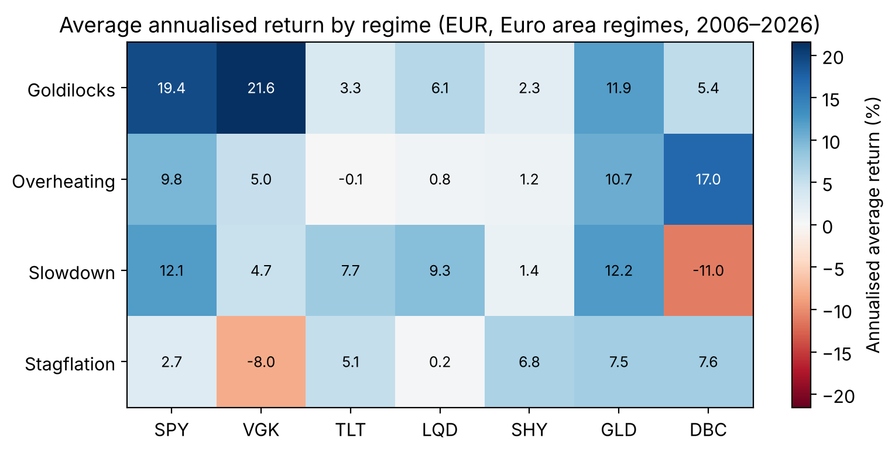
Figure 1. Average annualised returns by regime.

5. Backtest design
The strategy is tested from the perspective of a euro investor holding seven US-listed ETFs, with all returns converted to euros at month-end exchange rates. It starts from a neutral portfolio of 45% equities, 40% bonds and 15% real assets, and each month tilts it according to the Euro area regime (Table 2). The tilts were set in advance from economic reasoning rather than estimated from the data. In Goldilocks, rising profits and low rates favour equities over cash and gold. In Overheating, strong demand favours commodities, while rising policy rates hurt long bonds and credit. In Slowdown, falling rates favour long bonds and gold, and dollar cash tends to gain as the dollar strengthens. In Stagflation, falling profits and rising rates hurt both equities and long bonds, favouring cash, gold and commodities. Tilts of 5 to 10 percentage points sum to zero in every regime, so the portfolio is always fully invested, and no weight falls below zero.
Each month, the lagged regime signal (one month for the Euro area, two months for the US version) selects the target weights. Returns are measured from month-end to month-end, so a one-month lag assumes that each month's Euro area regime is acted on at about the time its last input, the flash HICP estimate, is published around the turn of the month. With a two-month lag, which removes any doubt about timing, the strategy returned 8.08% a year against 8.11%, so the result does not depend on this assumption. The historical series contains final inflation figures, whereas in real time only the flash estimate was available for the latest month. Trading costs of 0.1% are charged on the total value traded, measured as the sum of absolute changes in weights. The strategy is compared with two benchmarks: the neutral portfolio, which holds the same assets with fixed weights and isolates the value of the regime tilts, and a conventional 60/40 portfolio (30% US equities, 30% European equities, 40% long Treasuries). Both benchmarks are rebalanced monthly without costs, which slightly favours them. Performance is measured over March 2006 – September 2026 (247 months) by compound annual return, volatility, return divided by volatility (a simplified Sharpe ratio, without deducting a risk-free rate) and maximum drawdown.

Asset | Neutral | Goldilocks | Overheating | Slowdown | Stagflation
SPY (US equities) | 25 | +10 (35) | +5 (30) | −5 (20) | −10 (15)
VGK (European equities) | 20 | +10 (30) | +5 (25) | −10 (10) | −10 (10)
TLT (long US Treasuries) | 20 | 0 (20) | −10 (10) | +10 (30) | −5 (15)
LQD (investment-grade credit) | 10 | 0 (10) | −10 (0) | 0 (10) | 0 (10)
SHY (short US Treasuries) | 10 | −10 (0) | 0 (10) | +5 (15) | +10 (20)
GLD (gold) | 10 | −10 (0) | 0 (10) | +5 (15) | +10 (20)
DBC (commodities) | 5 | 0 (5) | +10 (15) | −5 (0) | +5 (10)
Total | 100 | 0 (100) | 0 (100) | 0 (100) | 0 (100)

Table 2. Neutral weights and regime tilts.
Implementation notes. Turnover is measured as the change in target weights between months and ignores small rebalancing trades caused by price drift, so it slightly understates trading. The bootstrap in Section 7 uses the average monthly return difference multiplied by 12 (1.01 points), which differs slightly from the difference in compound annual returns (1.04 points). The missing October 2025 US CPI value was filled by linear interpolation using the November figure, which was published later; this affects only one month of the US version. The lag comparison in Figure 5 uses the common period March 2006 – July 2026, limited by industrial production data, which is why its figures (8.05% and 7.09%) differ slightly from Table 3.

6. Results
Over March 2006 – September 2026, the regime strategy returned 8.11% a year after costs, against 7.07% for the neutral portfolio and 6.99% for 60/40 (Table 3): €100 grew to about €498, against €408 and €402. The strategy was slightly more volatile than the neutral portfolio (8.55% vs 8.02%) but had a better return relative to risk (0.95 vs 0.88) and a smaller maximum drawdown (−13.5% vs −16.3%). Turnover averaged 173% of the portfolio a year, and trading costs reduced the return by about 0.2 percentage points a year.
 | Regime strategy | Neutral | 60/40
Annual return | 8.11% | 7.07% | 6.99%
Volatility | 8.55% | 8.02% | 9.74%
Return / volatility | 0.95 | 0.88 | 0.72
Maximum drawdown | −13.5% | −16.3% | −24.5%
Worst drawdown period | Jan – Mar 2020 | May 2007 – Mar 2009 | May 2007 – Feb 2009
Turnover per year | 173% | — | —
Value of €100 at end | €498 | €408 | €402

Table 3. Performance summary, March 2006 – September 2026 (euro investor, after costs).

Figure 2 shows when the difference arose. The strategy built most of its lead in 2008, when Euro area sentiment fell before the worst of the crisis and the portfolio had already moved towards bonds, gold and cash. Its worst loss came instead in early 2020: the COVID shock was so sudden that markets fell before the data could react, and the strategy turned defensive only as markets recovered. The lower panel also shows that both diversified portfolios lost far less than 60/40 in 2008–2009 (−16.3% for neutral against −24.5%), and again in 2022 (−10.6% against −18.6%).
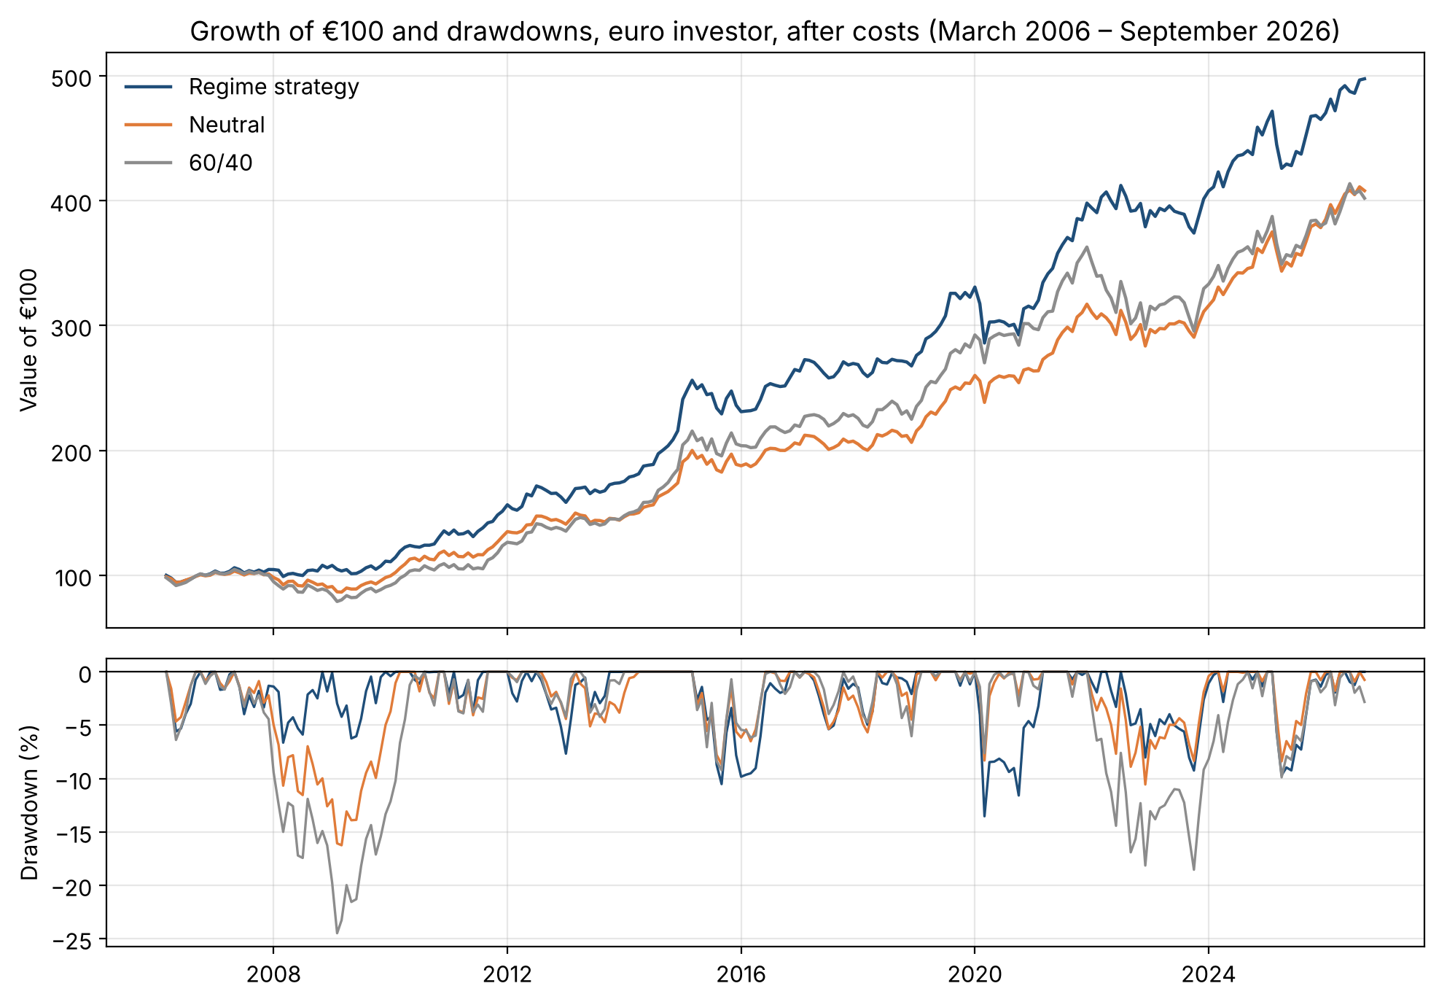
Figure 2. Growth of €100 and drawdowns.
Year by year, the strategy beat the neutral portfolio in 12 of 21 years (Figure 3). The largest gains came in periods when regimes changed gradually: 2008 (+11.9 points), 2013 (+6.3), and 2021–2022 (+6.7 and +5.8), when the model moved into Stagflation the month after Russia's invasion of Ukraine. The largest losses followed sudden shocks, in 2020 (−6.9) and 2009 (−3.8), when the model turned defensive as markets rebounded. From 2023 to 2026 the strategy lagged in four consecutive years: growth and inflation stayed close to their 12-month averages, so the regime switched often on small, uninformative moves.
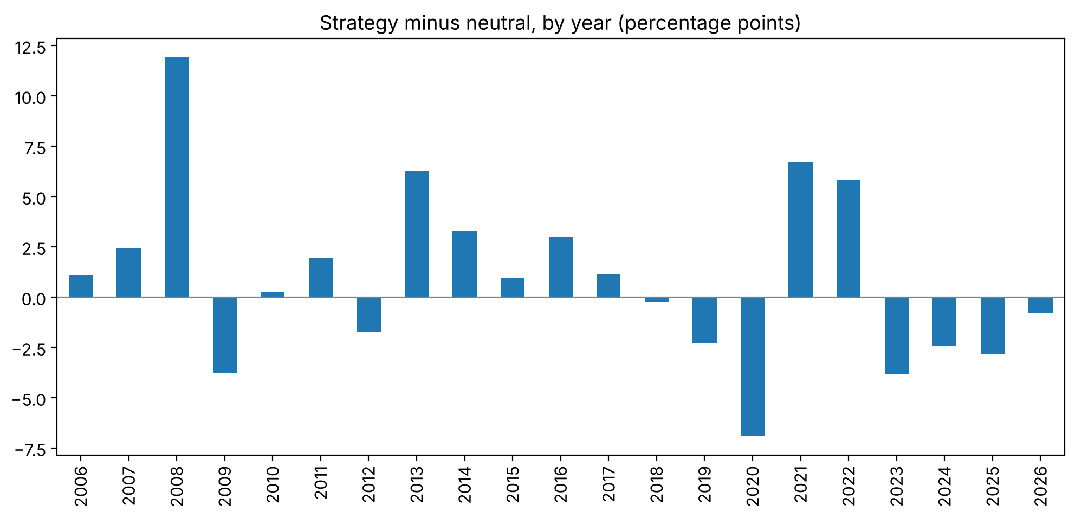
Figure 3. Regime strategy minus neutral portfolio, by year (2026 covers January–September).

7. Robustness
The tests in Table 4 ask whether the 1-point edge is reliable. The first question is whether it could be luck. A block bootstrap of the monthly difference between the strategy and the neutral portfolio (10,000 samples of 12-month blocks, which preserve the persistence of regimes) gives a 95% confidence interval of [−0.9, +3.0] points a year, with 14.6% of samples showing no outperformance (Figure 4), so the edge is not statistically significant. A permutation test asks a different question: whether the timing of the regimes carries information. Shuffling whole regime episodes 1,000 times, while keeping their number and length, the real strategy beats 90.4% of the shuffled versions (p ≈ 0.10). This is weak evidence of information, and it is optimistic, because two growth measures were tested and the better one is reported. The shuffled strategies average 6.88%, close to the neutral portfolio after costs, so the edge comes from timing rather than from a different average allocation.
Test | Strategy | Neutral | Edge (pts)
Base case (EUR, lag 1, 0.1% costs) | 8.11% | 7.07% | +1.04
Trading costs 0.3% | 7.74% | 7.07% | +0.67
2006–2015 | 9.13% | 6.68% | +2.45
2016–2026 | 7.18% | 7.43% | −0.25
Excluding 2008 | 8.47% | 8.06% | +0.41
US investor (USD, US regimes, lag 2) | 7.15% | 6.81% | +0.34
Block bootstrap, 95% interval for the edge |  |  | [−0.94, +2.97]
Permutation test (share of shuffles beaten) |  |  | 90.4% (p = 0.10)
Table 4. Robustness tests: regime strategy vs neutral portfolio.
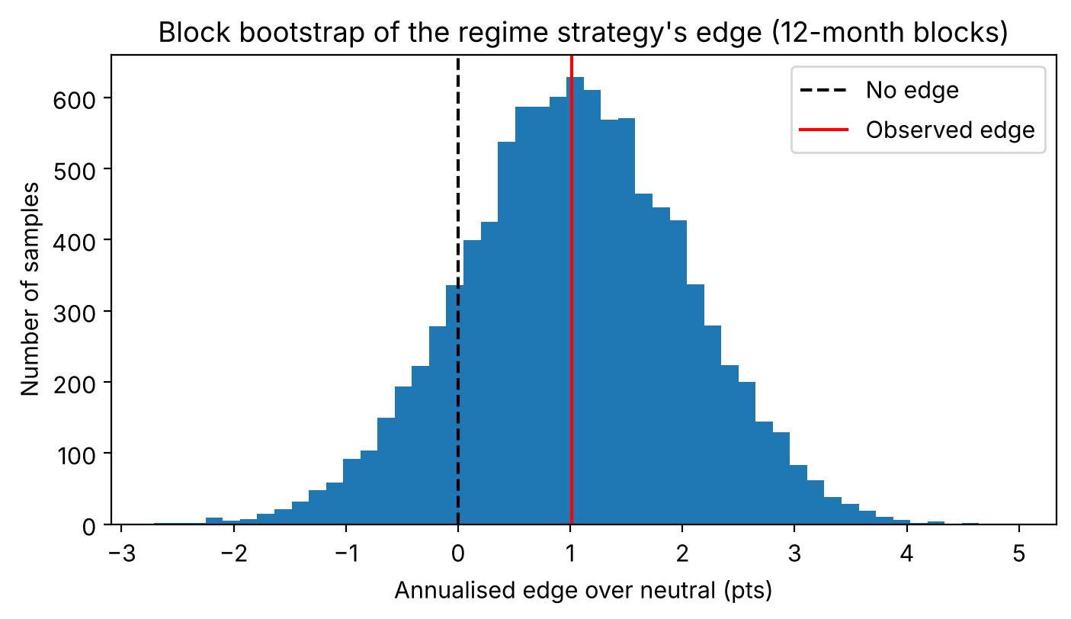
Figure 4. Block bootstrap of the strategy's edge.
The edge is also concentrated in time. It came entirely from 2006–2015 (+2.5 points); since 2016 the strategy has slightly lagged the neutral portfolio. Excluding 2008 alone reduces the edge to 0.4 points, and the neutral portfolio then has the better return relative to risk (1.03 vs 0.99). For a US investor using US regimes and dollar returns, the edge shrinks to 0.3 points and appears in the opposite half of the sample, which suggests that its timing depends on the particular episodes in the sample rather than on a stable relationship.
Two implementation choices matter less than expected. Trading costs are not the constraint: the edge would only disappear at around 0.65% per unit traded, several times the cost of trading liquid ETFs. The growth measure matters through timeliness rather than quality (Figure 5). At the same lag, industrial production performs as well as the ESI, or slightly better at short lags, but its value falls quickly as the lag grows, and at its realistic lag of three months it barely beats the neutral portfolio (7.33% vs 7.09%). The ESI holds its value for lags of one to three months, so at its realistic lag of one month it returns 8.05%.
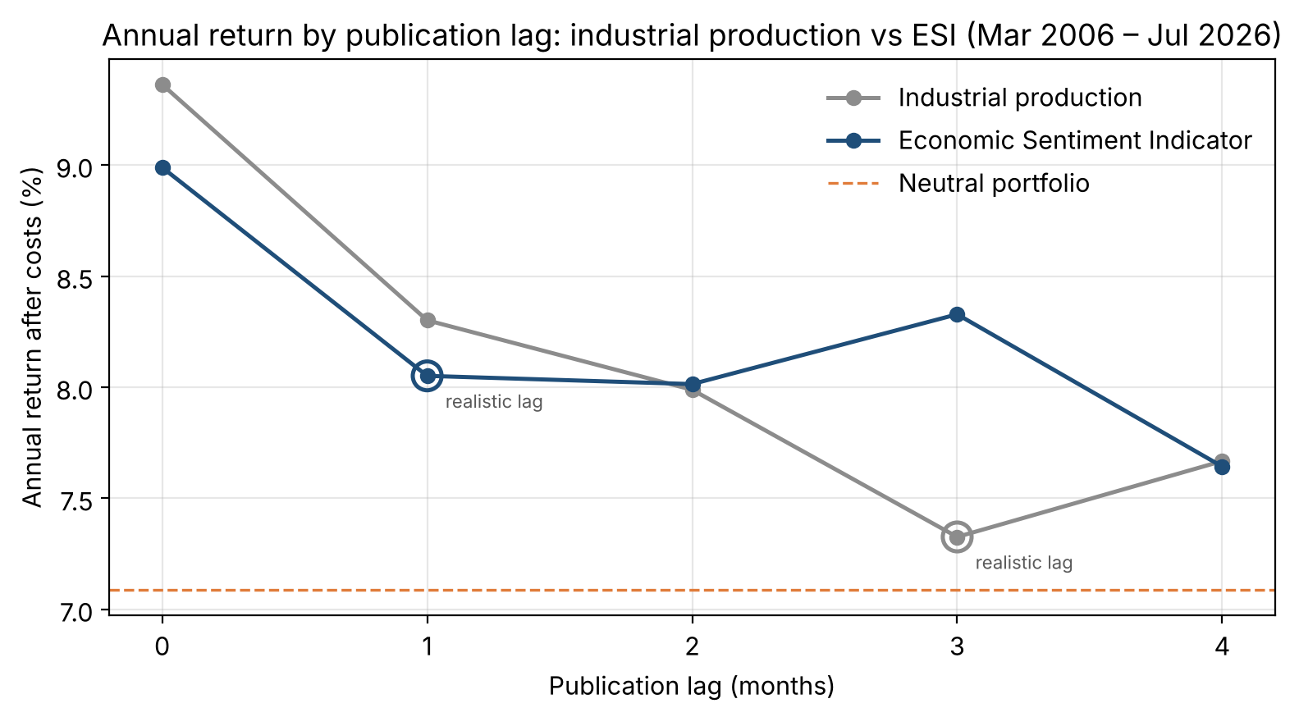
Figure 5. Annual return by publication lag: industrial production vs ESI.
The advantage of the neutral portfolio over 60/40 also needs a closer look, because the two differ in more than diversification: the neutral portfolio holds 45% in equities rather than 60%, and part of its bond allocation is in short-term Treasuries and credit rather than long Treasuries. Compared with a portfolio holding the same 45% in equities and 55% in bonds (long and short Treasuries and credit) but no gold or commodities, the neutral portfolio had a similar worst loss (−16.3% vs −16.4%) but a higher return relative to risk (0.88 vs 0.70), with most of the difference after 2016 (0.96 vs 0.65). Most of its smaller drawdown therefore reflects its lower equity share and shorter bond duration, while gold and commodities improved its risk-adjusted return, especially around 2022.
Finally, the hedging value of bonds has an important exception. The correlation between European equities and long US Treasuries in euros is negative over the sample (−0.23) and in every regime except Goldilocks, so bonds usually hedge equities. In 2022, however, an inflation shock, the correlation turned positive (+0.34) and both fell together. That year the regime tilts added 5.8 points over the neutral portfolio, by moving away from long bonds.

8. Current positioning
Notebook 04 applies the model to the latest data, as of 3 October 2026. With the same publication lags as the backtest, the October portfolio is set by September data for the Euro area and August data for the US, and both regions are classified as Overheating. Figure 6 shows how clearly. Through 2025 the Euro area stayed close to the centre of the chart, with sentiment and inflation near their 12-month averages, which explains the frequent regime switches of recent years. In spring 2026 inflation rose while sentiment fell, a period of Stagflation, and from July sentiment recovered. By September both were well above their averages: the ESI by 1.1 points and inflation, at 3.8%, by 1.2 percentage points, the largest inflation deviation of the past two years. The US signal is much weaker, with growth and inflation only 0.1 and 0.2 points above their averages, so it could change with the next data release. The euro-investor strategy follows the Euro area signal: it moves 20 percentage points out of long Treasuries and investment-grade credit into commodities (+10) and equities (+5 each for US and European). Given the results in Section 7, this should be read as a modest tilt to a diversified portfolio, not a strong market call.
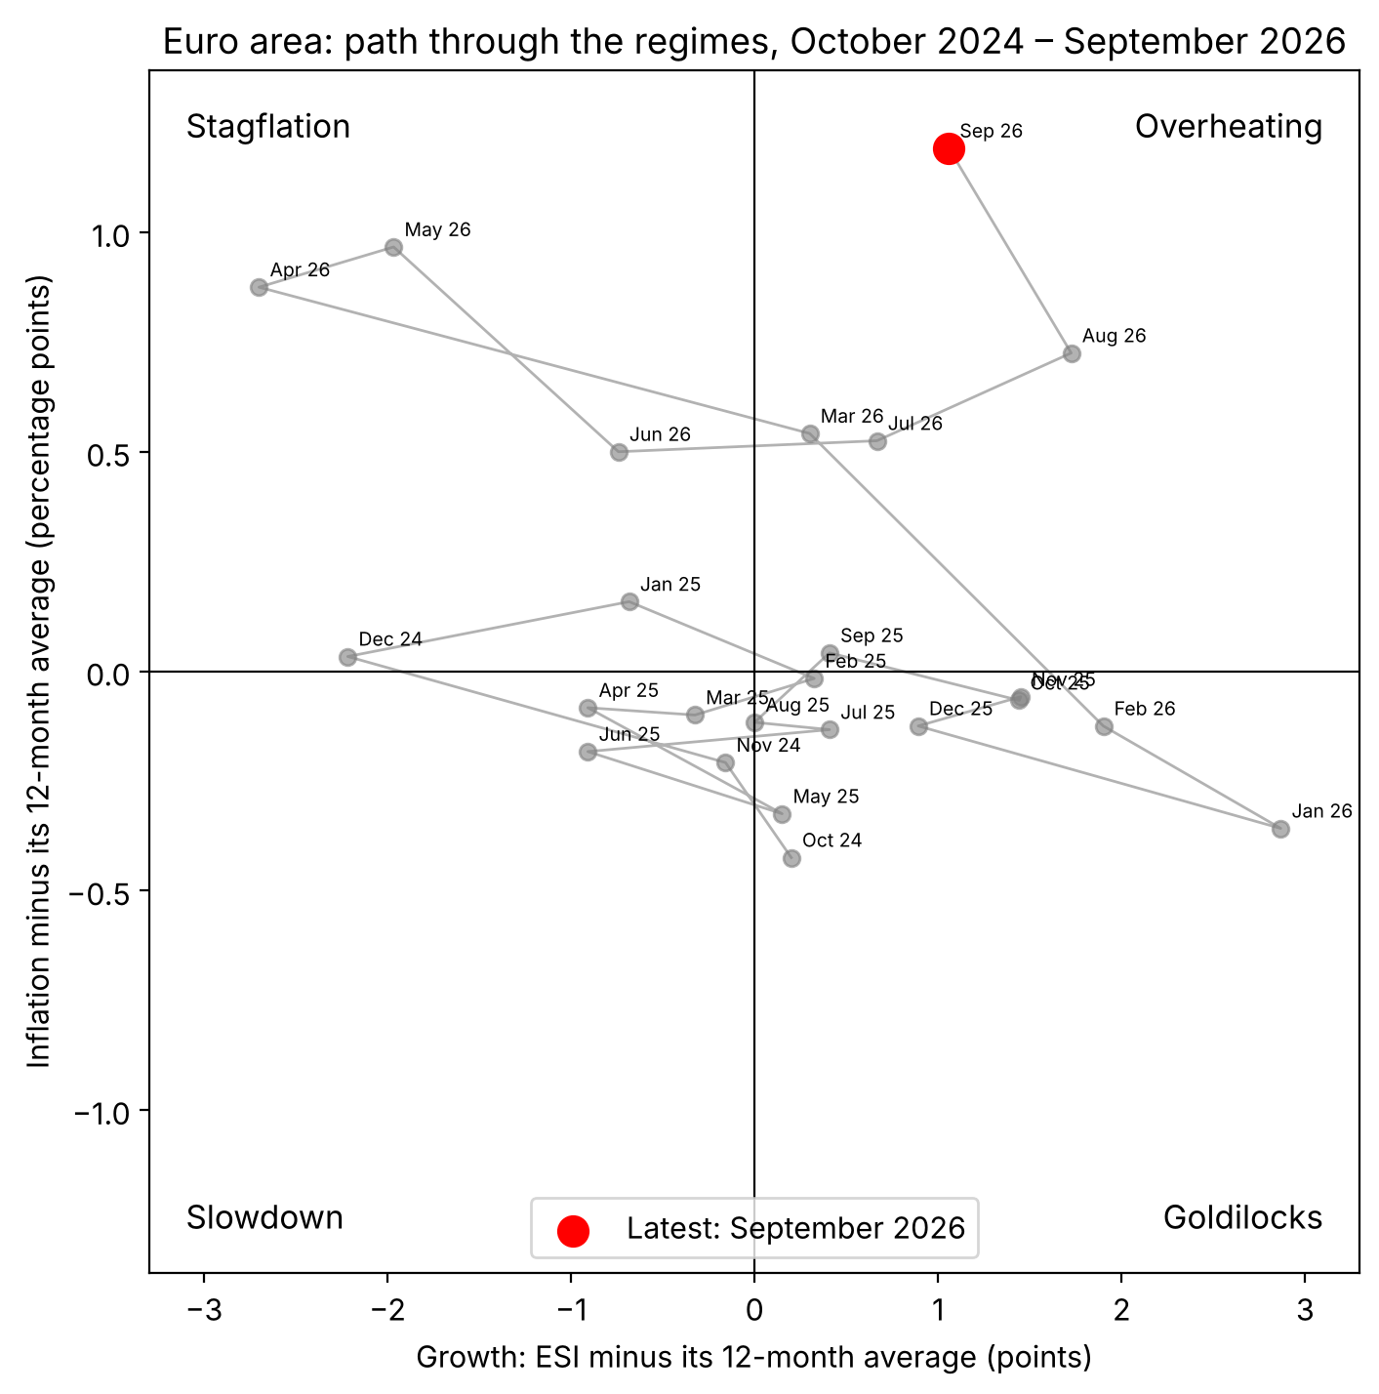
Figure 6. Euro area path through the regimes.

9. Limitations and future work
The results are subject to several limitations. First, the sample is short: it starts in 2006, when the youngest ETF began trading, so it excludes the 2000–2002 bear market, and much of the edge depends on a single episode, 2008. Second, the backtest uses today's revised data rather than the figures available at the time, and the latest Euro area inflation figure is a flash estimate that can be revised. Third, monthly economic data reacts after markets in sudden crises, as in 2020, so the strategy can turn defensive just as markets recover. Fourth, for a euro investor the short US Treasury fund is dollar cash, so tilts into it are partly currency positions. Fifth, the return-to-volatility ratio ignores the risk-free rate, and the benchmarks are rebalanced without costs. Finally, two growth measures and several lags were examined, and modelling choices were made with the full history in view, so the reported p-value does not fully account for multiple testing and the comparison of subperiods is not a true out-of-sample test.
Several extensions follow from these limitations. Real-time (vintage) data, available from ALFRED for the US and the ECB's real-time database for the Euro area, would remove the effect of revisions. US industrial production could be replaced by a timely survey measure such as the ISM manufacturing index, as was done with the ESI for the Euro area. A threshold rule, switching regime only when a series moves clearly away from its average, could reduce the switching seen in 2023–2026, provided the threshold is fixed in advance rather than chosen from backtest results. Regime-based weights could be estimated with a walk-forward method and shrunk towards the neutral portfolio, instead of using fixed tilts. Finally, similarity-based regimes (Mulliner et al., 2026) and a test of whether US regimes lead Euro area regimes are natural next steps.

10. Conclusion
With realistic publication lags, macro regimes can be identified soon enough to act on, but the advantage they give a portfolio is small and unreliable. With publication lags imposed and after trading costs, a euro investor tilting a diversified portfolio by Euro area regime would have earned about 1 percentage point a year more than a static neutral portfolio over 2006–2026. This edge is not statistically significant, comes mostly from 2008 and disappears in the second half of the sample. The choice of growth measure mattered through timeliness: survey data published within the month kept its value after a delay, while industrial production did not. The more robust result concerns portfolio construction: a static portfolio of seven asset classes had lower volatility and a much smaller worst loss than a 60/40 portfolio in every test. Most of the smaller loss reflects its lower equity share and shorter bond duration, while gold and commodities improved its return relative to risk, notably around 2022, when stocks and bonds fell together. For an investor, the evidence supports building a well-diversified portfolio first, and treating regime signals as a modest, low-conviction adjustment rather than the basis of the strategy.

References
Ang, A., & Timmermann, A. (2012). Regime changes and financial markets. Annual Review of Financial Economics, 4, 313–337.
Bailey, D. H., & López de Prado, M. (2014). The deflated Sharpe ratio: Correcting for selection bias, backtest overfitting and non-normality. Journal of Portfolio Management, 40(5), 94–107.
Blitz, D., & van Vliet, P. (2011). Dynamic strategic asset allocation: Risk and return across the business cycle. Journal of Asset Management, 12(5), 360–375. https://doi.org/10.1057/jam.2011.12
Greetham, T., & Hartnett, M. (2004). The investment clock. Merrill Lynch.
Harvey, C. R., & Liu, Y. (2015). Backtesting. Journal of Portfolio Management, 42(1), 13–28.
Ilmanen, A., Maloney, T., & Ross, A. (2014). Exploring macroeconomic sensitivities: How investments respond to different economic environments. Journal of Portfolio Management, 40(3), 87–99.
Kritzman, M., Page, S., & Turkington, D. (2012). Regime shifts: Implications for dynamic strategies. Financial Analysts Journal, 68(3), 22–39.
Mulliner, A., Harvey, C. R., Xia, C., Fang, E., & Van Hemert, O. (2026). Regimes. Journal of Portfolio Management, 52(4). https://doi.org/10.3905/jpm.2025.1.798

