**Project graphic**

**INTRUDER ALERT**

David Cotter W20062924

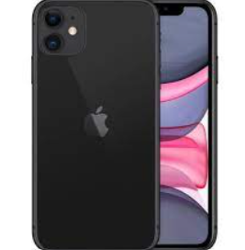

Rpi sends the picture of the person to firebase/glitch and Blynk/phone

Camera takes picture of the person

Motion Sensor to detect person entering the room