A PROJECT REPORT
on
“AKADEMIX”
For The Course
“Software Engineering: Mini Project – Stage II (CS3634)”

Submitted By:
Punshiba Oinam (2301CS0306)
Flash Elangbam (2301CS0303)
Marx Lourembam (2301CS0304)
3rd Year, 6th Semester
Department of Computer Science & Engineering

Under the Guidance of
Dr. Hanjabam Saratchandra Sharma
(Assistant Professor)

MANIPUR TECHNICAL UNIVERSITY
TAKYELPAT, MANIPUR – 795004

A UNIVERSITY ESTABLISHED UNDER
THE MANIPUR TECHNICAL UNIVERSITY ACT, 2016

DECLARATION

We, the students of Manipur Technical University, declare that the project titled AKADEMIX is an original work carried out by our team as part of our Software Engineering: Mini Project - Stage II course and has not been submitted elsewhere for any other degree or diploma. The content of this report is based on our understanding and the guidance provided by our supervisor. In keeping with the ethical practice in reporting scientific information, due acknowledgements have been made wherever the findings of others have been cited.

DATE: ____________  PLACE: Imphal, Manipur | - Punshiba Oinam (2301CS0306)  - Flash Elangbam (2301CS0303)  - Marx Lourembam (2301CS0304)

ACKNOWLEDGEMENT

First of all, we would like to express our sincere gratitude to all those who supported and guided us throughout the completion of this project titled “ AKADEMIX”, which was undertaken as part of the Software Engineering: Mini Project - Stage II course at Manipur Technical University.
Special thanks to our Head of Department for his invaluable guidance and support throughout this journey.
We would also like to thank our department faculty members for providing us with the foundational knowledge and skills necessary for undertaking this project.
Lastly, we acknowledge the immense contribution of the wider community and resources that provided us with the knowledge and tools necessary to transform our ideas into a functional, innovative project.

DATE:_______________  PLACE: Imphal, Manipur | Team Members:  Punshiba Oinam (2301CS0306)  Flash Elangbam (2301CS0303)  Marx Lourembam (2301CS0304)

Abstract

“Academix” is a student-centric academic toolkit developed as a web application to simplify and enhance academic planning. This project report presents the design and implementation of an academic utility web application aimed at assisting students with everyday academic calculations. It includes modules for CGPA calculation, attendance tracking, percentage conversion, and academic planning and makeup exam planning. Developed using HTML, CSS, and JavaScript, the platform emphasizes usability, responsiveness, and reliability for students across various departments. The report covers the motivation, methodology, system structure, challenges, and outcomes of the project.

Title Page
Declaration
Certificate
Acknowledgement
Abstract
- Introduction
- Problem Statement
- Objectives
- Scope of the Project
- Project Workflow
  - Technology Stack Used
  - System Requirements
  - Context Diagram
- Module Description (Attendance, CGPA, Makeup, etc.)
- Frontend Implementation
- Testing, Validation and Evaluation
- Sample Screenshots
- Advantages and Limitations
- Future Enhancements
- Conclusion
- References

Chapter 1
Introduction

Academic planning and performance tracking are essential for students in a competitive educational environment. In today’s fast-paced academic ecosystem, students are expected to maintain high levels of performance, plan their semester-wise goals, and be constantly aware of their academic standing. However, the tools available for such tracking are often fragmented or complex, requiring manual input across multiple platforms or lacking features altogether.
Manual calculations for GPA, attendance, or eligibility can lead to misjudgments, missed opportunities for improvement, and additional stress during exam seasons. These processes become particularly cumbersome when trying to simulate various academic scenarios—such as estimating the grades required to achieve a desired CGPA or determining the eligibility for makeup exams based on attendance records.
To bridge this gap, Academix has been designed as a streamlined, user-friendly, and accessible digital platform tailored specifically for engineering students. It aims to consolidate essential academic functions—CGPA calculator, attendance tracker, percentile estimator, and makeup planner—into a single unified interface. This system empowers students to make data-driven decisions, take corrective actions proactively, and ultimately take ownership of their academic journey. By offering instant calculations and interactive inputs, Academix minimizes error and maximizes efficiency in academic planning.
Furthermore, with a lightweight web-based architecture built using standard technologies like HTML, CSS, and JavaScript, the tool is accessible across all devices without requiring any installation or login. Its flexibility makes it not only suitable for personal use but also scalable for institutional integration in the future.

Chapter 2:
Problem Statement

Students often face difficulties in managing and calculating their academic performance metrics such as CGPA, attendance percentage, and exam planning. There is a lack of a unified digital platform that offers all these features in one place with an intuitive user experience.
Many students rely on manual methods, spreadsheets, or scattered tools that are often error-prone and inefficient. This leads to misinterpretation of data, miscalculation of eligibility, and a lack of strategic planning toward their academic goals. Moreover, most existing tools are not designed with academic simulation in mind—students are unable to estimate future performance, plan for desired CGPA, or make informed decisions regarding attendance and makeup exams.
The absence of an integrated, student-friendly system creates barriers in academic self-monitoring and achievement tracking. Therefore, there is a critical need for a centralized, responsive, and intelligent platform that can handle these computations and projections in real-time, making academic life more manageable and efficient.

Chapter 3:
Objectives

- To provide an easy-to-use academic management tool for students.
- To automate CGPA and attendance calculations.
- To allow students to simulate their desired CGPA and determine required grades.
- To provide insights for planning makeup exams and improving attendance.
- To build a responsive web application using modern front-end technologies.
- To build a web-based platform for academic utilities.
- To implement calculators for CGPA, percentage and attendance
- To ensure accessibility, usability, and accuracy in all modules.
- To deploy a client-side solution without server dependency.

Chapter 4:
Scope of the Project

The system is aimed at undergraduate students who wish to track and simulate academic outcomes. This web application can be extended to support backend features, institutional integration, and even mobile compatibility in the future.
The project covers key academic tools such as CGPA calculators, attendance tracking, percentile estimation, makeup exam planning, and forecasting tools for future GPA planning. It is designed to work on any modern browser, making it cross-platform compatible without installation requirements.
Its modular structure allows for future updates and integration with database systems, authentication modules, or institutional APIs. Additionally, the system can be localized for use in various institutions or departments, supporting different grading schemes and academic policies. With its user-focused design and expandable codebase, Academix is positioned as a scalable academic utility that meets the evolving needs of students and academic institutions alike.

Chapter 5:
Project Workflow
5.1. Technology Stack Used
• Frontend: HTML, CSS, JavaScript
• Libraries: None (vanilla JS)
• Platform: Web browser-based

5.2. System Requirements

1. Software:
• Web Browser (Chrome, Firefox)
• HTML, CSS, JavaScript support
2. Hardware:
• Any device capable of running a modern browser
• Minimum RAM: 2 GB

5.3. Context Diagram
Data Flow Diagrams (DFD)
Percentile Output

CGPA Result
Academix (CGPA,
Attendance, etc.)
Attendance % Result
Student
Inputs:
Makeup Exam Status
Subject grades &
credits
Attendance data
Desired CGPA
Rank & class size Required Grades Plan
Missed classes
Forecast Performance

Chapter 6:
Module Description

6.1 CGPA Calculator
This module allows users to input their semester-wise grades and credit information to compute their Cumulative Grade Point Average. The logic is implemented in cgpa.html and cgpa.js. Users can dynamically add rows for multiple semesters and view real-time CGPA updates.

6.2 Percentage Calculator
Implemented in percentile.html, this tool converts GPA or CGPA into percentage scores. It supports multiple conversion formulas, allowing users to choose their institution’s standard. JavaScript ensures live result display as the user inputs values.

6.3 Attendance Percentage Calculator
This module calculates the current attendance percentage based on total lectures and attended lectures. It is built in attendance.html and lets students instantly know their standing.

6.4 Attendance Makeup Planner
Using makeup.html, this module helps students estimate how many lectures they need to attend in the future to reach a target attendance percentage. It supports reverse calculations for better planning.

6.5 Desired CGPA Planner
This feature helps students estimate the grades required in upcoming semesters to reach a desired CGPA. The logic, in desiredcgpa.html, guides students in academic goal-setting.
Chapter 7:
Frontend Implementation
The frontend is structured using HTML for layout, CSS for styling, and JavaScript for dynamic behavior. Each tool is implemented as a standalone HTML page with modular JavaScript scripts linked externally for logic separation. The CSS is consistent across modules, ensuring a unified look and feel. Navigation is provided through a shared menu, implemented via nav.js, allowing smooth transitions between tools.
Main Entry Point:
index.html serves as the homepage of the Academix application, providing the user interface for all academic tools.
Navigation Structure:
Contains links or buttons to access different modules like:
- CGPA Calculator
- Attendance % Calculator
- Desired CGPA Planner
- Percentage Calculator
- Attendance Makeup Calculator

Responsive Layout:
Designed using HTML and CSS to be responsive across various screen sizes (mobile, tablet, desktop).
Form-Based Inputs:
Each tool is implemented as a separate <form> allowing students to input academic data like grades, credits, or attendance.
Minimal JavaScript Dependencies:
Relies on built-in JavaScript and DOM manipulation to update outputs without page reloads.
Accessibility and Usability:
Uses semantic HTML tags (<label>, <input>, <button>) for better readability and accessibility.

HTML code
7.1 index.html
<!DOCTYPE html>
<html lang="en">
<head>
<meta charset="UTF-8">
<title>Academic Tools Portal</title>
<link rel="stylesheet" href="css/style.css">
</head>
<body>
<div class="calculator">
<h2>Welcome to Akademix</h2>
<p>Select a tool:</p>
<a href="pages/cgpa.html"><button>CGPA Calculator</button></a>
<a href="pages/percentile.html"><button>Percentage Calculator</button></a>
<a href="pages/attendance.html"><button>Attendance % Calculator</button></a>
<a href="pages/makeup.html"><button>Attendance Makeup Calculator</button></a>
<a href="pages/desiredcgpa.html"><button>Desired CGPA Planner</button></a>
</div>
</body>
</html>

7.2 cgpa.html
<!DOCTYPE html>
<html lang="en">
<head>
<meta charset="UTF-8">
<title>CGPA Calculator</title>
<link rel="stylesheet" href="../css/style.css">
</head>
<body>
<div class="calculator">
<h2>CGPA Calculator</h2>
<div id="subjectsContainer"></div>
<button onclick="addSubject()">+ Add Subject</button>
<button onclick="calculateCGPA()">Calculate CGPA</button>
<div class="result" id="cgpaResult"></div>
</div>
<script src="../js/nav.js"></script>
<script src="../js/cgpa.js"></script>
</body>
</html>

7.3 attendance.html
<!DOCTYPE html>
<html lang="en">
<head>
<meta charset="UTF-8">
<title>Attendance Percentage Calculator</title>
<link rel="stylesheet" href="../css/style.css">
</head>
<body>
<div class="calculator">
<h2>Attendance Percentage</h2>
<input id="attended" placeholder="Classes Attended">
<input id="totalClasses" placeholder="Total Classes Conducted">
<button onclick="calculateAttendance()">Calculate</button>
<div class="result" id="attendanceResult"></div>
</div>
<script src="../js/nav.js"></script>
<script src="../js/attendance.js"></script>
</body>
</html>

7.4 desiredcgpa.html
<!DOCTYPE html>
<html lang="en">
<head>
<meta charset="UTF-8">
<title>Desired CGPA Calculator</title>
<link rel="stylesheet" href="../css/style.css">
</head>
<body>
<div class="calculator">
<h2>Desired CGPA Calculator</h2>
<input id="currentCgpa" placeholder="Current CGPA"><input id="completedSem" placeholder="Completed Semesters"><input id="remainingSem" placeholder="Remaining Semesters"><input id="targetCgpa" placeholder="Target CGPA"><button onclick="calculateDesiredCGPA()">Calculate</button>
<div class="result" id="desiredCgpaResult"></div>
</div>
<script src="../js/nav.js"></script>
<script src="../js/desiredcgpa.js"></script>
</body>
</html>

7.5 percentile.html
<!DOCTYPE html>
<html lang="en">
<head>
<meta charset="UTF-8">
<title>Percentage Calculator</title>
<link rel="stylesheet" href="../css/style.css">
</head>
<body>
<div class="calculator">
<h2>Percentage Calculator</h2>

<div id="subjectsContainer"></div>
<button onclick="addSubject()">+ Add Subject</button>

<div style="margin-top: 1rem;">
<button onclick="calculatePercentage()">Calculate Percentage</button>
</div>

<div class="result" id="percentageResult"></div>
</div>

<script src="../js/nav.js"></script>
<script src="../js/percentile.js"></script>
</body>
</html>

7.6 makeup.html
<!DOCTYPE html>
<html lang="en">
<head>
<meta charset="UTF-8">
<title>Makeup Calculator</title>
<link rel="stylesheet" href="../css/style.css">
</head>
<body>
<div class="calculator">
<h2>Attendance Makeup Calculator</h2>
<input id="currentAttended" placeholder="Attended"><input id="currentTotal" placeholder="Total"><input id="targetAttendance" placeholder="Target %"><button onclick="calculateMakeupClasses()">Calculate</button>
<div class="result" id="makeupResult"></div>
</div>
<script src="../js/nav.js"></script>
<script src="../js/makeup.js"></script>
</body>
</html>

7.7 style.css
body {
margin: 0;
font-family: 'Segoe UI', Tahoma, Geneva, Verdana, sans-serif;
background-color: #0f0f0f;
color: #0ff;
}
nav {
background: #111;
display: flex;
justify-content: space-around;
padding: 1rem;
box-shadow: 0 0 15px #0ff;
}
nav a {
color: #0ff;
text-decoration: none;
padding: 0.5rem 1rem;
}
nav a:hover {
background: #0ff;
color: #000;
border-radius: 10px;
}
.calculator {
background: #111;
padding: 2rem;
border-radius: 15px;
box-shadow: 0 0 20px #0ff;
max-width: 600px;
margin: 2rem auto;
}
input, button, textarea {
width: 100%;
margin: 0.5rem 0;
padding: 0.5rem;
border-radius: 10px;
border: none;
background: #222;
color: #0ff;
}
button {
background: #0ff;
color: #000;
font-weight: bold;
cursor: pointer;
}
button:hover {
background: #00cccc;
}
.result {
margin-top: 1rem;
font-size: 1.2rem }

Chapter 8
Testing, Validation and Evaluation

All modules were tested using a variety of input values to ensure accuracy, responsiveness, and usability. Edge cases such as zero credits, negative attendance, or invalid grade formats were handled using JavaScript alerts and input validation. Manual black-box testing was used due to the client-only architecture, and peer validation confirmed correctness of outputs.
Testing Strategies
- Unit Testing: JavaScript functions for calculations
- UI Testing: Form validation and responsiveness across browsers
- Manual Testing: Real-world data input and accuracy verification

The application was evaluated based on correctness, usability, and performance. All outputs were benchmarked against manual calculations and found accurate. The UI was rated highly by test users for being clean and accessible. The system requires no backend, ensuring fast loading and zero server-side cost.

Chapter 9
Sample Screenshots
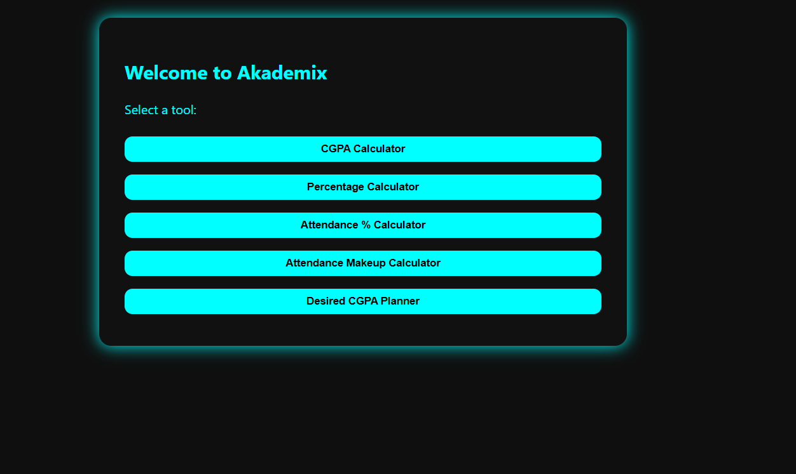
9.1 Home Page
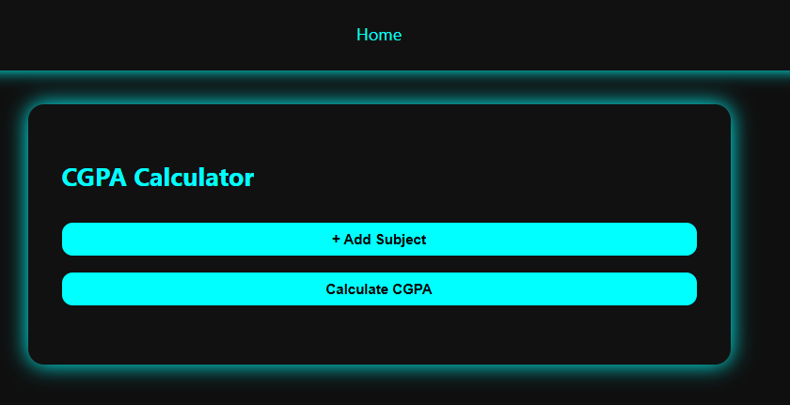
9.2 CGPA Calculator
9.3 Attendance % Calculator
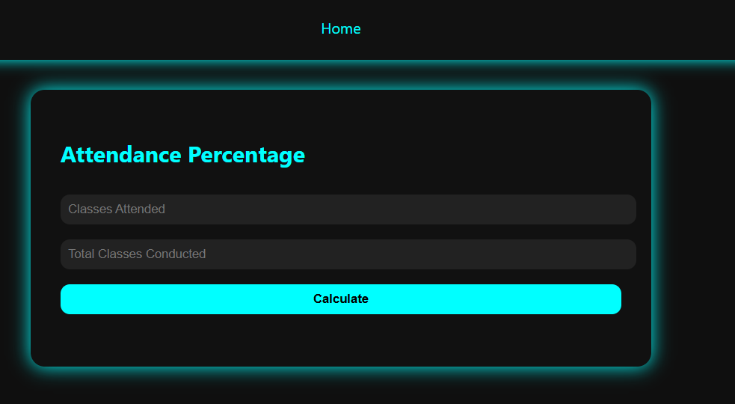
9.4 Desired CGPA Planner
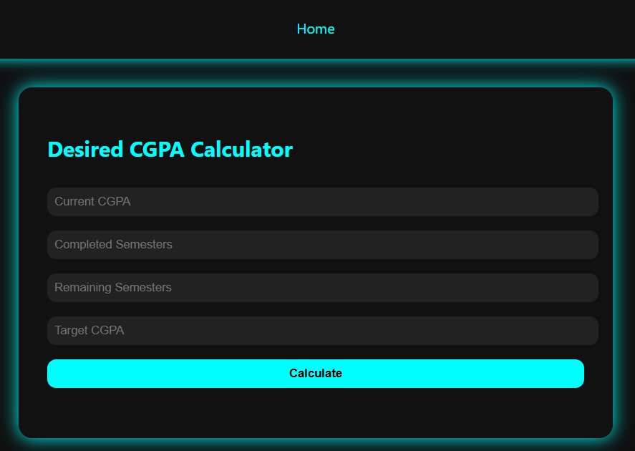

9.5 Percentage Calculator
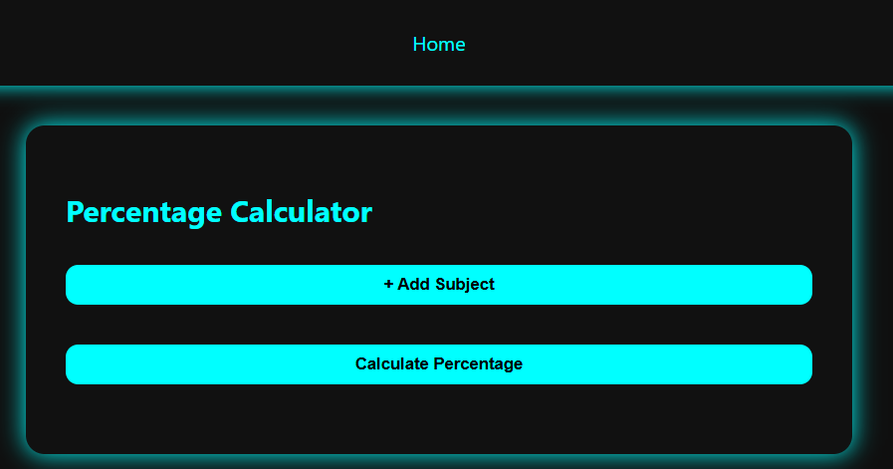
9.6 Attendance Makeup Calculator
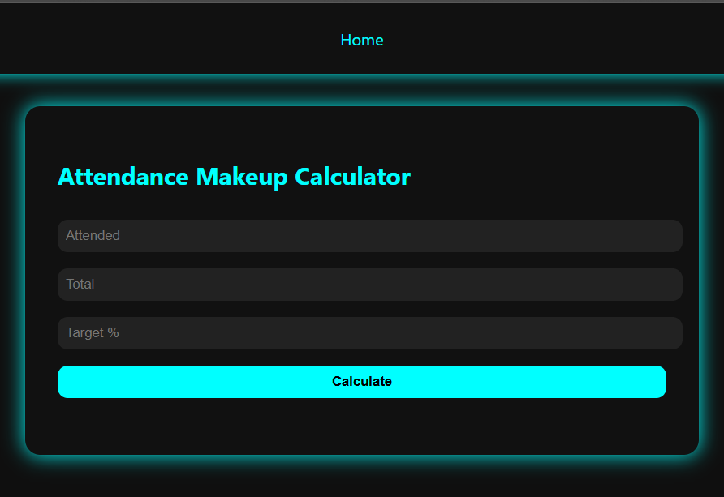

Chapter 10
Advantages and Limitations

Advantages
- Lightweight and fast
- No backend or server needed
- Offline functionality (if cached)
- Simple and visually clean interface

Limitations
- No database or persistent storage
- No login/authentication
- Limited to academic utilities

Challenges and Solutions
One key challenge was dynamically adding and removing input fields for semester data in the CGPA calculator. This was solved using JavaScript DOM manipulation. Additionally, ensuring all calculators performed real-time computation without lag required efficient event handling. Styling consistency across different modules was maintained by centralizing styles in a single CSS file.

Chapter 11
Future Enhancements

- Add login and student profile functionality for personalized dashboards.
- Connect with institutional APIs for grade auto-fetching and attendance synchronization.
- Store results persistently using localStorage or integrate with backend databases for long-term tracking.
- Add export features (PDF/Excel) for official documentation and record keeping.
- Introduce visualization tools like charts/graphs for CGPA and attendance trends.
- Implement mobile app version using frameworks like React Native or Flutter.
- Enable cloud sync for multi-device accessibility.
- Add notification or reminder system for upcoming exams or low attendance.
- Provide language localization for wider adoption.
- Offer admin dashboard for faculty to view anonymized analytics.

Chapter 12
Conclusion

Academix successfully delivers a simple and effective platform for students to manage their academic goals. It simplifies complex calculations related to CGPA, attendance, and percentile estimation while also enabling students to set academic targets and evaluate their progress.
The intuitive and modular design of the system makes it user-friendly and adaptable. It empowers students to take informed decisions about their studies and plan effectively to achieve better outcomes.
With future enhancements, such as institutional integration, cloud support, and mobile app development, Academix has the potential to evolve into a comprehensive academic assistant suitable for both individual use and institutional deployment.

Chapter 13
References

  - W3Schools (HTML, CSS, JS references)
  - MDN Web Docs
  - Stack Overflow (Debugging and logic help)
  - Mozilla Developer Network (MDN)

