Phase II Requirement Meeting Minutes for the Rehabilitation System

System Interface Reference
The following image shows the current session record page. The comparison curve is shown as a single-session walking test. The red curve represents the patient curve, and the blue curve represents the standard curve.
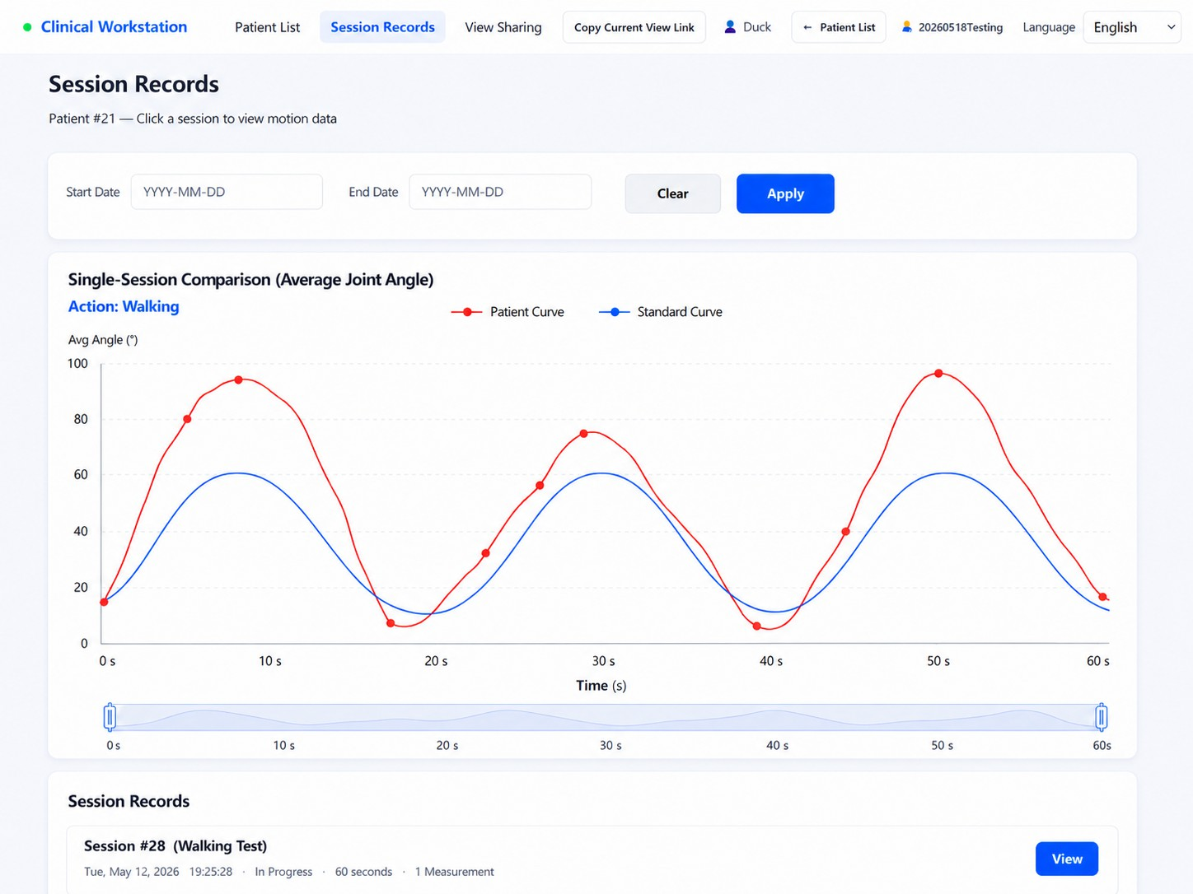
Figure 1: Session Records - Single-Session Comparison for Walking

Current System Issues
- The doctor-side system can currently view all patient data. A doctor-patient binding mechanism is missing.
- The collected motion curves are disorganized and lack standard reference curves.

- The AI recommendation function has not been implemented. The current data volume is insuﬀicient, so AI is not suitable for the present stage.
- Sensor Bluetooth compatibility varies across different mobile phones. A unified doctor-side device is recommended for data acquisition.

Core Requirements Raised by Dr. Yin
- Standard curves: Standard rehabilitation actions should be designed, including squat, walking, and stair climbing. Healthy-person data should be collected as the baseline and displayed against patient curves.
- Doctor-patient binding: Patients must register through a link or QR code provided by the doctor. After registration, the patient is automatically bound to that doctor. Independent registration should not be allowed.
- Unified acquisition device: Sensors should be bound to a single doctor-side device, such as a tablet, to reduce Bluetooth adaptation issues caused by different mobile phones.
- Postponed AI recommendations: Because the current data volume is insuﬀicient, AI recommendations should be postponed. The system should first accumulate enough valid data.
- Doctor assistant AI: A WeChat-based AI assistant may be considered for answering common patient questions, such as clinic hours, appointments, and process explanations. WeChat platform restrictions need to be evaluated.

Standard Action Images
The following three images keep the original visual content unchanged, with the text translated into English.

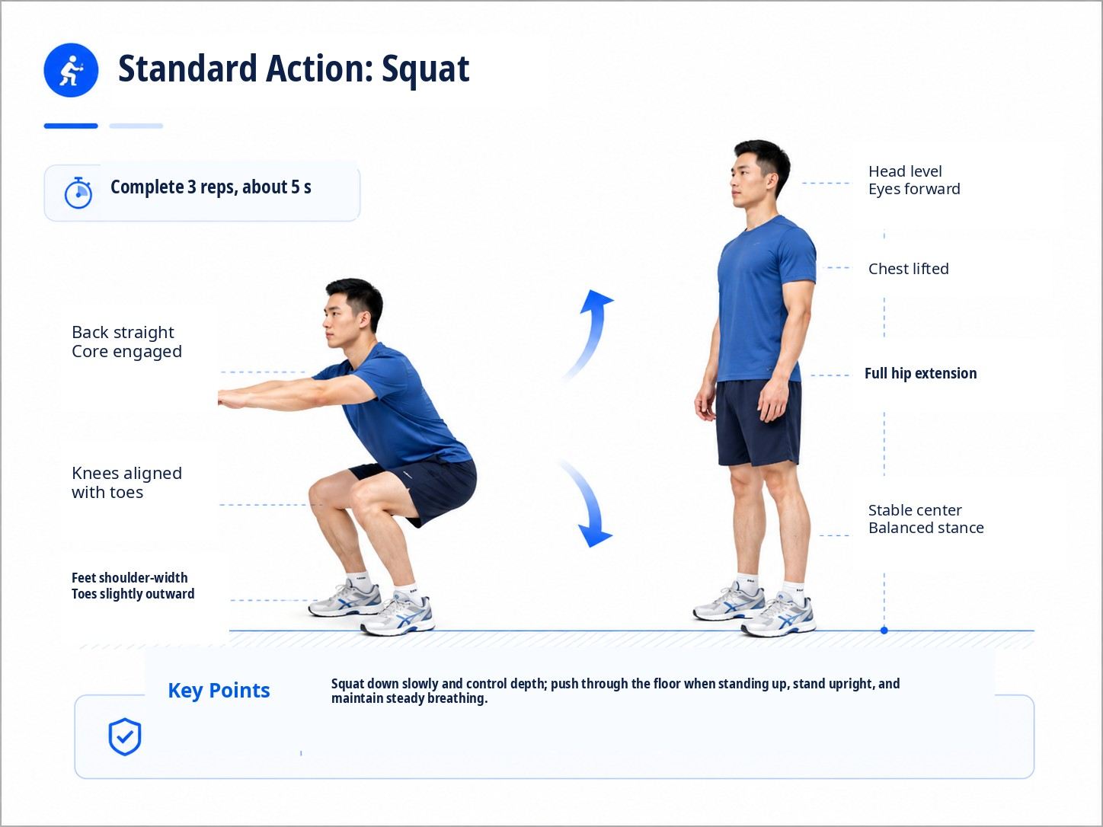
Figure 2: Standard Action - Squat

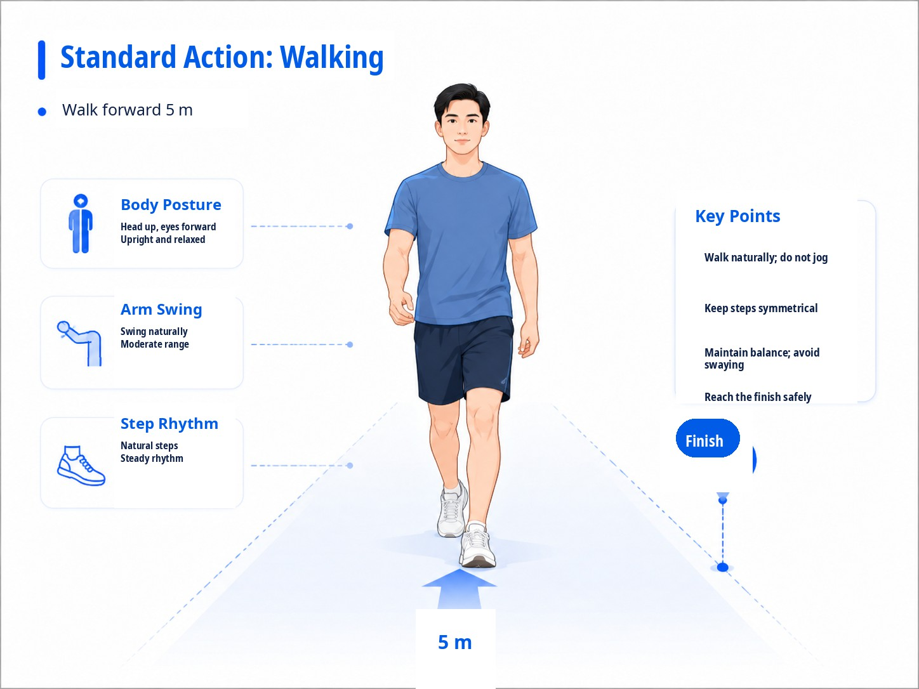
Figure 3: Standard Action - Walking

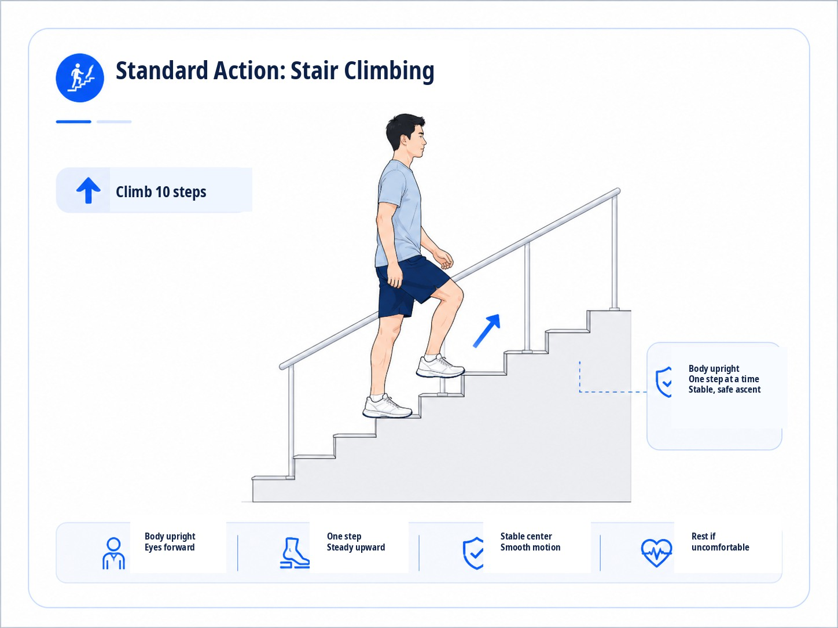
Figure 4: Standard Action - Stair Climbing

Phase II Tasks by Group

M2: Web End for Doctors
    - Add the standard-curve comparison function.
    - Design three standard actions: squat, walking, and stair climbing.
    - Receive generated baseline curves and overlay them with patient curves.
    - Support comparison analysis of amplitude, frequency, width, and other curve features, so doctors can view functional differences more intuitively.
    - Establish the doctor-patient binding mechanism.
    - Allow doctors to generate registration links or QR codes. Patients register through the link and are automatically bound to the doctor.
    - Ensure doctors can only view data from their bound patients.
    - Support action selection and prescription delivery.
    - Allow doctors to select rehabilitation actions from a preset action list of about 10 to 20 actions.
    - Allow doctors to issue instructions including repetitions, sets, and precautions.
    - Allow the patient end to view the prescription and mark it as completed.

M1: Mobile End for Patients
    - Support patient registration and binding.
    - Patients can only register through a link provided by the doctor.
    - After registration, patients are automatically bound to that doctor.
    - Independent registration is not allowed.
    - Display rehabilitation actions issued by the doctor, with teaching videos attached.
    - Allow patients to mark an action as completed.
    - The patient end does not have to use sensors by default. Patients may practice according to the video only.
    - If sensors are used, compatibility with the doctor-side device must be ensured.

S1: Sensor Group
    - Design the standard-action acquisition workflow.
    - Squat: complete 3 consecutive repetitions in about 5 seconds.
    - Walking: walk forward for 5 meters.
    - Stair climbing: climb 10 steps.
    - Collect data from multiple healthy participants and provide it to the AI group for standard-curve fitting.
    - Improve data acquisition quality to ensure smoother and more regular curves.

S2: Data Group
    - Support storage and processing of both standard curves and patient curves.
    - Provide a data export interface for later analysis.
    - Optimize data visualization.
    - Support zooming and dragging to select a time range.
    - Allow direct clicking on a collected session record in the chart to enter the detail page.

V1: AI Group
    - Receive healthy-person curves provided by the S1 group.
    - Fit a standard curve based on healthy-person data.
    - Compare differences between patient curves and standard curves to help doctors analyze patient status.
    - A possible later-stage function is that, after a patient completes a measurement, AI automatically analyzes the difference from the standard curve and suggests possible functional problems and rehabilitation directions.

    - The main purpose is to reduce the doctor’s workload.
    - The group should further consider what capabilities are required for implementation.

V2: Database and Backend Group
    - Support doctor-patient binding logic.
    - Bind the doctor ID when the patient registers.
    - Ensure doctors can only query data from their own patients.
    - Support storage and comparison queries for standard curves.
    - Optimize data loading speed and resolve server-side lag after deployment.

Implementation Priority
- Priority 1: Doctor-patient binding, standard curves, and unified acquisition device.
- Priority 2: Prescription delivery, data visualization, and data export interface.
- Priority 3: AI-based analysis recommendations and the optional WeChat assistant.
The core principle is to solve the data and workflow foundation first, then gradually introduce AI capability. The system should avoid advancing AI functions before the data quality and workflow structure are suﬀiciently stable.

