# CS 340 README Template

## About the Project/Project Title

The goal of this project is to be able get information from a database of adoptable dogs to be able to train for search and rescue. It takes data from the database and allows it to be displayed in a table that is filterable by pre-determined factors

## Motivation

This is being designed to make it easier to find available dogs in animal shelters that may be a good match for search and rescue training.

## Getting Started

To start you will need to start Mongo in a command line interface. You will also need to edit the username, password and port number in the code so that it can login. I have hard coded them to me for now and will add login credentials later. Last you will need to make sure that you have the information uploaded into your database.

## Installation

You will need a python IDE and have Mongo installed to be able to access the database.

## Usage

### This code will load up a database and will display the information in table form for easier reading.

### Code Example

Looking at the button filtering code

### Tests

Unfiltered data loaded

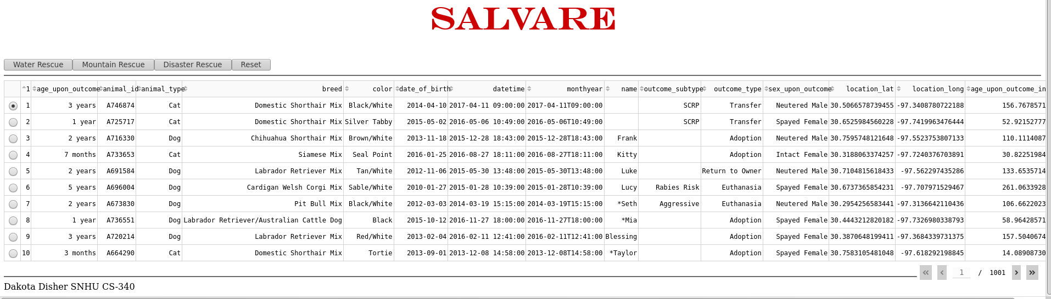

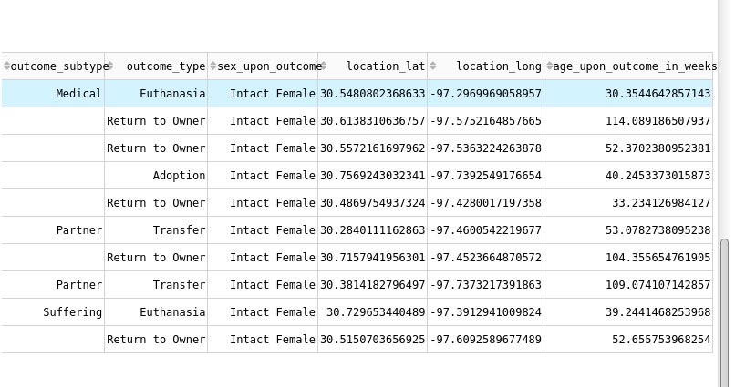

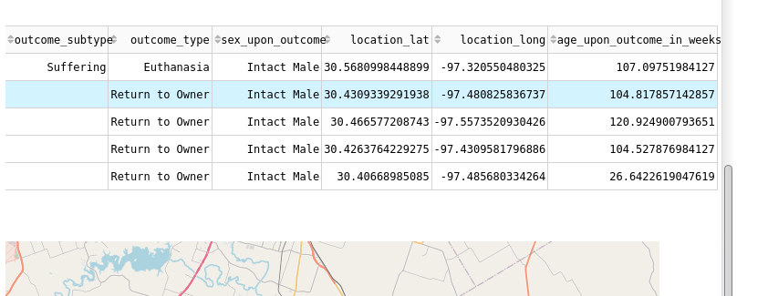

Disaster Rescue Button

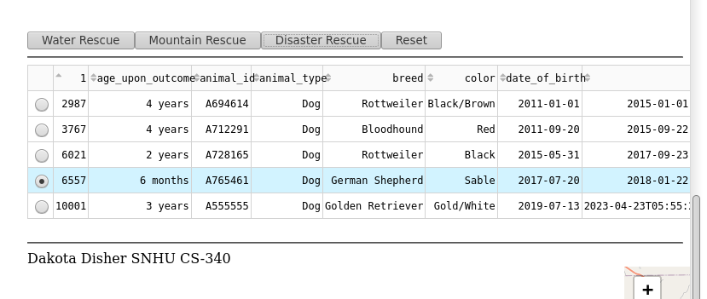

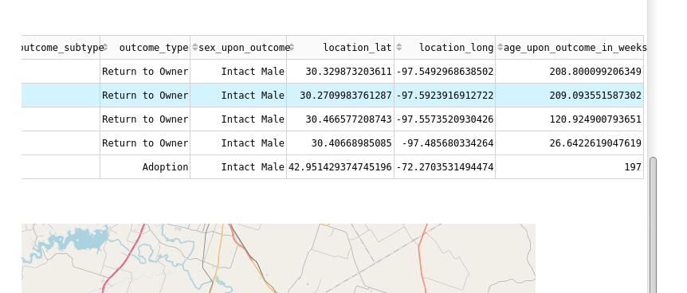

Reset Button

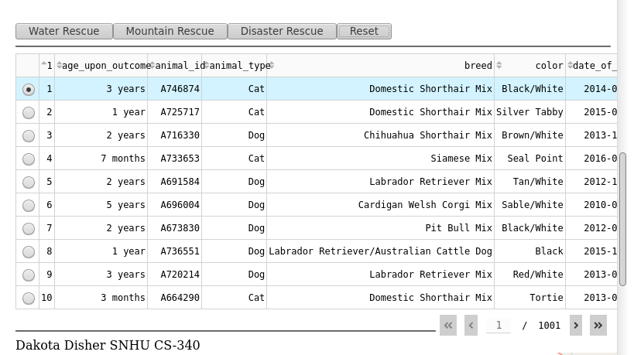

All buttons work to filter data by what the customers wanted.

Map updates after selecting new animal

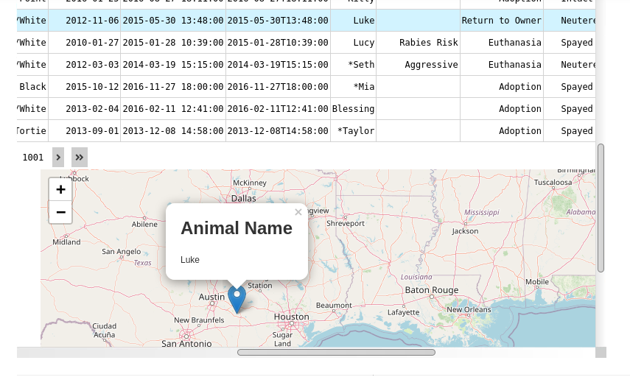

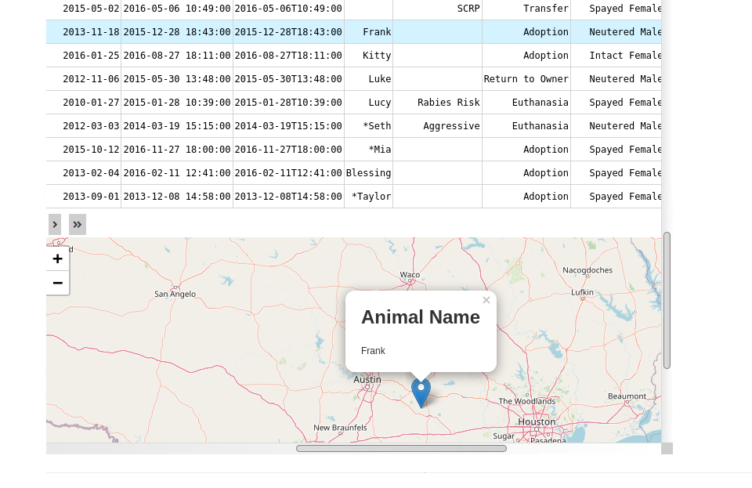

A graph and map are both shown. Graph does not support database data at this time.

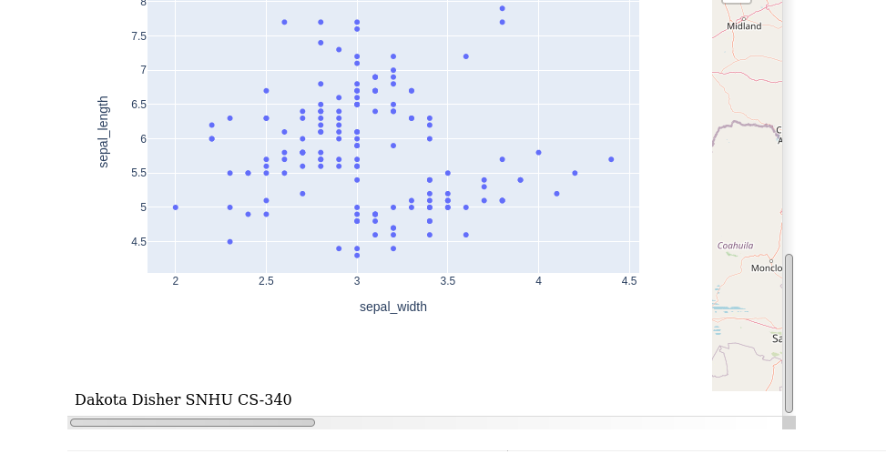

Logo displayed on next page

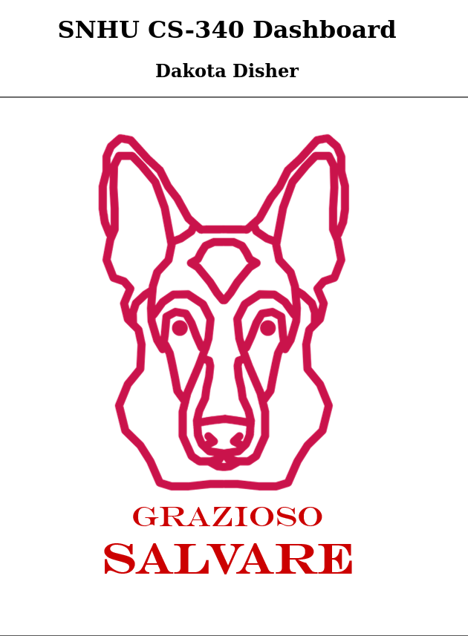

## Roadmap/Features

**Know issues:**

Graph does not show data from database. Currently showing pre-installed data for proof of concept

Map marker does not move when different animals are selected. Also problem with incorrect data being shown after a couple of entries down the page usually one index off.

## Contact

Dakota Disher