***BUG REPORT***

**Bug Title:** GET METHOD Missing, **ID: 1**

**Environment:** Testing and development

**Steps to Reproduce a Bug:**

1. To reproduce the bug go to <http://127.0.0.1:5000/>
2. The web page on loopback address should display Method Not Allowed
3. The output for reference:

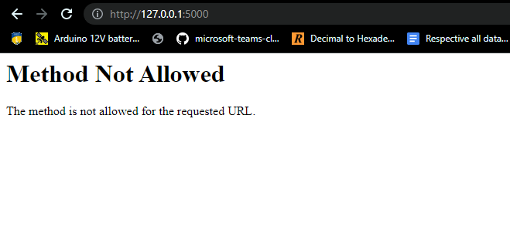

**Expected Result:**

1. The web page should load normally.
2. The user should be able to see the webpage and create notes.
3. The output for reference:

**Actual Result and Fix:**

**Problem Caused:**

1. Because of the BUG user can’t access the page and hence won’t be able to create notes
2. This bugs stops the workflow at the beginning itself.
3. The bug is in backend i.e., Flask Server

**The Fix:**

1. There is need to add GET method on the server, so that page can be rendered for the very first time.

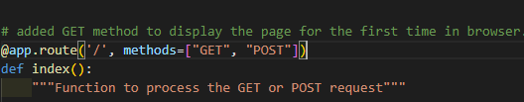

1. While GET Method is added, we need to check if request made was POST request or not.

Now , the above should fix the first bug and will allow loading of page normally.

**Bug Title:** POST METHOD Error, **ID: 2**

**Environment:** Testing and development

**Steps to Reproduce a Bug:**

1. To reproduce the bug go to <http://127.0.0.1:5000/>
2. Try to add a note, it should add None.
3. The output for reference:

**Expected Result:**

1. The web page should load normally.
2. The user should be able to see the webpage and create notes.
3. The output for reference:

**Actual Result and Fix:**

**Problem Caused:**

1. Because of the BUG user can see the page but can’t add notes
2. This bugs allow the adding of notes, but the content will go missing and none will be displayed.
3. The bug is in the backend i.e., Flask Server as well as in HTML Form Method.

**The Fix:**

1. 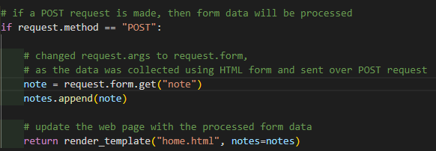There is need to add to change request.args to request.form as its on POST method, we need to process the FORM
2. While the form is going to be submitted over POST method, there is need to update the same in HTML form.



Now , the above should fix the bug and will allow loading of page normally and adding Notes.

**Bug Title:** Empty Notes, **ID: 3**

**Environment:** Testing and development

**Steps to Reproduce a Bug:**

1.       To reproduce the bug go to <http://127.0.0.1:5000/>

2.       Try to “Add Note” without providing data, it should add an empty note

3.       The output for reference:

**Expected Result:**

1.       The web page should load normally.

2.       The user should be able to create notes but should not allow empty notes .

3.       The output for reference:

**Actual Result and Fix:**

**Problem Caused:**

1.      Because of the BUG, users can add empty notes that are of no use.

2.      This bug is a minor one and hence doesn’t crash the server or disrupts the work flow.

3.      The bug is in basically on the frontend side

**The Fix:**

1. Just need to add “required” in HTML input filed.

Now , the above should fix the bug and will not allow users to add empty notes.

**REPORT SUMMARY**

1. Number of bugs found: 3
2. Number of bugs fixed: 3
3. Status of Application: Working as Intended

Output / Results:

1. If input is provided, the note is added.

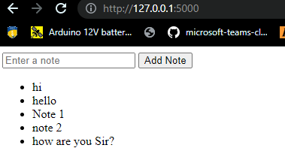

1. If input is not provided, the note is not added and dialogue is displayed to add a note.

