**Overview: Volume RV MTF Indicator**

This Volume RV TF Indicator is a pattern-following forex trading predictor that is able to track market patterns very precisely and continually scans inside the trend possibilities for future investment opportunities. This metric provides tremendous ease of use and a simple way for beginner traders to learn it. Volume RV MTF Indicator Trading of all sorts of forex trading platforms across the capital markets is applicable. In addition, with all kinds of period of time charts even within MT4 major exchanges, this measure works perfectly.  
  
**Overview of Volume RV MTF Indicator**  
The trading map would look like the images attached after downloading the Indicator also at MT4 interface:

[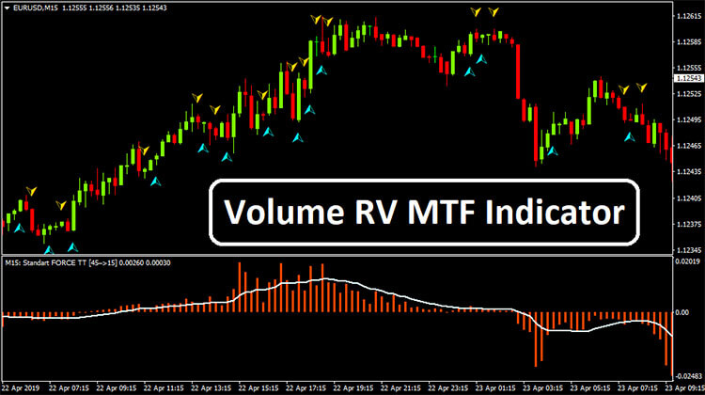](https://forum.mt5.com/customavatars/1230486572.jpg)

**Volume RV MTF Indicator**  
This represents a specific channel for the oscillator to chart the pattern triggers. This also levels sensor arrows to validate the trade signals throughout the main map frame. With both the affirmation of both the bullish pattern, volume RV MTF barrels turn favorable together with an ascending arrow just below price level is known as the buying indicator. Amount RV MTF bars should indeed be made unfavorable for sale inputs, and the signal indicator must concurrently be against the price bars. Until verifying any business entry, all signal markers and volume bar indicators will be balanced.  
  
**How to use the Volume RV MTF Predictor to trade?**  
Everything about interpreting cumulative market trends is exchanged also with MTF Indicator. Throughout the stocks, ETF, graph, currencies and any other medium you may be selling, there will also be market cycles that span larger time periods through to the chart you are gazing at at any specific moment. The wider the temporal periods, the greater the trend will be within the lower timescales. What you might be searching within these MTF lines was its convergence of trends inside the lower time periods, that will enable you to validate direction or pro conduct. Verify out the explanations below for clarity.  
  
Non-juncture inside the higher time span diagrams is generally because of the absence of certainty for a predominant example. In the guide above, nonpartisan, rough, side-way and ambivalent are for the most part ways that you can depict these areas. As you would have speculated, this is on the grounds that buyers and merchants are ambivalent. This prompts a side-path cleave in cost when purchasing and selling is practically adjusted. When the higher time spans adjust all the more precisely, you will see the specks of certainty get back to your top line and you will have a superior possibility of a directional change. Seeing volume is a typical move for brokers in the financial exchange in the wake of taking a gander at cost. It can show a wide range of valuable information that you can not separate from cost alone. Bigger sizes, for example, show more elevated levels of investment and a higher number of members. This will assist you with seeing how much force lies behind a value change, similar as energy.

[Try Forex indicators in MT4 with $1000 No Deposit Bonus now](https://www.instaforex.com/no_deposit_bonus?x=MBZKY&uifd=657)!

[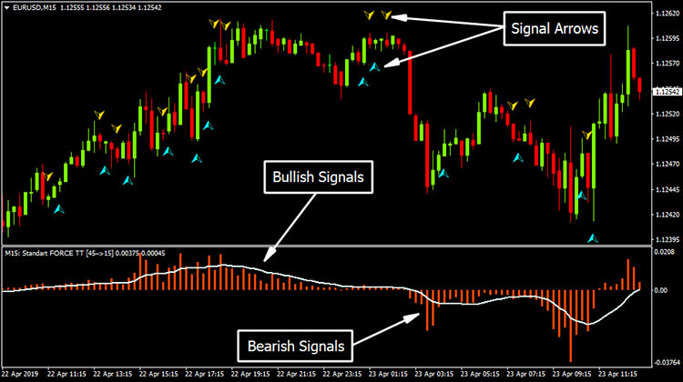](https://forum.mt5.com/customavatars/1983876942.jpg)

Additionally, the low volume of exchanging seems to propose less financial backers and lower interest levels in the instrument being referred to. In this manner, low volumes could show shortcoming behind an adjustment in costs. These thoughts are a portion of the essential structure squares of an exchanging system for a volume pointer. Furthermore, you can see the value of setting aside the effort to take a gander at amounts of exchanging. The information is not difficult to get a hold of with stocks-stocks are traded on trade, and it is enlisted and delivered for anyone passing by to view each time an exchange experiences. With regards to getting hold of this information for Forex, however, there's a trick. The decentralized,' Over-The-Counter' (OTC) presence of the Forex markets implies that there is no exact outline of such information. At the core of worldwide FX exchanging, the huge banks that make up the interbank market appear to intently monitor their own exchanging volumes as exclusive data, and they won't be conscious of the general picture.  
  
**Volume RV MTF Indicator Conditions**  
**Buy Conditions**

1. The bars of the Predictor transform positive
2. Behind the price bars, Signal Arrow emerges
3. Where the above objectives are satisfied, buy signals
4. Place Signal Arrow to Avoid Loss Below
5. Whenever a descending signal arrow emerges just above price bar, leave long / take benefit

**Sell Conditions**

1. Bars of the Predictor transform negative
2. Just above price bars, Signal Arrow emerges
3. Sale triggers while satisfying the above requirements
4. Set the failure stop over the Signal Arrow
5. Exit simple benefit if its upward signal indicator underneath the price bar emerges

**Does this truly work?**  
It is essential to remember one of the previous focuses in this article while tending to this inquiry. In other words, the marker doesn't genuinely reflect genuine market volumes of exchange. Nonetheless, even with this admonition, there is justification for trusting it to be a reasonable measure by which to gauge it. For example, the volume marker reliably addresses such conduct in key news discharges, where we would anticipate that volumes should be higher. Moreover, the unavoidable idea of specialized examination additionally gives this methodology trustworthiness. An extremely critical number of individuals continually take a gander at these standards and stock up on what they mean to control purchaser conduct.

[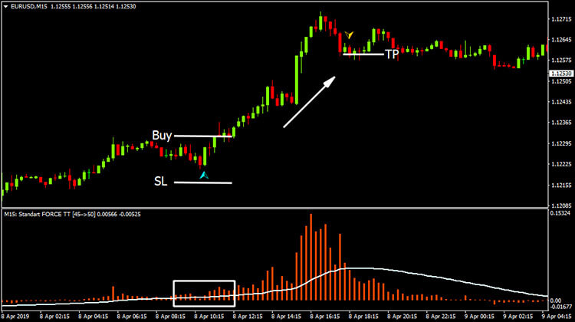](https://forum.mt5.com/customavatars/1682971149.jpg)

Be that as it may, with genuine cash, this sort of experimentation can be exorbitant, which is the reason it is helpful to have a danger free climate to exchange. With a demo exchanging account from Admiral Markets, this is conceivable. Live rates are genuine, and the instruments are completely useful, yet you're not utilizing genuine cash, and you're exchanging virtual assets for all things considered. See what turns out best for you first, so when you exchange live business sectors, you will be secure in your technique. The MetaTrader Supreme Edition is a customized module, explicitly worked to give you a more front line scope of exchanging assets than you get with customary MetaTrader downloads by industry experts. To delineate the contention, obviously, utilizing Keltner Channels related to the Forex volume marker is only a model. You can well find for yourself an unrivaled blend of markers. By experimentation, the most ideal approach to locate this out is.  
  
**Consolidating different measures with volumes**Most brokers acknowledge that the computation of higher outline time spans starts with the most recent market status survey. The exploration is completed downwards to bring down time spans before the one where exchanges are done. This technique for study will in general be a necessary piece of the specialized way to deal with powerful exchanging. Clients regularly need to open a few windows or switch between graph times to direct multi-time span investigation if similar arrangement of instruments is utilized. The fundamental examination is accordingly led. The answer for this issue is a pointer that gathers information from different time periods or various exchanging images and shows nitty gritty information on the screen so the economic situation can be estimated adequately by the shopper. These pointers will show the genuine condition of the market pattern notwithstanding essential subtleties and recommend further exchanging exercises.  
  
Procedure of the OBV Trend and Trend Line Basically, a financial exchange marker and, as per MQl5.com, the essential definition Granville used to build his OBV pointer was that the all out volume of the day is called up-volume If a stock closes over its past day by day close. In examination, if a stock closes underneath the past day by day close, all the volume of the day is called down-volume. The OBV line was shaped by the entirety of the positive and negative volume streams. Studies by Granville proposed that shifts throughout the On Balance Volume pointer anticipated future value heading inversions. For instance, if merchants started to buy a market vigorously (for example forex, item, stock, value), an expanded volume would cause the OBV line to climb, which would drag the cost higher thusly.

**Application In Other Trading Scenarios**  
In a purchasing pattern, if the sum quit developing, it was emblematic of purchasing compel starting to diminish, and the probability that the bull pattern was not, at this point reasonable, was expanding. For the bearish subject, the equivalent applies. Granville proposed utilizing a 20-period moving normal in blend with the OBV to give more proof that an example could be debilitating. Subsequently, by recording any hybrids of the OBV line and its moving normal, OBV clients could then notice those occasions undeniably more without any problem. A market inversion is inescapable if the OBV demonstrates a deviation from value variances. For instance, if the cost is rising, anyway the OBV starts to drop, there could be a potential deal opportunity. The accompanying occasion shows us how the cost is following another upward pattern and how the OBV is following the MA intently.

[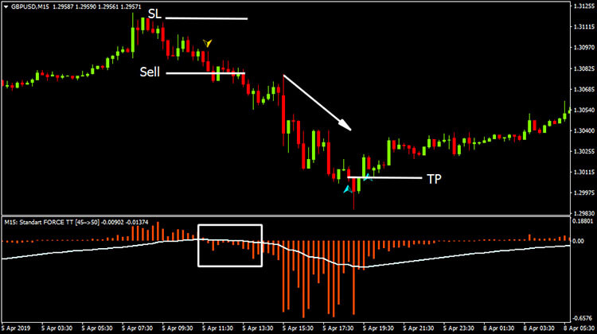](https://forum.mt5.com/customavatars/1040528935.jpg)

Each time the OBV goes beneath and afterward over the EMA 20, the value dismisses the pattern line, permitting another skip the upward way. This can, especially when joined with the Admiral Pivot Indicator, be the reason for an OBV technique. Inversion of OBV Pattern - Divergence The OBV may likewise work before the cost, similarly as with most divergences, demonstrating the course wherein a value breakout may happen. It's truly imperative to get a handle on OBV difference. On the off chance that the expense is lower, however the OBV is lower, we call it bullish dissimilarity. On the off chance that the OBV makes a lower high, we call it bearish dissimilarity, yet the value makes a higher high. On the off chance that the pattern is up and the OBV shows a bearish difference, merchants for the most part take a short position when the value breaks beneath its current trendline.  
  
A stop-misfortune is set over the current swing and the cost is higher. Brokers may decide to keep the exchange as long as it is checked by the OBV and when the value drifts down towards help. In the event that the pattern is down and the OBV is showing a bullish disparity, when the value breaks over its current trendline, dealers ordinarily take a long position. A stop-misfortune is placed in the cost beneath the latest swing, and higher. Merchants could keep on keeping the exchange as long as it is checked by the OBV and when the value patterns higher towards obstruction. At the point when the cost is at obstruction (for short exchanges) or at help, OBV difference actually works best (for long exchanges). The Admiral Pivot marker, part of the honor winning MetaTrader Supreme Version module for MetaTrader 4 and MetaTrader 5, is a decent choice to utilize.