We'll see that the currency exchange metrics in the latest article that any trader should remember. Each technical and financial observer must know their architecture and usage of often used MT5 instruments, as metrics are a vital piece of stock investing.

**Relative Strength Index**

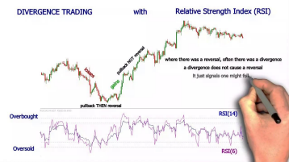Found in: https://www.contracts-for-difference.com/wp-content/uploads/2018/06/rsi.jpg

The index of perceived popularity moves between zero levels towards index 100. Where even the price is expected to increase, this example demonstrates. Unless the stock goes past the 70 rates in an upward direction, it signals a bullish market turnaround. Likewise, whenever, in such a downward trend, the value falls just below 30 thresholds, it implies a volatile stock turnaround. On the other side, by generating a difference with both the market, RSI gives trading strategies.

**Bollinger Bands**

A Bollinger Bands indicator was developed by John Bollinger. Price movements are the primary feature of both the Bollinger bands. Throughout the center, there have been 2 known positive and negative aspects variations, as well as a traditional, exponentially weighted moving. Pretty much across the board, this market predictor is indeed very simple to do and an extremely simple admission is given. The superior and inferior layer of the Bollinger bands predictor serves as complex degrees of support but tolerance. A potential admission is implied by any expulsion from all these ranks. Besides, successful trades are also given by every breakout from these stages. That being said, the ability to measure the very next step is provided by a candle near under that is above the centerline.

**Moving Average Convergence Divergence (MACD)**

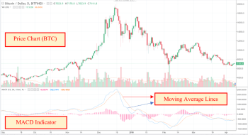

Found in: https://masterthecrypto.com/wp-content/uploads/2018/04/wsi-imageoptim-MACD1-1.png MACD comprises both a histogram as well as a linear simple exponential as well as being a market predictor. The primary aim of this measure is to measure market differentiation. Regular variations between MACD and cost suggest a turnaround of the economy, while their secret difference implies a continuity of the trend. To construct a strategy and methods, investors frequently use that as a correctional administrator. From the other extreme, to find a possible price turnaround stage or a continuing stage, you will be using this predictor. Consequently, as shown in a business plan focused on certain trading platform's metrics, anyone may access the exchange.

**Fibonacci**

Because it is connected to any entity in the world, Fibonacci is indeed a market instrument that indicates a most specific market path. The standard model of 1.6 is perhaps the most critical element of the Fibonacci device. Investors are using this ratio throughout the foreign exchange sector to describe the turnaround of the sector as well as the revenue market. Unless the stock shifts with a pattern, transitions around 61.8 percent Fibonacci retracement, and demonstrates a trend turnaround, the price is likely to change 161.8 percent of the existing leg's Fibonacci up with developments. Besides, it is focused on the economic dynamics and traction. Other rates of Fibonacci also occur.

**Stochastic**

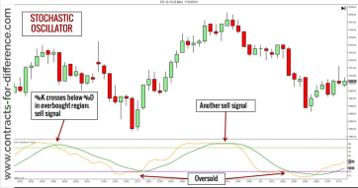

Found in: https://www.contracts-for-difference.com/wp-content/uploads/2018/06/stochastic-indicator.png Stochastic, which was produced throughout the 1950s, is a common vertical movement. Identifying the massively oversold versus oversupplied region is the main goal of this predictor. In the stock portfolio, brokers also need to locate a potential revenue place. Consequently, to locate the position from which the value is supposed to change, they are using this trading platform's predictor. That Stochastic Indicator flips between zero to 100 degrees. The market would possibly shift if the market reaches past the Seventy rates. From the other side, it provides the risk of a constructive turnaround if the market moves far below 30 thresholds.

**Average True Range**

The Overall True Variance shows the variance of a pair of currencies. Measuring liquidity is quite relevant in the forex industry since it is linked to the realistic detail of the market. In each stock market, a rise in invariance implies a turnaround of the industry, and a decline in volatility implies a continuity of the industry. The smaller Average True Range reveals the lesser uncertainty and the greater fluctuations are indicated by the greater ATR. Consequently, unless the uncertainty is minimal, you will extend the benefit you receive. You will find turnaround trading configurations, but on the other side, in the lower returns.

**Ichimoku Kinko Hyo**

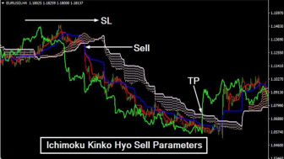

Found in: https://i.ytimg.com/vi/Dw262PsaudM/maxresdefault.jpg

A market predictor including components to build a full trading plan is Ichimoku Kinko Hyo or even the Ichimoku Cloud. Different components throughout this metric help investors to understand every portion of the industry. The whole first aspect of this measure that allows us to comprehend the background of the business is the Kumo Cloud. Unless the market is moving just below Kumo Cloud, the pattern is dovish average, but bullish just above Kumo Cloud. Kijun Sen as well as Tenkan Sen, on the other side, are two essential elements of this predictor that have been based on the simple moving principle. Those other two lines shift with both the price and a selling transaction is generated by every rejection of them.

**Parabolic SAR**

The trading pattern of a nation's currency is shown by Parabolic SAR. The general trend is positive unless the value is towards the Parabolic SAR. If the value is under the SAR, but on the other hand, the general picture is highly leveraged. To define the pattern, dealers are using this signal. Also, a common reference point is given by the business acceptance of the Parabolic SAR predictor. The focal method defines a currency pair's intermediate degree of production

and consumption. If the market recovers the trend line mark, it means that the supply and demand are the same as the unique couple. It means that the market for a country's currency is strong if the market reaches just above the moving averages mark. That being said, the demand would've been large if the market were to move far below the reference line.

**The Moving Average Calculator**

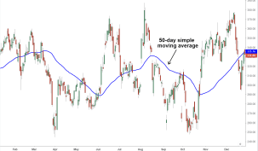

Found in

https://www.investopedia.com/thmb/G0sJ5M7lr_947rvQBJ60s3IU98E=/1543x905/filters:no_upscale():max_bytes(150000):strip_icc() /SMA-5c535f2846e0fb00012b9825.png

Any trader must know the definition of the price movement. The foreign currency market is dominated by the Federal Reserve including foreign corporations. Consequently, understanding what is occurring at the global level is critical. The average price from the last signal of torches that reflect the total price perception is a standard rate. That is an indicator that investors monitor the market while the market is moving over the price movement. From the other side, if the market is selling far below the moving average, this implies that perhaps the value is regulated by traders.

People should also concentrate on purchasing purchases in their financial strategy unless the cost should be above the price movement. A dealer should recognize that this was one of the better foreign currency metrics. Besides, the reduced traffic median represents the typical price from the last number of signals to help investors understand the implications of the industry. The moving averages scale, on the other side, is based on the current trend that lets shareholders reach a deal

**Pivot Point**

Throughout the stock market, markets appear to move only at the state of the intersection until the path is set. Therefore, from the denial of the reference line, the selling predictor offers a potential trading entrance. Foreign exchange indexes are major market instruments and should be identified to many other investors. The usefulness of a technological trading measure, though, relies on how you use it. Many metrics with various criteria are also used by traders to improve the risk of a trading volume.

References:

https://www.elearnmarkets.com/blog/top-10-forex-indicators-that-every-trader-should-know/