Nowadays, people tend to use their mobile devices in everything. Especially in terms of entertainment, they rather watch something that is available online hence the use of streaming platforms such as Netflix, VUI, and so much more. However, there are still television series that can only be watched on the usual television. Many people miss some wonderful series that the old television scan offers such as the T.V. series called “The Good Place”.

This article serves as an insight into the first three seasons of “The Good Place”.

Before I start to the portion where I will be reviewing each season, I will give you a brief overview of what the series is about. TV series entitled The Good Place is focused towards a woman who died after living a greedy and immoral life. However, in the afterlife, she finds herself living in heaven because of mistaken identity and the series shows her journey to make some amends and hide the past that she regrets.

**Insights for Season One of The Good Place**

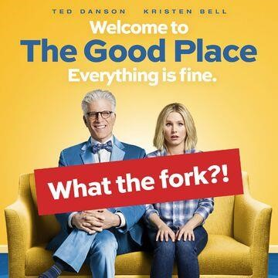

Sourced fro[m *https://vignette.wikia.nocookie.net/thegoodplace/images/f/ff/The-Good-Place-season-1poster.jpg/revision/latest/top-crop/width/360/height/360?cb=20180915212324*](https://vignette.wikia.nocookie.net/thegoodplace/images/f/ff/The-Good-Place-season-1-poster.jpg/revision/latest/top-crop/width/360/height/360?cb=20180915212324)

The season one of “The Good Place” is consists of 13 episodes and here are the episodes with their corresponding title.

Everything Is Fine

Flying

Tahani Al-Jamil

Jason Mendoza

Category 55 Emergency Doomsday

What We Owe to Each Other

The Eternal Shriek

Most Improved Player

…Someone Like Me as a Member

Child’s Choice

What’s My Motivation

Mindy St. Claire

Michael’s Gambit

Egoistic Eleanor Shellstrop, the protagonist in this series portrayed by Kristen Bell, finds itself in The Good Place following her demise, owing to an administrative mistake. Helped by a well-run script and an amazing plot that boasts lots of cliffhangers along with the case, The Good Place's first season is a great comedy series. The bold, vibrant colors help to highlight the life after death's hallucinatory beauty, and the dry humor is timed and did manage through most of it, even though this kind of humor will not appeal to everybody.

For vast timeframes of the season, the storyline is focusing on Eleanor and focusing exclusively on being her voyage from self-centered, self-absorbed catastrophe to a reasonably good woman, enough consideration is given to the supporting characters to accentuate them out too. The Ethics professor Chidi, supporting character played by William Jackson Harper, is by far the most likable of the four main characters, with British young woman Tahani, portrayed by actress Jameela Jamil, and Buddhist mystic, acted by an actor named Manny Jacinto, completing up the foursome that becomes a casualty of some frustrating stereotypes. Many of these protagonists' characteristics are exaggerated to the extent that they often become boring and irritating, but the dry satire used in the episodes tends to mask that fairly well. Undeniably enough, with such dependence on this kind of humor it may very well end up alienating some individuals but there is still a lot to like for all those who appreciate this kind of sarcasm.

Even though the unpleasant quips deeply rooted in a few of the cast members, the chemistry between all the protagonists is brilliant too, and the screenplay lends itself more to significant moments among them all. There's also a good use of flashbacks, which show each of the characters' lives before they end up at The Good Place. Fortunately, they 're used carefully so that they don't seem overpowered and there was enough humor to make every episode a great pleasure as it moves between one scene to another. Each of the characters grows and continues to evolve from what was originally portrayed at the series start with Eleanor which is given with the most important progression. The climactic episode produces a remarkable set of circumstances and it will be entertaining to see precisely where they are going with this tv series in the season 2, without offering too much down the road.

Although it's obviously not ideal, The Good Place delivers a decent entertaining season that performs very well from beginning to end. The concept is completely bonkers yet tied down in realism, the cast members do have sharp contrasts which seem to mix and the screenplay is all seem decent. With just enough suspense and drama surrounding upcoming scenarios and a satisfying storyline throughout the seasons of the show, The Good Place is worth the watch, particularly with a second season promising to be just as excellent as the other. Yes, the show doesn't come to us perfectly, but through its enjoyable first period, The Good Place is delightful enough to conveniently disregard its imperfections.

The evaluation that I can make in the first season is a strong 8.5 out of 10.

**Insights for Season Two of The Good Place**

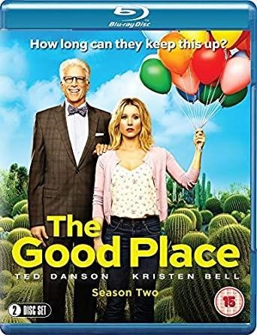

Sourced fro[m *https://images-na.ssl-images-amazon.com/images/I/5135QXpSM0L._AC_SY445_.jpg*](https://images-na.ssl-images-amazon.com/images/I/5135QXpSM0L._AC_SY445_.jpg)

The season two of “The Good Place” is consists of 12 episodes and here are the episodes with their corresponding title.

Everything Is Great!

Dance Dance Resolution

Team Cockroach

Existential Crisis

The Trolley Problem

Janet and Michael

Derek

Leap To Faith

Best Self

Rhonda, Diana, Jake, and Trent

The Burrito

Somewhere Else

The quirky, upbeat comedy series comes back with yet another 12 chapters of afterlife awesomeness after its unexpected accomplishment last season and an inventive twist during the season finale. The second season simulates the work that has been done last year with a whole other solid adventure season with a returning cast and a good sense of humor exuding through the screenplay. Following a strong beginning, the episodes have more meaningful love story-driven plotlines between the protagonists before the climactic ending which sees the participants leave comfort and security in the hope of reaching the real Good Place. The comedy and irony of the series plot are not going to be for everybody those that haven't watched the first season are going to be so out of their depth. The Right Place completely performs for those who have loved the first season but are also looking for more and more.

After resetting the four human beings by Michael, the second season picks up towards the end of last season with the protagonists reset and seemingly ignorant of their changing circumstances. That was until Eleanor and even the party finally find out what's going on again which will lead to an intriguing scuffle with Michael. As the story continues, previous relationships and more backstory surface across the Bad Place, Michael's leader Shaun and the method of obtaining access to The Good Place are all established, offering to help to tease out the series and continue driving the storyline in fun and innovative ways forward. While most of the season actually occurs in last season's fictional Good Place, this last half of the series uncovers The Bad Place as well as other areas outside of the gang's deluded reality to help to bring more inventiveness to the sequence.

The original cast members namely Kristen Bell, William Jackson Harper, Jameela Jamil, and Manny Jacinto all appear to their respective roles, the four distressed humans assisted by the series focal characters, automated Janet and guardian Michael. Their interconnected dynamics and funny bits of conversation with each other are the cause why The Good Place works well as it is. This season, Michael attempts to learn morality from Chidi, Janet's new fiance Derek, which causes all kinds of funny disasters and the party that visits The Bad Place. The second season is and has always been ways much more enthusiastic than the first, with such a variety of unique possible situations used to push the idea forward while never losing track of the humor that remains peculiar and intelligently written all throughout twelve episodes

It was really going to be a tough request to reproduce the originality and wonderful humor of the first season did manage to congeal so flawlessly but this is handled wonderfully by the second season. The humor is timely, extremely hilarious, and continues to play for each personality on the idealized traits. For example, the very same problems involving one-note roles still play an important role here, but the reboot and circumstance that leads the roles to try and recall oneself is a reason to justify the second season's repetition of this. The Good Place is purely an amusing, light - hearted sitcom that reproduces last season’s great work and adds a big dollop of originality to keep the program fresh. The future looks exciting with a third season already greenlighted for this outstanding comedy that achieves another outstanding entertaining season.