**Binary Options & Fractal Strategy in Forex**

**How traders earn profit and what is a binary option?**  
  
The **binary option** is indeed an easy and surprisingly easy **financial tool** that allows investors to bet over whether, for instance, the Google share value, the Bitcoin market value, which USD/GBP currency value or even the gold price, the price of a commodity would rise or decline in the long term. The time period could be as within about 60 seconds, making it very easy to transact in every world market dozens of times each day. People know just how much you expect to earn before placing a trade if your forecast is right. This makes life even easier for risk assessment and investment decisions. The consequence is usually a Yes or No response, whether you gain everything or you risk everything, so this is a binary decision. The costs and benefits are identified in advance and that one of the appeals is this organized payout.  
  
Transaction binaries are all now accessible, which means that dealers should not sell it against brokerage. They just need to have a compliant broker account to begin buying (or licensed). Select one from the list of suggested brokers, which contains only brokerage firms who have proven themselves to also be reliable. For most traders, the top brokerage has been chosen as the best option. Whether you are totally new to binary options, people can create a payment gateway with most exchanges until depositing serious cash to test out their site and then see what it was like to exchange.  
  
**Different Option Types**  
  
The most popular form of binary alternative is the basic Up/Down exchange. That being said, there are various types of choices. One other common factor is that even the result would have a binary answer (Yes or No). These were some of the forms available:

[](https://forum.mt5.com/customavatars/112956584.png)

* Up/Down and High/Low – The simple and most popular binary alternative. Can a price end greater or lesser than that of the present rate at the time of end date.
* In/Out, Spectrum or Threshold – This choice sets a high estimate but low start figuring. Traders forecast whether another market will finish inside, or beyond, from these thresholds or ‘limitations.
* Touch/No Touch – All have fixed prices, greater or lesser than the market valuation. The seller needs to guess when the real price would ‘touch’ certain values at some point between both the time of the transaction and expiration. Note with a contact choice, that the deal will close even before expiration date – unless the market price is reached until the term ends, therefore the “Touch” option will pay off automatically, irrespective of whether the market falls away from the control level after.
* Ladder – These contracts act like a standard Up/Down swap, but instead of using the actual market price, the staircase may have predetermined pricing ranges ‘laddered’ gradually up or down. These could also be any distance from the actual market price such contracts usually require a substantial price change, payments can sometimes go above 100 percent, but all parts of both the exchanges would not be accessible.

**Introduction to the Market Fractal Indicators**

The measure I will be speaking for today was considered the Fractal. Since when does ‘fractal imply? This is a simple geometric concept where identical patterns replicate themselves again and again. And that in trade, its Fractal predictor is based on the trends that are found frequently mostly on price maps. The fractal indicator catches potential pivotal moments on the map and draws that arrow. They demonstrate the pattern forming. The fractal pattern may be a positive or a pessimistic one. Helps determine and points out cost extremums helping to predict the business tendency. Market Fractals predictor established by a prominent trader and publisher of technical indicators guides Bill Williamson.

**Fractals: Description, Adjustment and Application**  
  
All economies are distinguished by stabilization of prices over the lengthy amount of time and therefore only occasionally patterns shifts may occur. The most lucrative times are when values only at companies change due to the definite pattern.  
  
Fractals has been one of fifth Bill Williams markers which helps it to detect bottom either top. Technical definition of the upward fractal is a set of maximum five successive bars whereby two bars containing lower durations are put pre and post largest maximum. Contrary structure is backward fractal. At the map Fractals has meanings High and Low; these are shown by the down through up arrows.  
  
Signals with technical indicator Fractals can be filtered either by complex function Alligator. In many other terms, they must not buy if Fractal is smaller than Alligators heads, then you shouldn't sell if Fractal is over the Alligator's dentures. Once the Fractal symbol becomes created and has its strength, which is proven by its location from outside Alligator's head, it lasts as a symbol until it has been struck and until a different Fractal signal emerges.  
  
**Use Fractal Indicator in Instaforex**

[](https://forum.mt5.com/customavatars/278938480.jpg)

One of the leading trading platforms that enables an integration of Fractal Indicator was InstaForex. **InstaForex gathered more than 30 financial awards** to justify their credibility and performance. Aside from that, numerous analysts are present in the platform that will provide you their insights and analysis of the current market trends to guide you trade proficiently. InstaForex does treat its platform traders well by having a prize pool and giveaways monthly as well as annually. The **24/7 availability of InstaForex** around the globe is attributed to its investment in its I.T. Structure by having multiple servers in different nations. The platform does provide video lessons for the different indicators and much more regarding forex.  
  
  
**Different Fractal pattern on InstaForex**

* Fractal high  
    
  The fractal pattern consisted of five candle holders. The arrow becomes positioned beneath or beyond the middle candles which would be the moderate or medium points of the design. The bearish fractal trend appears as there are bottom two highs and one higher peak among. It is indicated by a plus sign and indicates possible fall in the market. The bullish geometric pattern occurs where there are three extreme lows or one lower low among them. It is indicated by a down arrow which gives an indication which price could go upwards.
* Fractal low  
    
  Estimating the trend is mostly an intuition than math. They need to just look for medium and moderate levels on the value map. Once you separate those, you just had to test what torches are formed on the left hand side of any low/high. Instead, you will just have to watch until the next two candles to validate the trend. So if you see a pinnacle and that there are three side points on the left hand side, it is very likely that was our trend. Give it a rest, still, before two additional candles emerge. Whether there are both lower peaks, the fractal is completely developed. Then you separate a low point and that there are three extreme lows to the left of your level, and instead two higher highs appear afterward, the positive fractal is total.

**Using Fractals to forecast market trends**  
  
Traders may use fractal metrics to assess the potential course of price in a business. One form in which investors use it, is by searching for fractured fractals. A fractal is called broken until a fractal was already confirmed and now the price falls into either high or even the low of both the sequence. If the user purchases an upward fractal therefore the trajectory of the market is called up but if the price breaks a downward fractal otherwise the market becomes deemed down. The picture below shows how all this looks on a map because as price has crossed a most current down rural and poor.

1. The fractal small candle
2. Two candle indicating high lows to either the right
3. Candle shattering the low of the fractal light (1)

[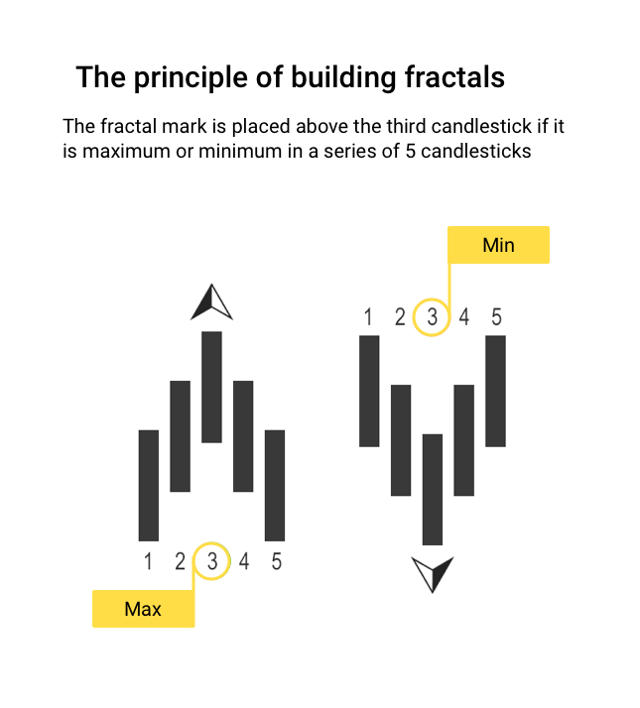](https://forum.mt5.com/customavatars/1779197906.png)

If you can see from the table above, the very last fractal to be split was a downward fractal. This indicates the market is pessimistic, suggesting buyers may be searching for selling openings.  
  
The next example demonstrates because when price has separated an up fractal:

1. The fractal strong candle
2. Two torches marking actually supported to the right
3. Candle shattering the high of the fractal flame (1)

The map above shows that the most prominent up fractals were destroyed. This indicates the market is positive, meaning buyers may be searching for purchasing opportunities.  
  
Fractals appear to be more accurate markers of direction while used for longer time scales than for shorter periods of time.  
  
**How People Make Money From Binary Options Trading**  
  
And we'll get to where even the concrete reaches the highway: making profits through trading strategies. Designers not concerned about making a profit in such a single purchase. There, we’re relating to creating a stable handling complex that allows you to achieve a fair return and over longer term. We’ll send everyone a few other tips to get you going.

[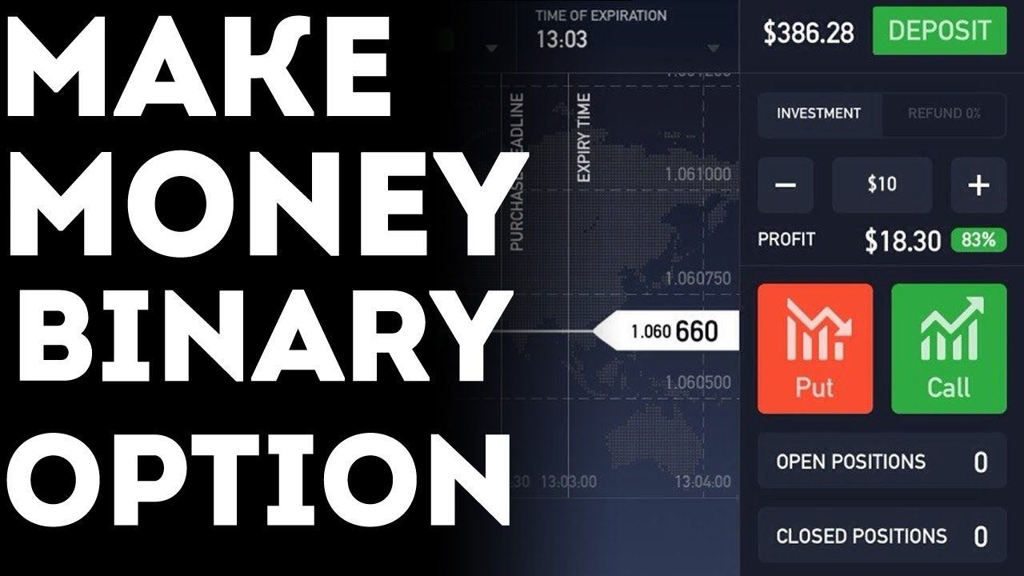](https://forum.mt5.com/customavatars/556231778.jpg)

1. **Read and understand candlestick graphs.** A lot of the pricing behavior you’ll see around binaries can be modeled by observing historical price trends. This is basically what line graphs display. The diagrams itself could seem confusing at first, but are really easy to read once you understand the fundamentals and the popular candlestick trends.
2. **Research the historical market behavior** of your preferred underlying properties. Trading financial products for gains is not like betting. This is not a throw of the dice but a flip of both the coins. A savvy trader may use information and details to select binaries that are much more probable to expire in the capital. Any of the most significant details are contained in the investment recent cost.
3. **Control and track marketing patterns.** If the value of gold is already increasing for the past 3 hours, fight the urge to gamble on a turnaround. Similarly, if IBM shares already plummeted and begin to slide, should believe a purchasing demand is going to miraculously eventuate and drive the stock upward. Betting on patterns is a safe practice when selling simple terms plugins. Betting on patterns is begging for problems.
4. **Don’t gamble your monthly rent.** Even though you’re completely confident a binary choice can’t fail, that it’s sure to go the way but make you wealthy in the meanwhile, hang onto that entire paycheck. There has been considerable risk added to selling this sort of measure. And if a strong suspicion or a recommendation from a buddy turns out to be right, it may do so beyond the lifetime of the business. Be cautious with your fund. Be wise.
5. **Get any practice** before losing a significant portion of the cash flow. So many brokers sell sample portfolios. Users will exercise conducting trades in all of these funds while putting one's own assets at risk. People have an opportunity to become used to the financial derivatives site hosted either by traders.

**Final thoughts about using the Fractal indicator**  
  
The Fractal predictor is focused on the trends that replicate themselves frequently. It helps to anticipate a shift in the trajectory of the price. People can be frustrated by the intensity the arrows display. It is crucial that you realize not all of them will be trading indicators. People should not be using everything all but, rather, you can continue to wait until a few first candles to grow or use additional markers and other ways of study.  
  
That arrows normally occur in the center of the chart. They can offer a misleading idea of good entrance points. Keep in mind, there are two more torches that have to be established before the pattern could've been verified. Therefore, users should not enable a trade sooner than on the fifth candle after the arrow grows. It is advised that you check how well the **Fractal predictor functions on a demo mode**. Such as this, they will also have the opportunity to know it more and to understand how to do that in order to get the right entry points. When you get trust by using the Fractal, exchange with that on a main account.