**Why Forex Sites Give Free Money**

**When did the ‘bonuses’ started in forex?**

[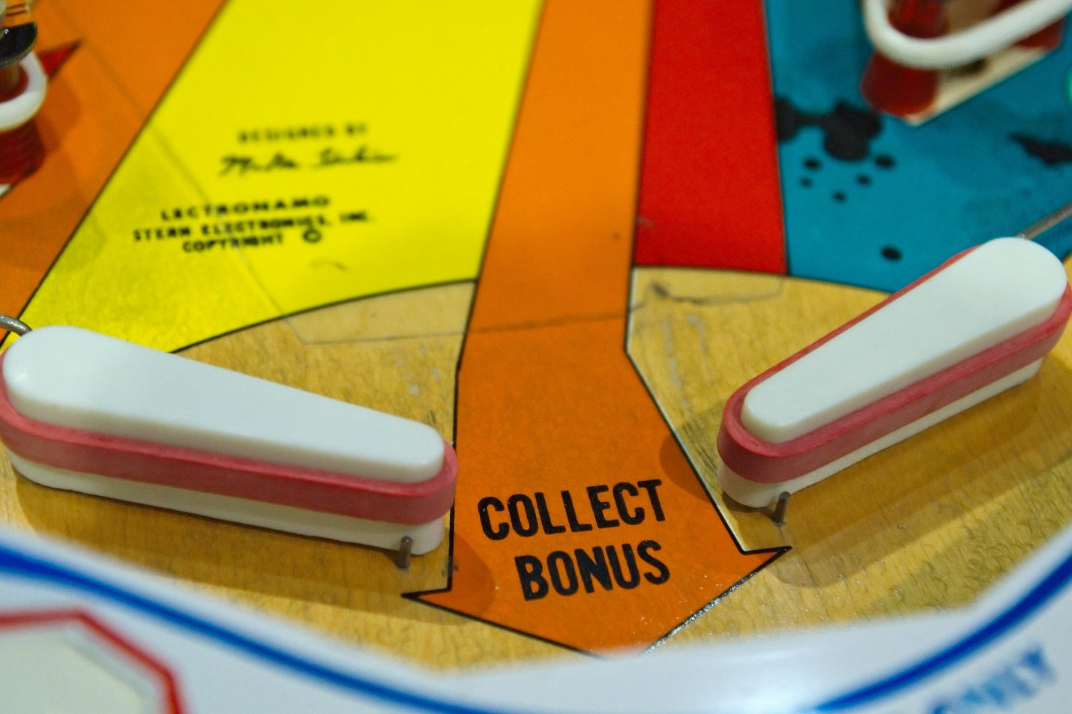](https://forum.mt5.com/customavatars/1561161633.jpg)

In the early days of forex trading, brokers didn't offer bonuses towards starting users of their platform. Most of the time, brokerage firms or trading portals boast their multiple modes of payment options such as through local banks and PayPal. Their main selling point is to attract prospective users with their features or easier trade channels. There’s a point in time, around the 1980s, where brokerage firms or trading institutions went to call each of the individuals in the phonebook to persuade them to buy certain stocks for specific companies. The invention of the Internet started a revolution in each sector of the market, especially the trading market. As the trading institutions tried to cope-up with the change, all of them transitioned to trade online giving birth to the now commonly known as online trading. As the internet was saturated with multiple trading options, trading institutions started to give out additional bonuses, lower fees, and other propagandas to entice new and existing traders to continuously use or support their platform.

**Bonus from AmegaFX**

Up until this time, in the 21st century, companies still offer starting bonuses to users that will avail their platform. AmegaFX is one of them, especially that this company only started this 2017. Even though they offer bonuses, they only provide it at certain periods in a year, not unusual for a young company these days. However, they always provide a benefit for their regular traders who deposit money in their platform. If you are not convinced with how AmegaFX bonuses work, there are plenty of other trading platforms to choose from. These will be discussed in the latter part of the article.

**Can you abuse the entry bonus rewards?**

[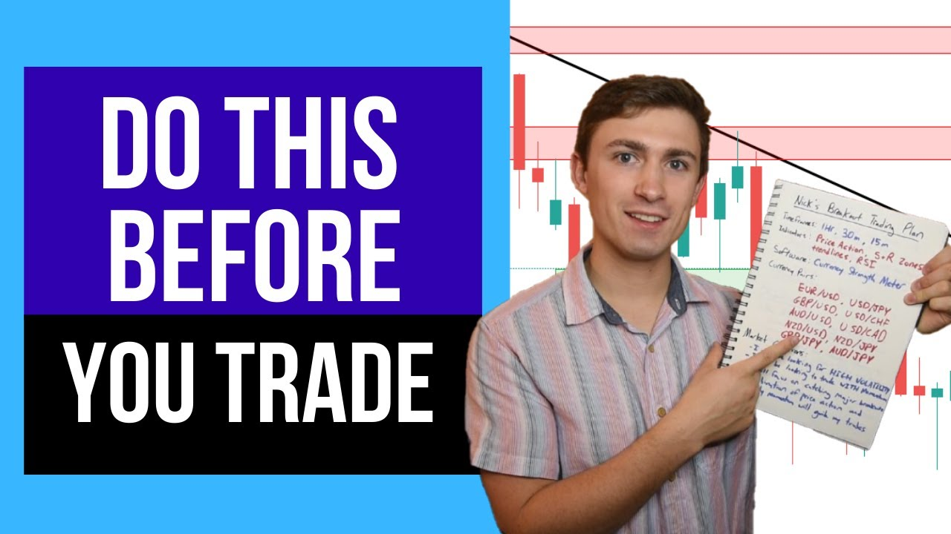](https://forum.mt5.com/customavatars/288770813.jpg)

**The answer is simply no**. All trading platforms have strict regulations and validation processes that enable them to keep one user per account. There are strict tracking systems in place like requiring one (1) IP address (your internet identity given by your internet service provider) per account. Suspicious activities may result in temporary account ban which leads to further evaluation by the trading institution. Aside from that, necessary personal identification is needed to submit to your chosen trading platform upon registration. Creation of accounts in multiple platforms is not illegal and the common practice however transferring of funds across different trading platforms is not foreseeable.

**What is in Forex to Trade for?**

The term Forex is an abbreviation for Foreign Exchange. On some kind of financial market, it refers to the exchange of one currency with another. Forex trading has been around since the 1970s of the twentieth century. It is just one among the world's fastest-growing and most extensively traded marketplaces. The daily online Forex market transaction is almost 4 trillion dollars. Here are the top things traded in the forex market:

* **Foreign Currency**

The trade of one currency with another is known as foreign exchange commonly known as forex or FX. One could, for example, exchange the US dollar for the British Pound. The foreign exchange market, commonly known as the forex market, is where foreign exchange purchases may be made. With billions of dollars injected into the economy each day, the FX market is the world's biggest and most competitive marketplace. There is no one point of contact. The Trading volume, on the other hand, is a global electronic connection of banks, brokerages, organizations, and individual traders (people who were self taught).

* **Cryptocurrency**

A digital currency and financial instrument that is protected by encryption, making counterfeiting and double-spending almost impossible. Many cryptocurrencies have been built on cloud computing, which is a distributed ledger controlled by a global network of computers. Cryptocurrencies are generally distinguished by the fact that they are not released by any government control, making them potentially resistant to government intervention or exploitation.

* **Company Shares**

Shares are units representing share purchase interest in a business that function as a financial instrument that provide for an equitable distribution of any residual earnings in the form of rewards, if any are issued. If the business's worth grows, shareholders may benefit from investment income. Common shares and preferred shares are indeed the two types of stocks that make up a company's equity stock. As a result, the terms "shares" and "stock" are frequently interchanged.

**Leading Forex Sites to Offer Generous Bonuses**

* **Instaforex (Best Site Overall)**

[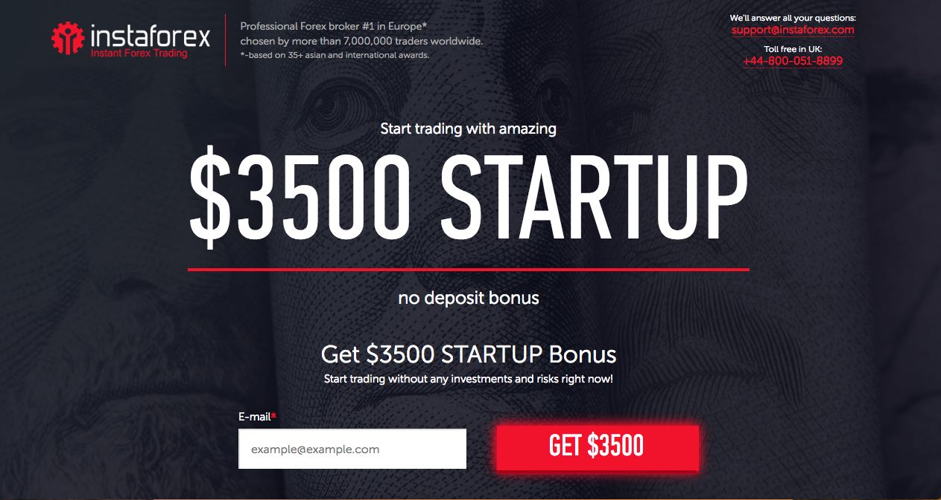](https://forum.mt5.com/customavatars/1354004974.jpg)

Instaforex has **received a lot of excellent reviews from its customers** and is heavily regulated. So far, traders' trade experience with them has been nothing short of fantastic. The platforms are all fantastic (most traders favorite is the smartphone app), and the trading costs are reasonable. For novices, it's fantastic. This trading platform bags multiple awards for years as the best trading platform in the world. Instaforex offers countless promotions and bonuses to their current and new traders just like signing bonus, trade bonus, milestone bonus to name a few. Aside from that competitions among traders, per proficiency level, were occasionally conducted and had prizes ranging from thousands of dollars up to high-end cars like ferrari to multiple users.

* **eToro (Best for Crypto Traders)**

eToro is a contender for its simple copy-trading platform, which allows users to mimic the trades of other investors across over 2300 products, including ETFs, FX, CFDs, and major cryptocurrencies. eToro was established in 2007 and is accredited in two tier-1 and one tier-2 countries, making it a low-risk broker for trading FX and CFDs. In 2021, we recommend eToro for both social copy trading and cryptocurrency trading, and it is our top selection in both categories. eToro also has a user-friendly online platform and smartphone app for casual investors, particularly newbies. Lately, eToro is expanding towards the investment sector.

* **Moneta Markets (Best for traditional trading)**

Moneta Markets provides its users with a positive overall experience. The broker's sophisticated MT4 and MT5 systems guarantee that users are sufficiently briefed about the most recent market movements and can make more informed investment decisions as a result. As a multi-asset broker, eToro goes as far as to ensure that traders have a pleasant experience. For instance, Moneta Markets gives you the option of trading CFDs or the underlying asset straight from the trade-ticket window. It's simple, yet it's really effective.

**Why is Forex Popular Nowadays?**

* **Feature of the Forex market**

Forex, just like every other industry, exchanges specific products, in this case national currencies from several nations. The necessity for government bodies and business firms all over the world to transfer earnings earned abroad into their home currencies is the basic premise of currency movements. However, they only account for 5% of the total Forex turnover. The remaining 95% originates from currency dealers' theoretical money, which is focused on profiting from currency swings.

* **The foreign exchange market is steady**

It is common knowledge that any financial industry faces a major danger of collapsing. Unlike other markets (equity and commodities), Forex trading is protected from a crash due to the characteristics of its goods or services, namely a currency that is the most flexible and trustworthy trading instruments accessible. The majority of speculative transactions (85%) include the most prominent currencies known as "majors," such as the US dollar, Japanese yen , Euro , British pound , Swiss franc , Canadian dollar , and Australian dollar.

* **Anyone may trade in forex**

Online merchants may now conduct business with consumers from different nations thanks to the Internet. As a result, uninterrupted foreign exchange rate interactions, traders' analytical talents, and cutting-edge software make it feasible to start a profitable business in no moment. Trading brokers' services are becoming increasingly popular since they allow clients to exchange with one another by giving their best bid and asking values.

* **Easy access to the market is provided through forex**

To begin trading on Forex, a trader only has to deposit one US dollar into an account. InstaForex provides reasonable trading conditions to its customers. Simply establish a trading account and begin earning money.