**Forex Guide: Forex Forum Sites (4C Forum)**

4C-Trading is without a doubt one of, if not the most, skilled crypto trading communities available. Their product line means that everybody can find something they want, and it is full of high-quality items:

1. **A Trade Room:** Join the 4Cs professional traders in a share and care trading community.
2. **The SMART Bots:** The ideal Bots for trading Smart BTC, ETH, and LINK to secure and expand your money in a fully automated fashion.
3. Effective 4C-Trading Signals on Binance and FTX
4. The 4C-trading Diamond Study, which shines a light on undiscovered crypto diamonds.

**Offerings of 4C- Trading Forum**

[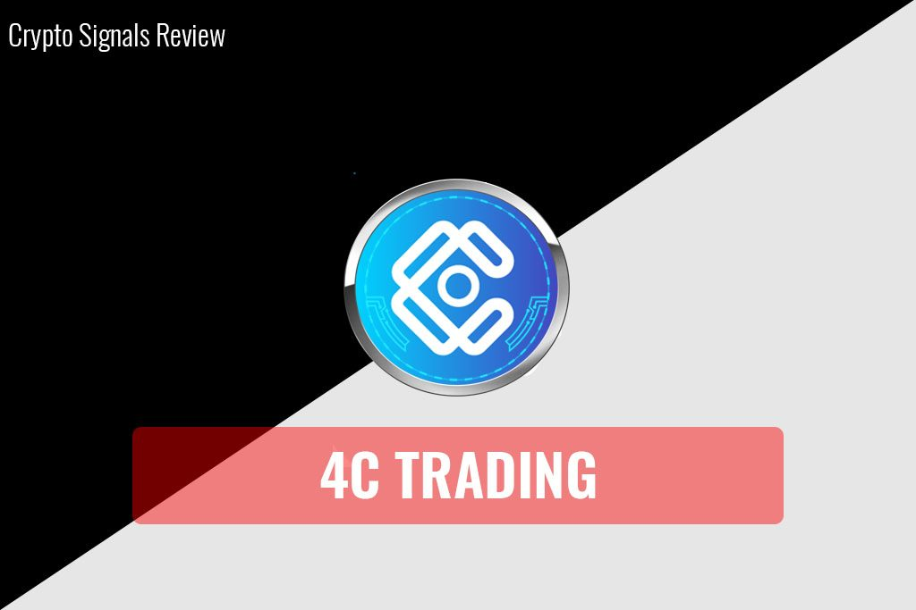](https://forum.mt5.com/customavatars/547823120.jpg)

Many utilities that deliver decent value still receive favorable feedback, but none of them "will" compete with 4C-Trading in terms of total bundle. If we dig a little further, we'll start with what a full-fledged member enjoys when they subscribe to 4C-trading; keep your pen set, because this is going to be a long list:

1. Binance and FTX have their own SMART Bots (For Binance Spot and SMART Margin and fully adjustable, no Cornix)
2. Signals from Binance and FTX
3. A trading app that allows you to exchange on Binance and FTX directly from Telegram.
4. Depending on your subscription, you'll have access to several chat rooms.
5. The weekly 4C-Trading Diamond Report is a demand, opportunity, and macro forecast report.
6. Livestreams with established profitable traders every week

[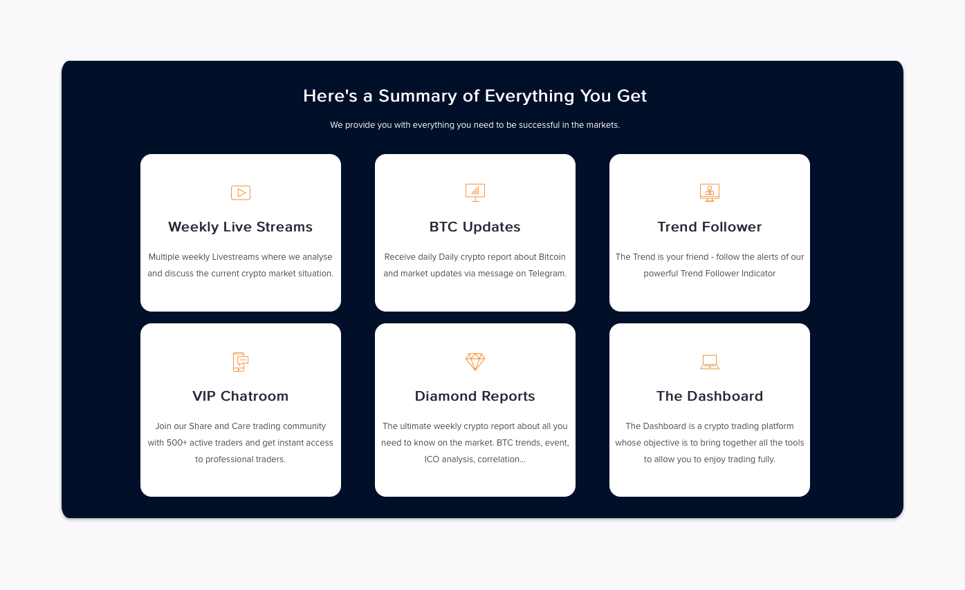](https://forum.mt5.com/customavatars/694947872.jpg)

1. When you're sleeping, SMART Bots, a set of automated bots that switch between BTC, ETH, and LINK pairs, amass.
2. Full-fledged schooling entails the acquisition of a wide range of skills. Have you ever wished to work as a professional trader? You're covered for the 4C-Trading tutorial.
3. A call with a crypto specialist and dealer to get you started right away.
4. Customizable based on your investment objectives
5. In a safe and stable digital world, a full-featured trading and portfolio dashboard is available.
6. Three levels of sets, each tailored to your investment objectives and budget.

**What distinguishes this 4C-Trading Forum from others?**

4C-Trading is the all-in-one solution for those interested in cryptocurrency trading. The authority kit has everything you might possibly want: good signals, excellent auto traders, bots, a superb professional dashboard, as well as a high level of efficiency. Overall, a full range of offerings offered in a spotless and competent setup – see the pros in action!

[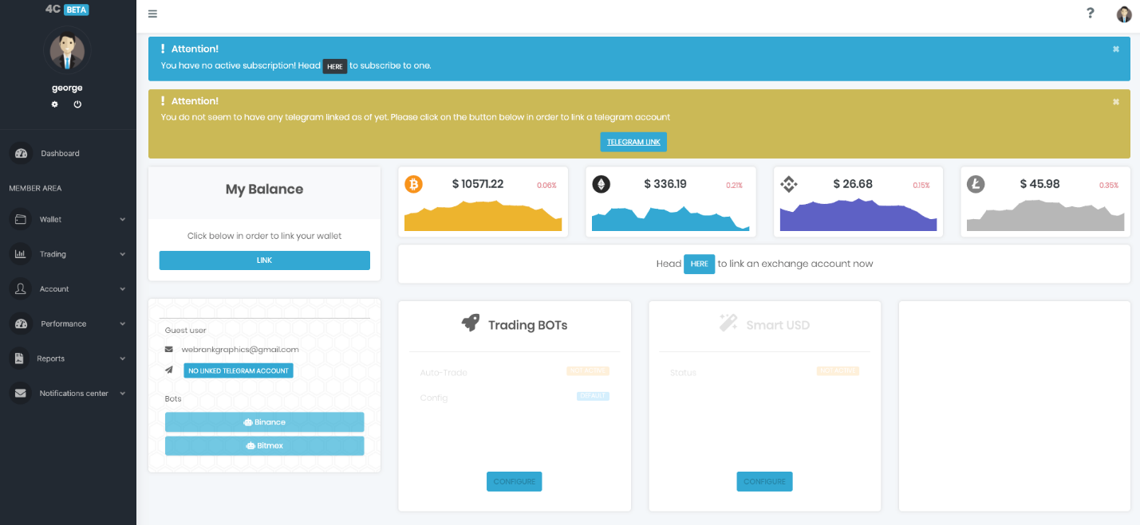](https://forum.mt5.com/customavatars/1680008288.png)

What sets them apart is how adaptable they are to market conditions and how they are continually expanding their crypto product line. They took audience input seriously and sorted it out from there – the merger between the two organizations brought together two of the most experienced organizations in the world, and this, in my mind, would only improve. 4C-Trading is a one-of-a-kind enterprise with plenty of pioneering spirit and the highest quality of technical product available. And, indeed, this distinguishes them from the competition.

**Strong points of 4C-Trading Forums**

**Frequent Trading Bonuses**

If traders like reading about trading or engaging in trading posts in order to make profits, trading forums are the place to be. People join trading forums for a variety of reasons, one of which is to get free bonuses. If you write those blogs, reports, or something else related to forex trading, traders can earn money via the forex reward system. Traders would be compensated for creating unique, educational, and informative documentation to assist forum members. Traders will earn bonuses for each post they make, and if other members begin to post on your subject, traders will earn even more. Traders will benefit from both forex trading and forum postings, in other words.

**Up-to-date Forex News**

Traders will join these forums to keep up to date on the latest trends in the forex industry and other related fields. When traders enter, they will have the opportunity to get first-hand updates about what is going on in the forex industry. Here you'll find all of the content, both nostalgic and industry-related. Trading experts say that having access to information is critical, particularly if traders want to succeed in this field. Traders will hear about stock market patterns, how to get started trading stocks, which stocks to avoid, and other stock-related details. There's still more. Since traders will make friends and get trading guidance on these forums.

**Can Learn New Methods**

This may also convey progressive thoughts and enhance the supplier. Another gain of collaborating in a discussion board is that we are able to research new tactics to handle people, and saving cash on the cease of the day also can be a manner to fulfill new guys and women. By assembly new people, we may also locate new objects. And at the side of this, we are able to additionally have new experiences. A Forex market discussion board may be used to alternate recommendations and perspectives.

**Can Discuss Your Doubts and Questions**

A the Forex market discussion board is an area to enhance your Forex market buying and selling game. Once you find out something approximately yourself, you may be capable of apprehending matters better. A discussion board is simple to locate online. On each internet site you speak, there are numerous boards. In the Forex market boards, we are able to speak and ask a few questions. Since there are numerous clients and for every part of those boards, you may find out many aid engineers. In case you open the internet site, there's a hyperlink in which you may speak your doubts as opposed to eliminating them.

**Can Access It Everywhere and at Anytime**

This offers the administrator of that device the ensure to maintain the gadget in an everyday location, simply as cease-customers have the gain of having an in depth enjoy with their pc desktop. The Forex market Forum is a critical device that can't be discarded. It is a getting to know device for buying and selling. Many one of a kind factors may be effortlessly learned. Today, nearly all web sites have the Forex market Forum replacement. But we are able to best get it relying on the host.  
  
Value introduction strategy. The primary goal of the Forex market Trading is to explain cash marketplace buying and selling. Many boards are used, however they are satisfactory inside the discussion board. On the Internet, we may also locate tips on the way to use a discussion board, and it's far a totally handy manner to discover a greater state-of-the-art one. A discussion board will permit novices to get to recognize many new products. It is a manner to educate younger people. The titles are for novices with enjoyment and skills. There are many motion pictures from which we ought to effortlessly research in a brief time.

**Ending Thoughts**

Overall, traders will be pleased to see 4C-Trading leading the way in this niche market. It's a big step forward for the entire Crypto Signal Market, as many providers will now have to up their game, which will help everybody. If you can see from what you've read so far, we're very enthusiastic about the 4C-Trading service and the massive number of utilities included with the subscription. To sum it up, we'd like to say: If you want the complete trading kit and the most modern equipment, 4C-Trading is the best choice. If you're hunting for a low-cost service that just focuses on signals, this isn't the provider for you.