**Advantages of Using Forum Sites in Forex**

If you want to learn how to trade forex? If that's the case, you can visit some online trading sites to learn more about forex trading and stay up to date with what's going on. The trading forums are important for both beginners and experienced traders. That's where you'll meet and chat with your fellow traders. Surprisingly, thanks to technology and social media, you can visit a variety of trading forums. Most are relatively recent, whilst others have been around for a long time, but they both provide essential forex trading knowledge.

**Background of NinjaTrader Group**

The NinjaTrader Group is a trading software and forex brokerage firm that houses active traders online and offline. Founded in 2003, the NinjaTrader Group developed into one of the trusted brokerage and online trading firms operating. The NinjaTrader Group is now catering 100,000+ trades across the globe, representing 150 countries, and affiliating 600 vendors throughout its channels.

**Offers of NinjaTrader Group**

[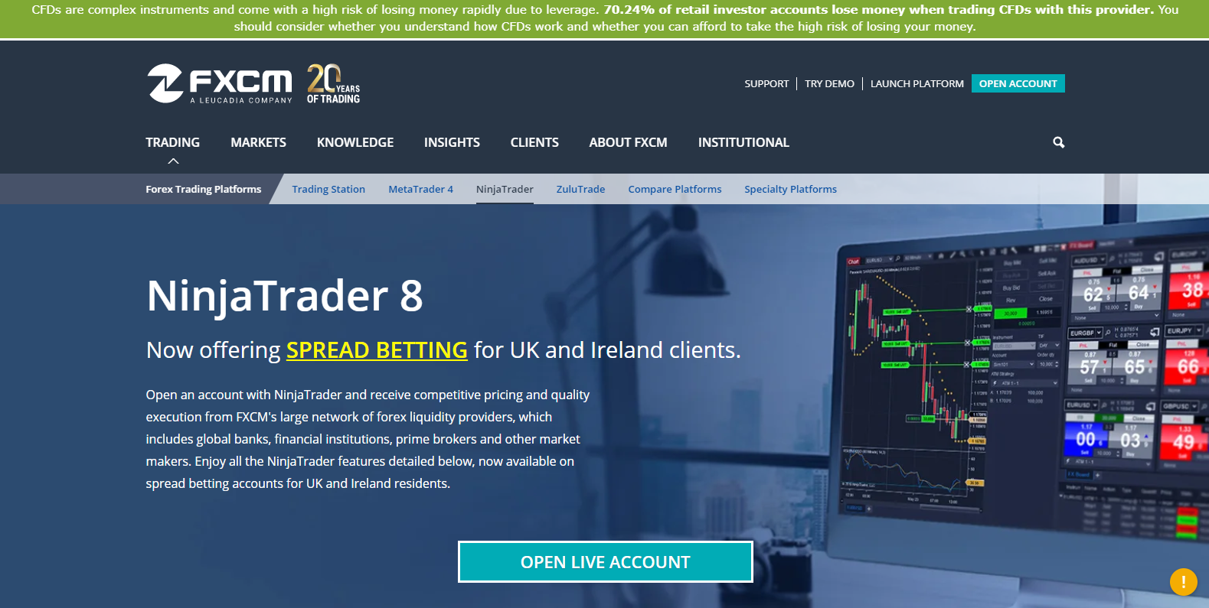](https://forum.mt5.com/customavatars/1769065610.png)

NinjaTrader is a cutting-edge derivatives exchange site that specializes in futures, forex, including options trading. A variety of special trading platforms are available on the website. There is a free edition that lacks the extra features of OrderFlow + and Trader + , but users can still break down tables, backtest tactics, and exchange without paying anything up front. NinjaTrader offers its own brokerage services, but customers can choose from a variety of other brokerage products. Account minimums vary depending on the shares exchanged, and fees differ depending on the network edition. The platform's vast array of instruments and analyzers will provide limitless entertainment for advanced derivatives traders.  
  
The free edition, which comes standard for all brokerage accounts, is an excellent way for new traders to get started without making a financial investment. Traders can add more complexities as their trading skills improve and be able to prepare for more resources and features offered by NinjaTrader.

**For Whom Is NinjaTrader Intended?**

* **Long-term Traders (Investors)**

The long-term traders (Investors) profit directly from NinjaTrader's brokerage services. With unrestricted free use of sophisticated charting, market forecasting, and simulated trading, it's the perfect destination for both successful and new traders.

* **Traders who are more experienced**

NinjaTrader's cutting-edge trading platform offers a wide range of features throughout three license tiers, allowing traders to choose the right option for their trading style. Trader + and Order Flow + are the two selected features available.  
  
Although all consumers get free access to advanced charting, price forecasting, and virtual trading, licensing Order Flow + or Trader + unlocks premium features including an upgraded SuperDOM, an advanced alerting mechanism, volumetric bars, semi-automated order execution, and other complex charting systems.

* **Traders that are actively trading**

With a few of the lowest commissions in the market, traders will keep their per-contract costs down. NinjaTrader's low margins are ideal for active traders as well. The trading platform's technical assistance software will assist consumers in identifying openings and managing execution in competitive markets.

**Forex Forum Sites like NinjaTrader Forum**

The NinjaTrader Forum is somehow difficult for beginner traders to explore. This is mainly because the NinjaTrader platform itself is intended for advanced and veteran traders in the forex exchange community. These forum sites enable the traders, regardless of their knowledge, to exchange information, discourse several topics, and help each one out.  
  
One forum site that is beginner friendly is MT5’s forum site, forum.mt5.com. The platform is dedicated to be user-friendly for beginners and veteran traders. Beginners will be able to relate more on multiple topics it has since there are several categories to choose from.

***Here is the video on how to create an account on the MT5's forum site.***

**Here are some of the benefits of these forums.**

* **They Provide Latest Forex Information**

If you want to stay up to date with the latest developments in the forex market and other relevant fields, you can enter these forums. Users will have the chance to get first-hand reports about what is going on in the forex market if you enter. All material, both nostalgic and industry-related, is available here.  
  
Access to knowledge, according to trading experts, is crucial, particularly if you want to succeed in this area. You'll learn about market trends, how to start stock trading, which stocks to avoid, and other stock-related stuff. And, there's more. Although on these forums, you can make friends or receive trading instructions.

* **Free Trading Bonus**

One of the key reasons why people enter trading forums is to get free bonuses. Trading forums are the venue to be if traders like reading about trading or participating in trading posts so traders can gain money from it. What causes this to happen? Traders will gain money via the forex incentive scheme if you write those blogs, posts, or something else relevant to forex trading.

[](https://forum.mt5.com/customavatars/188028435.jpg)

Traders will be paid to compose original, instructional, and insightful documents to aid forum users. Traders will win bonuses for each post traders make, and traders will earn even more if other members begin to post on your subject. In short, traders can profit from forex trading as well as forum postings. This fantastic opportunity comes to everyone who joins these forums.

* **Forex Education**

Joining forex exchange forums as a beginner is vital for learning what's going on and getting the necessary tips and software to run a forex trading company. Traders will engage with professionals in these forums that have enough resources and guidance to assist traders in the industry. The closed-loop forex pattern indicator is one of the tools and applications included in these forums to assist traders with their forex trading.  
  
There are also a plethora of materials, advice, preparation, and other important guides to help anybody, from a novice to a seasoned pro, succeed. And, there's more. As previously said, traders can gain money by sharing their ideas to teach and train others. It is a win-win situation joining these forums.

* **You Get Counseling**

Foreign exchange trading is not for the faint of heart. Individuals who refuse to consider challenges are not capable of trading. Depending on how the economy is doing, traders can make it or risk it with forex trading. So, where does that put the trader? It would be beneficial if traders had therapy under certain circumstances. **The representatives who work with forex markets are the right ones to advise beginner traders**. What's the best place to look for them? These individuals can be found in Forex Trading forums.

The forums have excellent coaches and moderators on hand to assist and advise newcomers to the industry. They'll give beginner traders tips on what to do and what not to do, and they'll grip your hand until you're ready to rise again. They'll even mold traders' mindset to embrace the consequences, no matter what they are, and keep traders' hands when things go wrong. You'll just be able to enjoy any of these in forums. It's similar to a business school where you'll learn the ropes and have someone to rely on when things go wrong.

* **Real-time Discussions**

Do you know that you will learn how to trade forex by simply listening to discussions? Yes, it's probable. Most sites **have active conversations on new economies**, how to get into an industry, how to get out of an industry, and other strategies. Following your much-needed training, you'll need to keep up with conversations on the most recent facts and tips. You may also join in to help keep the company alive, forming a small trading family in the process.

* **Platform for Meeting Foreign Traders**

Traders may have encountered your local traders and are unsure how to **communicate with traders from several other countries**. Interacting with traders from other countries is easy. The easiest method is to enter forums that attract people from all around the world. You'll be able to hear about their trading module, the stocks they sell, and their overall perspective on stock trading in their country by engaging with representatives from these countries. Traders will learn all of the tricks used for meeting members from other nations, and you will feel at one with the other participants.  
  
Traders could even become friends with them, get their contact information, and ask if they would invite you to visit their community. The biggest advantage is that it expands your horizons in terms of what you sell outside of your world. Forex trading necessitates quick access to data. Parents, coworkers, and even local merchants would not be able to provide you with these details. Joining forums to extend your trading experience is the smartest thing you can do when trading. I hope that this post has been helpful in your quest for the right forum to enter.