**Learn More about Forex Price Action Scalping**

**Overview on Forex Price Action**

Without any need for indices, price action trading helps you to analyze the Forex market. In making trading choices, you use candles, help and opposition, and other chart analysis instead of markers. Since it encourages you to make fast trade decisions, price action is ideal for scalp trading.

**Price Action & Scalp Trading**

* So, why do price action and Scalp Trading complement each other so well?
* Price action investing is all about being in touch with what price is doing right now so you can forecast what it will do next with a high degree of precision.
* Scalp trading is somewhat **similar to day trading**.
* A scalp exchange usually lasts between 5 and 30 minutes. To scalp efficiently, you must first determine what price is doing now and what it will do in the next 30 minutes or so.

**What are indicators, then?**

When it comes to scalping, the majority of traders use indicators, which is a terrible idea. The issue with indicators is that they are slow to respond. Scalp trading and using indicators aren't a good combination. Scalping generally requires quick analysis, quick decision-making, and trade exchange. Price action trading is all about **speed and productivity** at its base.

**The Basics of Price Action Scalping**

Forex Price Action specializes in reversal trade on longer time frames. It uses market action to reverse direction from places of support and opposition. Reversals do not perform well on short time frames. This is because reversal investing is based on pinpointing the exact moment that a pattern ends. There is too much noise on short time frames to reliably detect the culmination of a pattern.

[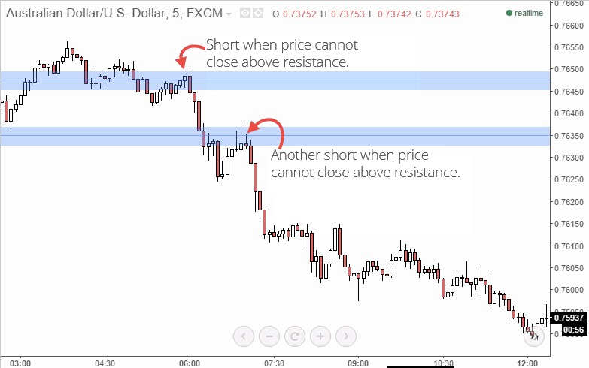](https://forum.mt5.com/customavatars/846518403.png)

As a result, for Forex market action scalping, a different approach is needed. Trend continuations can be traded by traders. We'll be looking for market action signs that suggest a solid trend. When price pulls back to a level of support or opposition, we'll exchange a continuity. This can seem to be a straightforward task, but it is very stressful. One of the most important aspects of this approach is to keep the risk-to-reward ratio below 1:3.

**So, let's sum-up the Basics of Price Action Scalping**

* Only from places of help and opposition will we join scalp trades.
* Only pattern continuations will be traded.
* We'll only enter a trade if our goal is three times bigger than our halt.

The third stage is the most difficult. Many people simply shut out a transaction as it is two pips away from its goal and then reverses five pips. You can't do that; the 1:3 ratio must be maintained. Even if it means your stop will be reached, you must adhere to the 1:3 ratio. I'll go over this in more detail later.

**Areas of Support and Resistance**

You'll have to draw the zones of support and opposition yourself. But don't worry, it's really easy. Let's begin with the two golden rules of resistance and support. These guidelines are applicable not only to scalping Forex market action, but also to the standard help and resistance zones:

* It is still more important to use recent data. Continually.
* The importance of body bounces outweighs the importance of wick bounces.

The first rule is straightforward. Fresh data is often preferable to old data when positioning assistance and resistance zones. This is especially true when working in short time frames. The significance of price action formations which always occurred twenty minutes ago is greater than that of formations that occurred two days ago. Be sure to prioritize recent data when positioning assistance and opposition. On the 5 minute map, traders can generally only look at the last two days. The second rule can be a bit more difficult to grasp. In the examples below, I'll go over it in greater detail.

Let's break down the support and resistance placement process into **three steps**.

STEP 1: **Recognize Bounces**

Identifying bounces on the map is the first step in positioning reinforcement and resistance. Ideally, you'll like a few bounces that are evenly spaced.  
  
A 5-minute chart of the Australian dollar against the US dollar is seen below. Three pairs of noticeable bounces have been illustrated. The lower set demarcates a service zone which is outlined in green. The higher set denotes a resistance zone, which is outlined in red.

[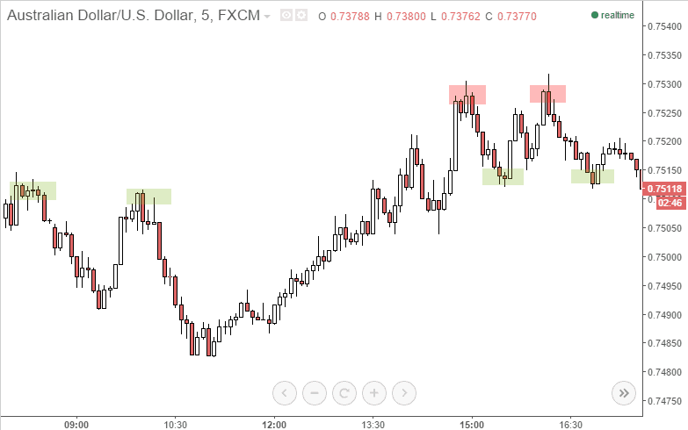](https://forum.mt5.com/customavatars/1224275415.png)

Bounces aren't quite as obvious as this. The greater the field, however, the more noticeable the bounce; thus, you should only try to find the most noticeable bounces.

STEP 2: **Link the bounces with a straight line.**

If you've identified a few bounces, connect them with a horizontal line. The AUD/USD picture from above has been updated to include assistance and resistance zones.

[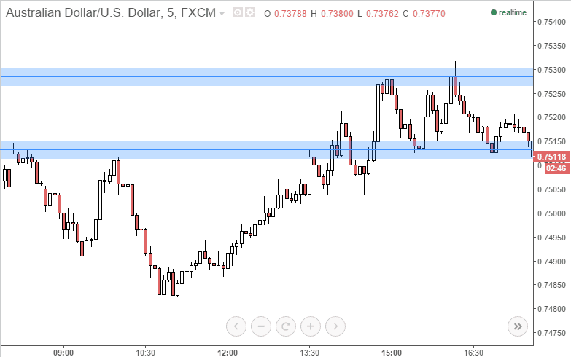](https://forum.mt5.com/customavatars/952509143.png)

That's what there is to it. You aim for areas with a lot of bounce and draw lines there. On longer time frames, support and resistance will become more difficult. On 5-minute maps, though, it's a piece of cake. Know law number two? Is it true that body bounces matter more than wick bounces? You'll note that I draw my line across the candle bodies rather than the wicks in the picture above. Help and opposition should not be imposed at the wicks.

STEP 3: **Continuations Spotting**

Traders should now have a clear idea of where assistance and resistance areas should be placed. The next move is to look into trading opportunities. And I'll teach you how to do it step-by-step. However, there could be a minor issue. The information below can be confusing if you are unfamiliar with candlestick patterns and trend fundamentals. If you're having trouble with the definitions below, check out my market action fundamentals in the Forex education segment. There, I go into the fundamentals of market action and candlestick patterns. The material below will be simple after you've grasped certain principles.

**Spotting the Trend Continuation**  
Have you heard the proverb, "the pattern is your mate"? In this instance, though, the proverb is quite accurate. Price behavior can be used to assess the pattern, get a decent entry, and ride it for a short time. Traders should also be familiar with how to spot a dominant trend; the topic was discussed in the paragraph above.  
  
But the thing about patterns is that they seldom, if ever, follow a smooth path. On a five-minute map, if sellers regulate price for 24 hours (288 candles), price would not go down smoothly per candle for 288 candles. The following is how trends move:

[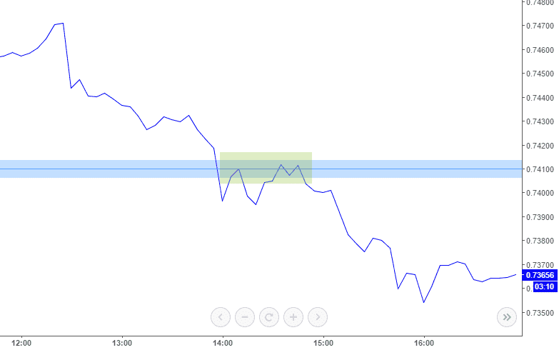](https://forum.mt5.com/customavatars/1995584311.png)

Observe how, once sellers have broken through, buyers drive back up to the previous help level. (indicated in green) A pattern operates in this way. In a bearish trend, sellers have full price power. Buyers are always attempting to gain leverage. Buyers take over for a short period of time, but sellers reclaim control and the cycle continues downward.

Here's an illustration of how trade continuity scalps work. The GIF below will play like a video which will demonstrate how exchange continuity trading operates.

[](https://forum.mt5.com/customavatars/483338609.gif)

Trading with the pattern is the fundamental principle. Traders can tell if a pattern is still alive by using candlestick analysis with help and resistance. You enter a trade for a fast 10-20 pips if the pattern is still alive. Let's look at those specific trade scenarios now.