**Export Live Data from MT4 to Excel**

**MT4 And Excel Overview**

The MetaTrader 4 platform is a well-known Forex trading platform. It comes with a slew of features and resources that can help you trade more efficiently. These techniques can be used by traders to create effective trading strategies. To get the most out of these methods, you'll need to be familiar with MQL programming. Many people are unfamiliar with coding, and handling all of the Expert Advisors (EAs) and benchmarks can be overwhelming. If you're having trouble understanding MQL, you may want to try Microsoft Excel.  
  
Microsoft Excel is a platform that nearly everybody uses. You can use this app to arrange anything from material to expenses and more, whether you're a student, a businessperson, a broker, or even a stay at home mother. Microsoft Excel seems to be a sheet that will help you handle the content on the board. However, it has a slew of other features that, when used properly, may be extremely beneficial to traders.

**Export MT4 data to Excel**

A trader will use a free MT4 file to export live data from MT4 to Excel. During the first process, a trader must open Enable Dynamic Data Exchange Service (DDE server) in Metatrader Tools/Options. For the next move, a trader needs to open the DDE-sample file from its Program Files directory. A trader can adjust values, add new rows and columns, including new instruments in the Excel file.

**Step-by-Step Guide of Exporting MT4 Data to Excel**

**Step 1: Turn-on the DDE server of MT4**

[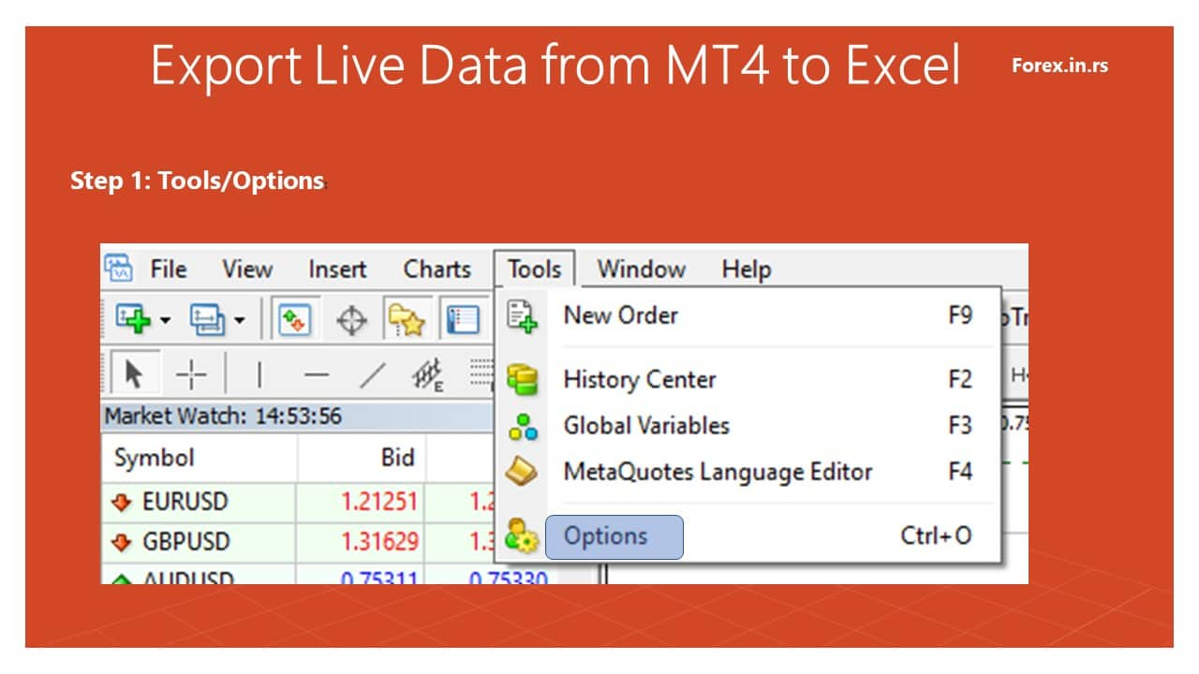](https://forum.mt5.com/customavatars/1192907857.jpg)  
[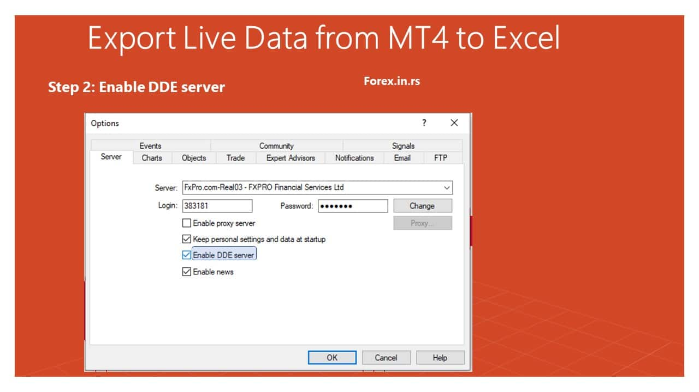](https://forum.mt5.com/customavatars/946006034.jpg)

**Step 2: Execute the DDE sample in Excel file:**

[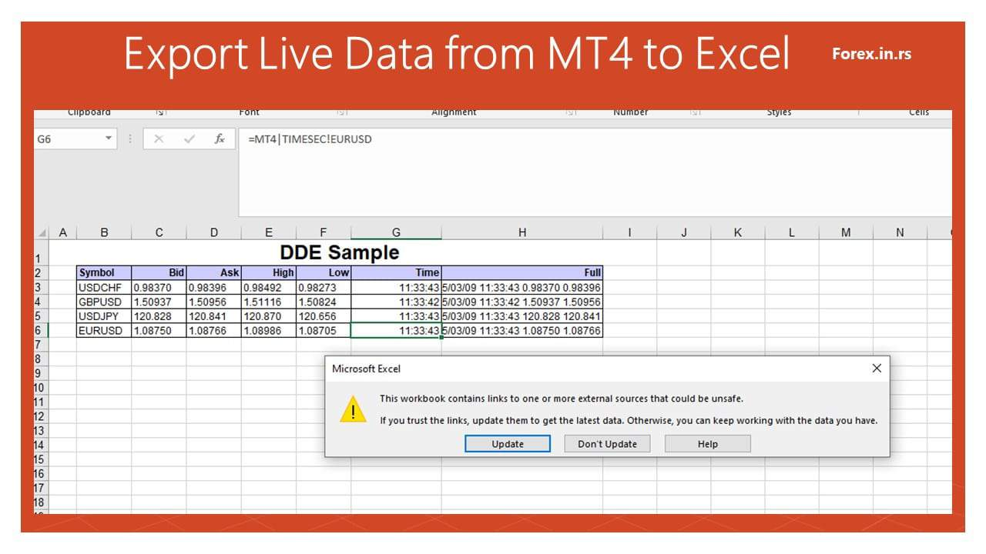](https://forum.mt5.com/customavatars/646653980.jpg)

**Step 3: Establish a connection between MT4 to Excel. Traders can use new instruments such as quotes, rows, and columns and update live data (low, high, ask, and bid price):**

In Excel, traders can call different functions such as BID, ASK, LOW, and HIGH price using commands and manually add new instruments:  
  
In the trading community, this is one of the most obvious changes. Live data from MT4 can be easily exported to Excel. Here is how you can switch values around:

* Open the Excel program and create a Chart.
* Select the file by clicking on it. A box will open in front of you. To save the file, go to File > Save As.
* You may now rename the file as desired.
* Check to see if the file is in.csv format. The term CSV stands for Comma Separated Values. This format is supported by Microsoft Excel.
* After that, press 'Save,' and you're done.

**Advantages of Exporting MT4 Data to Excel**

Let's start with the obvious: Microsoft Excel is simple to use. There are several guides available online that can help you learn techniques. Since it is a well-known program, you should be able to contact someone in your area who can teach you something about it. Let's take a look at some of the other features of this app that will persuade you to export MT4 prices:

1. Traders can easily see data over longer periods of time.
2. Excel files don't take up a lot of space. As a result, you can conveniently swap Excel files as attachments with someone.
3. If you use several brokers on the MT4 website, you can use this app to compare prices.
4. Excel does not need high-speed internet. It even happens when you're not connected to the internet.
5. If you are one of the people who finds it difficult to set up websites, you will benefit from this software.
6. Excel does not fail in the same way as other platforms do. If it does, the information will be saved automatically.
7. It is not a pricey piece of tech. Excel would not cost you much if you still have Office.

**Benefits of Live Data Monitoring in Forex**

* **Traders can look for a broker capable of providing traders with high-quality streaming news, market insight, real-time tracking, and live forex prices** from well-designed trading platforms. Because of these features, traders will be able to respond quickly to all industry trends as they occur. As a result, you won't have to wait for the markets to open before taking necessary action.
* Traders also are able to see the **importance of all their positions in real time** and react to market developments. Any time the exchange rates adjust, this crucial information for the account is reassessed and revised. Traders have instant access to comprehensive statistics about any open location, open order, and the benefit or loss caused per trade. This means traders never have to guess at account equity or be concerned with margin availability. Ideally, traders can try to get access to the same high-quality warnings and insight as top institutional trading rooms have.
* If the broker will supply traders with 24-hour live news and expert commentary from Forex experts in trading rooms all over the world, **traders will be in good shape**. Traders will be able to keep track of important diplomatic, technological, and business movements around the world after that. This level of detail would provide traders with the real-time data traders need to judge business direction and make educated trading decisions.
* Also, look for a broker who will allow traders to trade using live charts, as this will be extremely beneficial. Traders should be **able to exchange directly from the charts of the currency pairs traders interested in**. All of traders jobs, including maps, different formats, and models, should be able to be saved. Traders charting software should help traders to evaluate their trades using Fibonacci lines, pivot points, and the most common technical indicators like the exponential moving average and the stochastic oscillator.
* Trades broker allows traders to sell directly from the charts by providing traders with a visual representation of all their trades and orders. This allows traders to **identify potential trading patterns** by providing them with a visual representation of all their trades and orders. Traders will also be able to fully configure their chart review, warnings, workspaces, and metrics to make their trading experience even better. Live maps will also give traders access to high-quality drawing materials and the opportunity to collaborate with family and friends on projects.