**Guide for Astro Indicator in MT4**

**Astro Indicator Overview**

The Astro Indicator for MT4 attempts to explain the price movements of the market in terms of the sun and moon cycles. People's behavior is affected by these loops, so this measure is expected to represent them in price movements. In short, this indicator correlates the behavior of the price market towards each phase of the moon and sun cycles.  
  
Aside from using the Astro Indicator in MT4, you can also use this in other platforms, precisely the MT5. Experienced traders use Astro Indicator alongside with their preferred type of indicator, it may vary from trend indicator, oscillators, scalping indicators, and so on.

*Note: The terminologies used in Astro Indicator were based on scientific terms that are used in moon and sun cycles.*  
  
  
**Components of an Astro Indicator**

In general, there are different types of Astro Indicator that focus on specific events. The classification was the following:

1. **PlanetCycles**- Focuses on displaying the Angle or Aspects among the two selected planets;
2. **Declination** - Focuses on displaying the declination of all planets
3. **BodyPosition** - Focuses on displaying the Position of all planets.

There are **four (4) elements** that build-up the Astro Indicator:

Coordinates & zodiac setup has 4 options.

* Heliocentric Tropical also known as Western Tropical
* Heliocentric Sidereal also known as Vedic Sidereal
* Geocentric Tropical also known as Geocentric Western Tropical
* Geocentric Sidereal also known as Geocentric Vedic Sidereal

The term **Heliocentric** refers to where the sun is at center. In trading you can **select an specific market variable** and all of the other factors will be monitored that will affect this specific variable that is selected.  
  
The term **Geocentric** refers to where Earth is at center. In trading you can **set a main variable and another variable as partners**. Other factors aside from the two selected variables were monitored to come-up with ideal predictions.  
  
The term **Tropical**is western zodiac method & sidereal is Vedic zodiac method followed by Indias. Meaning these are the connotations that **serve as the highest or lowest values** as possible in the trading that will still be profitable in the traders part.  
  
You can choose anything you like, but know this, with heliocentric coordinates there will not be any moon. Therefore, there will not be any moon aspect timing showing up on chart, nor any DR planet. In trading, there are several combinations of elements that can be paired however **you cannot use all of the elements at once**.

*Note: The words mentioned above (Geocentric, Heliocentric, Earth, and so on) may be confusing at first however if you have tried other indicators you can notice that Astro Indicator is in the field of Indicators that focuses on patterns.*  
  
  
**Steps in Installing Astro Indicator**

1. Install Astro Indicators.mq4 |**Download Link**: <https://www.mql5.com/en/code/download/2227.zip>
2. GetAstro Indicators.mq5 to your Metatrader 4 Directory / experts / indicators /
3. Begin or restart your Metatrader 4 Client
4. Pick Chart and Time Frame where you like to check your mt4 indicator
5. Look “Custom Indicators” in your Navigator in the left side in your Metatrader 4 Client
6. Right click on Astro Indicators.mq4
7. Insert to a chart
8. Change settings or press ok
9. Indicator Astro Indicators.mq4 is accessible on your graphs

**Steps in Removing Astro Indicator**

* Pick the Chart where is the Indicator working in your Metatrader 4 Customer
* Right click into the Graph
* “Indicators list”
* Choose the Astro Indicator and click remove

**Astro Indicator Paired with Turning Point Indicator**

[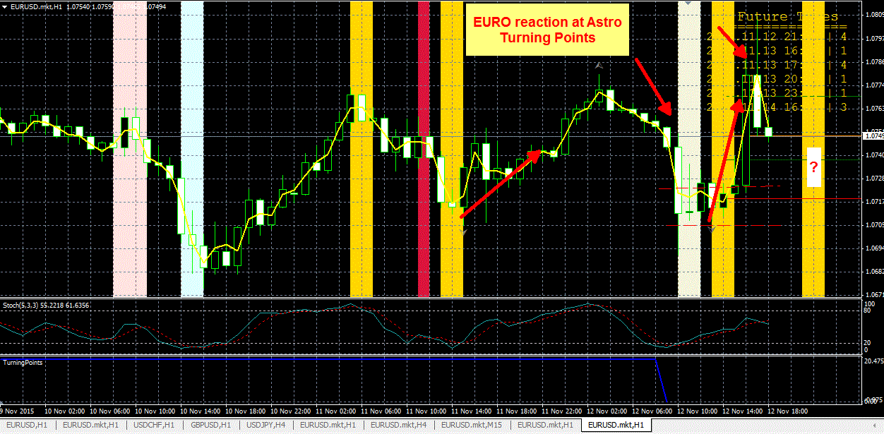](https://forum.mt5.com/attachment.php?attachmentid=361042&d=1618151093)

Combining multiple indicators at once is not new in forex exchange. One indicator that most commonly paired with an Astro Indicator was Turning Point Indicator since the Astro Indicator will be **identifying the patterns** in the specific market that the trader picked. On the other hand, Turning Point Indicator will be **setting the minimum and maximum value** of pips (percentage in point) for the specific phase in the Astro Indicator.  
  
Traders must understand that the Turning Point Indicator itself is not a compact indicator to rely on. The Turning Point Indicator can become your favorite pips predictor and can become any or more of your trading strategy if used cautiously. The features of Astro Indicator backs the lacking side of the Turning Point Indicator which is the ability to monitor and predict the market in each phase.

**Advantages of Astro Indicator or any Pattern Indicators**

[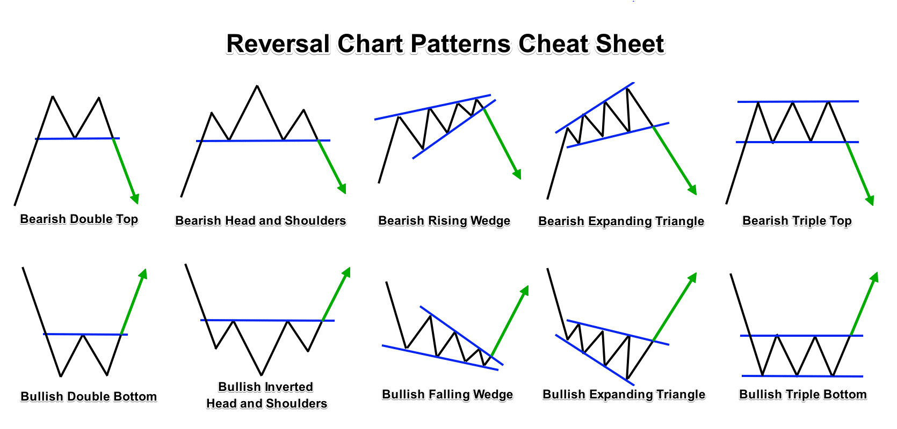](https://forum.mt5.com/customavatars/1699176455.png)

* **Traders will be able to see trends right away.**

Many trend-following tactics aim to **spot where a market is gathering enough traction** to shape a new trend, and as a response, you'll grab most, if not all, big trends. Given the fact that patterns will last for weeks, you might be in for a long and enjoyable journey.

* **Traders Entries and Exits Signal is not Exact**

Mostly as trend follower, you're looking to profit from the market's major changes and aren't bothered over small fluctuations. You clearly have **a lot of room to maneuver** and can afford to miss the peak of the trend.

* **It doesn't take a lot of time.**

Trend Following is a low-speed trading strategy that can be **used by people who work full-time**. Long-term trends emerge, and, as previously said, excessive accuracy isn't a vital consideration. As a result, because after the market closes, you will position your purchases for the next day. It's possible that for certain trend-following tactics, orders will only need to be posted once a week.

* **Lowered Transactional Fees**

Transaction costs would not be a problem since this is a relatively slow-paced trading process. This is a significant improvement over many other types of investing, such as day trading, where exchange costs will make certain techniques unsellable.

* **You reduce the losses as soon as possible.**

A big part of any great trader's trading performance can be attributed to their **ability to manage downside risk** while optimizing upside potential. Although this can seem to be self-evident, many new traders are unaware of it. The problem is that many people hang on to lost trades in the hopes that the economy will finally recover and offset their losses.

**In Summary**

To begin, the setup for the charts must be according to the astronomical position of the planets (selected variable) then the traders must test the other factors and see which of these factors contribute the most to the selected variable. If you try the same setup on EUR/USD.GBP/JPY, or Gold you can see which currency or variable is reacting then you need to focus on it more.  
  
Take advantage of the foreseen trends in your chart and decide whether it is time to purchase or sell some stocks. Take note that Trend following is one of the most common trading strategies, and it has been around for quite some time. However, as technology advances and consumers become more available, basic ideas from the past can no longer be applicable. You must come up with your own innovative ideas that most other industry players haven't yet encountered in order to stand a chance in the increasing competition.