**Guide to Fixed Fractional Trading**

**Introduction to Fixed Fractional Trading**

The **Fixed fractional trading is one of the Money Management Styles** out in the market. Alongside with Fixed Fractional was Fixed Ratio in which both help traders to maximize budgeting, planning, borrowing, spending, or overseeing their capital use. Investment management and fund management are two subsets of the concept.  
  
Day traders have developed a number of techniques for handling their assets over time. Few are founded on superstition, but the majority are based on mathematical probability hypotheses. The basic concept is that you can never bring any of your investments into a single transaction, but instead invest a reasonable sum based on the degree of uncertainty. You risk losing everything if you don't.

**Money Management Styles**

[](https://forum.mt5.com/customavatars/1965882372.jpg)

Money management is the practice of monitoring and arranging a person's or a group's capital use. Budgeting, borrowing, saving, and investing are also examples of money management in corporate and personal financing.  
  
Person clients receive money management products from private banking financial advisers. Corporate clients profit from commercial banking's money management services. Money management is also known as fund management and wealth management in the capital markets. Financial practitioners are in charge of managing portfolios and making investment decisions on large groups of money.

1. **Fixed Fractional**

In Fixed Fractional Trading, you can assign a percentage to what extent you want to reach before selling or buying. Fixed fractional trading means you want to restrict each exchange to a certain percentage of your overall portfolio, usually between 2 and 10%. Under that spectrum, you'd spend a greater percentage of your money in lower-risk trades and a lower proportion in higher-risk trades.

N is the number of contracts or share prices you could sell, f is the set percentage of the portfolio you've agreed to trade, equity is the actual value of your account, and trading risk is the sum of money you might lose on the deal. Since trade risk is a negative sign, the calculation must be transformed to a positive number (absolute value).  
  
This assumes that if you were to limit every trade to 10% of your portfolio, get a $20,000 balance, and the chance of loss is –$3,500.  
Of default, you won't be allowed to trade. The 57 of a deal, but you'd have to round up to one in this situation.

1. **Fixed Ratio**

The difference of Fixed Ratio to Fixed Fractional Trading is the setted value to be achieved before selling or buying a specific share. Trading options including futures employ the fixed ratio money management scheme. The aim of fixed ratio trading is to support you maximize your market visibility while still securing your earnings. This equation is used to determine the optimum number of calls or futures contracts to sell, N:  
  
The triangle, delta, seems to be the dollar sum you'd like before trading a second contract or another bunch of stock, and P is your total benefit to date. (Not to be confused with the delta, which is an indicator of volatility.)

A $3,500 minimum spread is expected for a Chicago Mercantile Exchange E-Mini S&P 500 call option, for instance. You won't be able to exchange a second deal till you have another $3,500 in your portfolio. If you exchange this future for fixed ratio wealth management, the delta will be $3,500.  
  
  
If the delta is $3,500 and your portfolio earnings are $10,000, you can exchange 1.2 deals (see figure). In practice, this means you can either exchange one or two contracts, with no options in between. One of the flaws in most money control schemes is this.

**Important Note:** Keep in mind that **Fixed Fractional and Fixed Ratio are money management processes**, it is still up to the trader on what technical indicators they will use in their daily trading process. The ideal technique is **having a Market Analysis tool, Money Management Process, and Technical Indicators** in place.  
  
  
**Advantages of using Fixed Fractional Trading**

[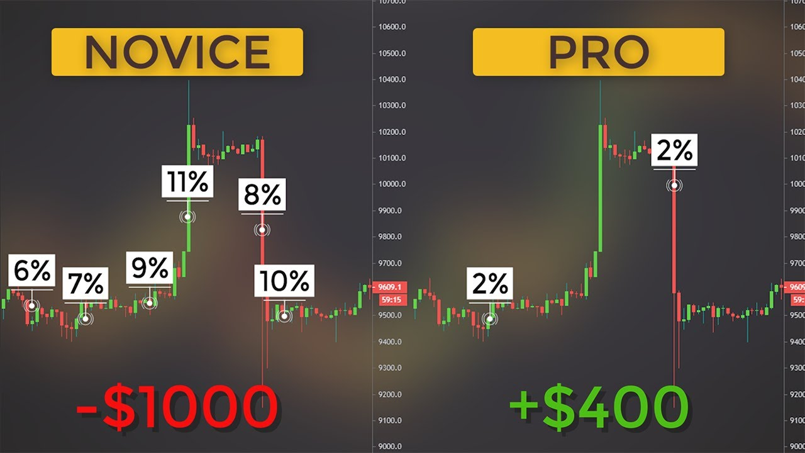](https://forum.mt5.com/customavatars/1345848271.jpg)

The best thing about this method is that you can **tailor it to your risk level** by changing the parameters. Several trading platforms such as Instaforex enable Money Management approaches to have merit, however traders choose this strategy because of its potential to be personalized and intrinsic flexibility.

* While marginally more difficult to use, all you need is an Excel spreadsheet with the exchange rates, account size, and percent risk feedback to get the proper location size. Traders must **have a robust spreadsheet** for all of the main currency pairs built in that is free to use.
* Since the size of the exchange remains equal to the equity, it is technically **difficult to go bankrupt** using the Fixed Fraction formula, so the official chance of complete bankruptcy is negligible. It is an anti-martingale tactic that seeks to protect one's wealth for as long as necessary.
* When using this form, the size of the place is steadily increased when you win and gradually reduced when you lose. Throughout a winning streak, **increasing the size of positions** helps the portfolio to expand geometrically; during a losing streak, reducing the size of trades reduces the chances of the trader's assets.

**Ending thoughts**

In trading in forex, it is important to ensure your profit over anything else. Having a money management process in use enables you to maintain on track. Most traders take for granted the essence of observing the market price fluctuations hence resulting in poor decision making. Aside from using these money management processes such as Fixed Fractal and Fixed Ratio, utilizing different market analysis will help traders come-up with positive decisions in trading.  
  
When trading for several pairs and time perspectives, the place size measurement must be streamlined. As a result, the Fixed Fractional model is not the most straightforward of the strategies. The Fixed Lot model, but on the other hand, simplifies the mechanism greatly, but it lacks the inventiveness needed to get the most out of your system's run-ups. Other variants of these money management frameworks to deal with will be discussed in a future paper.