**Install Now! Darvas Box on MT5**

The Darvas Box is indeed a Metatrader 5 foreign exchange indicator which illustrates Nicolas Darvas's graph data analysis, which is very common in the US and Europe. Nicholas Darvas' popularity is primarily attributed to its faith throughout his investment strategy. He honed some risk management skills and learned to take profits off the tables until the role could reverse. The Darvas Box indicator's technique is based on his system of identifying new patterns. Darvas used a special filter during its research, the Darvas Box indicator, which calculates the importance of different price acts. A blue upper boundary and a magenta lower boundary make up the indicator. In that sequence, the breakout of a top or bottom boundaries constitutes a buying and selling warning.  
  
**Example Chart**  
The Darvas Box Metatrader 5 forex indicator is seen in operation mostly on EUR/JPY Daily graphs.

[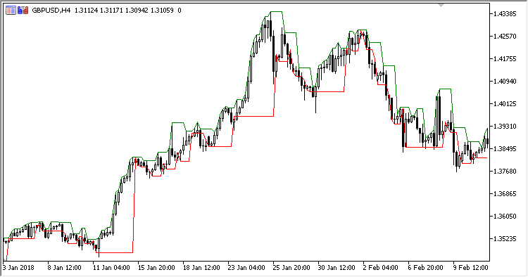](https://forum.mt5.com/customavatars/24844249.png)

**Basic Trade Indications**

**Buy Signal**: Whenever the value goes just above Darvas Box Metatrader 5 forex indicator's blue upper border, move high.  
  
**Sell Signal**: Whenever the value goes below the Darvas Box Metatrader 5 forex indicator's magenta lower border, move low.  
  
**Exit buy trade**: Unless the market drops below the lower boundary of the Darvas Box predictor when in a bullish pattern.  
  
**Exit sell trade**: If price bursts above the upper boundary of the Darvas Box indicator during a bear market, cancel all selling pressure.

**Tips**: The Darvas Box indicator plan is suggested for use on the regular chart because it is an excellent method for long-term trading.  
  
The Darvas Box indicator's approach is a tried-and-true tool for making correct investment decisions.  
  
**Download Instructions for MT5 Indicators**

[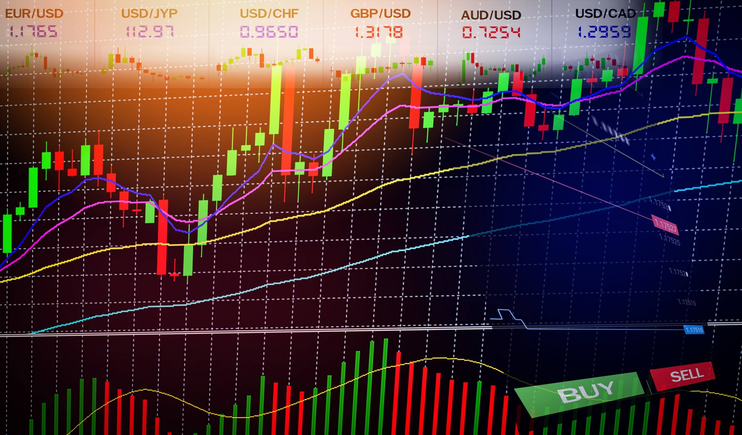](https://forum.mt5.com/customavatars/2000003189.jpg)

Darvas Box MT5 Indicator is a Metatrader 5 (MT5) indicator whose function is to convert cumulative historical data. Darvas Box MT5 Indicator allows you to spot multiple anomalies and trends in market movements that are otherwise undetectable to a human eye.  
  
**How to Install Darvas Box MT5 Indicator.mq5 to MT5 Chart?**

1. Install Darvas Box MT5 Indicator.mq5
2. Get Darvas Box MT5 Indicator.mq5 to your Metatrader 5 Directory / experts / indicators /
3. Begin or restart your Metatrader 5 Client
4. Pick Chart and Time Frame where you like to check your mt5 indicator
5. Look “Custom Indicators” in your Navigator in the left side in your Metatrader 5 Client
6. Right click on Darvas Box MT5 Indicator.mq5
7. Insert to a chart
8. Change settings or press ok
9. Indicator Darvas Box MT5 Indicator.mq4 is accessible on your graphs

Downloadable Link: <https://www.mql5.com/en/code/498>  
  
  
**How to remove Darvas Box MT5 Indicator.mq5 from MT5 Chart?**

1. Pick the Chart where is the Indicator working in your Metatrader 5 Customer
2. Right click into the Graph
3. “Indicators list”
4. Choose the Indicator and remove

**MT5 Indicator Features**

* Any currency pair is appropriate.
* Metatrader 5 is the trading site.
* Indicator of map template form
* Variable (symmetry, horizontal change of the indicator in bars), width, and style customization options are available.
* Type: trend

**Darvas Box Theory**

[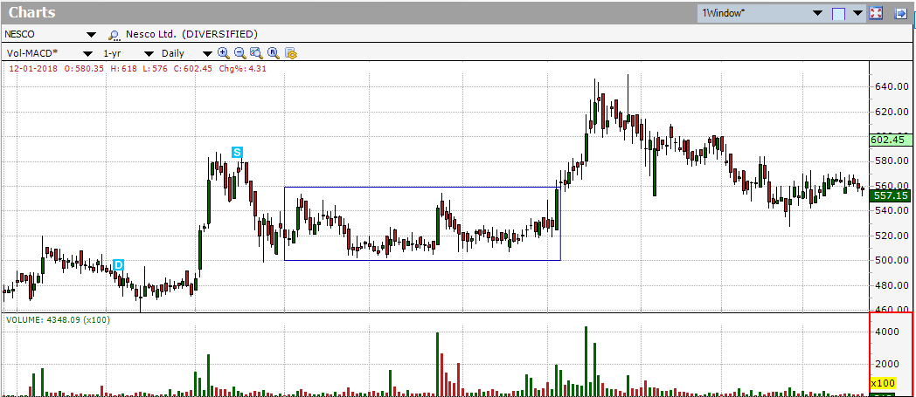](https://forum.mt5.com/customavatars/1987317424.png)

A form for market portfolio is the Darvas box theory. It decides whether to join or leave the market using market concept or topic or technical research.  
  
Darvas boxes are a basic symbol that is made by drawing a line between lowes and peaks. You'll see rising or dropping boxes as you update the rises and lows over time. Darvas box theory implies just selling rising boxes and adjusting stop-loss orders based mostly on peaks of the containers which have been broken.  
  
Despite becoming mainly a theoretical approach, Darvas box theory did include some fundamental research in order to decide which markets to approach when it was first developed. Darvas concluded that his approach performed well in markets where new technologies had the most ability to excite customers and customers. He also favored companies that had consistently high profits over time, especially unless the economy were volatile.  
  
**The Darvas Box Theory Provides Insights**  
While the Darvas Box Hypothesis was very influential at the time, it is unlikely to be as effective in today's investment environment. Today's knowledge quality is much better than it was when Darvas was successful. Whenever a stock's pricing activity increases past the previous peak then slips down to a price similar to that high, it is said to be in a Darvas box. Given this, that concept provides some important observations, including:

* Concentrating on **high-growth sectors**
* Investing in stocks with a **high selling rate**
* **Stop-loss orders** are included.

Darvas advised shareholders to pay attention to stocks with high volume because it was an indication of a stock's power. Although a large portion of trading volume is produced through algorithmic, non-human traders, such an activity could be restricted nowadays.

Stop-loss instructions were used to limit costs and keep profits off the table through roles. The stop-loss order is a kind of free order that tells a broker to offer a place if it falls below a certain threshold. It will assist in limiting place risks and establishing a comprehensive insurance plan.  
  
**Additional Info About Forex:**  
The term "forex" refers for "financial exchange," and it refers to the purchase or sale of one commodity with another. It's the world's most highly traded market since individuals, companies, even governments all engage, and it's a simple market to enter without a lot of money. 1 You're investing in the worldwide currency market as you go on a holiday or swap those US dollars for euros.  
  
The market for a specific currency would either drive it up or down in value in comparison to many other currencies at a certain given time. On currency trading, any exchange involves the simultaneous purchase and sale of currency pairs. These are referred to as 'currency pairs,' because they are made up of a main currency and a quotation monetary system.  
  
Financial instruments are often traded in currency trading. Since there are both currencies present while exchanging dollars for euros, the conversion often reveals the price of one currency in relation to the other. The EUR/USD rate, for instance, indicates how many US dollars (USD) are required to purchase one euro (EUR).