**Forex: Fractal Chaos Bands Indicator**

**Overview on Fractal Chaos Bands**

The **Fractal Chaos Bands** (FCB) incorporated by reference back in time based on the number of time periods the trader decided to graph. The higher fractal line is drawn by mapping the high prices of an instrument, while the lower fractal line is drawn by mapping the low prices. The Fractal Chaos Bands, in reality, show an overall picture of price movement by screening out minor price movements.  
  
Even the pickiest merchants can discover something that worked for them among the platform's many markers. Most traders tend to use well-known indicators because they have been thoroughly vetted by others and there are numerous materials and techniques available to clarify how to use them. Today, however, we'll look at Fractal Chaos Bands, a somewhat less influential but certainly worth trying indicator. If used properly, this indicator has the capability to eliminate the confusion in your traderoom, as its name suggests. It may be used alone or in conjunction with other signals. Let's take a look at what it can do for a merchant.

**Fractal Chaos Bands Indicator**

[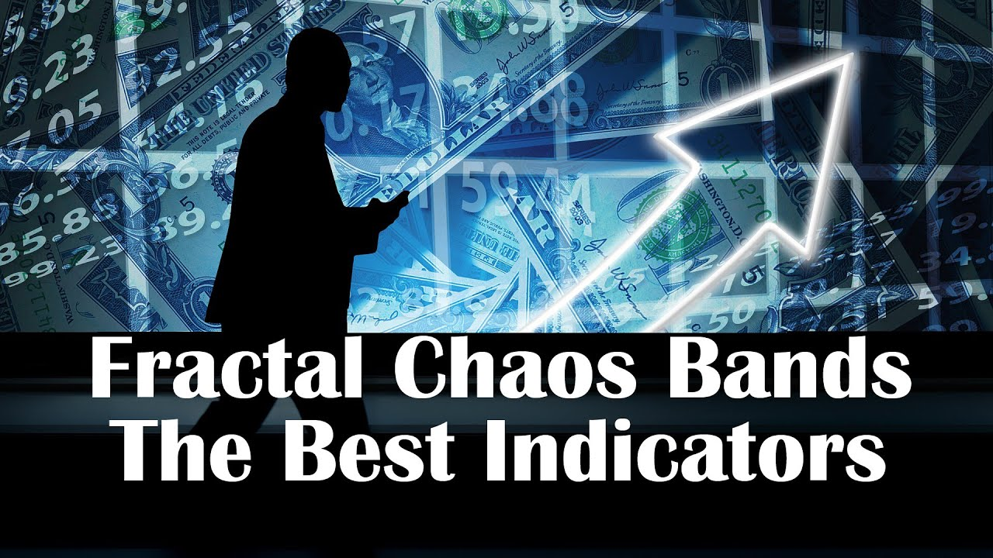](https://forum.mt5.com/customavatars/1041663180.jpg)

**Fractal Chaos Bands Indicator belong to Technical Indicators category**. This means that it is a pattern-based and does base its prediction from historic data or previous market data. Although the market appears to move in a chaotic manner, once irrelevant price fluctuations are removed, a trend can be discerned. This indicator conducts precisely that: it connects the higher and lowest pricing strategies on intervals to form upper and lower bands. The upper band is made up of premium highs, and the lower band is made up of price lows. The indicator's bands imitate the chart's mobility, but they smooth out the price noise by only taking into account important price changes.

**How to use Fractal Chaos Band Indicator?**

[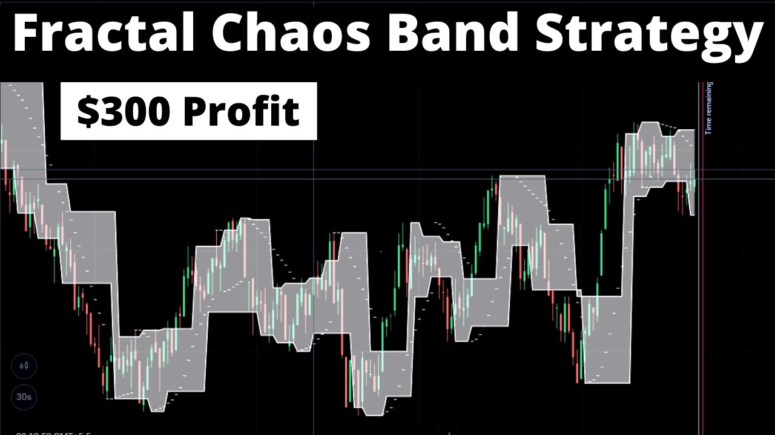](https://forum.mt5.com/customavatars/487590697.jpg)

Whenever the band is flat, the price of the asset is more unstable. Whenever the bands begin to move further apart, suggesting stair steps, this signals the start of a new trend.

* **Buying Signal**

While using this indicator, a trader should use the breakout technique. When another chart moves in a narrow strait and breaks through the upper band from below, a Buying signal is earned using this tactic.

* **Selling Signals**

When the price moves in a narrow channel and pulls via the lower band, it is considered a selling signal.

A Simple Moving Average can be used to assert the signals of Fractal Chaos Bands. A purchasing or selling signal from the bands will be validated by the chart stance of the moving average: attempting to cross from underneath in an upward trend both crossing from above and in a steady decline.

**How to apply Fractal Chaos Band Indicator?**

The indicator can be added to the chart directly from the Other section of both the Indicators tab on the platforms, because it does not require any additional calculations. For ease, the color of the bands can be altered. This indicator can be used in conjunction with other trend or momentum indicators, making it genuinely universal. In fact, no indicator can ensure success 100 percent of the time, so a risk management approach is essential. That now you understand how the Fractal Chaos Bands Indicator functions, you can test it out on a demo account and see if it will fit into your trade strategy.

**What is Forex Technical Indicator(s)?**

Forex pointers are used by agents reliably to grow the chance of making an advantage on the FX market while trading on **Instaforex**. Close by various sorts of data and assessment, markers can affect trading decisions and may be used as the justification Forex trading systems. With the **ability to review past market leads** and models, sellers may have the choice to use the best Forex pointers to help anticipate how the market will act later on and, thus, which trades are most likely going to be gainful.  
  
If you are using markers to help you make trading decisions on your **Instaforex** account, you'll need to use the best Forex pointers out there. With so various to peruse it will in general be difficult for new vendors to know which pointers are likely going to be by and large exact, yet Forex trading for learners may help them with picking what sort of market examination is more fit to their trading style.

**Where to Use Forex Technical Indicators?**

Exactly when you register for an **Instaforex** demo or veritable money account, you'll acquire induction to all our accommodating clues and associates too. With Forex pointers, curated adventures, a Forex signals application and an easy to-use trading stage, you could start trading on the FX market straight away. **Instaforex** even has an extent of electronic trading guides who are nearby to explain their very own trading decisions and procedures, so you can benefit from their dominance and experience. Trading on the FX market can bring enormous returns yet using Forex pointers to plan your trading framework can make your endeavors essentially more helpful. To find more or to examine the Forex markers available, register with Instaforex now.

**What Is MT4?**

MT4 is an instinctive and straightforward internet exchanging platform. It's utilized by dealers to hypothesize on the cost of major monetary business sectors. These incorporate forex, wares, stocks, files and even digital currencies. That is simply to give some examples. It became famous on the grounds that clients could make their own programmed exchanging procedures. Furthermore, has since gotten probably the best platform available for mechanizing your exchanges. On the off chance that proficiency is for you, so is MT4.

**Highlights of MetaTrader 4**  
A basic interface is the thing that makes this exchanging platform famous among Forex brokers. The platform upholds a wide range of exchanging strategies - both, supporting and LIFO. Though, MT5 doesn't uphold supporting and executing FIFO as a matter of course. It permits a merchant to send 2 market orders, 4 forthcoming orders, 2 execution modes, 2 stop orders and a following stop. Different dialects: merchants from everywhere the world can utilize the MT4 platform and its information in their local language.  
  
**Tools for charting**: you can alter shadings and styles, load preset layouts, just as erase superfluous highlights. Every one of these instruments work on outlines perusing. Since MT4 is profoundly famous among merchants, you can discover more information, books and models identified with exchanging on this platform. Likewise, the platform has a broad local area of designers of markers, contents, counsels, modules, and projects written in MQL4.The platform forces less framework prerequisites on a PC than MT5, and takes less RAM. Financial news channels are accessible in an online system.

1. There are nine different time periods.
2. A wide range of scientific analysis methods are available.
3. Financial news on the internet
4. Trading that is automated
5. Positions that have been locked
6. A large number of free indicators and consultants are available.
7. You have the option of creating your own indicators and advisers (MQL4)
8. 128-bit encoding ensures maximum security.
9. Trading with a single click
10. Stopping in the rear trail

**Types of Technical Forex Indicator(s)**

A technical indicator on Forex depends on an estimation of an exchange volume and a cost. Breaking down a forex indicator dynamic, a dealer can decide a transient value course or a level market. Brokers, who lean toward forex technical analysis, settle on choices by methods for forex technical indicators on whether to open or close positions.  
  
**There are several types of technical indicators**.

* **Trend indicators** break down value variances of an exchanging instrument. Utilizing trend forex indicators in exchanging, it is feasible to decide a value heading on different time spans. Additionally, a trader can decide whether a cost is trending firmly. Trend forex indicators are adaptable apparatuses which are useful to any exchanging procedure.
* Among **trend indicators**, there are indicators of trend lines. Having investigated past value designs, a trader attempts to broaden a trend line with an end goal to foresee a further value bearing. Notwithstanding, such expectations couldn't materialize practically speaking.
* **Channel indicators** are utilized when exchanging value channels. Essentially, such indicators are a visual portrayal of help and opposition in any time span. Utilizing channel indicators, you can set a channel width all alone and select introductory information which are expected to plot this indicator.
* **Oscillators** are forex indicators which empower traders to procure fair benefits in the level market. Oscillators are useful to decide new lows and highs on a graph as an oscillator signals when a cost will alter its course.
* **Leading indicators** predict future trends before they really appear in an economy of a specific country. By methods for instability indicators, examiners judge a benefit making condition on Forex.  
    
  [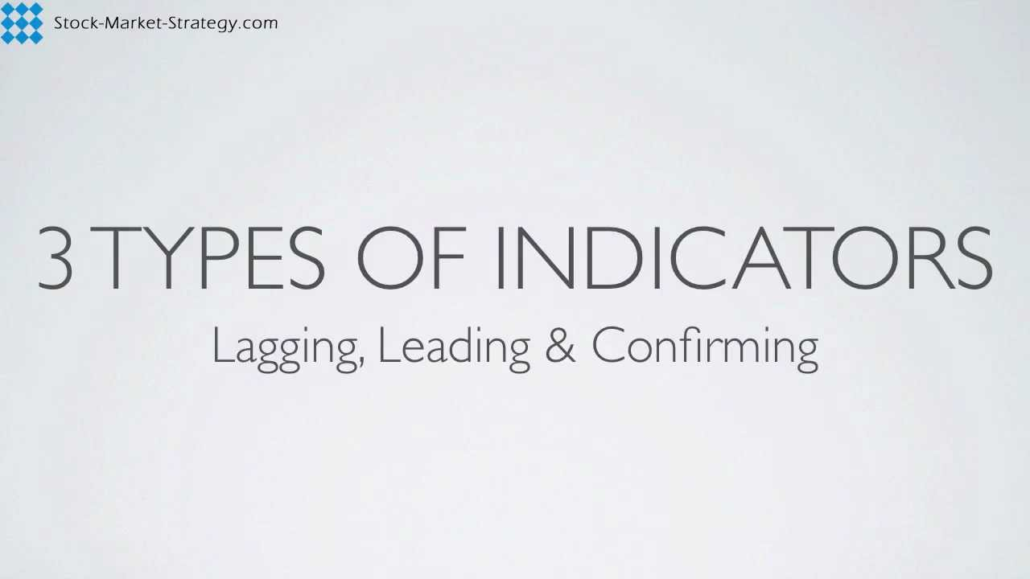](https://forum.mt5.com/customavatars/1133866165.jpg)
* **Pure scalping indicators**are seldom utilized on the lookout. A trader needs to build up a balanced scalping methodology for better exchanging results. Utilizing a solitary scalping indicator is of little assistance.
* A **trade volume forex indicator** empowers a trader to measure strength or shortcoming of a market move as it affirms a trend when a value rises or falls.
* A **divergence forex indicator** is a sign, which emerges if there should arise an occurrence of conflict between specialized indicators and a value dynamic on the diagram. This happens when the indicator doesn't fix a higher high and lower low. Any divergence forex indicator shows an obvious value deviation from the forex indicator's outline in an exchanging stage's window.
* **CSS indicator**is intended to quantify the strength of monetary forms comparative with one another. Count of definite CSS esteems depends on specialized information that permits traders to react instantly to any market changes.

To see signals for a market entry or exit, pointers are applied to value outlines and exchange volume graphs of monetary instruments. Investigation of pointer's qualities welcomes valuable data on a further value bearing or even an exact conjecture of a future cost. MetaTrader 4 has underlying forex markers that trigger pretty much every fundamental pointer that is available these days. Working with MetaTrader 4 empowers you to utilize every one of them when trading.

**Final Thoughts**

There are various benefits to forex trading nevertheless, correspondingly similarly as with any market, there are moreover related threats and it should not be sought after delicately. While this article has covered the guideline advantages of forex trading, it's moreover irreplaceable that you adapt yourself with the potential snares to promise it's the right decision for you. Forex trading isn't a fraudulent business model. Or on the other hand perhaps, it is a drawn out methodology that requires data and a sharp appreciation of what overall events can mean for the market. Before you center around a financial endeavor, you ought to do expansive exploration and assurance you understand the mind boggling subtleties of the market, think about totally related particular terms and are available to confronting theoretical difficulties with your capital.