**Download Now! Squeeze Momentum Indicator**

**What is Squeeze Momentum Indicator?**

The Squeeze Momentum Indicator, created by John Carter of Trade the Markets now branded as Simpler Trading, has become a volatility as well as momentum indicator that takes advantage of price's propensity to break out strongly after leveraging in a tight trading range.

**Download the Squeeze Momentum Indicator Here:**[**https://www.mql5.com/en/code/download/8840.zip**](https://www.mql5.com/en/code/download/8840.zip)

**What is Squeeze Momentum Indicator made of?**

The squeeze indicator is a combination of:

1. **Bollinger Bands**

The Bollinger Bands indicator is indeed a **technical analysis tool** that reflects assets ratio and price movements. For example shares, commodities, and even currency. The Bollinger Bands are derived using a moving average's standard deviation. It's normally shown on a price trends graph. Envelopes and Bollinger Bands are identical. The distinction between these two signals is that the Envelopes' borders were built on a fixed distance across each moving average, reflected in percent, whereas the Bollinger Bands' borders were built on a distance equivalent to the total of standard deviations. Because the standard deviation's rate is obtained by volatility, the Bollinger Bands adjust their width under their own: they expand when the market fluctuates and contract when the market is static.

Bollinger Bands are typically illustrated on a price graph, but they can also be used on an indicator map. The Bollinger Bands, just like Envelopes, are driven by the fact that prices tend to stay within the candlesticks' upper and lower limits. The Bollinger Bands as just an indicator are distinguished by their variable width, which is caused by price volatility. The bands expand during times of high volatility, allowing prices some breathing room. The Bollinger Bands broaden during times of low volatility, keeping costs within their bounds.

1. **Keltner Channels**

The Keltner Channel specialized marker was created by Chester W. Keltner in 1960 and first presented in quite a while in the book How to Make Money in Commodities. Later Linda Bradford Raschke distributed adjustments for the Keltner Channel giving more information examination. Today this variation of pointer is utilized in exchanging. The Keltner Channel **pattern marker** has a comparative construction to Silver Channel, Bollinger Bands, Donchian Channel and different pointers that work with value limits.

[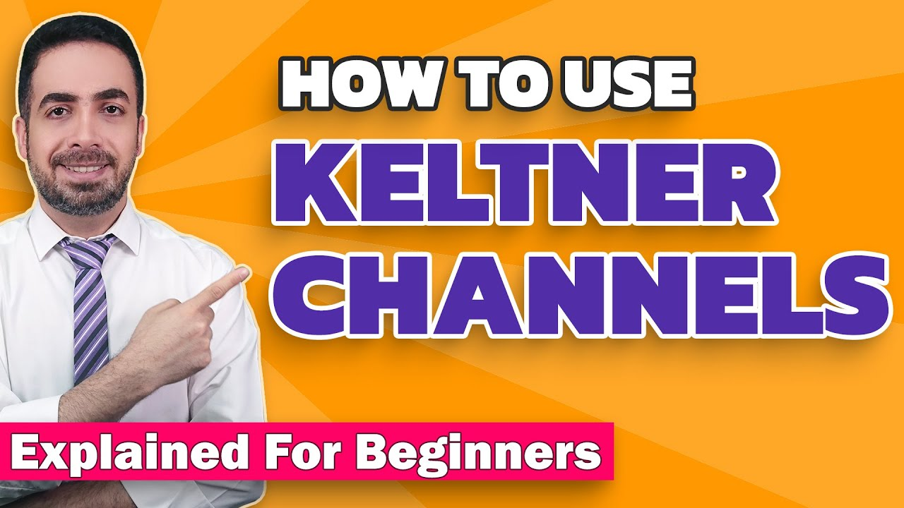](https://forum.mt5.com/customavatars/2137429111.jpg)

Both sell and purchase flags in this marker are produced by the costs that moved inside the channel for an extensive stretch of time and broke out. Subsequently, the best second to enter the market at breakout is the circumstance where the light body, which gave the sign, totally covers the upper or lower groups of Keltner Channel. For this situation the merchant can stay away from numerous bogus signs. The size and state of the light body are not significant. The entire flame body ought to cross the channel. One of the states of viable exchanging with Keltner Channel is to utilize higher time periods.

1. **Momentum Oscillator**

During times of low instability, Bollinger bands were restricted and exchanged inside Keltner channels. They can indeed get a limited amount of much before it can't contain the energy it's been building. At the point when the Bollinger bands return out, it detonates higher. Momentum indicator is the easiest pattern based indicator, a specialized investigation apparatus.

[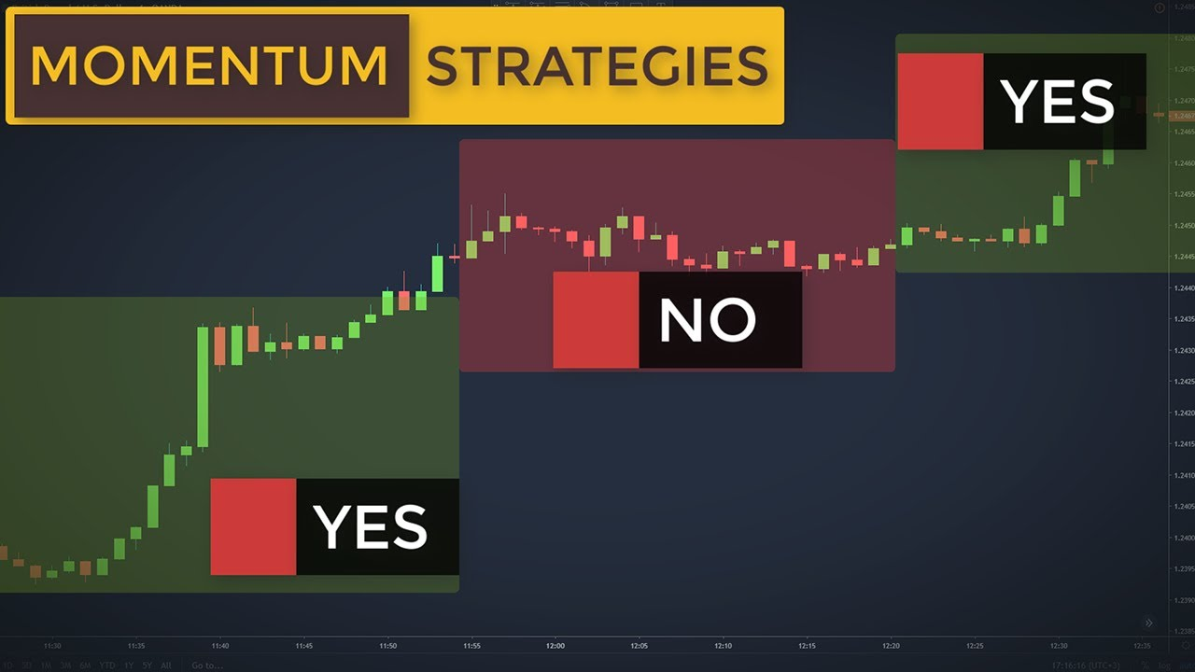](https://forum.mt5.com/customavatars/946076319.jpg)

Momentum demonstrates an adjustment in the cost of an exchanging instrument for a specific timeframe. It tends to be applied as:

**Oscillator**, following the pattern, like Moving Average Convergence/Divergence MACD. For this situation, a merchant gets a sign to purchase in the event that the Momentum indicator falls and goes upwards. A merchant should sell, when the Momentum indicator pinnacles and afterward goes downwards. To decide inversions of Momentum indicator all the more unequivocally, its short moving normal can be utilized. Especially high or low estimations of the indicator recommend that the pattern will endure. On the off chance that the Momentum indicator hits high qualities and, turns downwards, the cost is probably going to continue to rise. Be that as it may, a broker should take his/her opportunity to open or close a situation until the cost affirms the sign.  
  
**Driving indicator**. This method of utilization lays with the understanding that an unexpected climb in the cost is an antecedent to a finish of a bullish pattern (as everybody trusts it is to proceed), while an abrupt tumble bodes sick for a bearish pattern (as everybody attempts to stop the market). Fundamentally, these two situations happen, yet such speculation is excessively wide. When the market has shut into its pinnacle, Momentum shoots up. At that point, it begins plunging as the costs continue to develop or remain level. On the off chance that the market has reached as far down as possible, Momentum indicator droops just to switch upwards some time before the costs begin to rise. In the two cases, there is a hole among Momentum and the value levels.  
  
**How Might You Use It?**

1. To time directional moves.
2. To avoid premium selling plays when you accept a major directional move will occur.

The unpredictability part of the TTM Squeeze indicator estimates value pressure utilizing Bollinger Bands and Keltner Channels. On the off chance that the Bollinger Bands are totally encased inside the Keltner Channels, that shows a time of low unpredictability. This state is known as the crush. At the point when the Bollinger Bands grow and move back outside of the Keltner Channel, the press is said to have "terminated": instability increments and costs are probably going to break out of that tight exchanging range one heading or the other. The on/off condition of the crush is appeared with little specks on the zero line of the indicator: red spots show the press is on, and green dabs demonstrate the crush is off.

**When Can You Use It?**

[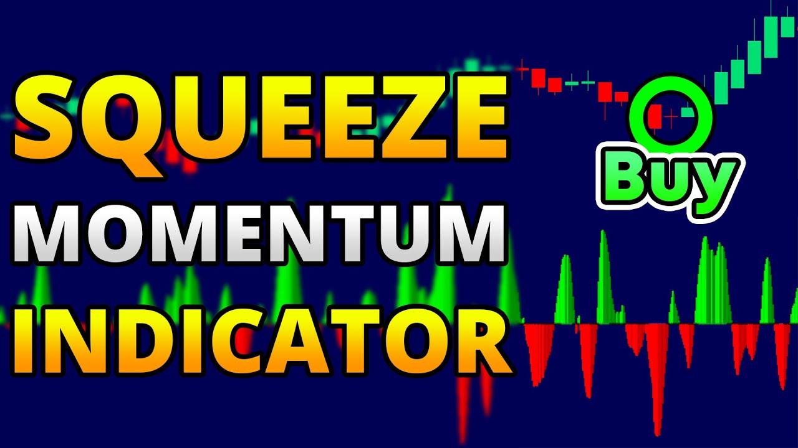](https://forum.mt5.com/customavatars/1336003037.jpg)

The Squeeze Momentum Indicator can be utilized on any time span, on any graph. The way to utilize it is simply understanding that once the squeeze fires, it as a rule endures 8-10 bars.  
  
For instance, if the crush is on a _ graph, the move will last roughly:

* **5-minute** graph: 5 minutes x 8 = 40 minutes.
* **30-minute** graph: 30 minutes x 8 = 240 minutes
* **Day by Day** graph: 8-10 days
* **Week after Week** Chart: 8-10 weeks
* **Month to Month** Chart: 8-10 weeks

**What is Forex Indicator(s)?**

Forex pointers are utilized by brokers consistently to expand the opportunity of making a benefit on the FX market while exchanging on **Instaforex**. Alongside different types of information and examination, markers can impact exchanging choices and might be utilized as the reason for Forex exchanging methodologies. With the capacity to inspect past market conduct and examples, dealers might have the option to utilize the best Forex pointers to help foresee how the market will act later on and, subsequently, which exchanges are probably going to be productive.  
  
In the event that you are utilizing markers to help you settle on exchanging choices on your **Instaforex account**, you'll need to utilize the best Forex pointers out there. With so numerous to browse it tends to be hard for new merchants to know which pointers are probably going to be generally precise, yet Forex exchanging for novices may assist them with choosing what kind of market investigation is more fit to their exchanging style. Extensively talking, there are four unique kinds of Forex pointers, including:

* Forex trend indicators
* Forex momentum indicators
* Forex volatility indicators
* Forex volume indicators

**Combining Different Indicators in Forex**

[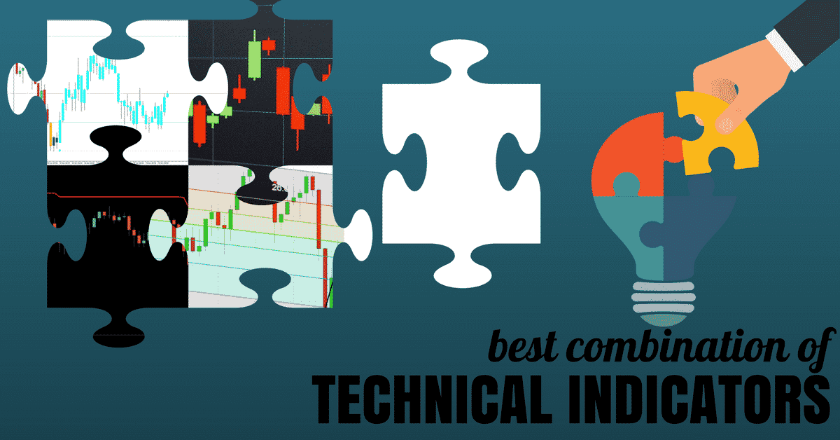](https://forum.mt5.com/customavatars/207681271.png)

Only the leading forex exchange platform supports multiple indicators in their system. The best example of a platform that supports multiple usage of indicators at a single moment was Instaforex. All merchants are extraordinary and have changing targets so the best Forex pointer mix will not really be something very similar for everyone. Indeed, you should utilize Forex pointers which are well on the way to improve your own exchanging procedure on the Instaforex stage.  
  
With various kinds of Forex exchanging pointers to utilize your Instaforex exchanges, you can choose the apparatuses which give the most pertinent examination to your goals. Moving normal assembly difference and moving midpoints pointers might be more helpful to financial backers with a drawn out procedure, for instance, though MT4 markers and the overall strength record might be more useful for brokers who wish to make transient exchanges.

**Where would you be able to use Forex Indicators?**

At the point when you register for an **Instaforex demo** or genuine cash account, you'll gain admittance to all our helpful hints and aides as well. With Forex pointers, curated ventures, a Forex signals application and a simple-to-utilize exchanging stage, you could begin exchanging on the FX market straight away. Instaforex even has a scope of web based exchanging mentors who are close by to clarify their own personal exchanging choices and techniques, so you can profit by their mastery and experience. Exchanging on the FX market can bring large returns yet utilizing Forex pointers to design your exchanging system can make your ventures significantly more beneficial. To discover more or to investigate the Forex markers accessible, register with Instaforex now.

**Benefits of using Squeeze Momentum in Forex Market**

Accessibility is perhaps the greatest benefit of forex exchanging. Contrasted with different business sectors, it is moderately simple to enter and doesn't need an enormous starting speculation, clarifying its fame with specialist brokers. Nonetheless, paying little heed to the measure of capital you put down, effective exchanging takes information and expertise.  
  
Free demo accounts permit you to work on exchanging forex without hazard, basically giving a 'attempt before you purchase' trial. By reenacting a live exchanging climate, demo accounts allow you to become acclimated to an exchanging stage, acquaint yourself with market developments and build up a danger of the executives technique, all without making any monetary responsibilities. Most representatives offer demo accounts so in case you're thinking about exchanging forex, make certain to exploit these devices first.

**Ending Remarks**

There are numerous advantages to forex trading be that as it may, similarly as with any market, there are likewise related dangers and it ought not be pursued softly. While this article has covered the principle benefits of forex trading, it's additionally indispensable that you acclimate yourself with the possible traps to guarantee it's the correct choice for you.  
  
Forex trading isn't a pyramid scheme. Or maybe, it is a drawn out procedure that requires information and a sharp comprehension of what worldwide occasions can mean for the market. Before you focus on any type of monetary venture, you should do broad research and guarantee you comprehend the intricate details of the market, know about completely related specialized terms and are open to facing speculative challenges with your capital.