**All about VP Forex Algorithm**

**VP Forex Algorithms**

Even though many of you may not even be familiar with VP trading forex, you could already be just using his Forex methods. Yes, **VP is a seasoned forex trader** as well as a **cryptocurrency exchange scholar**. VP has assisted others in making money in forex and cryptocurrency trading over the years. No Nonsense Forex was the most well-known of VP's works. If you come across the terms No Nonsense Forex or VP algorithm, they will assume they are interchangeable.

**What Is Forex Trading?**

Forex trade is, at its most basic level, similar to the exchange rates you would do when going overseas: An investor purchases another currency and sells another, and the rate of exchange goes up and down continuously as supply and demand dictate. The forex trading, an international market o**perating 24 hours per day**, Monday to Friday, is where currencies are exchanged. Every forex trading is done over the counter (Over-The-Counter), which means that there's no physical exchange, as there is for shares, and the trading is supervised by a worldwide network of banks and financial institutions, instead of a central exchange, like the New York Stock Exchange).

[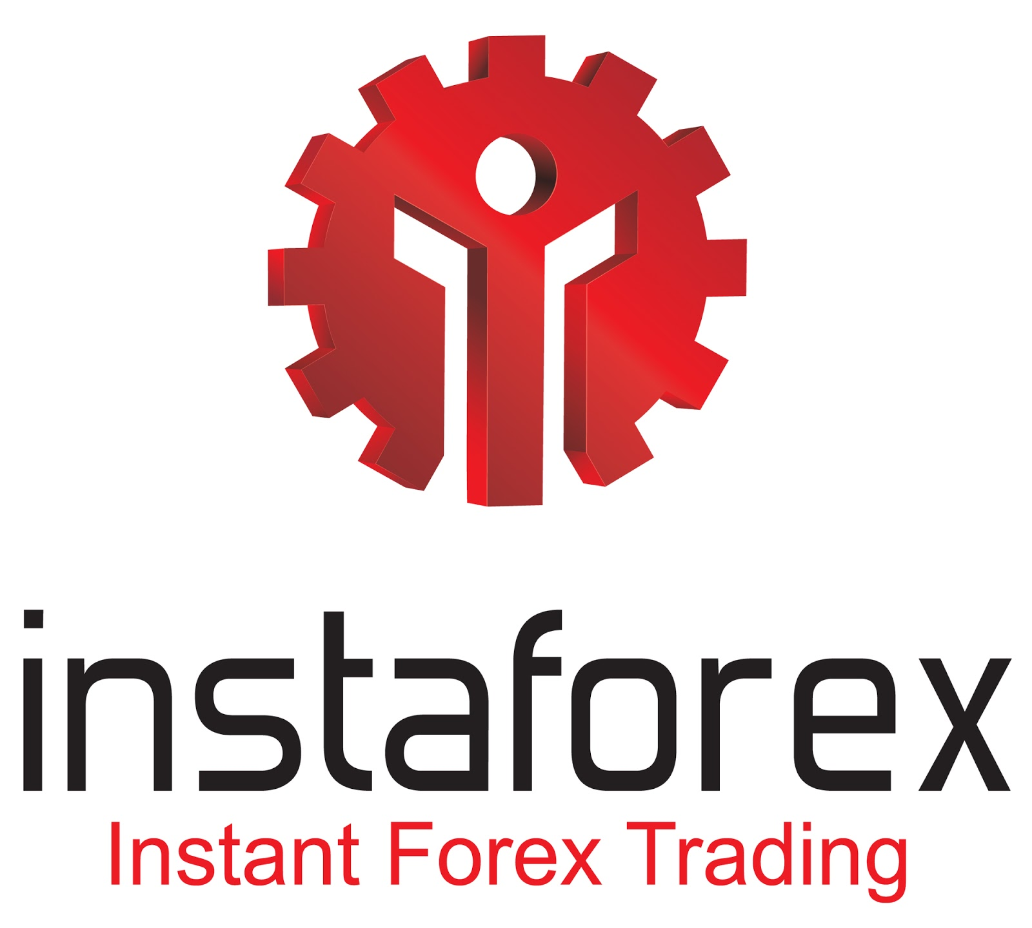](https://forum.mt5.com/customavatars/1047027694.jpg)

Infrastructural traders, such as those who collaborate for corporations, financial advisers, and large companies, account for the vast majority of trading activity in the foreign exchange market. These merchants may merely be going to speculate on or trying to hedge potential changes in exchange rates, not actually intending to take legal control of the currencies. A stock broker, for instance, would buy US dollars as well as sell euros if she thinks the dollar will rise in demand in the future, allowing her to acquire more euros. Alternatively, an American company having European operations could have used the exchange rates as a hedge unless the euro dampens, lowering the value of its earned revenue.

**VP Forex Advice for New Traders**

VP does have a youtube channel where he provides insights and tips to new traders. Check his advice regarding his **forex trading algorithms**.

**The Technical Analysis Tools to Avoid**

The old set of technical analysis methods, according to VP, is outdated, and technological developers are creating tools which are more applicable to today's global marketplace. So, which technological analysis methods can you avoid? He claims to see the 12-15 charting techniques and fundamental trading practices such as trendlines, support and resistance, and Fibonacci every time. He put them all through their paces and invested a lot of time in them because I expected them all outclassed the new indicators he was seeing. They didn't even get close.  
  
His channel is brimming with 'self-doers,' who are eager to put in the time and effort to locate indicators on their own so they can consider it their system, when it was previously nothing but annoyance.

**Using IG Client Sentiment Data**

Following that, VP describes how he uses IG client transport sector to estimate industry professionals' attitude, as well as how the data can be understood. Always seems to go something like this: if investors jointly go long, say on EUR/USD, the bankers, the individuals who earn enough money to change price, just go another direction, and IG client attitude data has become an excellent example of how this happens.

He cites the Forbes 500 and its rise as an instance, even as analysts discuss the impending recession. Bearish signals claim that counterfeit money is the only thing keeping the economy afloat. Day after day, they are shocked by the increase in the Forbes 500.

[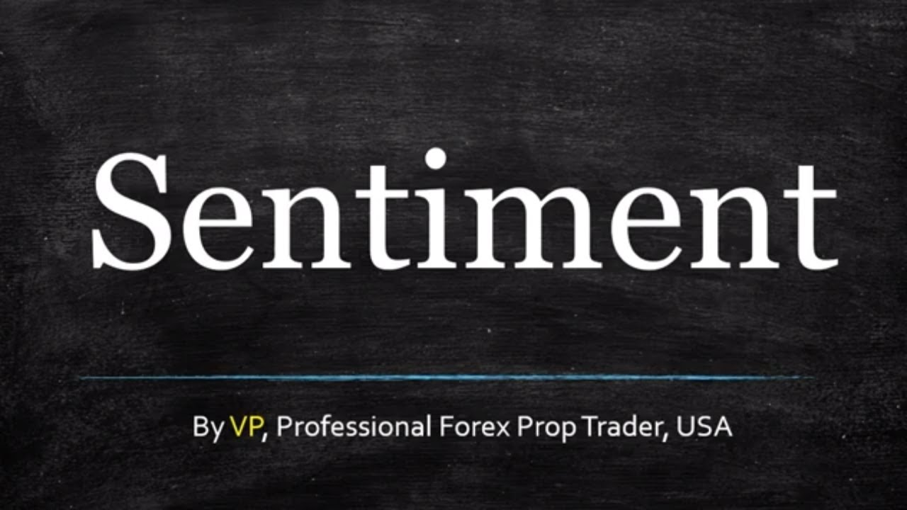](https://forum.mt5.com/customavatars/1111449754.jpg)

However, if they looked at the IG client sentiment analysis, they'd notice how limited everyone is. The increase, according to VP, will keep going as long as overall feeling is bearish, and will not reverse until the bulls revert. Don't expect this marketplace to drop again before that day arrives. There's an inverse relationship here, as well as the tool perfectly illustrates it.  
  
Finally, VP claims because when it came to emotion, it's not about when people have gone in the past, whether shorter or longer, but rather about where they are close to going. Attempting to assess where individuals will go is extremely difficult; there was no way to calculate it, and he will not suggest that as well; still, he loves the tool, but it's very telling in some ways.

**3 Easy Steps on FOREX market:**

* **Step 1. Training on a demo account.**  
  Anyone should open a demo account and understand how to use the trading platform and techniques for an incredible duration and at no cost. Even though you have no prior experience with the FOREX market, you will practice trading on even a demo mode. Regardless of the fact that all transactions on demo accounts are simulated, the terms are identical to those on live accounts. You should enter and exit positions on a demo mode just like you would on a genuine Forex account. No matter how many queries occur, you will use a demo account to try and find responses with risk. Users can create as many demo accounts as you like for free. Furthermore, help is provided 24 hours a day, 7 days a week via ICQ, chat, telephone, or web.
* **Step 2. Trading on a live account.**  
  Users should try trade on a live account after you've had some knowledge with the platforms and learned the big trading techniques. Because there is no minimum trading volume, you should trade according to the concept risk equals profit when you only control the size of your portfolios. Regardless of how good you look at virtual trading, live trading gets you more than a demo mode. When you trade with real money, even if it's just a few dollars, you start to notice a link with your profitability and money movements. This knowledge is essential for progressing to the next stage of trader growth.
* **Step 3. Professional work.**  
  With the required skills, a trader will operate independently mostly on the currency market, profiting from exchange rates using his or her own or appropriated investment strategies. A professional trader designs his trading strategy and selects methods that are appropriate for his approach. Although not all market participants will be able to attain this stage, the InstaForex Company guarantees that its team will make every effort to assist each investor in moving forward and receiving professional assistance if any difficulties occur.

**How to Earn Money in Forex**

The terminology Forex is an abbreviation for Foreign Exchange. On a money market, it refers to the swapping of one currency for the other. Forex trade has been around since the 1970s of the twentieth century. This is one of the world's fastest-growing and most highly traded economies. The daily internet Forex total trade is nearly 5 trillion dollars.

[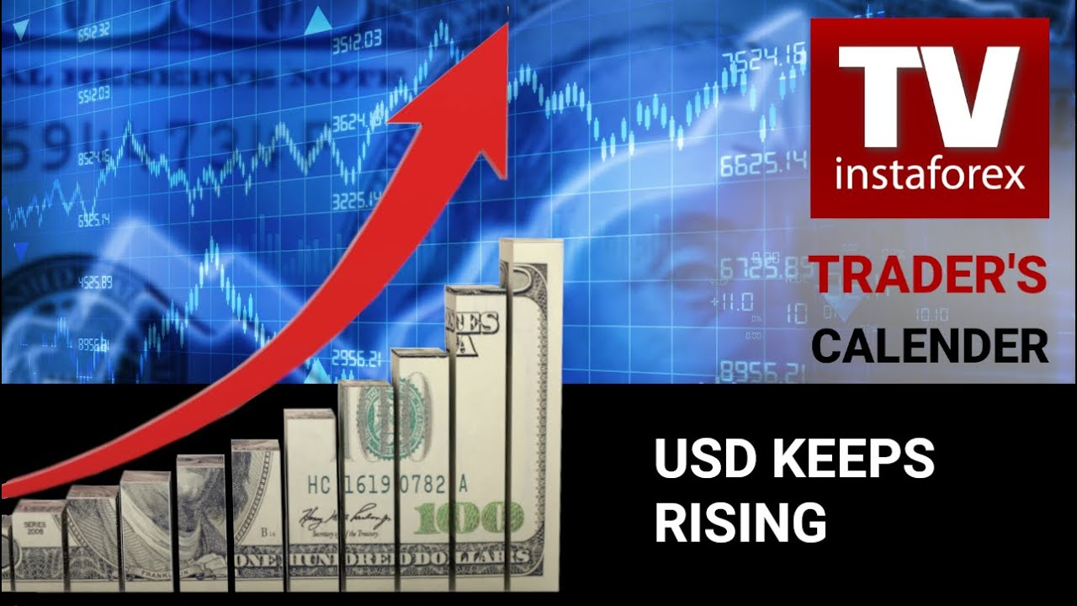](https://forum.mt5.com/customavatars/306433273.jpg)

Forex, just like every other marketplace, trades specific commodities, in this case national currencies from various countries.A need for government entities and large businesses all over the world that transform profits earned overseas into their home currencies is the central concept of currency mechanics. However, they only make for 5% of the total Forex turnover. The existing 95% derives from exchange traders' way to gain, which is concentrated on profiting from market volatility.

1. **Forex is stable**  
   It is common knowledge that any financial market faces a substantial risk of collapsing. Unlike many other exchanges (stock as well as commodity), however, Forex trade is protected from a crash due to the characteristics of its commodity, hence a currency that is the most liquid and credible trading instrument available. The majority of speculative trading (85%) include the most famous currencies known as "majors," including the Japanese yen (JPY), US dollar (USD), British pound (GBP), euro (EUR), Australian dollar (AUD), Swiss franc (CHF), and Canadian dollar (CAD).
2. **Forex is available to anyone**  
   Online merchants can now conduct business with clients from other countries thanks to the Internet. As a result, **constant foreign exchange rate** dynamics, merchants' intellectual capacity, and cutting-edge software make it easier to start a profitable company in no time. ECN brokers' services are becoming more popular because they allow customers to trade with one another by providing the greatest bid and ask pricing.
3. **Forex provides easy access to the market**  
   To make trades on Forex, a trader only needs to deposit one US dollar into an account. InstaForex provides reasonable trading terms to its customers. Try opening a brokerage account and begin earning money.

**Frequently Asked Question about Forex**

[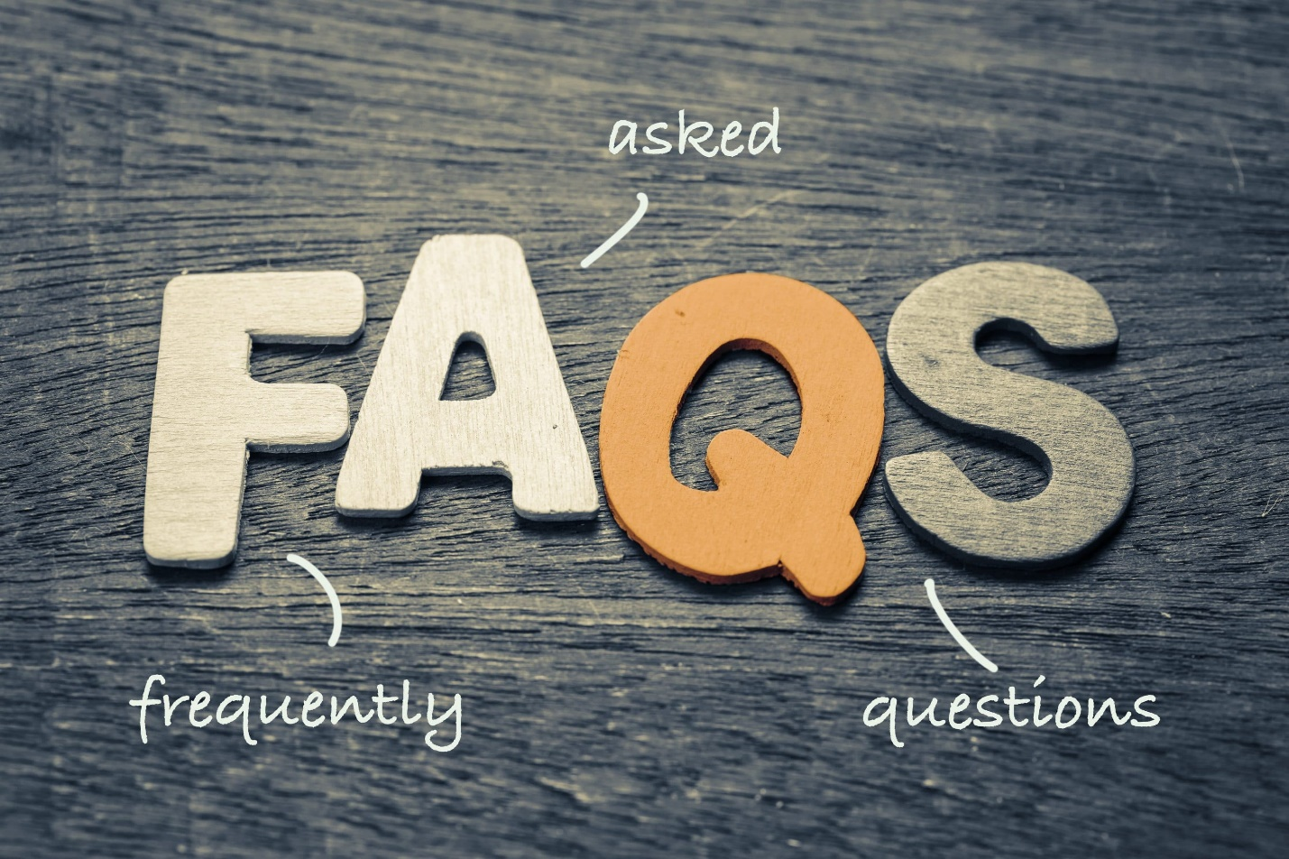](https://forum.mt5.com/customavatars/1725245385.jpe)

**Should I expect high and quick returns?**

Only other appropriate scenarios to both queries are **"No!" and "Not quickly"**. Of course, there's been instances where beginners have made a considerable profit on their first transactions. However, these are exceptional circumstances, and wishing for a repeat performance is pointless. Foreign currency trade is an exciting, exciting, and even risky way to make money! People will need to be patient and persistent quickly in order to supply yourselves with such a steady income that will increase the quality of your life. Patience will help you achieve the necessary experience, whereas hard work will help you gain insight and test hundreds of trading processes and tactics. Forex, on the other hand, is not magic, but rather an entirely autonomous arithmetically predictive model with its own set of laws that ensures the outcome to every physician and diligent trader. Any job, including that of a merchant, must be rewarded.

**Is it possible to trade Forex without risk or expenditure?**

Yes, but **only if you use a DEMO account**. Nevertheless, any investment with risk is inherent in any financial market involvement. Furthermore, in the currency market, you are solely responsible for the amount of money, the risk level, as well as the timing of the incidence. This can trade for as little even one dollar or a few dollars.

**What are the different kinds of accounts or what are the differences between them?**

Insta.Standard is the most famous account, Standard, provides standard trading terms without fees and with a specified spread per transaction. There, you can begin trading for any initial deposit and adjust the level of leverage as needed. Insta.Eurica does trading without spreading, or Insta.Eurica, means that the BID and ASK prices are always the same. This account is designed for new merchants. When the price exceeds these levels, all pending orders are completed. Cent.Standard and Cent.Eurica are appropriate for those who are new to trading. The trading size of 0.0001 in this individual account allows traders to limit their risks to deposits thanks to Micro Forex. The Cent accounts also are ideal for putting methods to the test.