**Forex BBMA strategies in English**

**What Is the Forex Market?**

[](https://forum.mt5.com/customavatars/105870091.jpe)

Currency trading takes place on the foreign exchange market. Many citizens across the world, although they know it or not, are concerned with currency since they must be traded in order to perform international commerce and industry. If you live in the United States and wish to import cheese through France, you or the business from which people purchase the cheese must compensate the French in euros (EUR).  
  
This implies that perhaps the distributor with in United States will have to translate the same sum of dollars (USD) into euros. The same is true when it comes to flying. Since euros are also not allowed in Egypt, another French visitor visiting that temples would be unable to payment for euros. As a result, the visitor must exchange his euros for both the domestic currency, that Egyptian pound, only at present exchange rate.  
  
There is just no common focus with financial services throughout this global economy, which is a special feature. Instead of exchanging on a single centralized market, currencies dealing is performed electronically over-the-counter (OTC), that implies that other trades take place over computer systems among trades all across the planet.  
  
The service is **available 24 hours per day**, 5 days per week, and cryptocurrencies were exchanged almost in each local time including London, New York, Tokyo, Zurich, Frankfurt, Hong Kong, Singapore, Paris, and Sydney, among other major economies. This implies that as the business day in the United States finishes, the forex market throughout Tokyo and Hong Kong starts again. As a result, the foreign exchange market can become very active at any period of day, with price quotes constantly evolving.

**The Benefits of Using Metrics While Selling Forex**

The greatest advantage of metrics is that they tend to understand price volatility. That dynamic methods of a predictor are easier to read than the simplistic contortions of a market map for foreign exchange shareholders. It's worth noting that "relatively simple" in this case **does not mean greater productivity.** Metrics, on the other hand, are an excellent tool for determining how to identify market uncertainty or influence, such as where a trend is increasing. It may have been impossible for a beginner trader to discern on a price chart, and they are often kept aware of minor changes with the help of such indicators that we have not yet learned to recognize on the price chart.

**The Use of Metrics throughout Trading Forex Has Its Limits**

[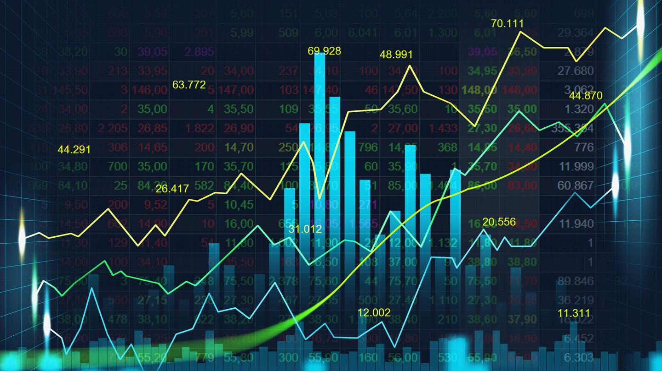](https://forum.mt5.com/customavatars/1156558731.jpg)

On the indicator, you can see a clear description of the math formula and value outputs. A metric won't really reveal anything more than what a qualified graph viewer or trader would see clearly by looking at the stock map (or volume) with no labels.  
  
Every chart has a flaw; that which confirms the idea of providing system adjustment at the wrong time, when that wasn't the correct moment that provides a market alert. If you're going using a prediction, look at the mathematics behind it. **You'll discover the flaws** in this path. Check not only at times whenever the indicator informs users to do so and you planned to benefit, but it's at the moments whenever the predictor refused to warn anyone regarding entering or leaving a deal.  
  
Another disadvantage to metrics would be that they normally only show what's going on within the price table, but in a different picture format. Metrics, according to market action shareholders, are outdated and meaningless since they can only provide information that market (and quantity) charts could. Since indexes are dependent on interest, they continue to decline behind what the economy is (or amount, or even both).

**What Are Bollinger Bands and What Do They Mean?**

[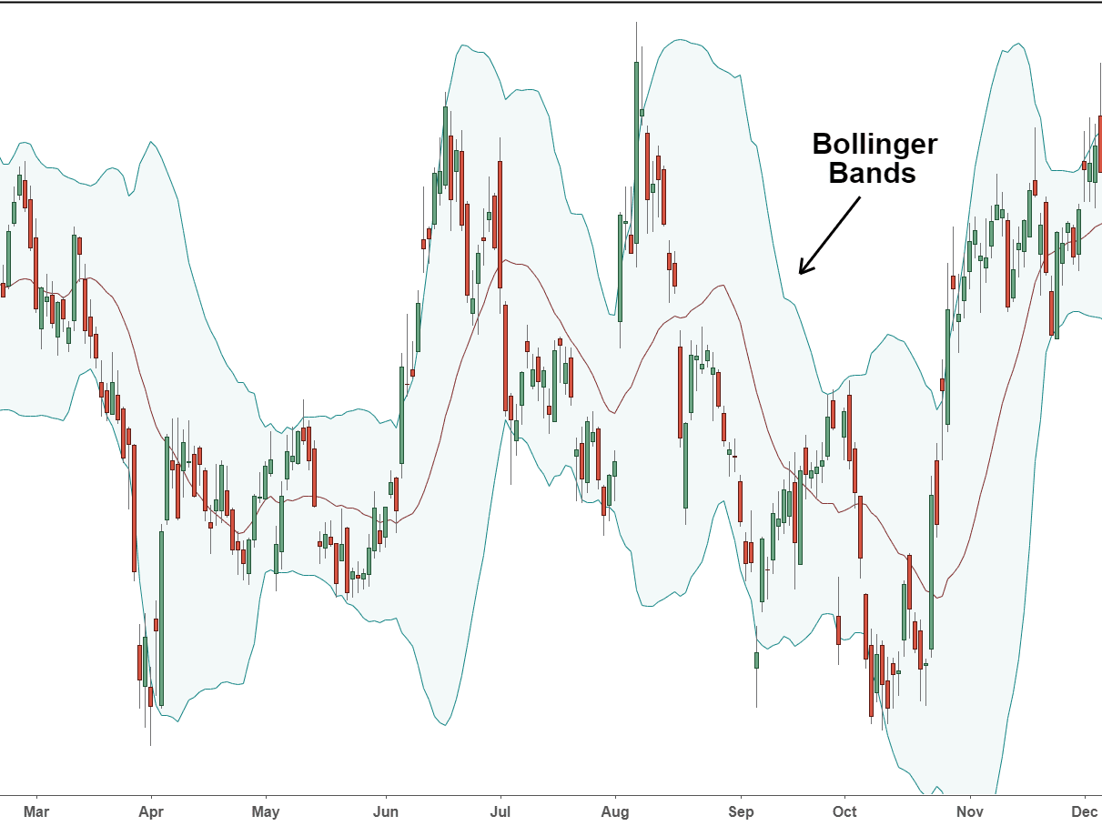](https://forum.mt5.com/customavatars/2001504329.png)

The Bollinger Bands indicator is an options trading instrument that depicts financial leverage price volatility (in example a commodity , currency or share). The Bollinger Bands was calculated using the rolling average's standard deviation. It is normally illustrated on even a value trends diagram. Bollinger Bands came next to the Envelopes.  
  
The difference between these two measurements would be that the boxes' borders are set along each trend line at a fixed distance, which would be expressed through percentage, whereas the Bollinger bands' borders are built at a distance equal to the number number standard deviations. Because the magnitude of a standard deviation is determined by fluctuations, Bollinger Bands regulate that inner width: when the price is high, it expands; because when business becomes stable, its contracts.

**Forex Bollinger Bands Indicator**

Bollinger Bands were usually shown on a price chart, but they may also be applied to a predictor chart. The Bollinger Bands, like the Envelopes, are based on the principle which wages should remain within the bands' thresholds. Due to demand volatility, the Bollinger Bands have an unusual aspect as just a metric: its persistent length. When there is a lot of confusion, the groups stretch to make way for ideals. During periods with low uncertainty, the Bollinger Bands limit the keeping prices inside the sets.

**The major characteristics of this measure are:**

1. Price changes suddenly after the band narrows, suggesting a decline in volatility.
2. If rates rise above the band's boundaries, the current trend is expected to continue.
3. If highs and lows just above bands were followed through ups and downs within the units, a trend reversal is possible.
4. A price movement that begins from one of the band limits normally follows the opposite limit. The latest insight becomes useful for estimating market valuation.

**Calculation**

* The Bollinger Bands has three lines to pay special mind to. The center line (MIDDLE LINE, ML) is a basic moving normal.
* ML = SUM [CLOSE, N]/N
* The upper line (TOP LINE, TL) is the center line moved upwards by a specific number of standard deviations (D).
* TL = ML + (D*StdDev)
* The lower line (BOTTOM LINE, BL) is the center line moved downwards by similar number of standard deviations.
* BL = ML – (D*StdDev)

**Where:**

1. Aggregate (..., N) – entirety for N periods
2. CLOSE – shutting cost
3. N – the quantity of periods utilized for count
4. SMA – basic moving normal
5. SQRT – square root
6. StdDev – standard deviation:
7. StdDev = SQRT(SUM[(CLOSE – SMA(CLOSE, N))^2, N]/N)

That center line ought to be a 20-period territory network scale, and as far as possible ought to be two standard deviations. Besides, estimates of or less 10 cycles are insufficient.

**MACD pointer equation and settings: depiction, change and application**

The Moving Average Convergence/Divergence (MACD) Technical Indicator is the very first predictive predictor of even a phenomena. It depicts the relationship between two quality price movements. The Technical Measure of Moving Average Convergence/Divergence was primarily **dependent mostly on difference** between both the twenty-sixth and twelfth moving averages. The MACD's signalling line (moving average of ninth indicators) is used to indicate the most desirable times. The MACD becomes simpler to use in a wide-swinging trading market. When there is a crossing or division between moving averages, as well as when the sector is significantly overvalued, Moving Average Convergence/Divergence usually generates signals.

**Crossroads**

Having to pass that hunted line with both the predictors was its basic MACD sharing location. Although MACD falls below the signal line, it's better to transfer, so when MACD goes just above the signal line, it's ideal to purchase. When the MACD crosses that entirely random, make purchases.

**Circumstances of overbought/oversold**

Average Convergence/Divergence can also be used to detect oversold situations. When the MACD grows, it suggests that the market is vastly undervalued, but that more fair rates will eventually come back.

**Divergence**

When the MACD diverges from the price, it's a sign that the current pattern is nearing completion. That distinguishing feature happens as price approaches a higher maximum limit, while the Moving Average Convergence/Divergence metric fails to achieve organization ’s success at the same time. A bearish convergence occurs as the market makes a new bottom while the MACD fails to do so. Both modes of variation are very important because both occur throughout the overvalued circumstances area.  
  
The Oscillator Moving Average Technical Predictor (OsMA) distinguishes between oscillator smudging and input voltage softening. The MACD main line is being used as the oscillator in this case, and the signal line is used to buffer the input voltage.

**Calculation of the MACD**

The MACD is calculated by subtracting the value of the twenty-sixth century exponential moving average from either the twelfth period easy moving average. A ninth cycle marked clear trend line of a MACD (the signaling section) could then be viewed all along edges of either a MACD.

* MACD = EMA(CLOSE, 12)-EMA(CLOSE, 26)
* SIGNAL = SMA(MACD, 9)
* Where:
* EMA - the Exponential Moving Average;
* SMA - the Simple Moving Average;
* SIGNAL - the signal line of the indicator.

**Final Thoughts**

There isn't a high quality to be found here. Many people pursue a straightforward answer to the issue of how to achieve an edge in Forex, and the vast majority among everyone probably wind up shifting to Forex signal suppliers. This is a simple way to get started trading Forex, but it's unclear if it'll be profitable in the long run, particularly as time passes by. The most critical thing to note here is that in order to make money in the Forex market, users should have had more penny stocks than negative bets.  
  
If your take-advantage amount becomes equal to that stop-setback level, this is obviously content. To translate this message into different terms to make it work even better into any trading strategy, we would suggest that in order to be effective in Futures markets, you must create the most correct movements that are incorrect ones.  
  
It's an easy method for getting started with Forex trading, but it's debatable whether it's a good one, especially as time passes on. The most pressing concern at the moment is that you'll have clearly more profitable industry segments in the Foreign trade sector than you could ever lose ones. Obviously, if your sign number equals your log jam total, this is all nonsense. Individuals claim that this is beneficial in Forex, but you can take further correct steps than incorrect ones to put this word into various phrasings and empower them to function much more efficiently in your trading scheme.