**Forex Binary Options Strategy Forum**

**A Strategy Manual**

[](https://forum.mt5.com/customavatars/1215635254.jpg)

Whenever it comes to binary options investing, a profitable tactic is one that makes more trades than what it losses, and most importantly, one that pays off more than the losers. Digital trades often pay back less than 100% of the initial investment, so merely gaining further trades than losing trades would not be enough to make a long-term gain.  
  
The **practice of profitably selling binaries** has certain parallels with the field of sports betting. Lifespan is indeed a key characteristic that unites all businesses. Only when the expectancy (the potential benefit within any exchange) consists in an optimistic assumption from such an exchange could lengthy risk trading binaries become extracted.  
  
Binary options trading techniques are thus used to define repeatable patterns and situations under which a transaction with a favorable (profitable) expectation may be made.  
  
**What Is a Binary Option?**

[](https://forum.mt5.com/customavatars/1110578560.jpg)

A twofold alternative is a monetary item where the gatherings engaged with the exchange are allotted one of two results depending on whether the choice terminates in the cash. Twofold choices rely upon the result of a "yes or no'' recommendation, thus the name "parallel." Binary choices have an expiry date or potentially time. At the hour of expiry, the cost of the basic resource should be on the right half of the strike cost (in light of the exchange taken) for the dealer to make a benefit.  
  
A double choice consequently works out, which means the increase or misfortune on the exchange is naturally attributed or charged to the broker's record when the choice lapses. That implies the purchaser of a twofold alternative will either get a payout or lose their whole interest in the exchange - there isn't anything in the middle. On the other hand, the dealer of the choice will either hold the purchaser's premium, or be needed to make the full payout. A paired choice consequently works out, which means the increase or misfortune on the exchange is naturally attributed or charged to the taking part gatherings' records when the alternative lapses.  
  
**How a Binary Option Works**

A double alternative might be just about as straightforward as whether the offer cost of ABC will be above $25 on April 22, 2021, at 10:45 a.m. The broker makes a decision: yes (it will be greater) or even no (it will be smaller) .  
  
Suppose the dealer figures the cost will exchange above $25 on that date and time and will stake $100 on the exchange. On the off chance that ABC shares exchange above $25 at that date and time, the dealer gets a payout per the terms concurred. For instance, if the payout was 70%, the twofold intermediary acknowledges the dealer's record for $70.  
  
In the event that the value exchanges underneath $25 at that date and time, the dealer wasn't right and loses their $100 interest in the exchange.  
  
**Sorts Of Trading Strategy**

[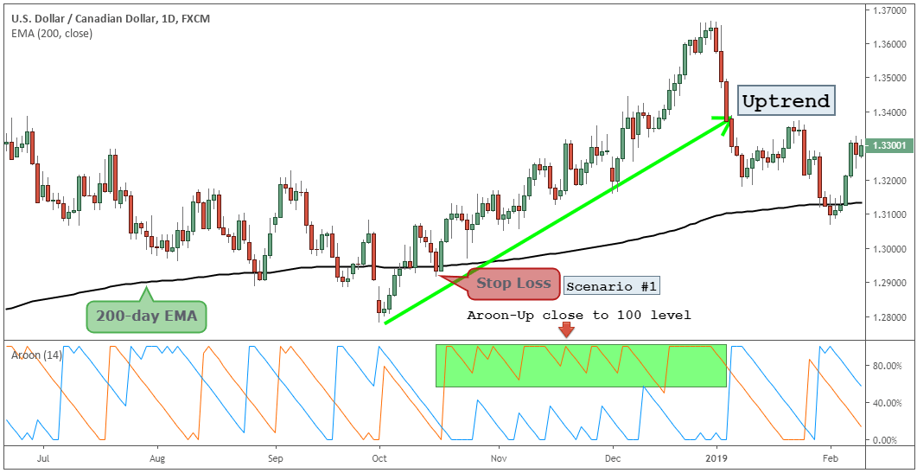](https://forum.mt5.com/customavatars/858803114.png)

There are a scope of strategies that can be utilized to recognize a double alternatives technique. New financial backers may get a kick out of the chance to investigate every one of them – each can be productive when utilized accurately.  
  
Notwithstanding the sort of fundamental, or customary, exchanging system featured above, there are likewise elective strategies;

1. **Outlining and specialized examination** diagramming (the investigation of charts and other specialized pointers) is regularly viewed as first while talking about systems. Much has been expounded on the patterns and examples that are routinely seen inside the valuing graphs, and a significant number of these can **make an interpretation straightforwardly** into exchanging techniques. Holding a straightforward procedure while attempting to bore into specialized investigation isn't in every case simple, yet gives a course to some knowledge that may not be promptly evident somewhere else.
2. **Basics**– Analysis of the essentials is just about an essential for most kinds of speculation or exchanging. With double choices exchanging nonetheless, the time scales are regularly excessively short for the basics to move the cost the normal way. There are still some paired choices exchanges that can be **gathered from investigation** of the basics however, and it is another possible course for a fruitful technique. Especially longer term alternatives. A few representatives presently offer expiry seasons of one and two months ahead making this type of methodology significantly more reasonable.

**The Benefits Of Good Trading Strategy**

[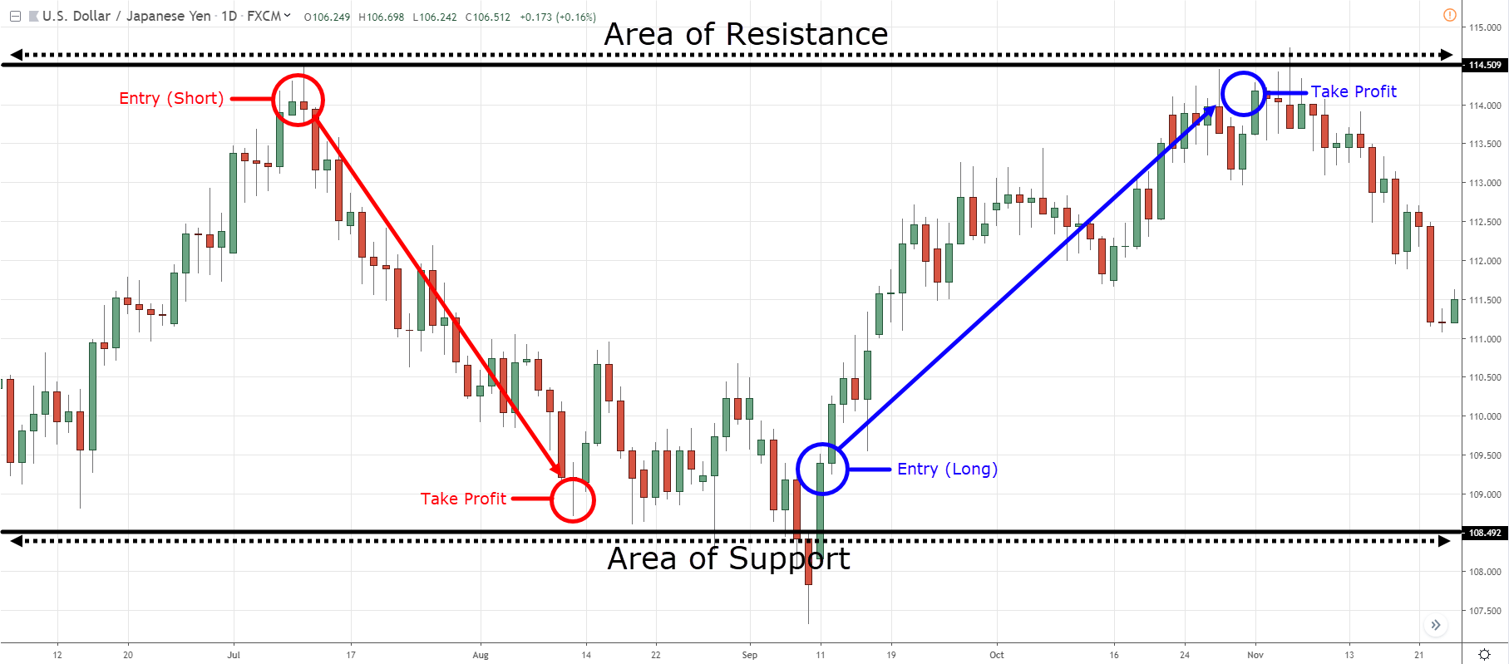](https://forum.mt5.com/customavatars/2141954827.png)

A decent double exchanging procedure will improve on a significant part of the dynamic about where and when to exchange. With timing the way to all that where exchanging is concerned, the less mystery there is around passage and leave focuses, the better. Especially for less experienced brokers.  
  
A repeatable methodology will consistently feature the exchanging openings, where something else, most of those openings would be missed. **Techniques energize discipline**, help cash the executives and give the most clear indicator to uplifting assumptions. While it is feasible for brokers to benefit from paired alternatives without a technique, it will be dramatically harder.  
  
Amateur brokers will likewise profit just from attempting to assemble their own twofold choices exchanging system. When some time has been spent breaking down various strategies and building a technique without any preparation. It is a lot simpler to evaluate methodologies offered by others. Without that underlying establishing in the specialty of exchanging systems, it would be not difficult to get inebriated by the guarantee of untold wealth utilizing another person's exchanging technique or costly programming.  
  
**Why Use A Strategy?**  
The exchanging system is the most celebrated kind of sub-technique for double alternatives. It is popular to such an extent that numerous dealers tragically think that it is the lone system they need. In any case, more on that later. For the present, how about we center around how you can **locate a decent exchanging system.**  
  
An exchanging procedure causes you to discover beneficial speculation openings. It characterizes which resources you dissect, how you break them down, and how you make signals. **Try opening a Demo Account** to familiarize with trading without loosing any capital.

For instance, an exchanging technique could characterize that you exchange just huge cash sets somewhere in the range of 8 and 12 AM, that you utilize a brief value diagram, and that you contribute when a 10 period moving normal and the Money Flow Index (MFI) both show a similar bearing – for instance, the moving normal needs to face up, and the MFI must be in an oversold region, or the other way around.  
  
Amateur merchants will likewise profit essentially from attempting to fabricate their own twofold choices exchanging procedure. When some time has been spent dissecting various strategies and building a procedure without any preparation. It is a lot simpler to evaluate methodologies offered by others. Without that underlying establishing in the craft of exchanging procedures, it would be extremely simple to get inebriated by the guarantee of untold wealth utilizing another person's exchanging methodology or costly programming.  
  
**Why Use Money Management?**

A cash the board technique is the second foundation of your exchanging achievement. To comprehend its motivation, we should return to the case of the coin flip. Regardless of whether you have a technique that gets the chances in support of yourself, for instance by ensuring that you will win 60% of the flips, this system will prompt calamity on the off chance that you generally wager all your cash on each flip. You may win the first, yet you will before long lose a flip, and all your cash will be no more.

[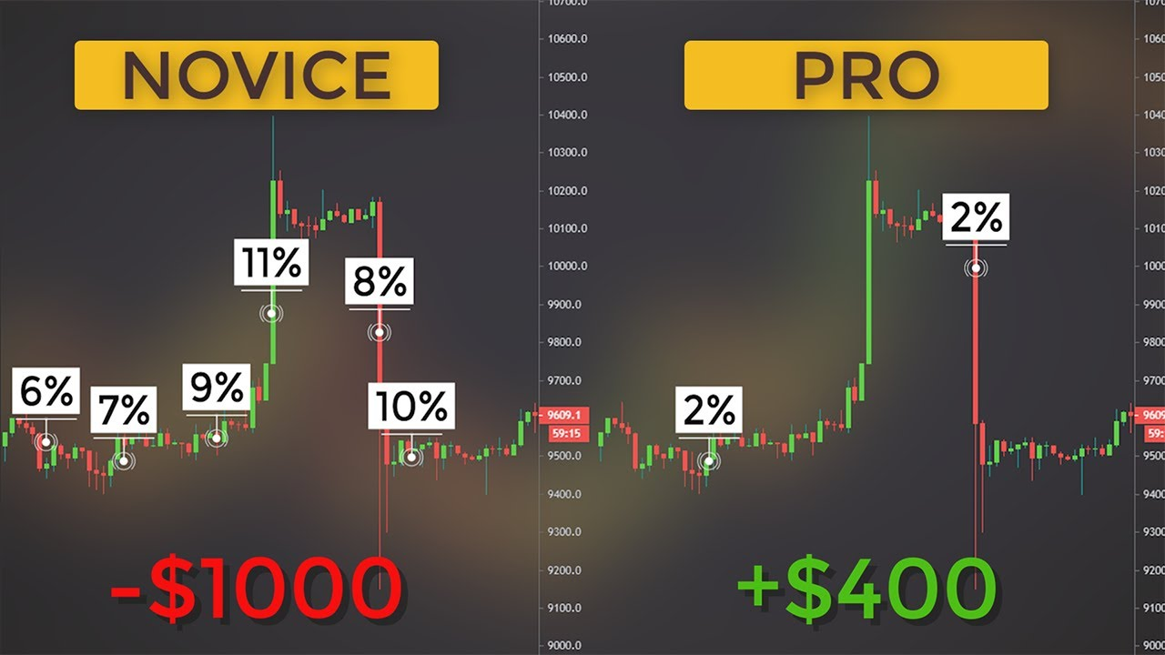](https://forum.mt5.com/customavatars/773270960.jpg)

To forestall liquidation, you need to restrict your ventures. This is the principal motivation behind a cash on the board procedure.  
  
The subsequent intention is to assist you with changing your venture as indicated by your capacities. We should return to the coin flip with a technique that successes you 60% of your exchanges and take a gander at various conceivable cash the executives systems that would fizzle:

* **Continuously contribute a similar sum.** On the off chance that you start with $100 and contribute $1 on each and every exchange, you would make a decent benefit first and foremost. You would likewise have sufficient space to endure a dash of misfortune. As your record balance increments, nonetheless, your venture would before long get excessively little. When you arrive at the &#163;1,000 mark, for instance, winning a &#163;1 exchange will barely have an effect. The issue with this kind of cash the board is that it neglects to develop with you.
* **Contribute the manner in which you feel**. A few dealers fluctuate their ventures dependent on their instinct. At the point when they feel or have won their last exchanges, they contribute more. This methodology is hazardous on the grounds that misfortunes weigh heavier than wins. At the point when these brokers lose a couple of exchanges a line and have contributed somewhat more on these exchanges, they have lost a huge level of their general record balance. They need to fundamentally lessen their speculation, which makes it hard for them to make it back. Bit by bit, they lose increasingly more cash. The openings they burrow for themselves will consistently be greater than your capacity to escape them.
* **Contribute more after a misfortune.** A few dealers increment their venture after a misfortune, for instance by multiplying their speculation. They desire to ultimately win an exchange, make a benefit, and start the cycle again. Such techniques work extraordinary – until they come up short. Regardless of whether you pick an exceptionally little beginning speculation, paired choices empower you to make such countless exchanges that you will be penniless inside a year.