**Using Horizontal Line Indicator in MT5**

**Why use Metatrader to trade?**  
  
The essential thing you should consider Metatrader is that it is a free and lightweight programming, which you can download clearly from its power website and grant you to perform exercises quickly, which is seen as an extraordinarily usually liked position while working in temperamental business areas. This stage licenses you to configuration stop incident, market, approaching and following stop solicitations to **increase benefits**. Finally, it offers you a trade history where you can see all the improvements you have made previously and the positions you have opened to help you with making fruitful methods for your future trades. Metatrader is ideal for Forex merchants who wish to abuse market instabilities through hypothesis and opening up of opposite positions.  
  
**Take note: YOU CAN ONLY TRADE IF YOU HAVE AN ACCOUNT.**  
The video below is a step-by-step guide on how to open an account in the **Leading Forex Trading Platform in the World, Instaforex**.

**Meaning of Getting Knowledgeable in Forex**  
  
To trade effectively, it's essential to get forex preparation. You can find a lot of important information on forex here at The Equilibrium. Contribute some energy getting some answers concerning how forex trading capacities, making forex trades, dynamic forex trading times, and directing risks, most importantly. As you may learn as time goes on, nothing beats knowledge, and if you need to learn forex trading, experience is the best educator. It will give you a nice specific foundation on the mechanics of making forex trades and getting adjusted to working with a specific trading stage.

[](https://forum.mt5.com/customavatars/611628706.jpg)

Something significant you may learn through experience, that no proportion of books or speaking with various shippers can teach, is the advantage of closing your trade and getting away from the market when your motivation behind getting into a trade is discredited. It is straightforward for sellers to calculate the market will return around on the side of themselves. You would be shocked if the quantity of intermediaries fall prey to this catch and are bewildered and distress stricken when the market simply presses further against the course of their interesting trade.  
  
**Four Horizontal Lines Metatrader 5 Forex Indicator**  
  
The Four level lines Metatrader 5 Forex pointer is a particular instrument that plots four level lines: two central even lines that are red as per normal procedure, over the high and under the Low of the Bar number bar and help lines that are green normally moved from the fundamental ones.  
  
**Plotting rule for fundamental lines**

1. The **High Low Up line** is plotted through the High of the Bar number notwithstanding Move;
2. The **High Down** and out line is plotted by the Low of the Bar number short Move.

**Plotting rule for help lines**

The Distinction Up Line is plotted by the High Low Up cost notwithstanding the differentiation between costs High Low Up and High Abject and Short Move. The Distinction Down Line is plotted by the High Wretched worth Short the difference between esteem High Low Up and High Abject and notwithstanding Move.  
  
**Fundamental Exchanging Signs of Horizontal Indicator**

1. **Purchase Signal**: Go long when worth breaks over the upper outside lime green level line of the Four level lines MT5 marker following an attestation bullish sign from another indicator(s).
2. **Sell Signal**: Go short when worth breaks out underneath the lower outer lime green level line of the Four level lines Metatrader 5 forex pointer following a certification bearish alert from another indicator(s).

[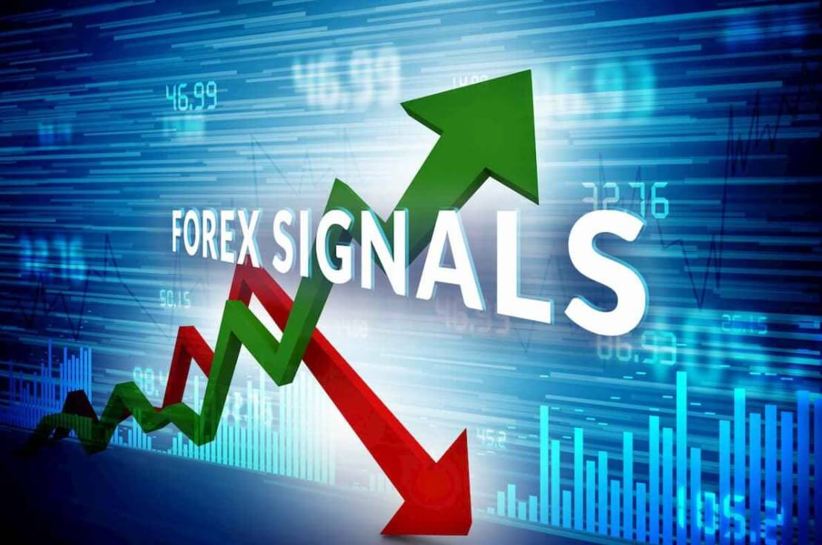](https://forum.mt5.com/customavatars/993101739.jpg)

1. **Leave purchase trade**: Close all purchase orders if while a bullish example is advancing, cost clearly drops underneath the upper outer lime green line of the Four level lines MT5 forex marker.
2. **Leave sell trade**: Close all sell orders if while a bearish example is ceaseless, cost apparently hops over the lower outer lime green line of the Four level lines MT5 forex pointer.

Tip: The Four even lines Metatrader 5 forex market is generally used for tremendous periods of time, beginning from 4-hour, which makes it a sensible instrument for long stretch vendors.  
  
**Have a Strategies in Forex Trading**  
  
Trading Forex gainfully requires that you use a positive method. There is no right technique to trade, rather what is critical, is for you to choose the one that you will get. A portion of the time, you'll find that a trading framework will work splendidly for a particular money pair in a given market, while another philosophy will work for that identical pair in another market, or a substitute plan of monetary circumstances. Trading Forex profitably **demands an evident level of control**, and a strategy urges you to stay focused and sidestep energetic trading, which has exhibited to be the annihilation of various dealers. Propelling your own framework goes with understanding. Novices are urged to trade on a Demo to address some ideal opportunity to practice and to perceive how the market capacities. At the point when you have the right attitude, incredible threat of the chiefs, and a technique that works for you, you will be closer to making benefits in Forex.

**Even Line Trading Conditions**  
  
**Buy Conditions**

* The bars of the Indicator change positive
* Behind the worth bars, Signal Bolt emerges
* Where the above targets are satisfied, buy signals
* Spot Signal Bolt to Dodge Misfortune Beneath
* At whatever point a slipping sign jolt emerges essentially above esteem bar, leave long/exploit

[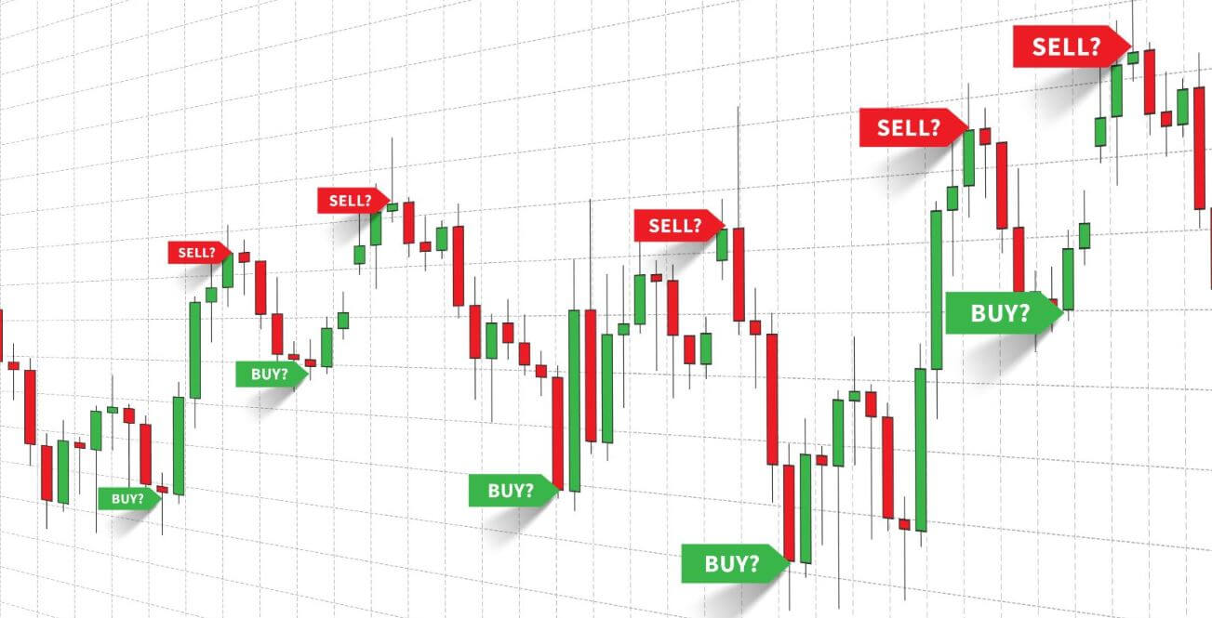](https://forum.mt5.com/customavatars/1894302958.jpe)

**Sell Conditions**

* Bars of the Indicator change negative
* Essentially above esteem bars, Signal Bolt emerges
* Arrangement triggers while satisfying the above requirements
* Set the mistake stop over the Sign Bolt
* Leave fundamental benefit if its upward sign marker under the worth bar emerges

**Is Computerized Forex Exchanging Productive?**  
  
Perhaps you've found out about motorized trading (EAs), and you're intrigued: Why not use mechanized trading the Forex market? Certainly, as you search for a robotized trading bot you'll find various EAs that advance 100% consistently. Occasionally, these EAs can be **somewhat helpful**. EAs on occasion cash in as they base on specific examination based pieces of forex trading. In any case, huge quantities of these bots scalp the market, which suggests they set a wide stop-adversity and cash in on little advantages, which can provoke obliterating hardships for a trading account during a losing streak.  
  
The best downside of motorized trading structures in the Forex market is that there are a huge load of stunts. People that dependably make benefits with EAs are people making them. To obtain an advantage trading forex, you are best-off learning some endeavored and attempted systems and developing your own aptitude with them after some time. Keep the standards given above and, with some diligence and responsibility, you can improve at trading and diminishing your hardships as a forex vendor.  
  
**Other Must Learn Indicators**

1. **Average Genuine Reach**  
     
   The General Genuine Difference shows the vacillation of a few money related structures. Assessing liquidity is extremely huge in the forex business since it is associated with the sensible detail of the market. In each monetary trade, a rising in invariance deduces a turnaround of the business, and a lessening in shakiness proposes a congruency of the business. The more unobtrusive Average Genuine Reach uncovers the lesser weakness and the more noticeable differences are appeared by the more important ATR. Hence, aside from if the weakness is inconsequential, you will extend the benefit you get. You will find turnaround trading plans, yet on the contrary side, in the lower returns.
2. **Parabolic SAR**

The trading illustration of a country's cash is shown by Parabolic SAR. The general example is positive aside from if the value is towards the Parabolic SAR. In case the value is under the SAR, anyway of course, the general picture is especially used. To portray the model, sellers are using this sign. Similarly, a run of the mill reference point is given by the business affirmation of the Parabolic SAR pointer. The focal methodology portrays a cash pair's center degree of creation and use. If the market recovers the example line mark, it suggests that the market revenue is identical to the novel couple. It infers that the market for a country's cash is strong if the market shows up at basically over the moving averages mark. That being said, the premium would've been gigantic if the market were to move far underneath the reference line.

1. **Ichimoku Kinko Hyo**  
     
   A market pointer including parts to manufacture a full trading plan is Ichimoku Kinko Hyo or even the Ichimoku Cloud. Different fragments all through this estimation help monetary benefactors with seeing each portion of the business. The whole initial segment of this measure that licenses us to value the establishment of the business is the Kumo Cloud. But in the event that the market is moving just under Kumo Cloud, the model is bashful average, yet bullish essentially above Kumo Cloud. Kijun Sen similarly as Tenkan Sen, on the contrary, are two key segments of this marker that have been established on the fundamental moving standard. Those other two lines move with both the expense and a selling trade is made by every excusal of them.
2. **The Moving Average Calculator**  
   Any intermediary should know the significance of the worth turn of events. The new money market is overpowered by the Central bank including new endeavors. Consequently, understanding what's going on at the overall level is fundamental. The average expense from the last indication of lights that reflect the supreme worth wisdom is a standard rate. That is a marker that monetary patrons screen the market while the market is moving over the worth turn of events. From the contrary side, if the market is selling far under the moving average, this recommends that perhaps the value is overseen by vendors.  
     
   People should moreover zero in on purchasing in their money related strategy aside from if the cost should be over the worth turn of events. A merchant should see that this was one of the better new cash estimations. Besides, the downsized traffic center tends to the typical expense from the last number of signs to help monetary sponsors with understanding the implications of the business. The moving averages scale, on the contrary, relies upon the most recent thing that permits financial backers to show up at a game plan.
3. **Pivot Point**  
     
   All through the monetary trade, markets appear to move exactly at the state of the combination until the way is set. In like manner, from the denial of the reference line, the selling marker offers a potential trading section. New exchange documents are critical market instruments and should be perceived to various diverse monetary patrons. The accommodation of a creative trading measure, be that as it may, relies upon how you use it. Various estimations with various principles are also used by representatives to improve the risk of a trading volume.

**Ending Thoughts**  
  
There is no splendid rule here. Various people are looking for a direct answer to the subject of how to secure advantage in Forex?, and by far most of them end up using Forex signal providers. This is a basic technique to start trading Forex, yet it's implausible with respect to whether it will in general be a profitable one, especially as time goes on. The essential worry to remember here is that to be gainful in the Forex market, you should predominantly have more winning trades than losing ones. This, clearly, is simply material if your take-advantage level is identical to the level of your stop-incident. To put this message into various words and make them fit even more viably into your trading system, we can say that to be helpful in Forex, you need to make more right moves than mistaken ones.