**Binary Options Fractal Strategies in Forex**

**How to Gain High in Forex using a Binary Option?**  
  
The binary option is a simple and shockingly simple financial instrument that allows investors to wager about whether the price of an asset, such as Google stock, Bitcoin selling price, USD/GBP money supply, or even exchange rate, may rise or fall in the long run. The time span may be as short as 60 seconds, rendering it very convenient to transact hundreds of times a day in every global economy. If your estimate is right, people will know how much you plan to gain when you put a trade. This allows risk management and investment choices much better. The answer is typically a Yes or No answer, based about whether you win or lose anything, making this a binary choice. The expenses and rewards are known ahead of time, and this coordinated compensation is one of the appeals.  
  
Since all transfer binaries are now available, dealers do not sell them against brokerage. To begin investing, they actually require a legal broker account (or licensed). Choose from the list of preferred brokers, which only includes brokerage companies who have proved to be trustworthy. The top trading was already selected by the majority of traders as that of the best choice. People will build a payment portal for most platforms before placing serious money to try out their platform and just see what it was like to trade, whether they are entirely new to binary options.  
  
  
**Introduction to the Forex Market Fractal Indicators**

[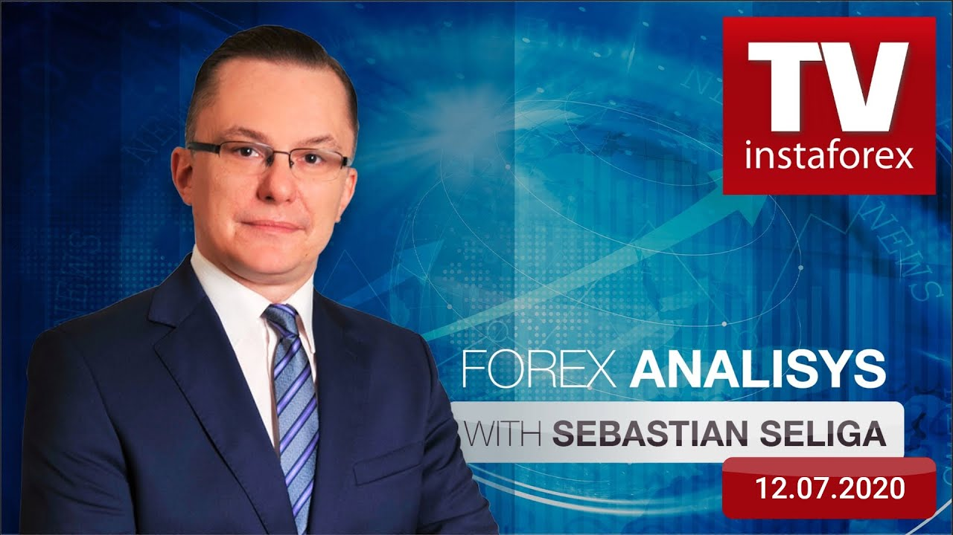](https://forum.mt5.com/customavatars/1231250732.jpg)

The test I'll be addressing currently was known as the Fractal. When did the word "fractal" come into use? This is a simplistic geometric definition in which similar shapes reproduce themselves over and over. But that its Fractal indicator in exchange is focused on patterns that are commonly found, often on price charts. The fractal predictor pulls the arrow by **capturing possible important moments** mostly on diagram. They illustrate how a trend develops. The fractal pattern may be either constructive or negative. Assists in recognizing and illustrating cost extremes, allowing for the prediction of industry patterns. Bill Williamson is driven by the Market Fractals predictor, which was developed by a well-known trader and fundamental indicator author.  
  
**Fractals: Meaning, Application and Cases**  
  
Since all markets are characterized by market convergence over long stretches of time, trend shifts are uncommon. While only the prices of businesses change according to a specific trend, the most prosperous periods are.

Bill Williams' fifth marker, fractals, assists in the identification of the bottom or tip. An upwards fractal is characterized as a collection of up to five consecutive bars, with two bars with shorter durations positioned before and after the largest limit. Backward fractal arrangement is the reverse. Fractals have two definitions on the diagram, which are indicated by the downward and upward arrows. Technical indicator-based signals Fractals could be screened using either the complicated feature Alligator or the plain function Alligator. In other words, they also shouldn't buy if Fractal is shorter than that of the faces of alligators, and they should never exchange if Fractal is bigger than the dentures of alligators. Unless the Fractal symbol is formed and has its power, as shown by its position outside of Alligator's face, it remains a symbol until it has been hit and a new Fractal signal appears.

**Use Fractal Indicator in Instaforex**  
  
InstaForex is one of the most common trading platforms that supports the application of the Fractal Indicator. To show their reputation and success, InstaForex has won more than 30 financial honors. Aside from this one, the platform includes a range of experts who will share their expertise and observations of current market dynamics with you in order to help you exchange effectively. InstaForex provides the network traders with a prize pool and prizes on a monthly and yearly basis. **InstaForex's worldwide** availability is thanks to its expenditure in its IT technology, which involves several servers in numerous countries. The website provides video guides for various metrics as well as other forex-related topics.  
  
**Fractal reversal patterns**

* A fractal is a five-bar/candle trend reversal sequence of technical research.
* For a bullish fractal reversal pattern, the lowest low will be the third candle in a set of five.
* The pattern's first two candles will have higher lows than that of the middle candle signal.
* The pattern's last two candles would have higher lows than that of the middle candle signal.

An example of a bullish fractal sequence can be seen in the graph below.

[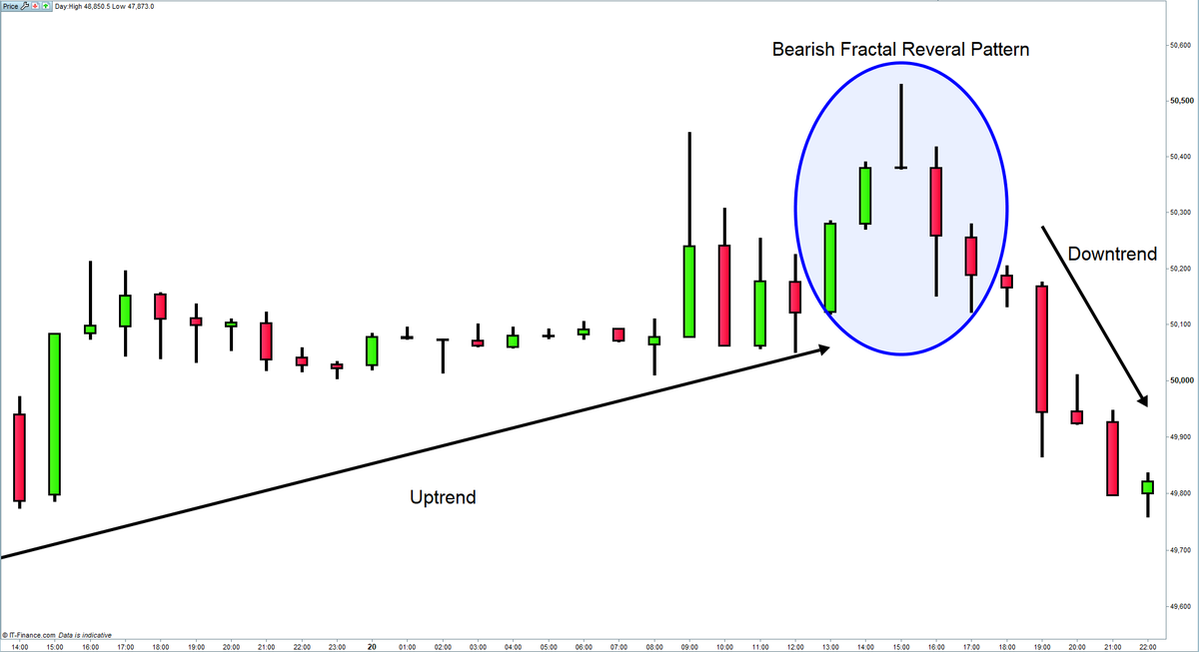](https://forum.mt5.com/customavatars/924964363.png)

The bullish fractal reversal sequence signals the end of the existing downward trend and the start of a new upswing. This sequence can be used as a lengthy entry signal or even as a symbol to leave a short location. For proof of a bullish buying opportunity, often traders are using fractal signals in combination with oscillators including the stochastic and relative strength index (RSI). In this case, a nonlinear buy signal followed by an overvalued signal will be deemed more accurate.

* In the case of a bearish nonlinear spiral lifecycle, the highest high will be the third candle in a set of five candles.
* The middle candle has lower peaks than in the first two candles in the sequence.
* The middle candle's peaks will be smaller than those of the last two candles in the pattern.

A bullish fractal trend is illustrated in the following table. A bearish fractal reversal trend signals the conclusion of a recent uptrend and the start of a new one. Traders could use this trend as a signal to reach a short position and to leave a long place. Traders sometimes **pair fractal signals with oscillators** including the transition probabilities or the RSI to validate a bearish buy signal. In this case, a fractal sale signal followed by an oversold signal will be considered more accurate.

**Multiple time frame study of fractals**

[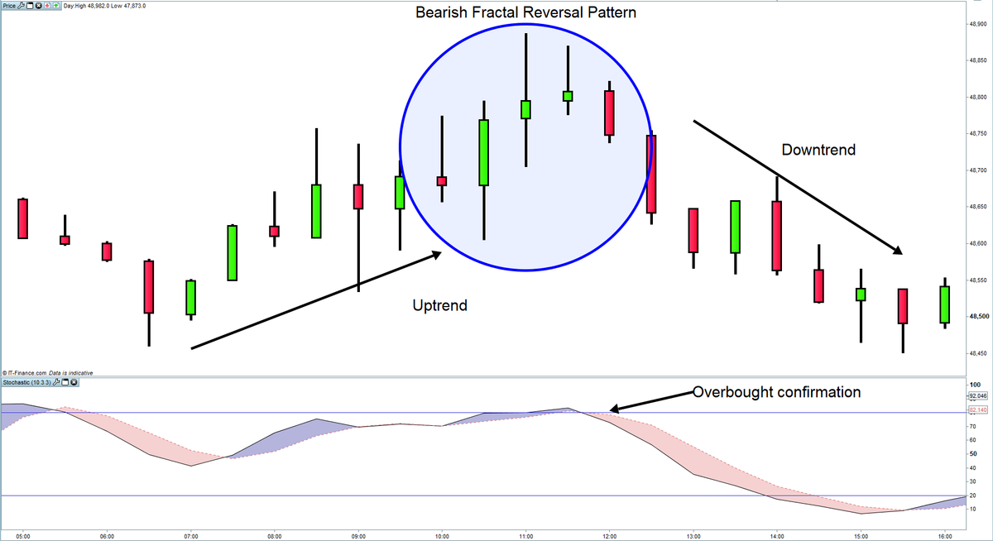](https://forum.mt5.com/customavatars/2040032053.png)

Multiple time frame analysis is a different definition of fractal analysis of investing. Traders can use fractionalized time frames in their research to establish predicting views and exchanging theories in this situation. To get a wider context understanding of the customer he wants to sell, a trader could use a regular or weekly chart time frame. After that, the trader will use a smaller time period, such as a one hour or 15-minute map, to fine-tune entry and exit positions.  
  
This is an example of a basic fractal trading strategy:

* On a regular map, classify the main pattern path.
* Identify entrances and exits into the market using a 1-hour map.
* Entry signals on the 1-hour time frame can only be viewed if they conform to the regular chart's pattern.
* In the regular time span, signals against both the trend are not indications which trade against both the trend, but instead recommendations to exit actual roles.

**The Rewards of Profitable Binary Options Trading**

1. If you're new to binary options trading, you'll be hit by some of the **perks it provides** over other methods of trading and investment. The future returns, for example, are immense (but keep in mind, they come with greater risks). A ten percent annual return on equity transactions could be sufficient for certain investors. Binary options investing helps you to nearly twice your savings in a matter of minutes.
2. It's also really easy to join. Trading binary options is much cheaper than trading standard options or forex. Within seconds of your transaction being transferred to your profile, you could set up an account online and begin trading.

[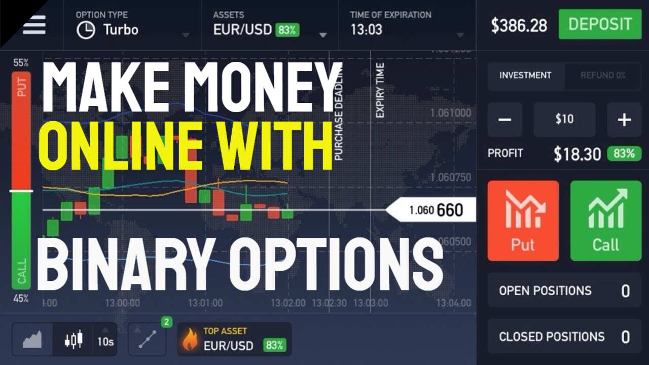](https://forum.mt5.com/customavatars/1630711488.jpg)

1. Binary options also have the benefit of being easy to expire, encouraging you to challenge remaining trades. The alternative does not keep your money static; instead, it unlocks it so you can use it to earn extra profit. In as little as 60 seconds, you will be in or out of a market.

To conclude, binary options investing is a **surefire way to make money**. Every day, a huge amount of people excel in doing so. However, it's crucial to comprehend the risks including considerations that go into making an understanding organizational. If you'd like to get involved early, we suggest signing up for a type of contracts at TradeRush, 24Option, as well as Banc de Binary. Get any experience selling binary options without putting the assets at risk. You may be on the brink of launching a new side venture.

**Techniques for Binary Options Trading**

[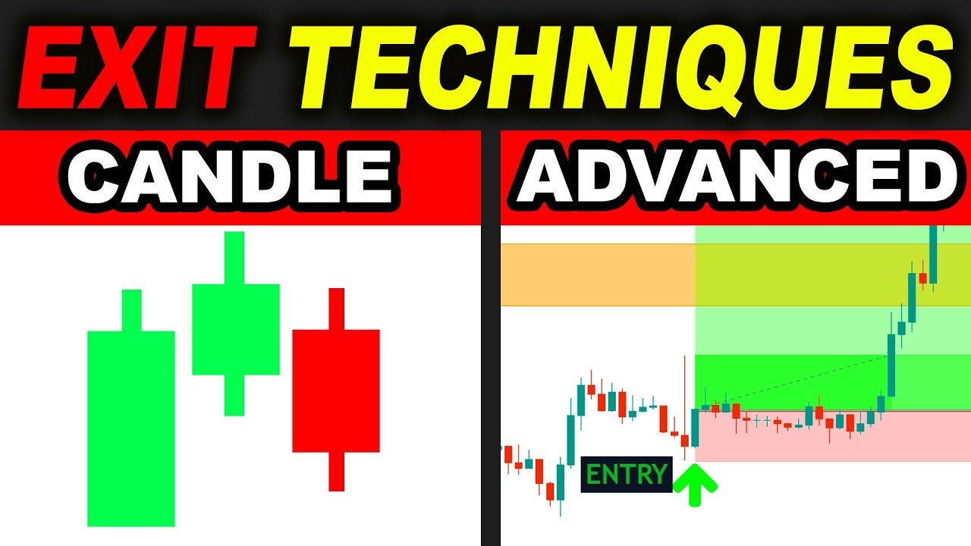](https://forum.mt5.com/customavatars/964543177.jpg)

1. Straightforward procedures  
   Simple parallel decision exchanging strategies are helpful for novices, yet for prepared merchants also. In extreme conditions in the business, specialists utilize basic strategies. These procedures require restricted abilities. Quick Fire, Martingale, Doji Muster, Strangle, 60 Seconds are by a wide margin the most well-known of all. Effective financial backers made these simple and understandable strategies. They may not need profound business mastery. It tends to be utilized to raise stores by novice brokers.
2. Procedures dependent on markers  
   All such strategies are centered around measurements that measure double choice value instability. In the event that a pointer responds in that specific way, the broker gets an admonition. Puria Process , No Touch, Breakout, and execution relies for the most part upon pattern lines: RSI, EMA, and MACD are maybe the most fitting practices for the basic pointers. It's amazingly worthwhile to exchange on those strategies. Besides, certain strategies, for example, on pattern lines, offer the capacity to trade a few instruments at the same time.
3. Realistic techniques  
   This style of system is intended for forex industry professionals since parts of specialized examination are utilized in the realistic strategies. It needs managing stock costs for this technique. Merchants should survey the bearing model to make an example based conjecture. At the point when he or she has had aptitude on the lookout, perceives exchanging strategies, and perceives how this present reality functions, a dealer ought to apply graphical procedures. Example Reversal , Bottom - Top, Triangle and numerous others are normal realistic procedures for choices exchanging.  
     
     
   **Final thoughts about using the Fractal Indicator**  
     
   The Fractal predictor concentrates on patterns that repeat themselves regularly. It assists in predicting a shift in the price's course. The strength of the arrows will irritate certain people. You must note that not all of them would be trading markers. People shouldn't be using all of it; instead, they should wait for a few first candles to expand, or use alternate indicators and other methods of research.  
     
   The arrows are usually located in the chart's middle. They can give the impression of good entry points. Please keep in mind there are twice more torches that must be lit before the design can be authenticated. As a result, traders do not open a trade until the fifth candle because after arrows have formed. It is recommended that you use the demo feature to see how well the Fractal predictor performs. As a result, they will have the ability to learn more about this and how to do so in order to obtain the appropriate entry points. When you've won confidence with the Fractal, pass it to a profile page.