**Guide in Free Scalping in Forex MT4**

**Easy Guide for Forex Scalping**  
Forex scalping is often a short-term trading technique that seeks to benefit from slight price fluctuations throughout the foreign exchange market. Scalpers can purchase and sell a foreign exchange pairs in a couple of seconds or moments, only holding the title for another few minutes or seconds. Those who instead, while taking advantage of market swings, repeat this method during the day to earn high returns. Throughout the foreign exchange market, the percentage of points that traders use to **calculate gains and losses** is another term for the slightest price movement a currency may produce. Forex scalpers seek to make a substantial profit by both the end of the day by scalping about 5-10 percentage points in each location. A method of trading was Forex scalping .

[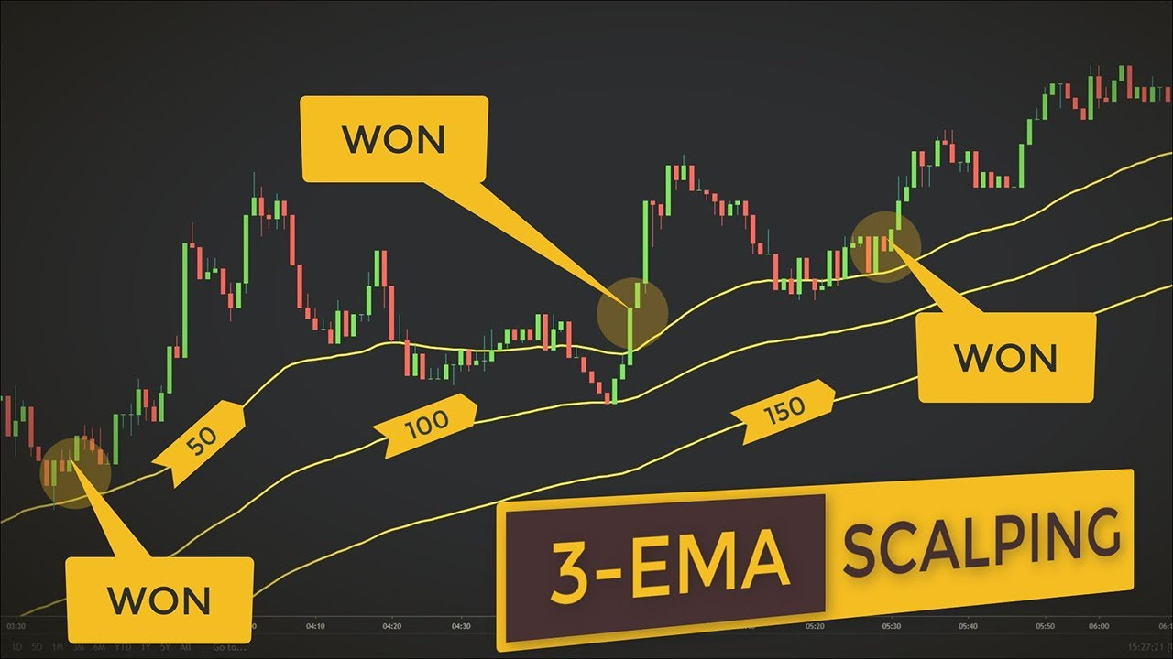](https://forum.mt5.com/customavatars/1740816341.jpg)

Leveraged investing provides the best foreign exchange scalping tactics. The use of forex leveraging is a strategy that helps traders to lend money from a broker, using just a small percentage of the maximum asset valuation as a collateral, to obtain more access to the foreign exchange market. If the price does not shift in the bet's favor, this tactic will magnify damages. Consequently, for any adjustments, forex scalpers are expected to keep a careful eye on the market.  
  
**Computerized scalping forex**  
Due to its rapid speed of exchange, several platforms give the potential for electronic trading that is very common between forex scalpers. Automated trading refers to software that operates separately to detect forex scalping signs, join and leave trades rapidly, and track the market fluctuations of your preferred currency pair. For forex traders, our globally hosted website, MetaTrader 4, provides automated exchange.

[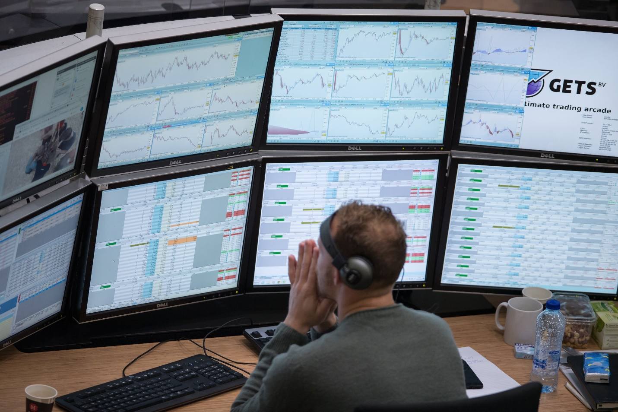](https://forum.mt5.com/customavatars/1111165484.jpg)  
  
**Know the right technique for forex scalping**  
Inside the foreign exchange market, we deliver attractive spreads on some more than 339 large, minor and foreign two currencies, the highest percentage in the business. Our goods have the potential to distribute bet or swap CFDs with flexibility, helping you to benefit from short-term market swings. It's an easy method to open the account: choose to start investing instantly or train mostly on the demo account with &#163; 10,000 worth of digital resources.  
  
**Forex scalping signals**

[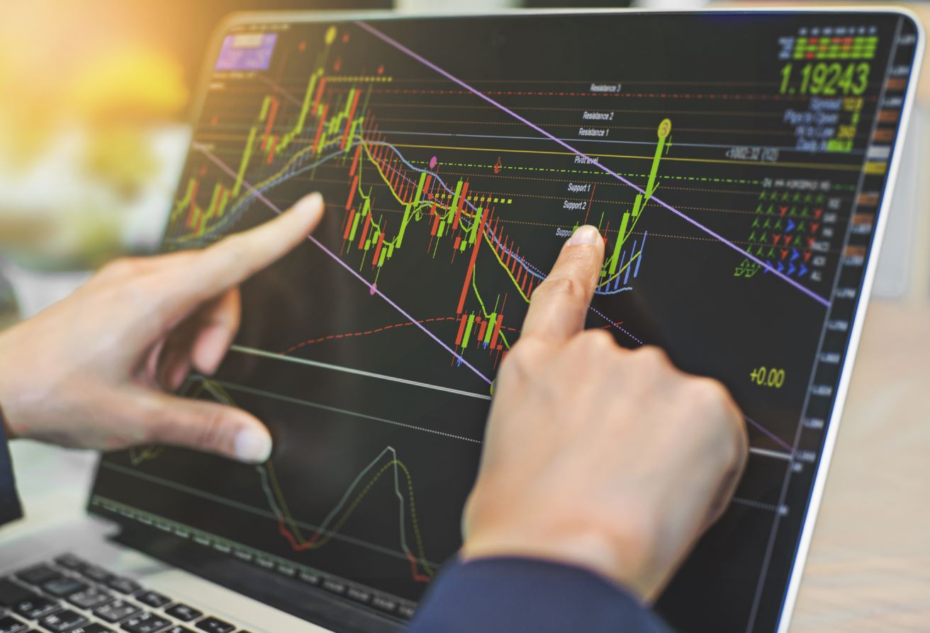](https://forum.mt5.com/customavatars/1690379007.jpg)

Trading signals are created by computers or technical analysis in dynamic markets to distinguish exchange entry and exit positions. Because of the speed of the exchange, forex scalping indicators become especially significant. Short and long signal companies in the forex industry both seek a variety of percentage points to aid scalpers identify new openings when the sector is especially unpredictable, or when it is calm because there is less demand. Business transactions, such as those described above, or forex scalping indicators have been used to produce forex scalping triggers. The majority of traders have used a forex scalping technique that gives them total access to diagrams, percentage in points, and forex technical metrics, as well as proximity to main region market times around the world. Market traders, in general, research price charts and search for openings at the busy hours of the day, and they must be totally centered at all times.  
  
**Forex Scalping Leading Indicators 2021**

Well, what is the perfect forex scalping indicator? The common indicators that they provide on the online trading platform are listed beneath. Bollinger Bands, nonlinear oscillators, including Keltner channels are examples of forex scalping indicators that function to display patterns and movements on price charts when tracking the digital trading platform.

1. **Bollinger Band Scalping**

A Bollinger Band map is efficient at showcasing the uncertainty of the foreign exchange market, which would be good for scalpers since their transactions are usually done in less than five minutes. Bollinger Band scalping is also an immensely important forex scalping predictor for major currencies with low gaps throughout the forex market, since these are the least unpredictable and, if conducted correctly, will produce several gains for the forex scalper at the same time. The EUR/JPY, EUR/USD, and GBP/USD are examples of minor and major currencies.

1. **Moving averages for scalping forex**

On a standard forex map, there are many moving average lines. The basic moving average (SMA) as well as the exponential moving average (EMA) are two of the most widely used forex metrics for scalping (EMA). This can also be used to reflect short-term swings in a currency's market patterns. Because of its ability to detect shifts quicker than other metrics, a moving average diagram is among the most widely used forex scalping metrics for specialists.

1. **Forex RSI scalping**

The relative strength index (RSI) would be a momentum oscillator which forecasts the forex economy's current prospects throughout time. Short-term traders, including day traders including scalpers, may minimize the RSI's default configuration to track just a few mins at a time, allowing them to locate the best entry and exit points. Throughout the forex market, calculating momentum will help traders find the right approach for the current situation.

**Some Forex Scalping Tips**

* To **maximize their odds of success**once scalping, traders must concentrate on one major currency or place at a time. Although trading several positions at once, it can be hard to keep track of the strategic charts correctly, and concentration is more likely to be lost.
* It's best to **only exchange currency pairs** with the greatest liquidity as well as volume. Scalping is indeed a fast-paced operation, so big currency pairs require liquidity to allow traders to easily enter and leave the market.
* Scalpers seem to have a temperament as well as personality that represents the **high-risk nature of their trading**. Scalping necessitates attention, critical skills, and a healthy degree of discretion, causing scalpers to make bad choices in the hopes of benefit.  
    
  **Top Currency Pair in Forex Scalping**

[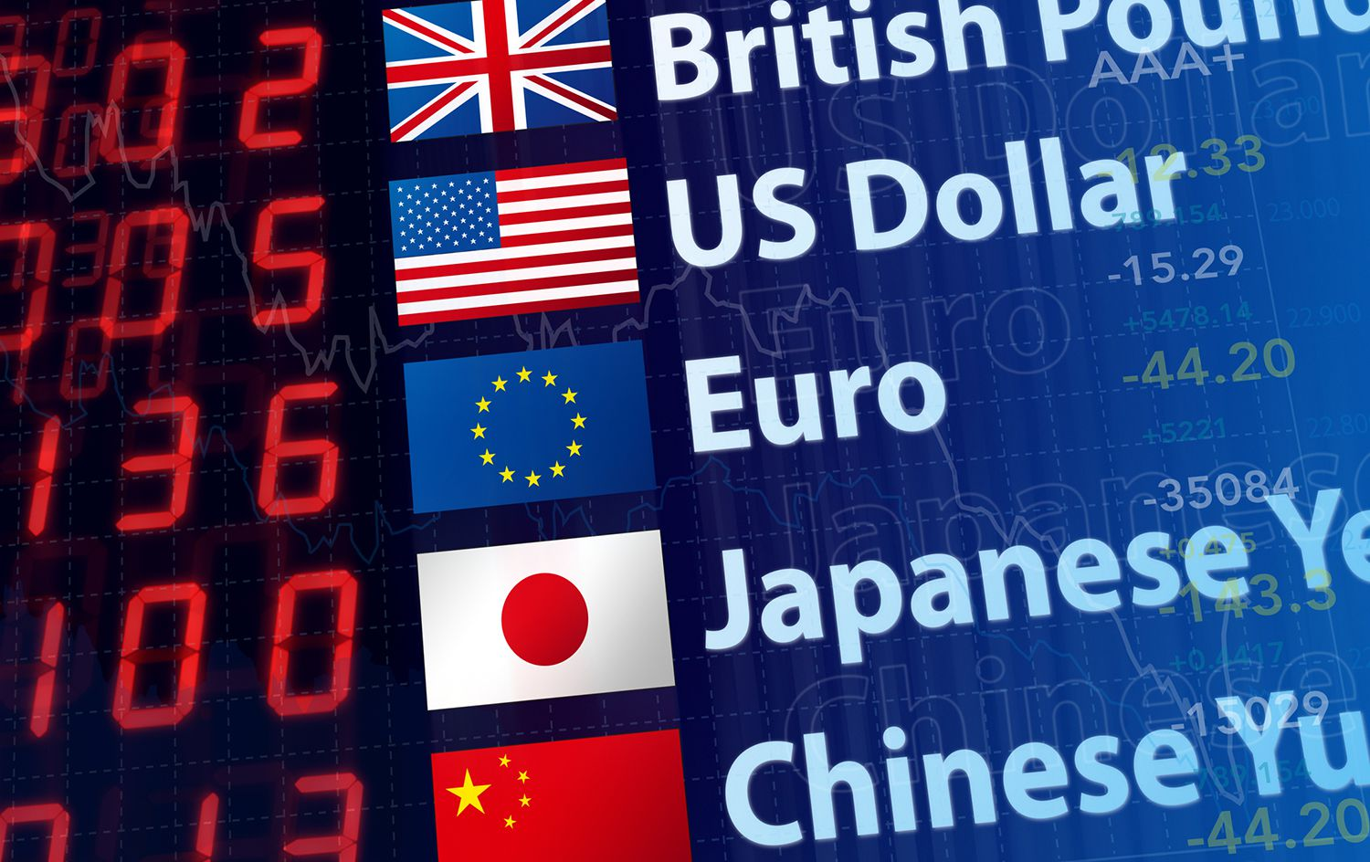](https://forum.mt5.com/customavatars/583586753.jpg)

Scalping large currency pairs like the **GBP/USD, AUD/USD, and EUR/USD,** as well as small foreign currencies like the AUD/GBP, is a viable choice for traders. That's also due to the fact that they will be into or out of the sector regularly, and these assets get the largest exchange rates and tightest spreads to reduce losses. The fewer percentage points, the rate needed to travel until your exchange is lucrative, the narrower the range. Some more seasoned traders, on the other hand, may tend to scalp major or unusual foreign currencies, which have better variance that major currency pairs but often bear increased odds.  
  
**Best time for doing forex scalping**

[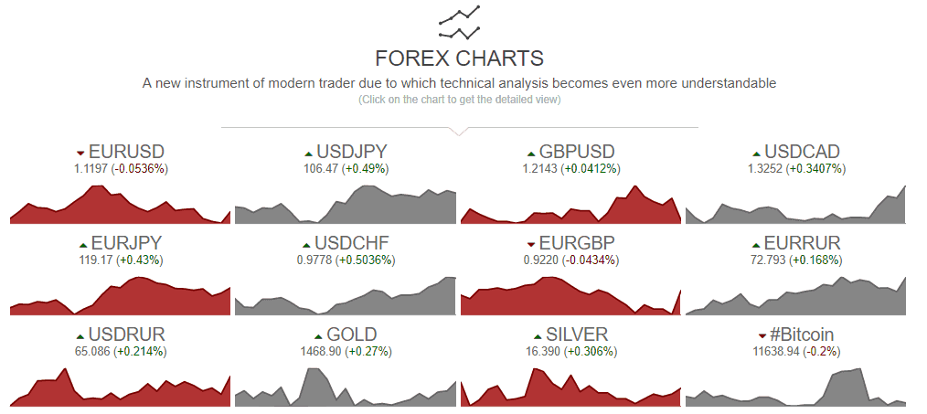](https://forum.mt5.com/customavatars/440581528.png)

The best times to scalp forex are usually settled upon by traders, but this varies depending on the asset. Trading an exchange rate based mostly on GBP, for instance, is most lucrative within the first quarter of the London market day, in the after-morning. Even so, since the USD has the largest trading rate, the best time to exchange any big currency pair is usually within the **first few hours** of the New York market cycle. Traders may not track charts from outside currency trading hours, it comes as no surprise. Few scalpers tend to sell in the wee hours of the morning when another market is most unpredictable, but this tactic is only recommended for experienced buyers, not novices, since the costs are higher.  
  
**Forex Scalping's Competitiveness**  
The foreign exchange market is notoriously unpredictable, and instead of exhibiting slight price changes, it will periodically crash or totally change course. This necessitates the scalper to move quickly about how to guarantee that the place does not suffer too many losses, and that future trades compensate for any damages with **higher profits**. Scalping also bears the possibility of joining and leaving trades too late. Unstable price fluctuations between asset classes are common, and if the economy starts shifting toward your open spot, closing the exchange fast enough to prevent losing money can be challenging. Using a significant amount of leverage is often highly dangerous. If scalpers were effective, forex yields can help **raise profits**, but they can also amplify risks if transactions are badly performed.[](https://forum.mt5.com/customavatars/1645623583.jpg)

Because of a scalper's focus and character, they ought to be able to identify these changes easily and close their place to avoid losing revenue. The further a place is held, the higher the probability that rates will shift beyond the scalper's tipping scope. As a result, most scalpers **adhere to the tighter exchange ranges** and avoid making too many volatile decisions in order to minimize risk. Because of the amount of experience, focus, and expertise expected of the foreign exchange market, a scalping technique is not recommended for inexperienced traders. In these cases, the odds of losing vacancies are far greater than the chances of winning positions. Scalping, arbitrage, and high-frequency trading (HFT) are typical techniques used by more seasoned or professional investors to conduct quality and standards.  
  
Although selling currencies in certain unpredictable environments, using stop-loss orders will help a trader properly control their risk and damages. Scalping helps traders to set a certain price at which their bets will immediately close out if the stock swings in the reverse direction. Since a scalp deal lasts just a few seconds at best, the dealer is unable to hang onto a losing role.  
  
  
**Final Thoughts**  
**InstaForex** is a broker that adheres to the highest degree of service when operating in compliance with international laws including local requirements in specific countries, according to the InstaForex analysis. Across the whole of its existence, the company has seen steady growth in terms of technology advancement, trading software, and overall customer offering. The fact that InstaForex has a customer base of about 7 million people is remarkable, but it also reflects their consistency and dependability. The large number of traders considered InstaForex to be the right alternative for them because of their comprehensive offering, which involves Tick Trades and, more specifically, Cryptocurrency dealing through some of the most effective and cheap portals of **MT4 as well as MT5**.  
  
That is real, traders with varying levels of stock trading will find your marketing solution at InstaForex, either via PAMM or ForexCopy systems, which allow traders can invest then copy investing without having to spend a lot of time making a decision, or traders about any strategy which is relevant to them specifically.